Title

2023-09-18

# remotes::install_github("davidgohel/officedown")  
devtools::install_github("davidgohel/flextable")

## Skipping install of 'flextable' from a github remote, the SHA1 (9321df67) has not changed since last install.  
## Use `force = TRUE` to force installation

library(flextable)  
library("officedown")  
library(dplyr)

##   
## Attaching package: 'dplyr'

## The following objects are masked from 'package:stats':  
##   
## filter, lag

## The following objects are masked from 'package:base':  
##   
## intersect, setdiff, setequal, union

library(table1)

##   
## Attaching package: 'table1'

## The following objects are masked from 'package:base':  
##   
## units, units<-

library(knitr)

## R Markdown

This is an R Markdown document. Markdown is a simple formatting syntax for authoring HTML, PDF, and MS Word documents. For more details on using R Markdown see <http://rmarkdown.rstudio.com>.

When you click the **Knit** button a document will be generated that includes both content as well as the output of any embedded R code chunks within the document. You can embed an R code chunk like this:

summary(cars)

## speed dist   
## Min. : 4.0 Min. : 2.00   
## 1st Qu.:12.0 1st Qu.: 26.00   
## Median :15.0 Median : 36.00   
## Mean :15.4 Mean : 42.98   
## 3rd Qu.:19.0 3rd Qu.: 56.00   
## Max. :25.0 Max. :120.00

## Including Plots

You can also embed plots, for example:

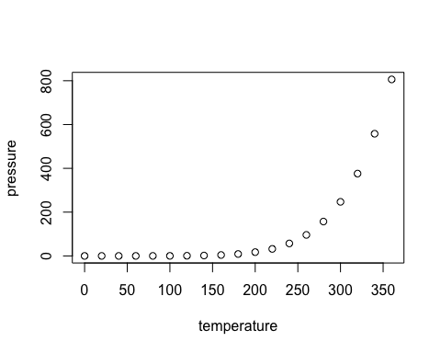

Note that the echo = FALSE parameter was added to the code chunk to prevent printing of the R code that generated the plot.

table1(~ speed, cars) %>%  
 kable()

|  |  |
| --- | --- |
|  | Overall |
|  | (N=50) |
| speed |  |
| Mean (SD) | 15.4 (5.29) |
| Median [Min, Max] | 15.0 [4.00, 25.0] |