HTML Document Object Model
The HTML DOM (HTML Document Object Model) is an Object Model for HTML Documents.

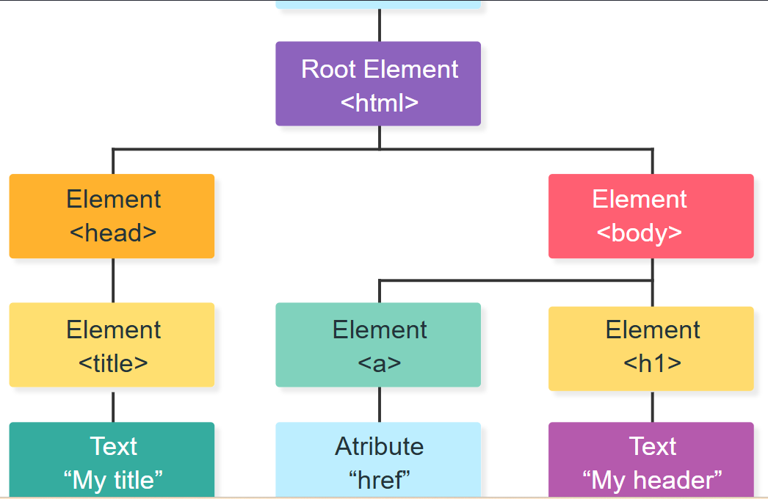

The DOM Tree
When a web page loads, the browser creates a tree-like representation of the HTML document.
Each part of the document are nodes in the tree:
Node | Description
Document | Owner of all nodes in the document
<html> | Element Node
<head> | Element Node
<body> | Element Node
<a> | Element Node
href | Attribute Node
<h1> | Element Node
My Header | Text Node

Accessing HTML Elements
The HTML DOM can be used to access HTML elements.
The most common way to access an HTML element is to use the id of the element:

Example
<html>
<body>
<p id="demo"></p>
<script>
// Access a paragraph Element
const myPara = document.getElementById("demo");
// Change the content of the Element
myPara.innerHTML = "Hello World!";
</script>
</body>
</html>
In the example above, the getElementById method used id="demo" to find the element.
- id="demo" is an HTML property
- getElementById() is a DOM Method
- innerHTML is a DOM Property

What is DOM Tree?
When a browser opens a webpage, it does NOT see HTML as text.
Instead, it converts HTML into a tree structure called:
DOM = Document Object Model

Example HTML
<html>
<body>
<h1>My Header</h1>
</body>
</html>

DOM Tree looks like this
Document
└── html
└── body
└── h1
└── "My Header"

What is a Node?
Every part of the HTML becomes a node:
Part | Type
<html> | Element Node
<body> | Element Node
<h1> | Element Node
"My Header" | Text Node
href, id, etc. | Attribute Node

1. document
document
Represents the whole webpage
Root of the DOM tree

2. getElementById()
document.getElementById("demo");
Finds an element using its id
Example:
<p id="demo"></p>
JavaScript:
const myPara = document.getElementById("demo");
This means:
“Find the element whose id is demo”

3. innerHTML
myPara.innerHTML = "Hello World!";
Changes the content inside the element
Before:
<p id="demo"></p>
After:
<p id="demo">Hello World!</p>

<p id="demo"></p>
<script>
const myPara = document.getElementById("demo");
myPara.innerHTML = "Hello World!";
</script>

Step-by-step:
- Browser loads HTML
- Finds <p id="demo">
- JavaScript runs
- getElementById("demo") finds that <p>
- innerHTML inserts text
- Output appears on page

Key Differences
Term | Meaning
id="demo" | HTML attribute (name of element)
getElementById() | JavaScript method (find element)
innerHTML | Property (change content inside element)

Simple Analogy
Think of a webpage like a house:
- DOM = house structure 🏠
- HTML tags = rooms
- id = room name plate
- getElementById = finding a specific room
- innerHTML = changing furniture inside room

The <em> tag is used to define emphasized text. The content inside is typically displayed in italic.
<!DOCTYPE html>
<html>
<head>
<style>
em {
font-style: italic;
}
</style>
</head>
<body>
<em>Some emphasized text</em>
</body></html>
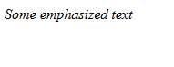
The <strong> tag is used to define text with strong importance. The content inside is typically displayed in bold.

<!DOCTYPE html>
<html>
<body>

<h1>The strong element</h1>

<p>This text is normal.</p>

<p><strong>This text is important!</strong></p>

</body>
</html>
|
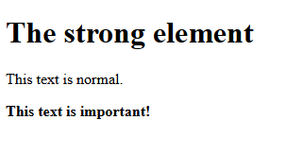
PARAGRAPH AND BREAK LINE
<!DOCTYPE html>
<html>
<body>

<h1>The br element</h1>

<p>To force<br> line breaks<br> in a text,<br> use the br<br> element.</p>

</body>
</html>

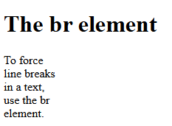

FONTS
<!DOCTYPE html>
<html>
<head>
<title>HTML Text Formatting</title>
</head>
<body>

<b>This text is bold.</b>
<strong>This text is important!</strong>.
<i>This text is italic</i>
<em>This text is emphasized</em>
<small>This is some smaller text.</small>
<p>Do not forget to buy <mark>milk</mark> today.</p>
<p>My favorite color is <del>blue</del> red.</p>
<p>My favorite color is <del>blue</del> <ins>red</ins>.</p>
<p>This is <sub>subscripted</sub> text.</p>
<p>This is <sup>superscripted</sup> text.</p>

</body>
</html>

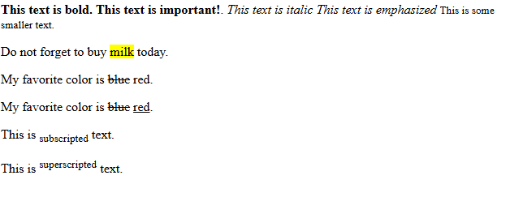
FONT MODIFICATION
<!DOCTYPE html>
<html>
<body>
<FONT SIZE="7">Big</FONT> <FONT SIZE="1">Small</FONT>
<FONT COLOR="red">This is red</FONT>
</body>
</html>

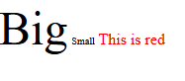

<!DOCTYPE html>
<html>
<body>

<p style="font-family:verdana">This is a paragraph.</p>
<p style="font-family:'Courier New'">This is another paragraph.</p>

</body>
</html>

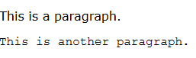

HTML LINKS
NOTE: DEMO.html and link.html should be present in the same folder
<!DOCTYPE html>
<html>
body>
<h2>HTML Links</h2> <p>
<a href=“DEMO.html”>Click here </a>
</p>
</body>
</html>

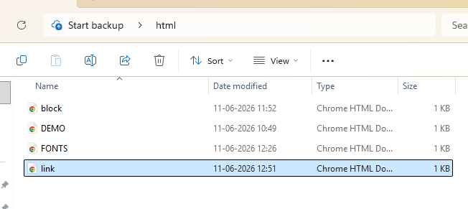

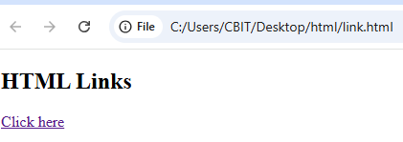

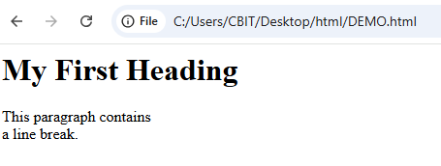

Images
NOTE: IMAGE CAN BE IN SAME FOLDER AS HTML FILE OR CAN PROVIDE ADDRESS ALSO
<!DOCTYPE html>
<html>
<body>
<h2>HTML Image</h2>
<img src="C:\Users\CBIT\Pictures\delighted.webp" alt="delighted" width="1000" height="1000">
</body>
</html>

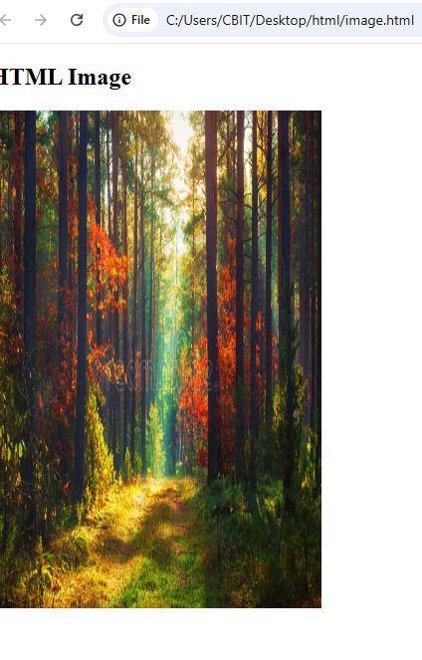

IMAGE IN THE FOLDER OF HTML FILES
<!DOCTYPE html>
<html>
<body>
<h2>HTML Image</h2>
<img src="delighted.webp" alt="delighted" width="333" height="500">
</body>
</html>

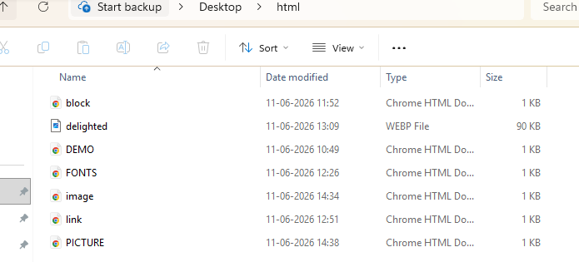

LISTS
<!DOCTYPE html>
<html>
<body>

<h3>Lowercase Roman (i)</h3>
<ol type="i">
<li>Item One</li>
<li>Item Two</li>
<li>Item Three</li>
<li>Item Four</li>
</ol>

<h3>Uppercase Roman (I)</h3>
<ol type="I">
<li>Item One</li>
<li>Item Two</li>
<li>Item Three</li>
<li>Item Four</li>
</ol>

<h3>Lowercase Alphabet (a)</h3>
<ol type="a">
<li>Item One</li>
<li>Item Two</li>
<li>Item Three</li>
<li>Item Four</li>
</ol>

<h3>Uppercase Alphabet (A)</h3>
<ol type="A">
<li>Item One</li>
<li>Item Two</li>
<li>Item Three</li>
<li>Item Four</li>
</ol>

<h3>Numbers (1) - Default</h3>
<ol type="1">
<li>Item One</li>
<li>Item Two</li>
<li>Item Three</li>
<li>Item Four</li>
</ol>
</body>
</html>

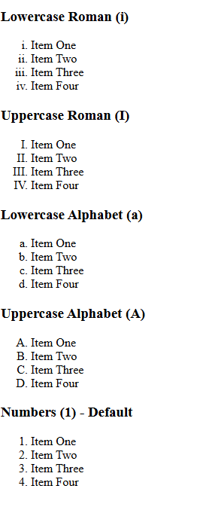
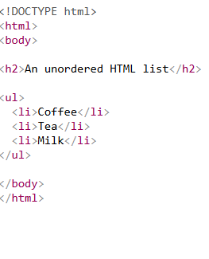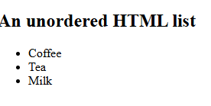
HTML Description Lists
HTML also supports description lists.
A description list is a list of terms, with a description of each term.
The <dl> tag defines the description list, the <dt> tag defines the term (name), and the <dd> tag describes each term:

<!DOCTYPE html>
<html>
<body>

<h2>A Description List</h2>

<dl>
<dt>Coffee</dt>
<dd>- black hot drink</dd>
<dt>Milk</dt>
<dd>- white cold drink</dd>
</dl>

</body>
</html>

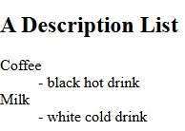
HTML FORMS
<!DOCTYPE html>
<html>
<head>
<title>HTML Form Example</title>
</head>
<body>

<h2>Student Registration Form</h2>

<form action="#" method="post">

<!-- Single-line Text Input -->
Name:
<input type="text" name="name" placeholder="Enter your name">
<br><br>

<!-- Multiple-line Text Input -->
Address:
<br>
<textarea name="address" rows="4" cols="30" placeholder="Enter your address"></textarea>
<br><br>

<!-- Radio Buttons -->
Gender:
<input type="radio" name="gender" value="Male"> Male
<input type="radio" name="gender" value="Female"> Female
<input type="radio" name="gender" value="Other"> Other
<br><br>

<!-- Checkboxes -->
Hobbies:
<input type="checkbox" name="hobby" value="Reading"> Reading
<input type="checkbox" name="hobby" value="Sports"> Sports
<input type="checkbox" name="hobby" value="Music"> Music
<br><br>

<!-- Dropdown List -->
Country:
<select name="country">
<option value="">--Select Country--</option>
<option value="India">India</option>
<option value="USA">USA</option>
<option value="Canada">Canada</option>
<option value="Australia">Australia</option>
</select>
<br><br>

<!-- Submit and Reset Buttons -->
<input type="submit" value="Submit">
<input type="reset" value="Reset">

</form>

</body>
</html>
ANOTHER EXAMPLE
<!DOCTYPE html>
<html>
<body>

<h2>HTML Forms</h2>

<form action="/action_page.php" method="get">
First name:<br>
<input type="text" name="firstname" value="Mickey"><br>
Last name:<br>
<input type="text" name="lastname" value="Mouse"><br>
User password:<br>
<input type="password" name="psw"> <br>
Gender :
<input type="radio" name="gender" value="male"> Male<br>
<input type="radio" name="gender" value="female" checked> Female<br>
<input type="radio" name="gender" value="other"> Other<br><br>
CheckBox:<br>
<input type="checkbox" name="vehicle1" value="Bike">I have a bike<br>
<input type="checkbox" name="vehicle2" value="Car">I have a car <br>

Country
<select name="country">
<option value="India">India</option>
<option value="Australia">Australia</option>
<option value="USA">USA</option>
<option value="Canada">Canada</option>
</select> <br><br>
Address :<br>
<textarea name="message" rows="10" cols="30">
Enter your Address
</textarea><br><br>

<input type="submit" value="Submit">
</form>
</body>
</html>
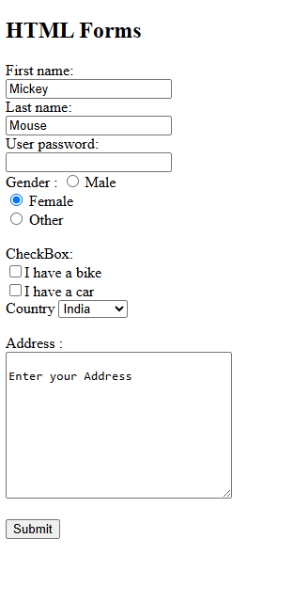
EXAMPLE FOR CUSTOMIZED NAME
<!DOCTYPE html>
<html>
<body>

<h2>HTML Forms</h2>

<form action="/action_page.php" method="get">
First name:<br>
<input type="text" name="firstname" placeholder="Enter your First name">><br>
Last name:<br>
<input type="text" name="lastname" placeholder="Enter your Last name"><br>
User password:<br>
<input type="password" name="psw"> <br>
Gender :
<input type="radio" name="gender" value="male"> Male<br>
<input type="radio" name="gender" value="female" checked> Female<br>
<input type="radio" name="gender" value="other"> Other<br><br>
CheckBox:<br>
<input type="checkbox" name="vehicle1" value="Bike">I have a bike<br>
<input type="checkbox" name="vehicle2" value="Car">I have a car <br>

Country
<select name="country">
<option value="India">India</option>
<option value="Australia">Australia</option>
<option value="USA">USA</option>
<option value="Canada">Canada</option>
</select> <br><br>
Address :<br>
<textarea name="message" rows="10" cols="30">
Enter your Address
</textarea><br><br>

<input type="submit" value="Submit">
</form>
</body>
</html>

HTML CANVAS
<!DOCTYPE html>
<html>
<body>

<canvas id="myCanvas" width="200" height="100" style="border:1px solid red;">
<script>
var c = document.getElementById("myCanvas");
var ctx = c.getContext("2d");
ctx.moveTo(0,0);
ctx.lineTo(200,100);
ctx.stroke();
</script>

</body>
</html>

Explanation:
getElementById() is a JavaScript method used to find and access an HTML element by its id.

Syntax
document.getElementById("id_name");
- document → represents the entire HTML page.
- getElementById() → searches for an element with the specified id.
- Returns the HTML element if found.

In Your Code
<canvas id="myCanvas" width="200" height="100" style="border:1px solid red;">
The canvas has:
id="myCanvas"
JavaScript accesses it with:
var c = document.getElementById("myCanvas");
This means:
- Look through the HTML page.
- Find the element whose id is "myCanvas".
- Store that element in variable c.
So after this line:
var c = document.getElementById("myCanvas");
c refers to:
<canvas id="myCanvas" width="200" height="100"></canvas>

Next Line
var ctx = c.getContext("2d");
- c is the canvas element.
- getContext("2d") creates a 2D drawing context.
- ctx is used to draw on the canvas.

Drawing the Line
ctx.moveTo(0,0);
Move the drawing cursor to coordinates (0,0).
ctx.lineTo(200,100);
Draw a line to (200,100).
ctx.stroke();
Actually display the line.

<!DOCTYPE html>
<html>
<body>

<svg width="100" height="100">
<circle cx="50" cy="50" r="40"
stroke="green"
stroke-width="4"
fill="yellow" />
</svg>

</body>
</html>

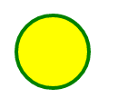
Attribute | Meaning
width="100" | SVG area width
height="100" | SVG area height
cx="50" | X-coordinate of center
cy="50" | Y-coordinate of center
r="40" | Radius of circle
stroke="green" | Border color
stroke-width="4" | Border thickness
fill="yellow" | Inside color
SPAN TAG
<!DOCTYPE html>
<html>
<head>
<title>Span Tag</title>
</head>

<body>

<h2>Example of span tag</h2>

<p>
I have chosen only
<span style="color:red;">red</span>,
<span style="color:blue;">blue</span>, and
<span style="color:green;">green</span>
colors for my painting.
</p>
</body></html>
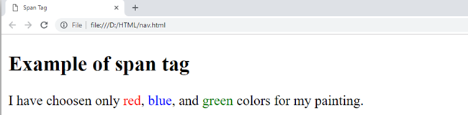
HTML AUDIO VIDEO FILES
<!DOCTYPE html>
<html>
<head>
<title>Video Example</title>
</head>
<body>

<video width="320" height="240" controls>
<source src="file_example_MP4_480_1_5MG.mp4" type="video/mp4">

</video>

</body>
</html>

CSS BACKGROUND AS IMAGE
<html>
<head>
<style>
h1
{
background-color: red;
}
p
{
background-color: yellow;
}

body
{
background-image: url("delighted.webp");
}
</style>
</head>

<body>

<h1>Hello World!</h1>
<p>This page has an image as the background!</p>

</body>
</html>

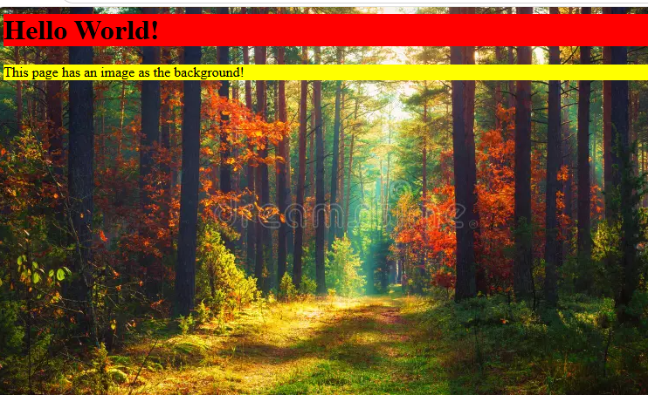

<html>
<head>
<style>
body
{
background-image: url("delighted.webp");
}
</style>
</head>
<body>
<h1>Hello World!</h1>
<p>This page has an image as the background!</p>
</body>
</html>


CSS Float:
The float property specifies whether an element should float to the left, right, or not at all.
Note: Absolutely positioned elements ignore the float property!
Note: Elements next to a floating element will flow around it. To avoid this, use the clear property.
CSS Syntax
float: none|left|right|initial|inherit;
Property Values
Value Description
none The element does not float, (will be displayed just where it occurs in the text). This is default
left The element floats to the left of its container
right The element floats to the right of its container
<!DOCTYPE html>
<html>
<head>
<style>
img {
float: left;
}
</style>
</head>
<body>
<h1>The float Property</h1>

<p>In this example, the image will float to the left in the text, and the text in the paragraph will wrap around the image.</p>

<p><img src="pineapple.jpg" alt="Pineapple" style="width:170px;height:170px;margin-right:15px;">
The pineapple is a remarkably patient tropical fruit, taking nearly three years for a single plant to grow and mature just one specimen. Anatomically unique, it isn't actually a single fruit, but a cluster of dozens of individual berries that fuse together around a central core as they ripen. Beyond its sweet and tart flavor, the pineapple contains a powerful protein-digesting enzyme called bromelain, which is responsible for that familiar, slight tingling sensation you feel on your tongue while eating it. Centuries ago, this spiky fruit was so rare and sought-after that wealthy Europeans would actually rent them for the evening simply to carry them around at parties as a ultimate symbol of luxury and high social status..</p>

</body>
</html>

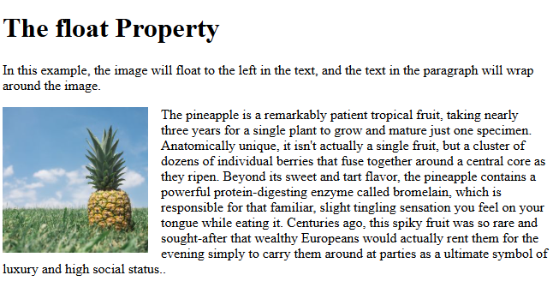

<!DOCTYPE html>
<html>
<head>
<style>
img {
float: none;
}
</style>
</head>
<body>
<h1>The float Property</h1>

<p>In this example, the image will be displayed just where it occurs in the text (float: none;).</p>

<p><img src="pineapple.jpg" alt="Pineapple" style="width:170px;height:170px;">
The pineapple is a remarkably patient tropical fruit, taking nearly three years for a single plant to grow and mature just one specimen. Anatomically unique, it isn't actually a single fruit, but a cluster of dozens of individual berries that fuse together around a central core as they ripen. Beyond its sweet and tart flavor, the pineapple contains a powerful protein-digesting enzyme called bromelain, which is responsible for that familiar, slight tingling sensation you feel on your tongue while eating it. Centuries ago, this spiky fruit was so rare and sought-after that wealthy Europeans would actually rent them for the evening simply to carry them around at parties as a ultimate symbol of luxury and high social status.</p>

</body>
</html>

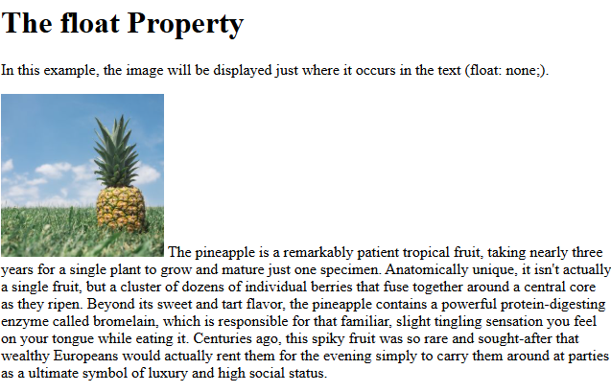

<!DOCTYPE html>
<html>
<head>
<style>
img {
float: right;
}
</style>
</head>
<body>
<h1>The float Property</h1>

<p>In this example, the image will float to the right in the text, and the text in the paragraph will wrap around the image.</p>

<p><img src="pineapple.jpg" alt="Pineapple" style="width:170px;height:170px;margin-left:15px;">
The pineapple is a remarkably patient tropical fruit, taking nearly three years for a single plant to grow and mature just one specimen. Anatomically unique, it isn't actually a single fruit, but a cluster of dozens of individual berries that fuse together around a central core as they ripen. Beyond its sweet and tart flavor, the pineapple contains a powerful protein-digesting enzyme called bromelain, which is responsible for that familiar, slight tingling sensation you feel on your tongue while eating it. Centuries ago, this spiky fruit was so rare and sought-after that wealthy Europeans would actually rent them for the evening simply to carry them around at parties as a ultimate symbol of luxury and high social status.</p>

</body>
</html>
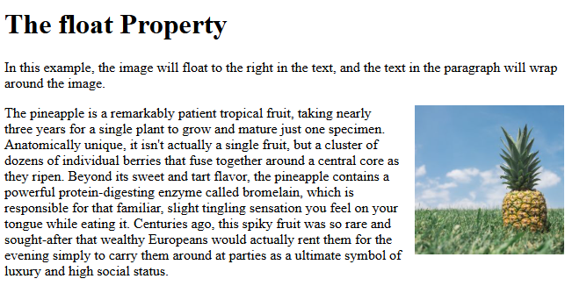

CSS clear Property
The clear property specifies what should happen with the element that is NEXT to a floating element.
The clear property prevents elements from wrapping around or beside the floated content.
This property can have one of the following values:
- none - Default. Allows elements to float on either side
- left - The element is pushed below floated elements on its left side
- right - The element is pushed below floated elements, on its right side
- both - The element is pushed below floated elements, on both its left and right side

.div2 {
padding: 10px;
border: 3px solid red;
width: 200px;
}

.div3 {
float: left;
padding: 10px;
border: 3px solid green;
}

.div4 {
padding: 10px;
border: 3px solid red;
width: 200px;
clear: left;
}
</style>
</head>
<body>

<h2>Without clear</h2>
<div class="div1">div1</div>
<div class="div2">div2 - Notice that div2 is after div1 in the HTML code. However, since div2 has no clear, the text in div2 floats around div1.</div>

<h2>With clear: left</h2>
<div class="div3">div3</div>
<div class="div4">div4 - Here, clear: left; pushes div4 down below the floating div3, on its left side.</div>

</body>
</html>

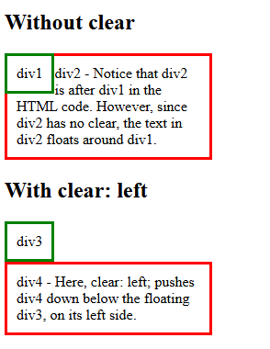

The CSS Clearfix Hack
If a floated element is taller than the containing element, it will "overflow" outside of its container. We can then add a clearfix hack to solve this problem:

Without Clearfix
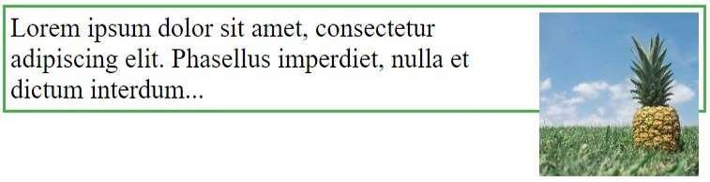

With Clearfix
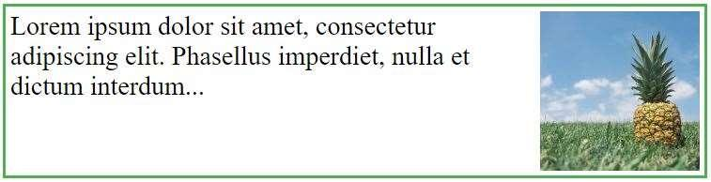
The clearfix hack involves the ::after pseudo-element, and is used to ensure that the parent container properly encloses its floated child elements:

<!DOCTYPE html>
<html>
<head>
<style>
div {
border: 3px solid green;
padding: 10px;
}

.img1 {
float: right;
}

.img2 {
float: right;
}

.clearfix::after {
content: "";
clear: both;
display: table;
}
</style>
</head>
<body>

<h2>Without Clearfix</h2>

<p>The image is floated to the right. It is also taller than the element containing it, so it overflows outside of its container:</p>

<div>
<img class="img1" src="pineapple.jpg" alt="Pineapple" width="170" height="170">
Lorem ipsum dolor sit amet, consectetur adipiscing elit. Phasellus imperdiet...
</div>

<h2 style="clear:right">Using the Clearfix Hack</h2>
<p>Add the clearfix hack to the containing element, to fix this problem:</p>

<div class="clearfix">
<img class="img2" src="pineapple.jpg" alt="Pineapple" width="170" height="170">
Lorem ipsum dolor sit amet, consectetur adipiscing elit. Phasellus imperdiet...
</div>

</body>
</html>

