Step 1: download css and js file from the below link
Download · Bootstrap v5.3

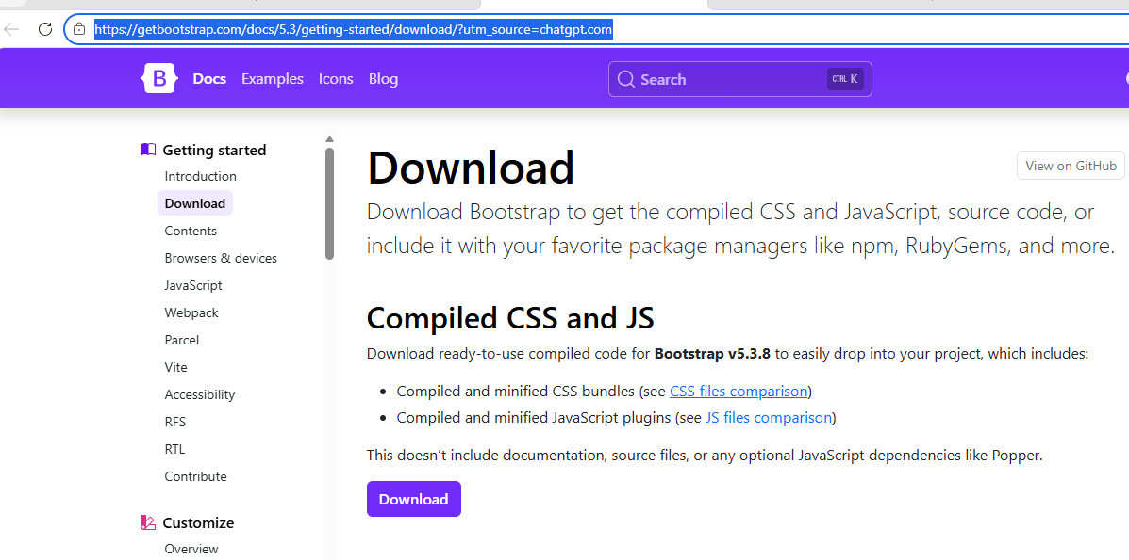

After downloading Bootstrap, you need to specify the file location (path) in index.html so the browser knows where to find the CSS and JavaScript files.

<link rel="stylesheet" href="C:\Users\CBIT\AppData\Local\Temp\e7b393b7-2d83-413a-a4f9-f7a42d70efc7_bootstrap-5.3.8-dist.zip.fc7\bootstrap-5.3.8-dist\css\bootstrap.min.css">

<script src="C:\Users\CBIT\AppData\Local\Temp\ae787ec4-9601-4ef8-b77f-3e6ad067a8d2_bootstrap-5.3.8-dist.zip.8d2\bootstrap-5.3.8-dist\js\bootstrap.bundle.js"></script>

INDEX.HTML

<!DOCTYPE html>
<html>
<head>
<title>Bootstrap Example</title>
<link rel="stylesheet" href="C:\Users\CBIT\AppData\Local\Temp\e7b393b7-2d83-413a-a4f9-f7a42d70efc7_bootstrap-5.3.8-dist.zip.fc7\bootstrap-5.3.8-dist\css\bootstrap.min.css">
</head>

<body>

<div class="container mt-5">
<h1 class="text-primary">Hello Bootstrap</h1>

<button class="btn btn-success">
Click Me
</button>
</div>

<script src="C:\Users\CBIT\AppData\Local\Temp\ae787ec4-9601-4ef8-b77f-3e6ad067a8d2_bootstrap-5.3.8-dist.zip.8d2\bootstrap-5.3.8-dist\js\bootstrap.bundle.js"></script>

</body>
</html>

