Naptime Filter

Overview:

The naptime filtering program can be used to remove rows (segments/blocks) from csv spreadsheets that correspond to naptime periods in recordings. In a typical scenario, you select a single csv file, or a folder of csv files to filter. Next, you specify a location in which you’d like to save the results. The program then uses naptime information from its database to identify any naptime rows in the file/folder, and writes the results to a new output file/folder. The original input files are never modified.

Starting the program:

To start the program, double-click the “Naptime Filter” icon on the LENA computer desktop. This should bring up a window that looks like this:

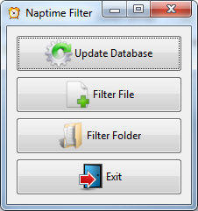

Each of the buttons are described below.

Update Database

In order to identify naptime rows in the input spreadsheets, the program needs some information about the time periods in the recording that correspond to naptime. This is done using a set of naptime spreadsheets.

Naptime spreadsheets are regular ADEX csv files that have had an extra column appended to them called “Naptime” (the capitalization is significant). In this column, each row that is naptime should contain the value “Naptime”, while all other rows should be left blank. These spreadsheets may be either block-level (each row is a 5 minute block) or segment-level (each row is a variable number of seconds). In order to detect what type of segmentation is present in a naptime file, the program first looks for a row called “Segment_Duration”. If this is present, it assumes the file was exported with segment-level details. If not, it looks for a row called “Audio_Duration” (in LENA < version 3.3, this was sometimes called “Block_Duration”). Finally, if this is not present, it looks for a column called “Block_Duration”. At least one of these columns must be present in each naptime file. If multiple columns are present, it will prefer “Segment_Duration” over “Audio_Duration”, and this over “Block_Duration”.

Clicking the “Update Database” button will bring up the following window:

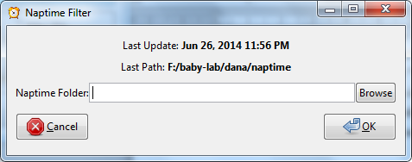

This window shows the date and time the the database was last updated, as well as the location of the naptime files that were used to update the database last time. If this is the first time you are running the program, these labels will be blank.

You can click the “Browse” button to select a folder that contains the naptime files you’d like to use to update the database. Note that this should be the root (“top”) folder. The program will search through any subfolders that appear within the selected folder (and any subfolders of subfolders, etc.), and locate any naptime spreadsheets that are present.

When you click “OK”, a progress bar is displayed. During this time, the program will go through all of the naptime files it finds, and use them to rebuild its naptime database.

*Note that the database is not appended to, it erased and rebuilt using the folder you specify.* *This means that if you need to add a new naptime file, you’ll need to put it in the same location as the others before you update the database.*

Any issues that are encountered during processing will be reported once the progress bar completes. The most common source of error is a miss-spelling of “Naptime” in the indicated file, or an extra space preceding or following the column name. This may also occur within the rows in the “Naptime” column.

You’ll also receive a notification message if the update completes without error.

Filter File:

If you just want to filter a single file, click this button. The following window is displayed:

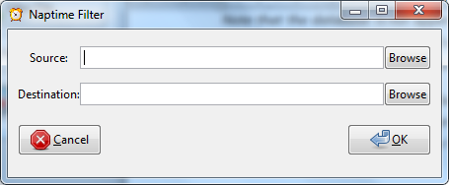

Use the “Browse” buttons to select the source (input) spreadsheet file, and the location (folder) to which you’d like to save the output file. Then click “OK”.

The output file will be written to the destination folder. It will have the same name as the input file, but contain the suffix “-no-naps”. So, it your input file is “C003_20100613.csv”, the output file will be named “C003_20100613-no-naps.csv”. This strategy prevents the output from accidentally overwriting the input files if the output directory is the same folder the input files are in.

Filter Folder:

Click this if you have a whole folder full of files that you want to filter. As with filtering a single file, the following window will appear:



Here, you can use the “Browse” buttons to select the folder that contains the spreadsheets you want to filter, and the folder you want to save the resulting files to. Files that appear within subfolders of the source directory will not be filtered. The naming convention for the output files is the same as the one described in the “Filter File” section above.

Other Notes:

The program filters out segments from the input spreadsheets if more than 50% of their duration falls within a naptime zone. This means it’s possible for segments to intersect with naptime periods, but still be included in the output.