Reliability Program 2

Overview:

This program is intended to assist with measuring the reliability of LENA data. It does so by providing the user with an interface to listen to audio clips and manually enter data. The results are recorded and can be compared with LENA output.

The input is a spreadsheet. Each row represents a 5 minute chunk of a particular recording. Recordings took place in two different environments (home and daycare). For each environment, there are a number of activities the child may have been engaged in (mealtime, playtime, etc.) at the time. Each row in the spreadsheet has a column that specifies an environment, and the activity within it.

This program will randomly pick rows from a pool of user-specified environments and activities. It will present them one-by-one to the user. The user may listen to the audio in configurable-sized clips, transcribe it, and record the number of child vocalizations. The program will save this data, in addition to the number of words in the transcription. Finally, the results can be exported in spreadsheet format.

Starting a new file:

To start working on a new input spreadsheet file:

1. Open the program using the shortcut on the LENA computer desktop labelled “Reliability 2 App.” The following window will appear:

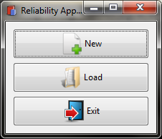

1. Click the “New” button. The form below should pop up:

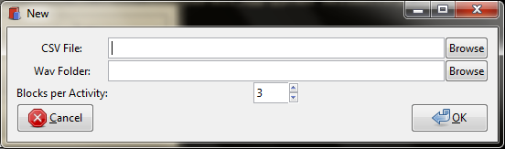

* “CVS File” - the location of the input spreadsheet. This must be in CSV format.
* “Wav Folder” - a directory to search for the wav files referred to in the input spreadsheet. Any subfolders will also be searched. If one or more wav files are missing from this directory, the program will prompt you for their location one-by-one when you click the “OK” button.
* “Blocks per Activity” – this is the number of rows (“blocks”) you would like to process for each activity, for each environment.

1. After you select a CSV File, the program will automatically go through it and pull out a list of all of the environments and activities it contains. These will be presented in a selectable list that looks like this:

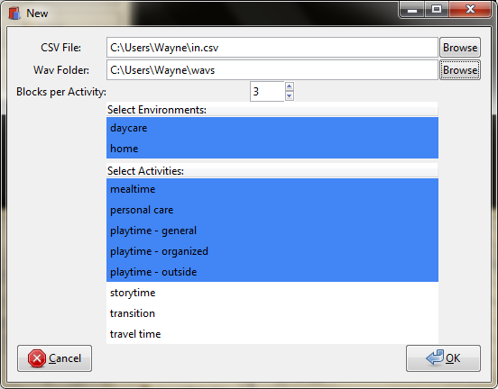

The default selection is shown in blue. You can hold down the control key and click on items to toggle their selected state (you’ll have to do this separately for each list).

In the image above, 3 rows will be processed for each of the 5 selected activities. This entire process will be repeated for each of the 2 selected environments. In total, 3 block/activity \* 5 activities/environment \* 2 environments = 30 rows will be processed.

1. Click the ok button. At this point, the program will go through your selections and make sure there is enough of each type of row in the input file. If not, an error message is displayed. Next, it will attempt to locate all of the wav files that are referred to in the input spreadsheet. If a particular wav file cannot be found within the “Wav Folder” directory you specified (or one of its subfolders), an “Open File” window will display, prompting you to manually specify the selection. The name of the wav file is shown in the title bar of the “Open File” window. This may happen multiple times if multiple files are missing.
2. A progress bar will be displayed as the program sets up for reliability checking. During this time, it is randomly picking segments from the categories you selected, and saving information to the database. When it completes, you’ll see the window described in the “Reliability Checking” section.

Loading a saved file:

Your progress is saved every time you exit the application. You can go back and resume previous work by clicking the “Load” button in the main window. Doing so brings up a window that looks like this:

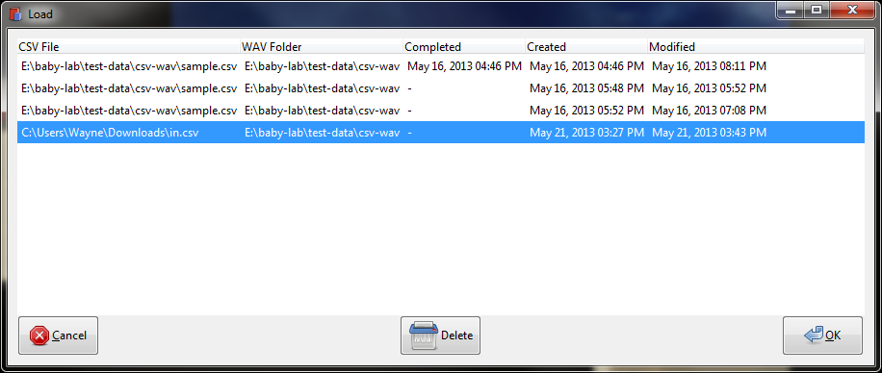

Each row is for a different input file that has been processed in the past. If the file has been completed, a date/time will be displayed in the “Completed” column. The “Modified” column shows the date/time of the last save. Other columns should be fairly self-explanatory.

You may delete saved entries from this list. Note that this does NOT delete the input csv file, (nor any wav files) only the program’s record of the reliability checking (which resides in an internal database). A confirmation dialog box is shown before the entry is deleted.

To load an entry, select it and click the “OK” button. This should bring you back to the place you last left off in the “Reliability Checking” windows described in the section below.

Reliability Checking:

At this point, you should see a window that looks like this:

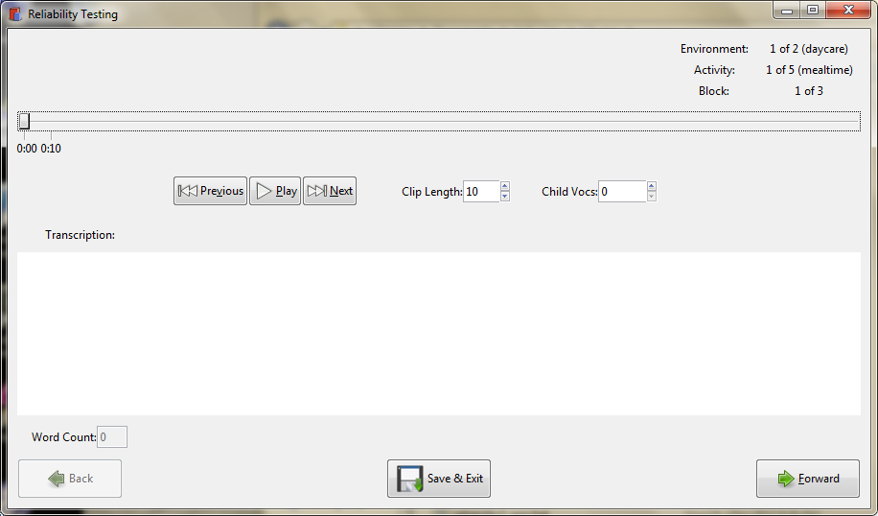

In the upper right-hand corner, you can see the current block, activity, and environment you’re on. The slider bar shows your location within the current block (5 minute chunk).

The “Play” button just below the slider can be used to play the current clip. The current clip starts at the slider knob, and goes up to the next tick mark on the slider bar (e.g. in the image above, clicking play would play the audio from 0:00 to 0:10). Once you have played a clip, the slider bar will appear “filled” in up to that point:

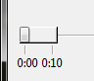

The slider knob may be shifted within the filled zone. Clicking the “Next” button (just below the slider bar) advances to the next clip. This will plot another tick mark on the slider bar:

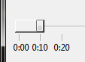

The clip length defaults to 10 seconds. In some situations, this may be inconvenient (e.g. the clip may end right in the middle of a word). You can adjust the length of the current clip by changing the value in the “Clip Length” spin button. The easiest way to do this is to move your mouse over it and scroll the mouse wheel. This will shift the last tick mark in the slider bar back or forward.

If you have listened to the current clip, adjusting the length will reset the fill level of the slider bar to the previous tick mark (i.e. the current clip will be marked as “unplayed”). This ensures that the user always listens to current clip at its final clip length.

You may move back to the previous clip by clicking the “Previous” button. This allows you to listen to them again, and/or adjust the transcription/child voc count. Moving to a previous clip does not change the fill level. The “Clip Length” spin button becomes inaccessible on previous clips. This is because if the user adjusted their length, it would push/pull all of the following clips, resulting in a different endpoint (causing the user to re-listen to, or skip a portion of audio).

You can record the transcription using the text box at the bottom of the window. As you type, the number of words will be counted in the “Word Count” box in the bottom left corner of the window. *The program will count contractions as two separate words (similarly for hyphenated words). If you wish to count them as one word, please omit the apostrophe (or dash).*

The number of child vocalizations can be recorded using the “Child Vocs” Spin button on the right side of the window. The easiest way to do this is to move your mouse over it, and scroll the mouse wheel the appropriate number of ticks.

Moving between clips:

When you have finished with one 5 minute clock, you can advance to the next one by clicking the “Forward” button in the bottom left-hand corner of the window.

At this point, the program will do a quick check and warn you if one or more of the following are true:

* You have not listened to the entire clip (the “fill level” of the slider bar is at less than 5:00)
* The transcription box is empty
* No “child vocs” have been recorded (the value is 0)

If so, a confirmation box is shown, and you may choose whether or not to proceed to the next block.

You can also move back to previous blocks by clicking the “Back” button in the bottom left-hand corner of the window.

The “Save and Exit” button will save your progress and close the “Reliability Checking” window. Please wait until the progress bar completes before you exit the program entirely. If you click the “Close” X in the “Reliability Checking” window, the program will also save your progress.

When you reach the final block, the “Forward” button will change to an “OK” button. Clicking this button will bring up a “Save” window, prompting you for a location to save the results spreadsheet:

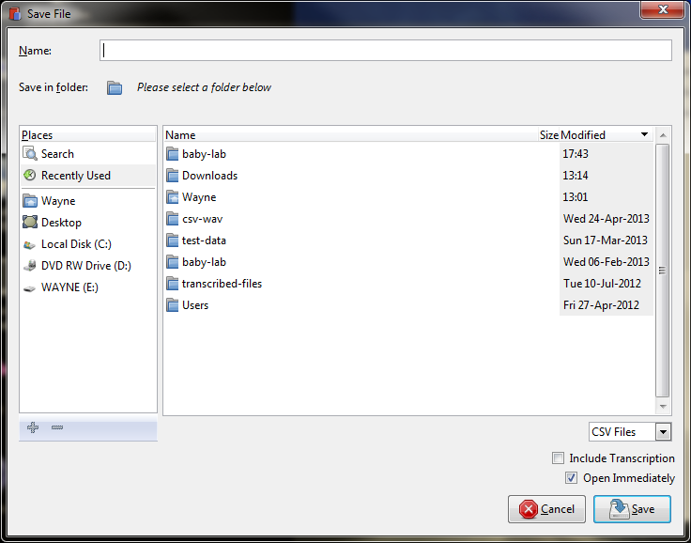

There are two checkboxes in the bottom-right hand corner of this window:

* “Include Transcription” – if checked, the transcriptions will be included in the results spreadsheet. Otherwise, they will not. Transcriptions are still saved to the program’s internal database, so you can always come back and re-export them later on if you change your mind.
* “Open Immediately” – if checked, the program will attempt to open the results spreadsheet in Excel as soon as the save completes.

After you’ve selected a name and location for the results spreadsheet, click “save.” If you chose not to open the spreadsheet immediately, a dialog will pop up to acknowledge that the save was successful. Otherwise, the spreadsheet should open in Excel shortly.