## Summary Generator

1. **Overview:**

The purpose of this summary generator application is to provide a tool to combine information from ADEX files, special case file and transcribed TRS file into one “overall” summary together.

1. **Terminology:**

*The ADEX files* are groups of csv files which generated from LENA Advanced Data EXtractor (ADEX) program directly. Generally there are 6 different types of data defined in it. They are Child Data, Female Adult Data, Male Adult Data, Other Data, AVA Data, Time Data and Signal Level Data. Each type of data is composed by a small number of criteria. For example, signal Level Data includes Average Signal Level and Peak Signal Level. You can check APPENDIX I for more details. Currently we only calculate the average from **“AWC, Turn_Count, Child_Voc_Duration, FAN_Word_Count, FAN, MAN_Word_Count, MAN, CXN, OLN, TVN, NON, SIL”** these criteria. If you need to calculate others, please contact programmer.

*The Special case file* is a spreadsheet file which is used to record abnormal situations or handwriting notes for the participants. The summary generator will use this file to create a series of filters to filter out some participants that we don’t want to include in the overall summary file. For example, you many want to create a filter to find out the participants who only spoke French or a filter to find out participants who were not sick during recording. The data in ADEX files and transcribed TRS file will be affected by these filters. **In order to make these filters work properly, you need to make sure there is a sheet named “Special Cases” in the excel**. And “ITS File” and “Study Number” are also required to make links with other information from ADEX files and transcribed TRS file. If you need to change these information, please contact programmer to update application also.

The Transcribed TRS file is generated from the “statics program” separately. In order to generate this file, you need to choose to “generate an overview file as well” in the statics program. Later the summary generator application will link the information in Transcribed TRS file and ADEX files together by applying some filters from the special case file.

*The ADEX summary files are mandatory for the application to work, but the special case file and transcribed TRS file are not.

1. **Usage:**

Figure 1. The main interface

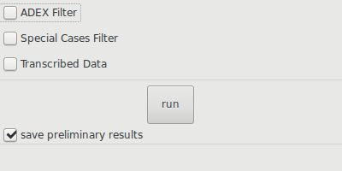

**3.1 setup ADEX output**

Figure 2. ADEX output configurations

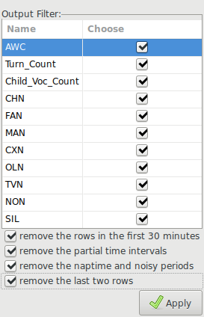

1. Select ADEX Filter.
2. A dialog will pop up to ask for the directories that contains ADEX files. Here you can select multiple folders at the same time.
3. As in figure2, the above part let you choose from which criteria you want to calculate the average. The down part are other operations you need to use on ADEX files*1.
4. Click Apply button or press “Esc” to close this dialog once you done.

*1: These preliminary operations here are help to clean data. Eg, time intervals is a chunk of time for LENA device to do recording. It can be 5 or 10 minutes. Any recordings are not up to this time interval can be discarded from future calculations.

**3.2 setup special case filters (optional)**

1. Select Special case filter.

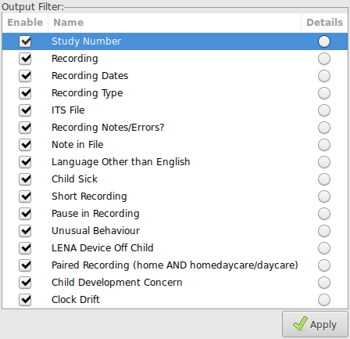

Figure 3. Special case configurations

1. A dialog will show up to ask for where is special case file.
2. A list of options will be generated from the special case file as in figure 3. The first columns are switches represent whether these filters are enabled or not. The second columns are filters name. The third columns are details for a specific filter.
3. If you need to use a filter, you can click that round circle at third column, a new dialog will appear with details in this filter. Figure 4 is an example for filtering certain Study Number.*2
4. Click Apply button or press “Esc” to close this dialog once you done.

*2: By default, a filter will include all the information for a specific term. So “All” button on the upper right corner is selected. If you want to make changes, you can click “All” button to deselect this status and then selected which entries you want in the first column. You can also use “inverse” button to get an opposite sets.

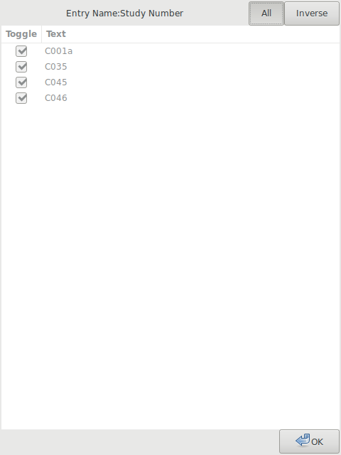

Figure 4. Details for a “Study Number” filter

**3.3 setup transcribed TRS configurations (optional)**

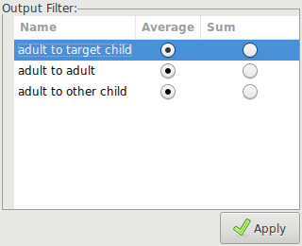

Figure5. Transcribed TRS configurations

1. Select Transcribed Data.
2. A dialog will show up to ask for the location of transcribed TRS file which is generated from statics program.
3. A list of objects will be generated from the transcribed TRS file. Select whether you want to calculate average value or sum for each object.
4. Click Apply button or press “Esc” to close this dialog once you done.

After all the configurations, the last step is clicking the “run” button on the main window. A dialog will pop up to ask where to store the final outputs. If you choose “save preliminary results”, the corresponding preliminary data will be generated for each filter (ADEX, special case, transcribed TRS) in the same folder. These preliminary files will show which files are proceeded and what types of filters are used if you selected special case filter. If you just want overall summary, you can deselect save preliminary. That will be much more faster.

Figure 6. Finish windows

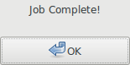

Once after choosing the final outputs folder, the application will begin to run. It may take 2 to 10 minutes to get results. Once the calculation are done, a dialog will pop up as figure 6.

**APPENDIX I: ADEX INFOMATION**

AWC - Adult Word Count

Turn_Count - Conversational Turns

-Key Child Data:

Child_Voc_Count - Key Child Vocalization Count

CHN - Key Child Segment Duration

Child_Voc_Duration - Key Child vocalization Duration

Child_NonVoc_Duration - key Child Non-vocalization Duration

-Female Adult Data:

FAN_Word_Count - Female Adult Word Count

FAN - Female Adult Segment Duration

FAN_NonVoc_Duration - Female Adule Non-Vocalization Duration

-Male Adult Data:

MAN_Word_Count - Male Adult Word Count

MAN - Male Adult Segment Duration

MAN_Nonvoc_Duration - Male Adult Non-Vocalization Duration

-Other Data:

CXN - Other Child Segment Duration

OLN - Overlap Segment Duration

TVN - TV Segment Duration

NON - Noise Segment Duration

SIL - Silence Segment Duration

FUZ - Uncertain Segment Duration

-AVA Data:

AVA_RS - AVA Raw Score

AVA_SS - AVA Standar Score

EMLU - Estimated Mean Length of Utterance

AVA_DA - AVA Develpmental Age

-Time Data:

Recording_Index Recording Index

Elapsed_Time - Elapsed Time

Clock_Time - Clock Time

Audio_Duration - Audio Duration

-Signal Level Data:

Average_Signal_Level - Average Signal Level

Peak_SignalLevel - Peak Signal Level