Pitch Study Testing Program

This program can be used to collect human judgements for the pitch study (“Melissa’s project”). It presents the user with a series of low-pass filtered sound clips, and asks them to rate how question-like they sound. This information is matched with previously recorded human judgements from the non-filtered versions of the clips. The results are output as a set of spreadsheets. All clips are maternal utterances.

The recordings are divided into “Batches”. Currently, there are 9 batches. Each batch contains segments from 4 recordings: 2 from mothers speaking with 10 month old infants, and 2 from mothers speaking with infants who were 14 months old. There are between 1000 and 1300 clips per batch.

Running Trials:

You can start the program using the “Pitch Study App” shortcut on desktop. You should see a window that looks like this:

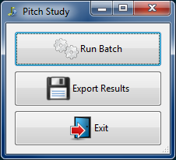

To run a batch, click the top button. The following window will appear:

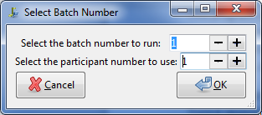

Select a batch number, and a participant number, and click ok. Currently each batch can be run for up to 10 participants.

If you select a setting that has already been used, you’ll see this warning:

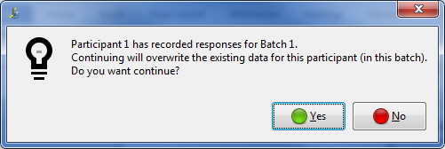

Click “Yes” to overwrite the responses for the selected participant in the batch, or “No” to cancel.

Testing window

Once you’ve selected the batch and participant numbers, you’ll see a new window with a single button labelled “continue”. Hit this button to begin.

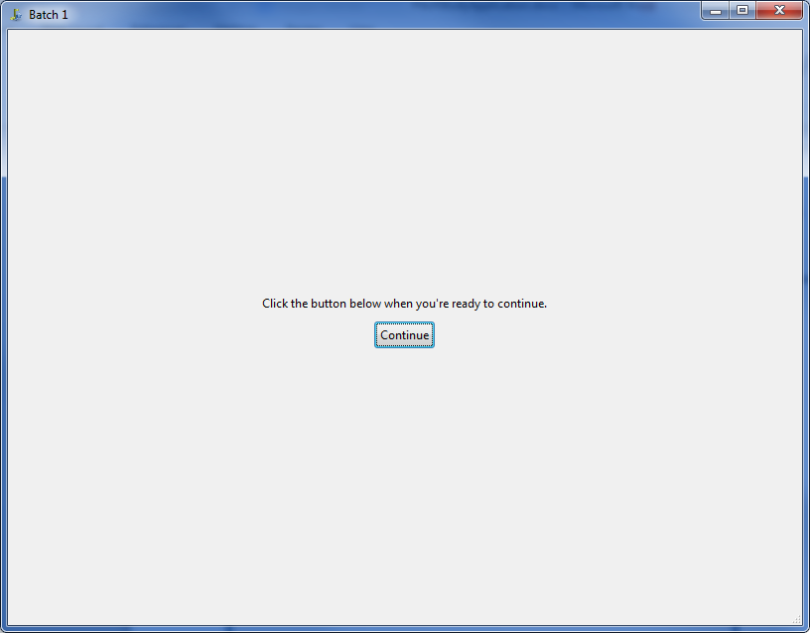

You’ll see a window that looks like this: 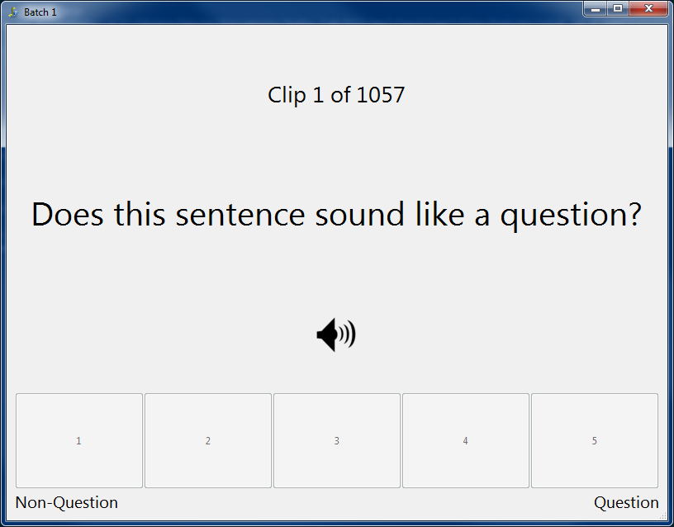

You can maximize the window if you wish.

The first sound clip will play immediately. After it has played, the user can rate the sound using the 5 buttons along the bottom of the window. After clicking a button, the next clip will play.

This process continues in intervals of 50 clips. At this point, the user has the option of taking a break - you’ll see the window with the “continue” button again.

When the batch is finished, the testing window will close and you’ll see a small window thanking you for your participation.

Exporting results

You can export the results at any time (even if you haven’t gone through all of the batches or participants yet). To do this, click the “Export Results” button in the main window. You’ll see a dialog box pop up prompting you for a folder in which to save the results. I recommend creating a new folder for this purpose, since anything inside an existing folder that has the same name as an output file will be overwritten.

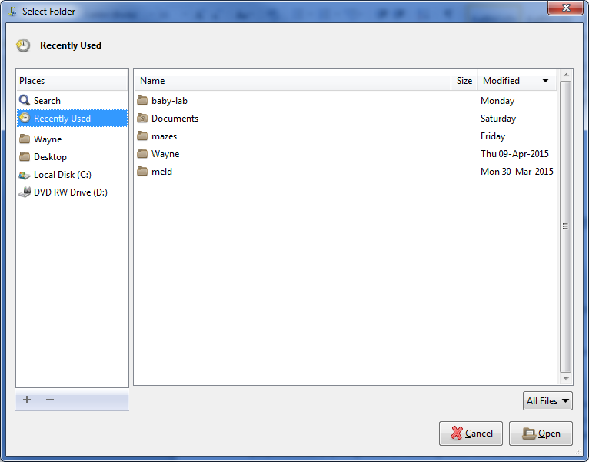

When you’ve selected your folder, click “Open”. A progress bar will be displayed.

Note: some versions of Windows don’t like it if you have the selected folder open in Windows Explorer window when exporting, so it’s best to either close those or move a directory up within them before exporting.

Once the export completes, you should see a set of sub-folders (one for each batch) inside the one you selected. Inside each is a set of spreadsheets, one for each participant. There is also a spreadsheet named “Stats.csv”. This one contains the mean, min, and max responses from the batch.

Each spreadsheet contains the user responses (the “Question Rating” column) for each utterance, plus the previously-collected information about the non-filtered version of the utterance.