TRS Splitting Application

The Splitter Application allows you to take a TRS file and break it into chunks of a specified length. Each chunk is each written to a separate TRS file. Users can open these smaller files in Transcriber and edit them. Finally, the Splitter Application can be run a second time to merge the split files back into a single TRS file.

The purpose of doing this is to reduce the amount of time that the Transcriber Application takes when opening files (large files can sometimes cause a long delay).

Accessing the Application

The Splitter Application is accessible via a shortcut (of the same name) on the desktop of the LENA computer. Running the program causes the main window to display:

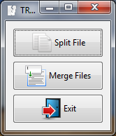

Splitting Files

Clicking the “Split File” button in the main window brings up a file selection window:

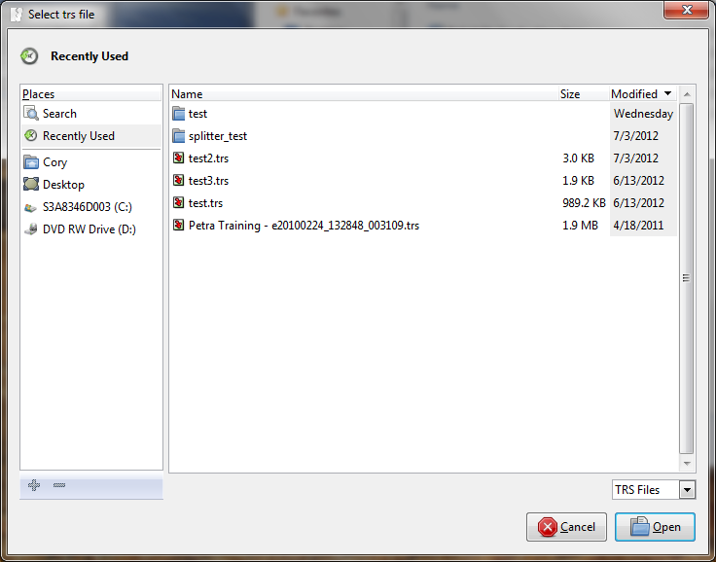

Select the TRS file you’d like to split, and click “Open.”

Next, another selection window opens, this time prompting you for the folder in which the split files should be stored:

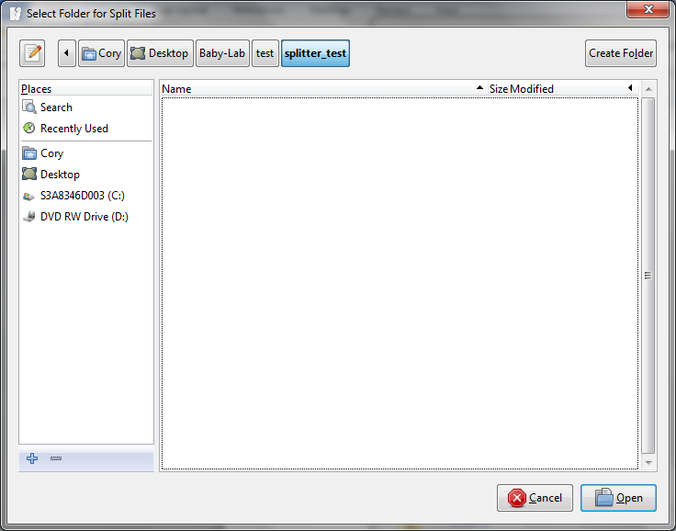

You should select an folder containing no other TRS files. It may be helpful to create a new folder and then select it. This can be done using the “Create Folder” button in the upper right-hand corner of the window. Once you have selected a folder, click the “Open” button.

Finally, an options window will be shown:

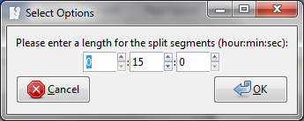

This window allows you to select the size of the intervals that the TRS file should be split into (See below for detail about what happens when a segment is larger than the specified time interval). The default interval setting is 15 minutes.

After clicking OK, a progress bar is shown as the TRS file is split. When a TRS file is split, the following processing occurs:

1. Segments are put into groups of the specified time period. If a single segment is found to be longer than the specified time period, it is put in its own individual file – segments are never split.
2. A segment with a “void speaker” is inserted at the beginning and end of each group. The purpose of these void segments is to provide padding to ensure that when the TRS file is opened in Transcriber, the real segments will still line up with the WAV file. For example, suppose you are splitting a TRS file containing segments with the following start and end times:

FAN, 00:00-15:00

MAN, 15:01-30:00

SIL 30:01-45:00

Splitting this file would result in three separate files:

File #1 => FAN (00:00-15:00), VOID (15:01-45:00)

File #2 => VOID(00:00-15:00), MAN (15:01-30:00), VOID (30:01-45:00)

File #3 => VOID (00:00-30:00), SIL (30:01-45:00)

1. The split files are written to a user-specified directory. The files are given names in the following format (<> not included):

“<name of parent TRS file>-[<start time of first segment from parent file>-<end time of last segment from parent file>]-<index number>.trs”

Where start and end times are specified as “hh_mm_ss.ss”. The index number on the end ranges from 0 to (number of split files – 1), and assists the merging process later on (see next section).

For example, suppose the file described in the previous example was named “test.trs”. Then each the split files would be:

test[00_00_00.00-00:15:00.00]-0.trs

test[00_15_01.00-00:30:00.00]-1.trs

test[00_30_01.00-00:45:00.00]-2.trs

Merging Split Files

After you have edited the split files, you can also use the Splitter Application to merge them back together into a single TRS file.

To do this, click the “Merge Files” button in the main window. In the window that pops up, select the location of a folder containing the split files you want to merge.

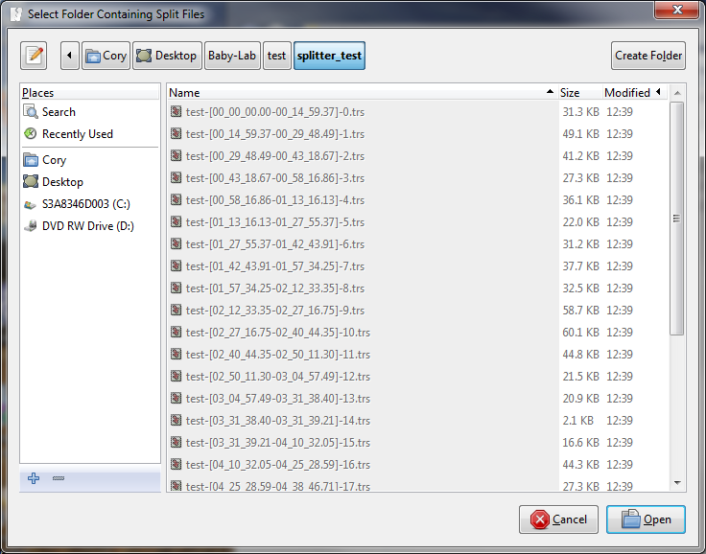

**Note:** the Splitter Application assumes that all TRS files in the selected folder are to be merged. Therefore you should not select a folder that contains TRS files that were not the result of a previous “split” operation. The program ignores any non-TRS files present in the folder.

Once you have selected a folder, click the “Open” button to proceed with the merge.

The merge operation does the following:

1. Sorts all TRS files in the selected folder by the index number (number on the end of the filename). This ensures that the files are in ascending order with respect to the segments they contain.
2. Removes the “VOID” speaker segments from all split files.

Creates a file named “<original filename>-merged.trs” (continuing with the previous example, the name would be “test-merged.trs”), and inserts the contents of all of the split files (minus the void speaker segments), into it in ascending order. This file is written to the same directory as the split files. The split files are not removed by the program.