Deep Learning - Image Classification with CNN

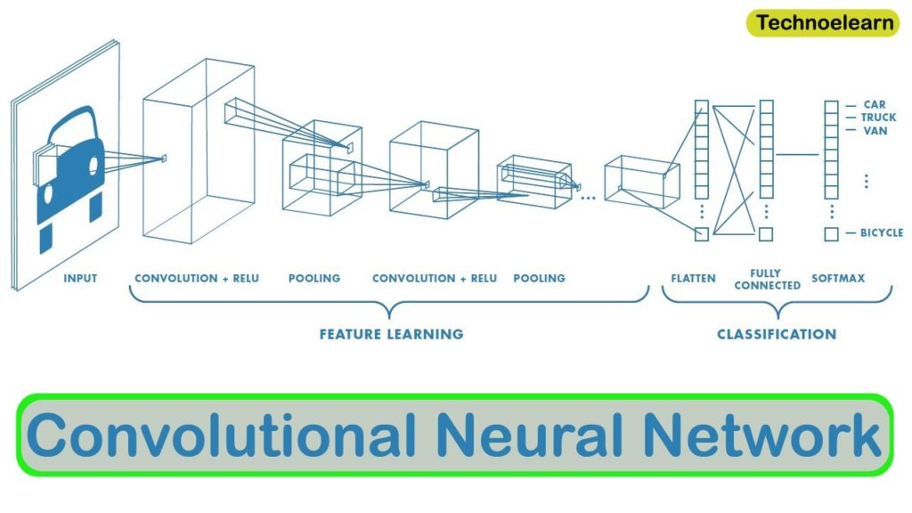

Index

Introduction: 3

Dataset and Preprocessing: 3

Model Architecture: 3

Conclusion: 3

# Introduction:

# Dataset and Preprocessing:

# Model Architecture:

# Conclusion: