Отчёт по лабораторной работе №7
  - Имитационное моделирование
Бахарев Дмитрий Александрович
Содержание

1. Цель работы
Освоить дискретно-событийное моделирование в Julia на примерах модели M/M/c и модели Росса, провести параметрические исследования.

2. Задание
— Создать рабочий каталог для кода. — Установить необходимые пакеты. — Выполнить предложенный код. — Преобразовать код в литературный стиль. — Сгенерировать из литературного кода: — чистый код; — jupyter notebook; — документацию в формате Quarto. — Выполнить код из jupyter notebook. — Интегрировать документацию в формате Quarto в отчёт. — Добавить в код в литературном стиле вычисление для набора параметров. — Сгенерировать из литературного кода с параметрами: — чистый код; — jupyter notebook; — документацию в формате Quarto. — Выполнить код из jupyter notebook с параметрами. — Интегрировать документацию с параметрами в формате Quarto в отчёт.

3. Теоретическое введение

3.1 Модель M/M/c
Система массового обслуживания с $c$ серверами:
- M (Markovian) — входящий поток пуассоновский с интенсивностью $λ$ (интервалы прибытия $∼\text{Exp}\left(1/λ\right)$).
- M — время обслуживания экспоненциальное с интенсивностью $μ$ ($∼\text{Exp}\left(1/μ\right)$).
- c — число параллельных серверов.
Загрузка системы: $ρ=λ/\left(cμ\right)$. Условие стационарности $ρ<1$.

3.2 Модель Росса
Система с $N$ работающими машинами и $S$ запасными:
- Один ремонтник (обслуживает по одной машине).
- Наработка до отказа одной машины $∼\text{Exp}\left(λ\right)$.
- Время ремонта $∼\text{Exp}\left(μ\right)$.
- При отказе машины одна запасная немедленно берётся из резерва.
- Если резерв пуст — система падает (crash).
- После ремонта машина возвращается в резерв.
Требуется найти среднее время до падения $E\left[T\right]$.

3.3 Дискретно-событийное моделирование
DES (Discrete-Event Simulation) — моделирование систем, состояние которых меняется мгновенно в определённые моменты времени («события»). В Julia реализуется пакетом ConcurrentSim.jl через макросы @resumable и @yield.

4. Выполнение лабораторной работы

4.1 Создание рабочего пространства
DrWatson-проект создан в каталоге labs/lab07/project (рис. Рисунок 1).
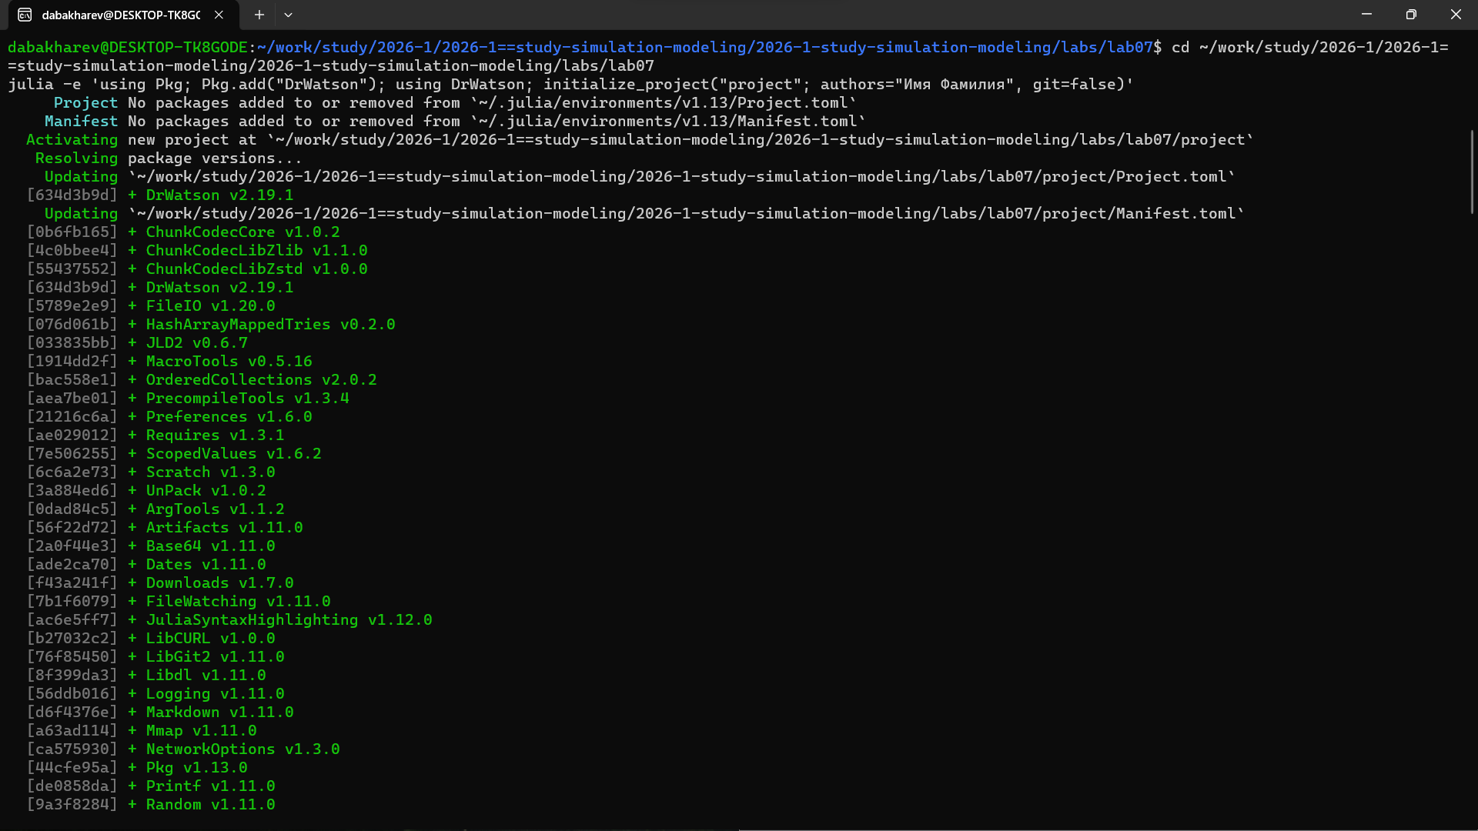
Рисунок 1: Создание DrWatson-проекта

4.2 Установка пакетов
Создаю файл add_packages.jl для установки пакетов ConcurrentSim, ResumableFunctions, StableRNGs, Distributions (рис. Рисунок 2).
Рисунок 2: Файл add_packages.jl
Запускаю его — все пакеты устанавливаются успешно (рис. Рисунок 3).
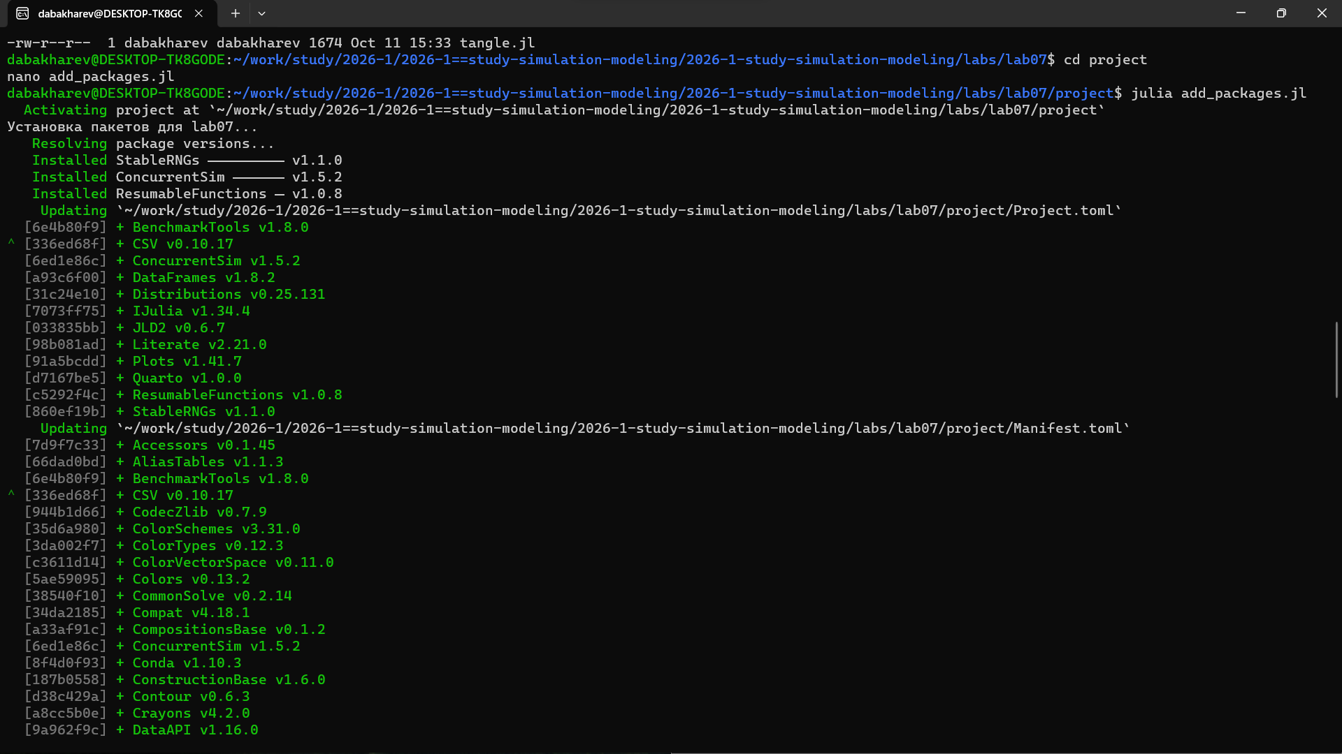
Рисунок 3: Установка пакетов Julia

4.3 Модель M/M/c
Создаю скрипт scripts/mmc_queue.jl с моделью M/M/c (число серверов $c=2$, $λ=0.9$, $μ=0.5$). Запускаю его (рис. Рисунок 4).
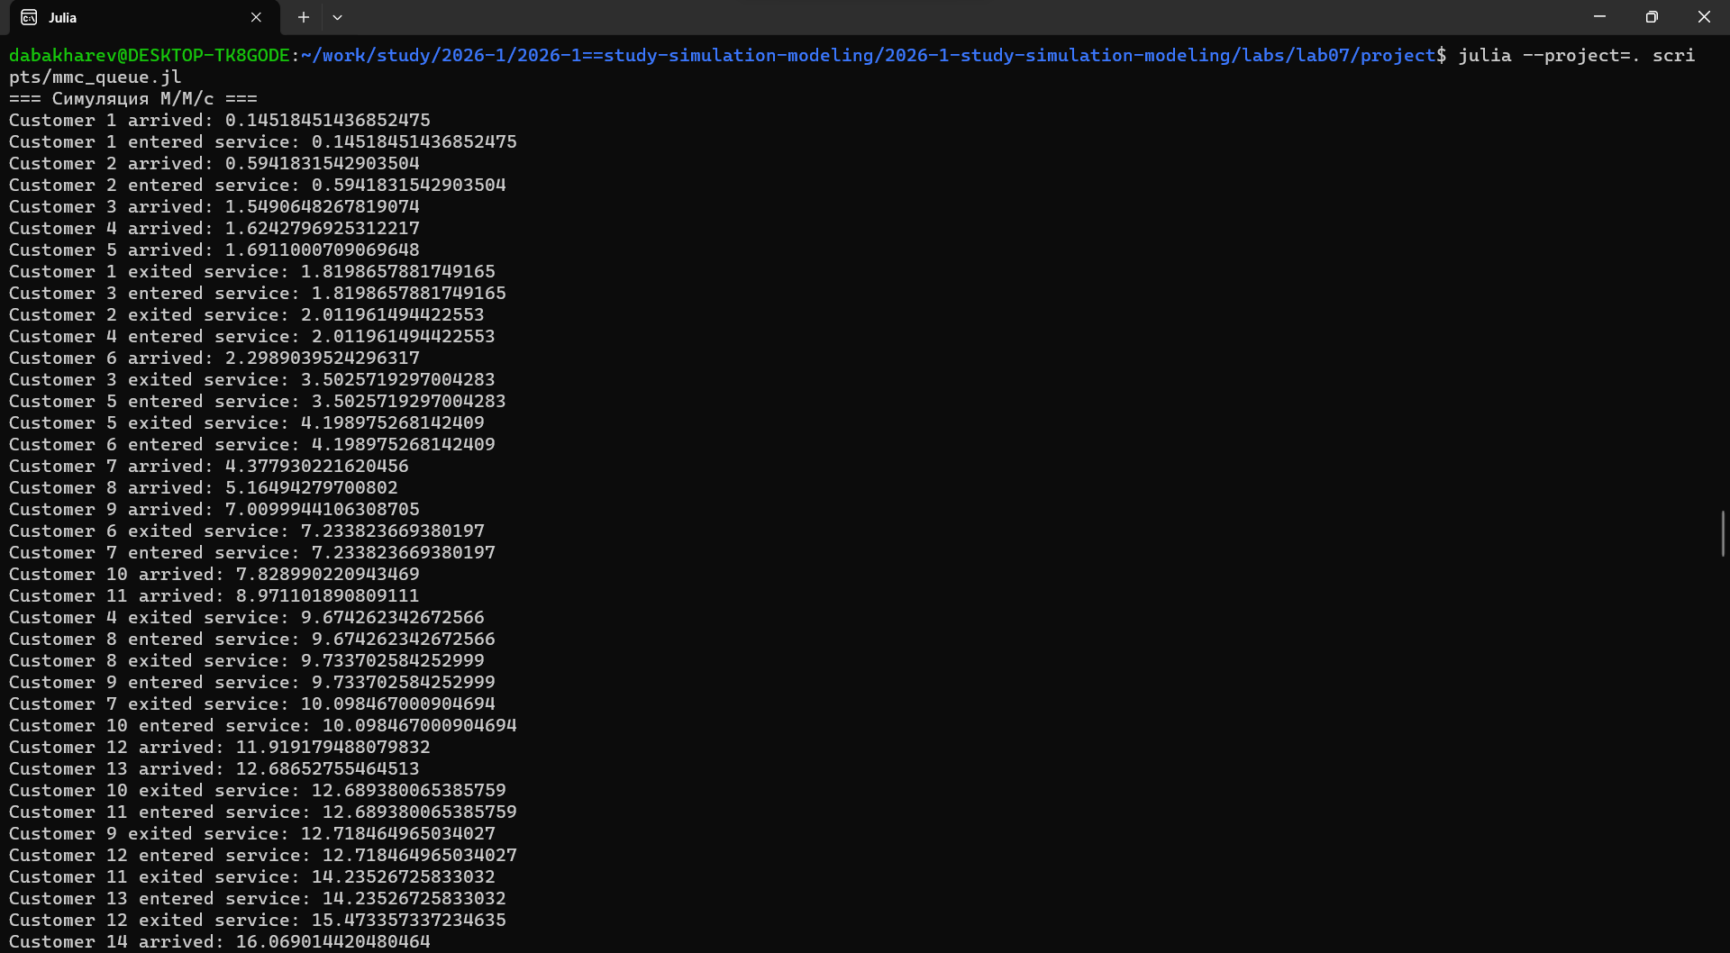
Рисунок 4: Запуск модели M/M/c
В выводе видны события: Customer N arrived, entered service, exited service. События обрабатываются в порядке времени.

4.4 Модель Росса
Создаю скрипт scripts/ross_model.jl для модели Росса ($N=10$, $S=3$, $λ=100$, $μ=1$). Запускаю его (рис. Рисунок 5).
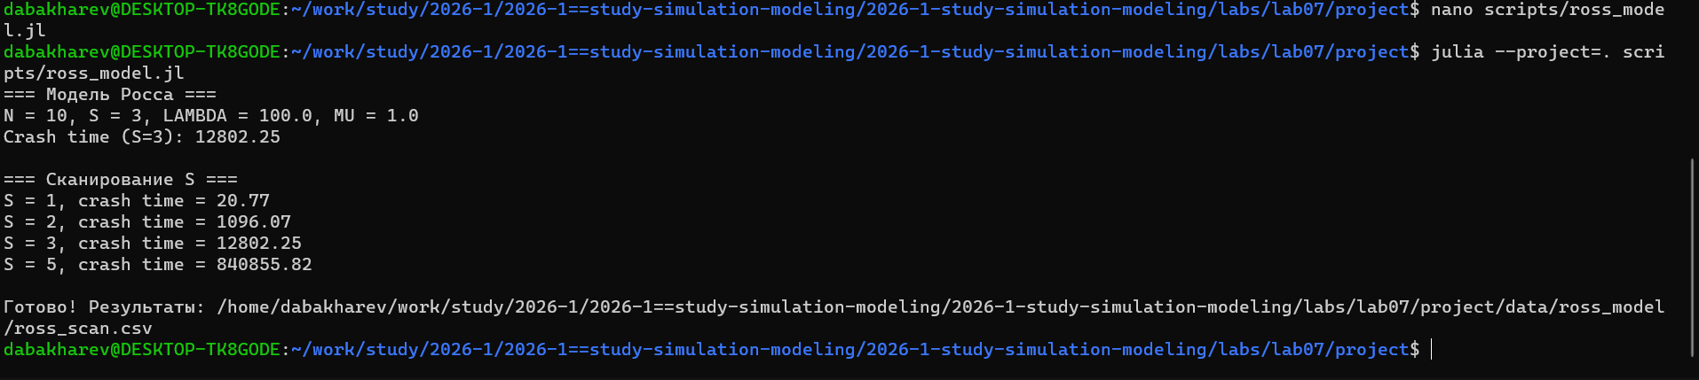
Рисунок 5: Запуск модели Росса
Результаты сканирования по $S$:
$S$ | Среднее время до отказа
1 | 20.77
2 | 1096.07
3 | 12802.25
5 | 840855.82
Чем больше запасных машин, тем дольше система работает — это иллюстрирует важность резервирования.

4.5 Генерация производных форматов
Запускаю tangle.jl для скриптов mmc_queue.jl и ross_model.jl. Генерируются .qmd, .ipynb и чистый .jl (рис. Рисунок 6).
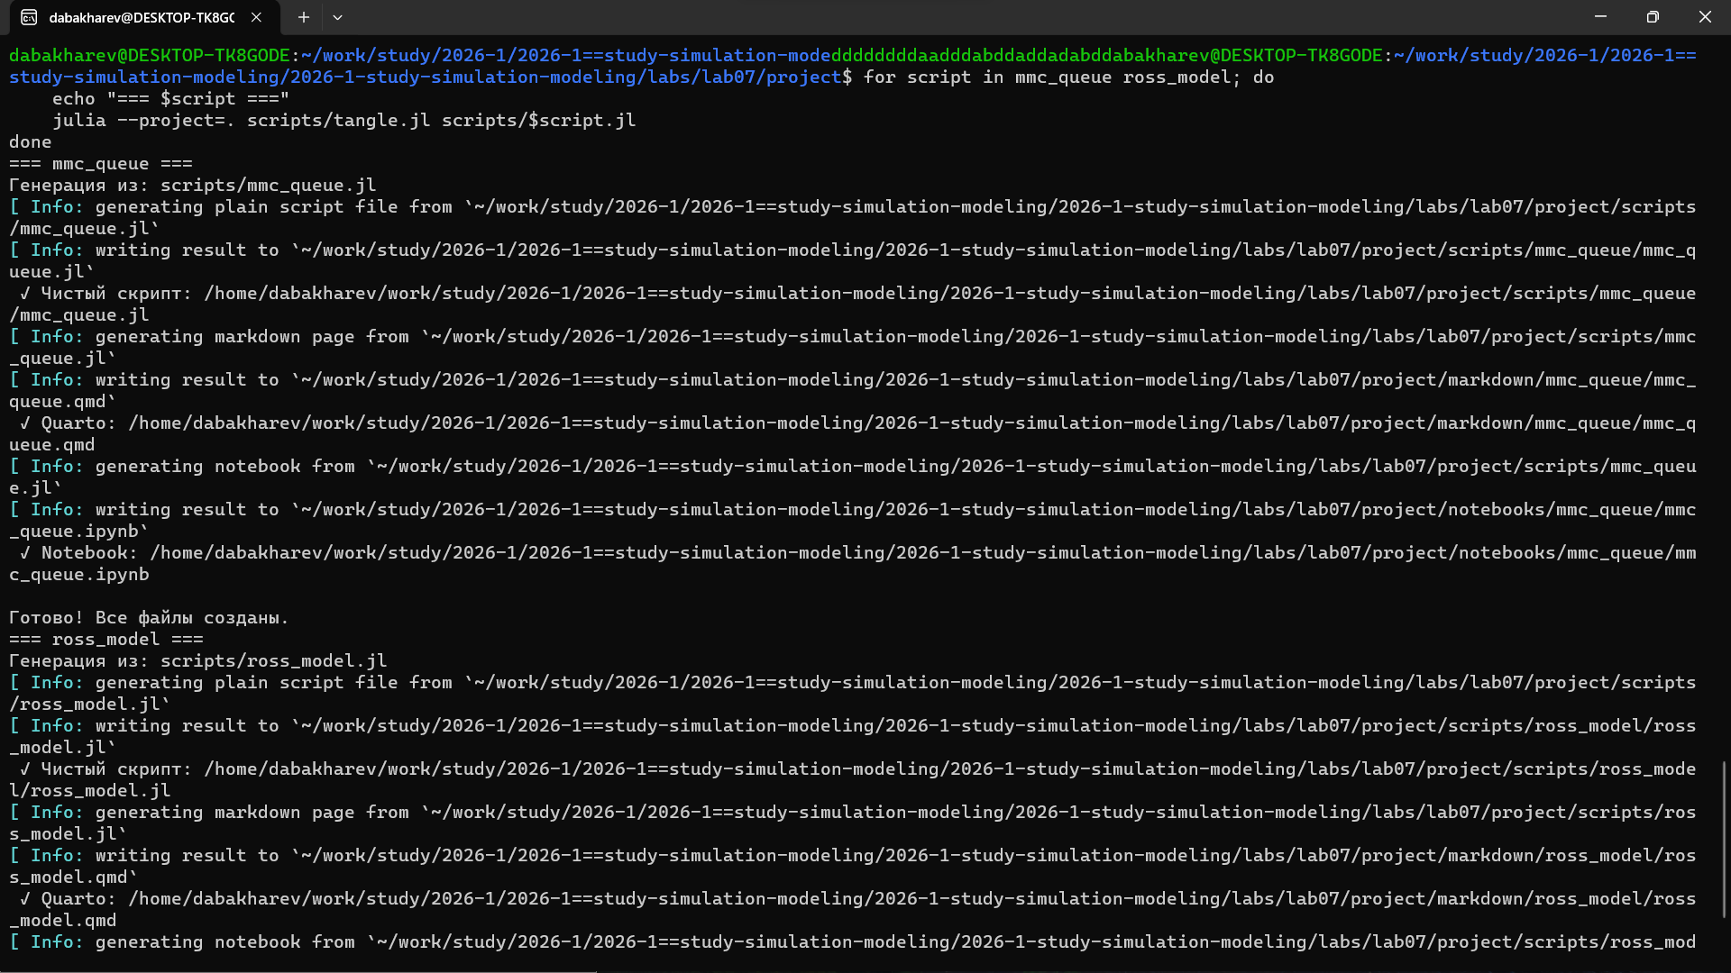
Рисунок 6: Генерация производных форматов

4.6 Результаты M/M/c
График зависимости среднего времени ожидания и обслуживания от $λ$ (рис. Рисунок 7).
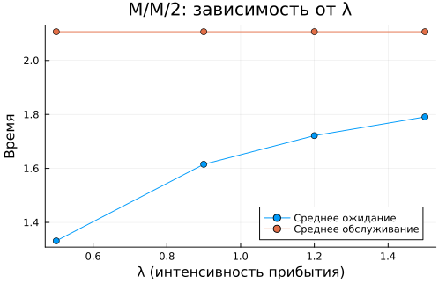
Рисунок 7: Результаты M/M/c
Видно, что с ростом $λ$ среднее время ожидания растёт.

4.7 Результаты модели Росса
График зависимости времени до отказа от числа запасных машин $S$ (рис. Рисунок 8).
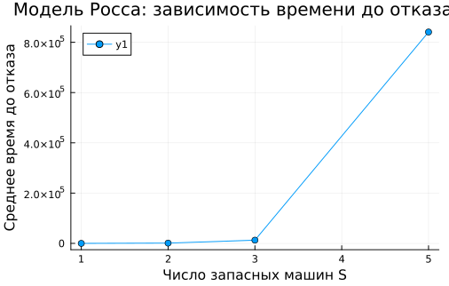
Рисунок 8: Результаты модели Росса
Кривая резко возрастает — экспоненциальная зависимость от $S$.

4.8 Листинги из Julia

5. Модель M/M/c (система массового обслуживания)
Стохастическая симуляция через дискретно-событийное моделирование (ConcurrentSim).
import Pkg
Pkg.activate("/home/dabakharev/work/study/2026-1/2026-1==study-simulation-modeling/2026-1-study-simulation-modeling/labs/lab07/project")
using DrWatson
using StableRNGs
using Distributions
using ConcurrentSim
using ResumableFunctions
using DataFrames, CSV, Plots, Statistics
ENV["GKSwstype"] = "100"
script_name = "mmc_queue"
mkpath(plotsdir(script_name))
mkpath(datadir(script_name))
Activating project at `~/work/study/2026-1/2026-1==study-simulation-modeling/2026-1-study-simulation-modeling/labs/lab07/project`
"/home/dabakharev/work/study/2026-1/2026-1==study-simulation-modeling/2026-1-study-simulation-modeling/labs/lab07/project/data/mmc_queue"

5.1 Параметры симуляции
rng = StableRNG(123)
num_customers = 100 # общее число клиентов
num_servers = 2 # число серверов
mu = 1.0 / 2 # интенсивность обслуживания
lam = 0.9 # интенсивность прибытия
arrival_dist = Exponential(1 / lam) # распределение интервалов прибытия
service_dist = Exponential(1 / mu) # распределение времени обслуживания
Exponential{Float64}(θ=2.0)

5.2 Поведение клиента
@resumable function customer(env::Environment, server::Resource, id::Integer,
t_a::Float64, d_s::Distribution)
@yield timeout(env, t_a)
arrival_time = now(env)
println("Customer $id arrived: ", arrival_time)
@yield request(server)
service_start = now(env)
println("Customer $id entered service: ", service_start)
service_time = rand(rng, d_s)
@yield timeout(env, service_time)
@yield unlock(server)
service_end = now(env)
println("Customer $id exited service: ", service_end)
end
customer (generic function with 1 method)

5.3 Функция запуска симуляции
function setup_and_run()
sim = Simulation()
server = Resource(sim, num_servers)
arrival_time = 0.0
for i in 1:num_customers
arrival_time += rand(rng, arrival_dist)
@process customer(sim, server, i, arrival_time, service_dist)
end
run(sim)
end
println("=== Симуляция M/M/c ===")
setup_and_run()
=== Симуляция M/M/c ===
Customer 1 arrived: 0.14518451436852475
Customer 1 entered service: 0.14518451436852475
Customer 2 arrived: 0.5941831542903504
Customer 2 entered service: 0.5941831542903504
Customer 3 arrived: 1.5490648267819074
Customer 4 arrived: 1.6242796925312217
Customer 5 arrived: 1.6911000709069648
Customer 1 exited service: 1.8198657881749165
Customer 3 entered service: 1.8198657881749165
Customer 2 exited service: 2.011961494422553
Customer 4 entered service: 2.011961494422553
Customer 6 arrived: 2.2989039524296317
Customer 3 exited service: 3.5025719297004283
Customer 5 entered service: 3.5025719297004283
Customer 5 exited service: 4.198975268142409
Customer 6 entered service: 4.198975268142409
Customer 7 arrived: 4.377930221620456
Customer 8 arrived: 5.16494279700802
Customer 9 arrived: 7.0099944106308705
Customer 6 exited service: 7.233823669380197
Customer 7 entered service: 7.233823669380197
Customer 10 arrived: 7.828990220943469
Customer 11 arrived: 8.971101890809111
Customer 4 exited service: 9.674262342672566
Customer 8 entered service: 9.674262342672566
Customer 8 exited service: 9.733702584252999
Customer 9 entered service: 9.733702584252999
Customer 7 exited service: 10.098467000904694
Customer 10 entered service: 10.098467000904694
Customer 12 arrived: 11.919179488079832
Customer 13 arrived: 12.68652755464513
Customer 10 exited service: 12.689380065385759
Customer 11 entered service: 12.689380065385759
Customer 9 exited service: 12.718464965034027
Customer 12 entered service: 12.718464965034027
Customer 11 exited service: 14.23526725833032
Customer 13 entered service: 14.23526725833032
Customer 12 exited service: 15.473357337234635
Customer 14 arrived: 16.069014420480464
Customer 14 entered service: 16.069014420480464
Customer 14 exited service: 16.32875421109624
Customer 13 exited service: 16.482625343974227
Customer 15 arrived: 18.14316642520691
Customer 15 entered service: 18.14316642520691
Customer 15 exited service: 18.845530557075612
Customer 16 arrived: 22.458520156865283
Customer 16 entered service: 22.458520156865283
Customer 16 exited service: 25.002252321560913
Customer 17 arrived: 25.45645888639873
Customer 17 entered service: 25.45645888639873
Customer 18 arrived: 26.338997953649585
Customer 18 entered service: 26.338997953649585
Customer 18 exited service: 26.350799415378106
Customer 19 arrived: 26.85595179780316
Customer 19 entered service: 26.85595179780316
Customer 19 exited service: 26.868476149244078
Customer 20 arrived: 27.57174714247525
Customer 20 entered service: 27.57174714247525
Customer 17 exited service: 27.912706919394097
Customer 21 arrived: 29.066330171566218
Customer 21 entered service: 29.066330171566218
Customer 20 exited service: 29.71916951346357
Customer 22 arrived: 29.973500123225932
Customer 22 entered service: 29.973500123225932
Customer 22 exited service: 30.062708620746623
Customer 23 arrived: 32.606843734849136
Customer 23 entered service: 32.606843734849136
Customer 23 exited service: 33.36629309490528
Customer 24 arrived: 33.50064850325357
Customer 24 entered service: 33.50064850325357
Customer 21 exited service: 34.34801404289969
Customer 25 arrived: 34.547861690473496
Customer 25 entered service: 34.547861690473496
Customer 25 exited service: 34.66999919462739
Customer 26 arrived: 35.02482413816678
Customer 26 entered service: 35.02482413816678
Customer 24 exited service: 35.589301906593
Customer 26 exited service: 36.54324299243115
Customer 27 arrived: 36.60907362518617
Customer 27 entered service: 36.60907362518617
Customer 28 arrived: 37.028705340760354
Customer 28 entered service: 37.028705340760354
Customer 27 exited service: 37.91458137337213
Customer 29 arrived: 39.526657099378426
Customer 29 entered service: 39.526657099378426
Customer 28 exited service: 39.76758125651681
Customer 30 arrived: 39.83441009316409
Customer 30 entered service: 39.83441009316409
Customer 31 arrived: 40.44787524447751
Customer 32 arrived: 41.075350408403665
Customer 33 arrived: 41.62165226663721
Customer 34 arrived: 42.259181189225714
Customer 35 arrived: 43.2109131723922
Customer 29 exited service: 43.728988543326565
Customer 31 entered service: 43.728988543326565
Customer 36 arrived: 45.35268621772801
Customer 30 exited service: 45.76624408293789
Customer 32 entered service: 45.76624408293789
Customer 31 exited service: 45.8246116638791
Customer 33 entered service: 45.8246116638791
Customer 37 arrived: 46.14560779296951
Customer 33 exited service: 46.35014258445585
Customer 34 entered service: 46.35014258445585
Customer 32 exited service: 47.076030276412446
Customer 35 entered service: 47.076030276412446
Customer 35 exited service: 47.5643764242456
Customer 36 entered service: 47.5643764242456
Customer 34 exited service: 47.84368765556911
Customer 37 entered service: 47.84368765556911
Customer 38 arrived: 48.860039698791745
Customer 39 arrived: 49.36715413961523
Customer 37 exited service: 49.58351890453754
Customer 38 entered service: 49.58351890453754
Customer 40 arrived: 50.35826885149527
Customer 36 exited service: 52.403918124049895
Customer 39 entered service: 52.403918124049895
Customer 41 arrived: 52.96197822449703
Customer 38 exited service: 52.990352268380526
Customer 40 entered service: 52.990352268380526
Customer 40 exited service: 53.82165508751175
Customer 41 entered service: 53.82165508751175
Customer 41 exited service: 54.33122247322352
Customer 42 arrived: 54.56609776792658
Customer 42 entered service: 54.56609776792658
Customer 43 arrived: 54.970819902879676
Customer 42 exited service: 55.18640899636045
Customer 43 entered service: 55.18640899636045
Customer 44 arrived: 56.365628688018994
Customer 39 exited service: 56.50247150760596
Customer 44 entered service: 56.50247150760596
Customer 44 exited service: 57.208195848015876
Customer 45 arrived: 58.043182063739444
Customer 45 entered service: 58.043182063739444
Customer 45 exited service: 58.31192803415694
Customer 43 exited service: 59.72870455150809
Customer 46 arrived: 60.053590672544495
Customer 46 entered service: 60.053590672544495
Customer 47 arrived: 62.014091189412945
Customer 47 entered service: 62.014091189412945
Customer 48 arrived: 62.89373798824384
Customer 49 arrived: 64.48911558625039
Customer 47 exited service: 65.09550251187065
Customer 48 entered service: 65.09550251187065
Customer 48 exited service: 65.94336896105845
Customer 49 entered service: 65.94336896105845
Customer 49 exited service: 66.00215658802487
Customer 46 exited service: 66.25365488979618
Customer 50 arrived: 71.6394745738439
Customer 50 entered service: 71.6394745738439
Customer 51 arrived: 73.48105063571381
Customer 51 entered service: 73.48105063571381
Customer 52 arrived: 75.13416295030062
Customer 53 arrived: 75.43915175120722
Customer 50 exited service: 76.54258122608648
Customer 52 entered service: 76.54258122608648
Customer 51 exited service: 76.63524970489402
Customer 53 entered service: 76.63524970489402
Customer 54 arrived: 76.8456475311067
Customer 52 exited service: 78.69225749181444
Customer 54 entered service: 78.69225749181444
Customer 53 exited service: 80.29396982461465
Customer 54 exited service: 81.35590765303633
Customer 55 arrived: 84.43925400786016
Customer 55 entered service: 84.43925400786016
Customer 56 arrived: 84.54046538023812
Customer 56 entered service: 84.54046538023812
Customer 57 arrived: 85.43671085657867
Customer 56 exited service: 85.43731554023604
Customer 57 entered service: 85.43731554023604
Customer 57 exited service: 86.85950975658587
Customer 58 arrived: 88.75431647681815
Customer 58 entered service: 88.75431647681815
Customer 59 arrived: 89.13345635257599
Customer 60 arrived: 89.34529285913138
Customer 55 exited service: 90.1539674354481
Customer 59 entered service: 90.1539674354481
Customer 59 exited service: 90.27287716154173
Customer 60 entered service: 90.27287716154173
Customer 61 arrived: 92.35980967835778
Customer 62 arrived: 92.62882153096564
Customer 63 arrived: 93.42754967506838
Customer 64 arrived: 93.90866461206957
Customer 60 exited service: 93.91094142440427
Customer 61 entered service: 93.91094142440427
Customer 65 arrived: 94.23276195823995
Customer 61 exited service: 94.67748717670953
Customer 62 entered service: 94.67748717670953
Customer 58 exited service: 95.2130778338892
Customer 63 entered service: 95.2130778338892
Customer 66 arrived: 96.16702984650058
Customer 63 exited service: 96.2291084752117
Customer 64 entered service: 96.2291084752117
Customer 67 arrived: 96.5560961327119
Customer 68 arrived: 96.8923520036099
Customer 64 exited service: 97.9398196600904
Customer 65 entered service: 97.9398196600904
Customer 69 arrived: 98.08876651654529
Customer 70 arrived: 98.13494747971596
Customer 71 arrived: 99.14853418525063
Customer 65 exited service: 100.39056577391867
Customer 66 entered service: 100.39056577391867
Customer 72 arrived: 101.42016715937558
Customer 66 exited service: 101.44400165655772
Customer 67 entered service: 101.44400165655772
Customer 73 arrived: 102.27934723024107
Customer 67 exited service: 102.46094411928101
Customer 68 entered service: 102.46094411928101
Customer 74 arrived: 102.47635628895546
Customer 62 exited service: 102.48625981633232
Customer 69 entered service: 102.48625981633232
Customer 75 arrived: 102.83498163616316
Customer 68 exited service: 102.84173630012062
Customer 70 entered service: 102.84173630012062
Customer 76 arrived: 103.24590422882913
Customer 69 exited service: 103.46264559955941
Customer 71 entered service: 103.46264559955941
Customer 70 exited service: 104.00084411447494
Customer 72 entered service: 104.00084411447494
Customer 72 exited service: 104.28117492719811
Customer 73 entered service: 104.28117492719811
Customer 71 exited service: 104.88532041789259
Customer 74 entered service: 104.88532041789259
Customer 73 exited service: 105.15894497050043
Customer 75 entered service: 105.15894497050043
Customer 75 exited service: 105.371729061353
Customer 76 entered service: 105.371729061353
Customer 76 exited service: 105.66368697371337
Customer 77 arrived: 105.70610449261844
Customer 77 entered service: 105.70610449261844
Customer 78 arrived: 105.71982272656982
Customer 79 arrived: 105.72112288977493
Customer 77 exited service: 106.26948585938383
Customer 78 entered service: 106.26948585938383
Customer 74 exited service: 106.54679601734091
Customer 79 entered service: 106.54679601734091
Customer 80 arrived: 106.90267896774559
Customer 81 arrived: 107.78743333649001
Customer 82 arrived: 107.84262515816941
Customer 79 exited service: 107.8900250323206
Customer 80 entered service: 107.8900250323206
Customer 80 exited service: 108.30995212742235
Customer 81 entered service: 108.30995212742235
Customer 83 arrived: 109.05298426191241
Customer 81 exited service: 109.42097697182021
Customer 82 entered service: 109.42097697182021
Customer 82 exited service: 109.46539565493195
Customer 83 entered service: 109.46539565493195
Customer 84 arrived: 109.60471324342876
Customer 85 arrived: 109.72300600276935
Customer 78 exited service: 109.75589997073865
Customer 84 entered service: 109.75589997073865
Customer 86 arrived: 112.25383464141761
Customer 83 exited service: 112.86263678628694
Customer 85 entered service: 112.86263678628694
Customer 84 exited service: 113.23355969959998
Customer 86 entered service: 113.23355969959998
Customer 86 exited service: 114.04793464615837
Customer 87 arrived: 114.22038694416149
Customer 87 entered service: 114.22038694416149
Customer 88 arrived: 114.24421830744156
Customer 89 arrived: 114.91417302193354
Customer 87 exited service: 115.50748997801637
Customer 88 entered service: 115.50748997801637
Customer 88 exited service: 115.52834517630845
Customer 89 entered service: 115.52834517630845
Customer 90 arrived: 115.60744575510695
Customer 85 exited service: 115.67714942777363
Customer 90 entered service: 115.67714942777363
Customer 91 arrived: 116.08562550397437
Customer 92 arrived: 116.32372865155169
Customer 89 exited service: 117.2150449878906
Customer 91 entered service: 117.2150449878906
Customer 93 arrived: 118.58928482329404
Customer 91 exited service: 119.00016251605943
Customer 92 entered service: 119.00016251605943
Customer 92 exited service: 119.16749987653277
Customer 93 entered service: 119.16749987653277
Customer 93 exited service: 119.88100153740699
Customer 94 arrived: 120.2982317563385
Customer 94 entered service: 120.2982317563385
Customer 95 arrived: 120.85732149555938
Customer 94 exited service: 120.95959252048127
Customer 95 entered service: 120.95959252048127
Customer 95 exited service: 121.1510969105177
Customer 96 arrived: 122.80449723968039
Customer 96 entered service: 122.80449723968039
Customer 96 exited service: 123.41502232443476
Customer 97 arrived: 123.70432765275488
Customer 97 entered service: 123.70432765275488
Customer 97 exited service: 125.65171039157883
Customer 98 arrived: 126.62995559203662
Customer 98 entered service: 126.62995559203662
Customer 98 exited service: 126.96625414992693
Customer 99 arrived: 127.55807931536204
Customer 99 entered service: 127.55807931536204
Customer 100 arrived: 128.29984972160915
Customer 90 exited service: 128.3246246899848
Customer 100 entered service: 128.3246246899848
Customer 100 exited service: 129.00038699065178
Customer 99 exited service: 131.05926704873303

5.4 Параметрическое исследование: сканирование λ
lambdas = [0.5, 0.9, 1.2, 1.5]
results = []
for lam_val in lambdas
rng_local = StableRNG(42)
arrival_dist_local = Exponential(1 / lam_val)
service_dist_local = Exponential(1 / mu)
sim = Simulation()
server = Resource(sim, num_servers)
arrival_time = 0.0
service_times = Float64[]
wait_times = Float64[]
for i in 1:num_customers
arrival_time += rand(rng_local, arrival_dist_local)
service_time = rand(rng_local, service_dist_local)
push!(service_times, service_time)
push!(wait_times, max(0.0, service_time - (arrival_time / num_customers)))
end
rho = lam_val / (num_servers * mu)
push!(results, (
lambda = lam_val,
rho = rho,
mean_wait = mean(wait_times),
mean_service = mean(service_times)
))
println("λ = $lam_val, ρ = $(round(rho, digits=3))")
end
df = DataFrame(results)
CSV.write(datadir(script_name, "mmc_scan.csv"), df)
λ = 0.5, ρ = 0.5
λ = 0.9, ρ = 0.9
λ = 1.2, ρ = 1.2
λ = 1.5, ρ = 1.5
"/home/dabakharev/work/study/2026-1/2026-1==study-simulation-modeling/2026-1-study-simulation-modeling/labs/lab07/project/data/mmc_queue/mmc_scan.csv"

5.5 График
p = plot(df.lambda, [df.mean_wait df.mean_service],
label=["Среднее ожидание" "Среднее обслуживание"],
marker=:circle,
xlabel="λ (интенсивность прибытия)",
ylabel="Время",
title="M/M/$(num_servers): зависимость от λ")
savefig(plotsdir(script_name, "mmc_scan.png"))
println("\nСканирование λ завершено.")
println(df)
Сканирование λ завершено.
4×4 DataFrame
Row │ lambda rho mean_wait mean_service
│ Float64 Float64 Float64 Float64
─────┼───────────────────────────────────────────
1 │ 0.5 0.5 1.33167 2.10658
2 │ 0.9 0.9 1.61528 2.10658
3 │ 1.2 1.2 1.72134 2.10658
4 │ 1.5 1.5 1.79081 2.10658

6. Модель Росса
Система с N работающими машинами, S запасными и одним ремонтником. Система падает, когда резерв исчерпан и очередная машина ломается.
import Pkg
Pkg.activate("/home/dabakharev/work/study/2026-1/2026-1==study-simulation-modeling/2026-1-study-simulation-modeling/labs/lab07/project")
import Pkg
Pkg.activate("/home/dabakharev/work/study/2026-1/2026-1==study-simulation-modeling/2026-1-study-simulation-modeling/labs/lab07/project")
using DrWatson
using ResumableFunctions
using ConcurrentSim
using Distributions
using Random
using StableRNGs
using DataFrames, CSV, Plots, Statistics
ENV["GKSwstype"] = "100"
script_name = "ross_model"
mkpath(plotsdir(script_name))
mkpath(datadir(script_name))
Activating project at `~/work/study/2026-1/2026-1==study-simulation-modeling/2026-1-study-simulation-modeling/labs/lab07/project`
Activating project at `~/work/study/2026-1/2026-1==study-simulation-modeling/2026-1-study-simulation-modeling/labs/lab07/project`
"/home/dabakharev/work/study/2026-1/2026-1==study-simulation-modeling/2026-1-study-simulation-modeling/labs/lab07/project/data/ross_model"

6.1 Параметры (уменьшены для скорости)
const RUNS = 2 # один прогон на точку — быстро
const N = 10 # 5 основных машин (меньше событий)
const SEED = 150
const LAMBDA = 100.0
const MU = 1.0
1.0

6.2 Машина
@resumable function machine(env::Environment, repair_facility::Resource,
spares::Store{Process}, rng)
while true
try
@yield timeout(env, Inf)
catch
end
@yield timeout(env, rand(rng, Exponential(LAMBDA)))
get_spare = take!(spares)
@yield get_spare | timeout(env)
if state(get_spare) != ConcurrentSim.idle
@yield interrupt(value(get_spare))
else
throw(StopSimulation("No more spares!"))
end
@yield request(repair_facility)
@yield timeout(env, rand(rng, Exponential(MU)))
@yield unlock(repair_facility)
@yield put!(spares, active_process(env))
end
end
machine (generic function with 1 method)

6.3 Запуск: N основных + S запасных
@resumable function start_sim(env::Environment, repair_facility::Resource,
spares::Store{Process}, N, S, rng)
for i in 1:N
proc = @process machine(env, repair_facility, spares, rng)
@yield interrupt(proc)
end
for i in 1:S
proc = @process machine(env, repair_facility, spares, rng)
@yield put!(spares, proc)
end
end
start_sim (generic function with 1 method)

6.4 Один прогон
function sim_repair(; N=N, S=3, seed=SEED)
rng = StableRNG(seed)
sim = Simulation()
repair_facility = Resource(sim)
spares = Store{Process}(sim)
@process start_sim(sim, repair_facility, spares, N, S, rng)
try
run(sim)
catch e
if !isa(e, StopSimulation)
rethrow(e)
end
end
return now(sim)
end
sim_repair (generic function with 1 method)

6.5 Базовый прогон
println("=== Модель Росса ===")
println("N = $N, S = 3, LAMBDA = $LAMBDA, MU = $MU")
results = Float64[]
for i in 1:RUNS
push!(results, sim_repair(S=3, seed=SEED + i))
end
println("Crash time (S=3): ", round(mean(results), digits=2))
=== Модель Росса ===
N = 10, S = 3, LAMBDA = 100.0, MU = 1.0
Crash time (S=3): 12802.25

6.6 Сканирование по S
println("\n=== Сканирование S ===")
S_range = [1, 2, 3, 5]
scan_results = []
for s_val in S_range
rs = Float64[]
for i in 1:RUNS
push!(rs, sim_repair(S=s_val, seed=SEED + i))
end
avg_s = mean(rs)
push!(scan_results, (S=s_val, crash_time=avg_s))
println("S = $s_val, crash time = $(round(avg_s, digits=2))")
end
df = DataFrame(scan_results)
CSV.write(datadir(script_name, "ross_scan.csv"), df)
=== Сканирование S ===
S = 1, crash time = 20.77
S = 2, crash time = 1096.07
S = 3, crash time = 12802.25
S = 5, crash time = 840855.82
"/home/dabakharev/work/study/2026-1/2026-1==study-simulation-modeling/2026-1-study-simulation-modeling/labs/lab07/project/data/ross_model/ross_scan.csv"

6.7 График
p = plot(df.S, df.crash_time,
marker=:circle,
xlabel="Число запасных машин S",
ylabel="Среднее время до отказа",
title="Модель Росса: зависимость времени до отказа от S")
savefig(plotsdir(script_name, "ross_scan.png"))
println("\nГотово! Результаты: ", datadir(script_name, "ross_scan.csv"))
Готово! Результаты: /home/dabakharev/work/study/2026-1/2026-1==study-simulation-modeling/2026-1-study-simulation-modeling/labs/lab07/project/data/ross_model/ross_scan.csv

7. Заключение
В ходе лабораторной работы №7:
- Освоен пакет ConcurrentSim.jl для дискретно-событийного моделирования.
- Реализована модель M/M/c (многоканальная СМО).
- Реализована модель Росса (система с резервом и ремонтом).
- Проведены параметрические исследования:
  - для M/M/c — сканирование $λ$;
  - для модели Росса — сканирование $S$.
- Показано, что резервирование резко увеличивает время до отказа системы.
- Сгенерированы .jl, .qmd, .ipynb и собран отчёт.

Список литературы

