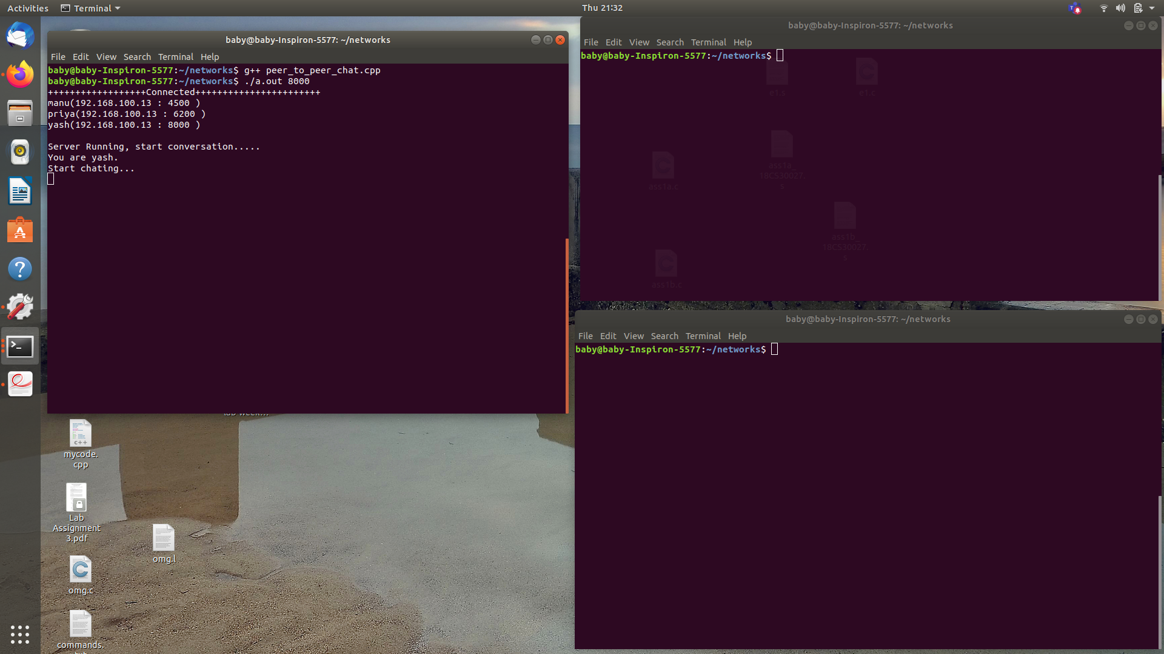
Screenshots (Users added in users.txt)

3 different chat clients : 1. Top left (port no: 8000 ) 2. Top right (Port no:4500) 3. Bottom-right (Port no:6200)

One peer has set up the connection (Top left--Yash)
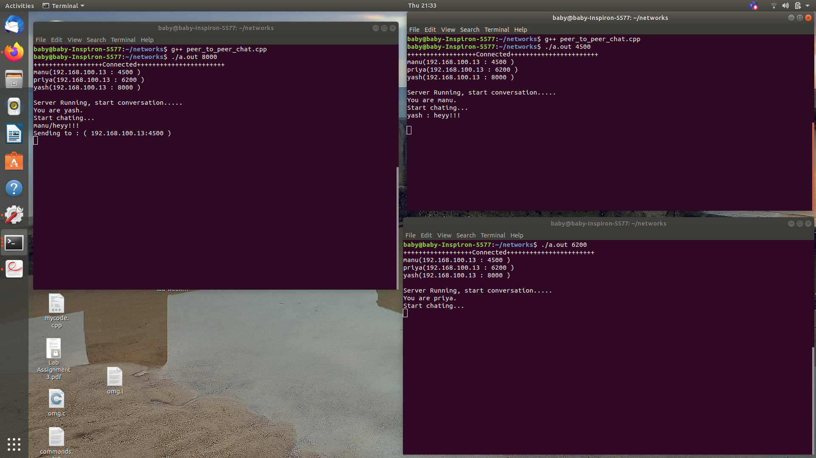

Other peers also set up the connection.

Yash sent a message to manu and manu received that message.

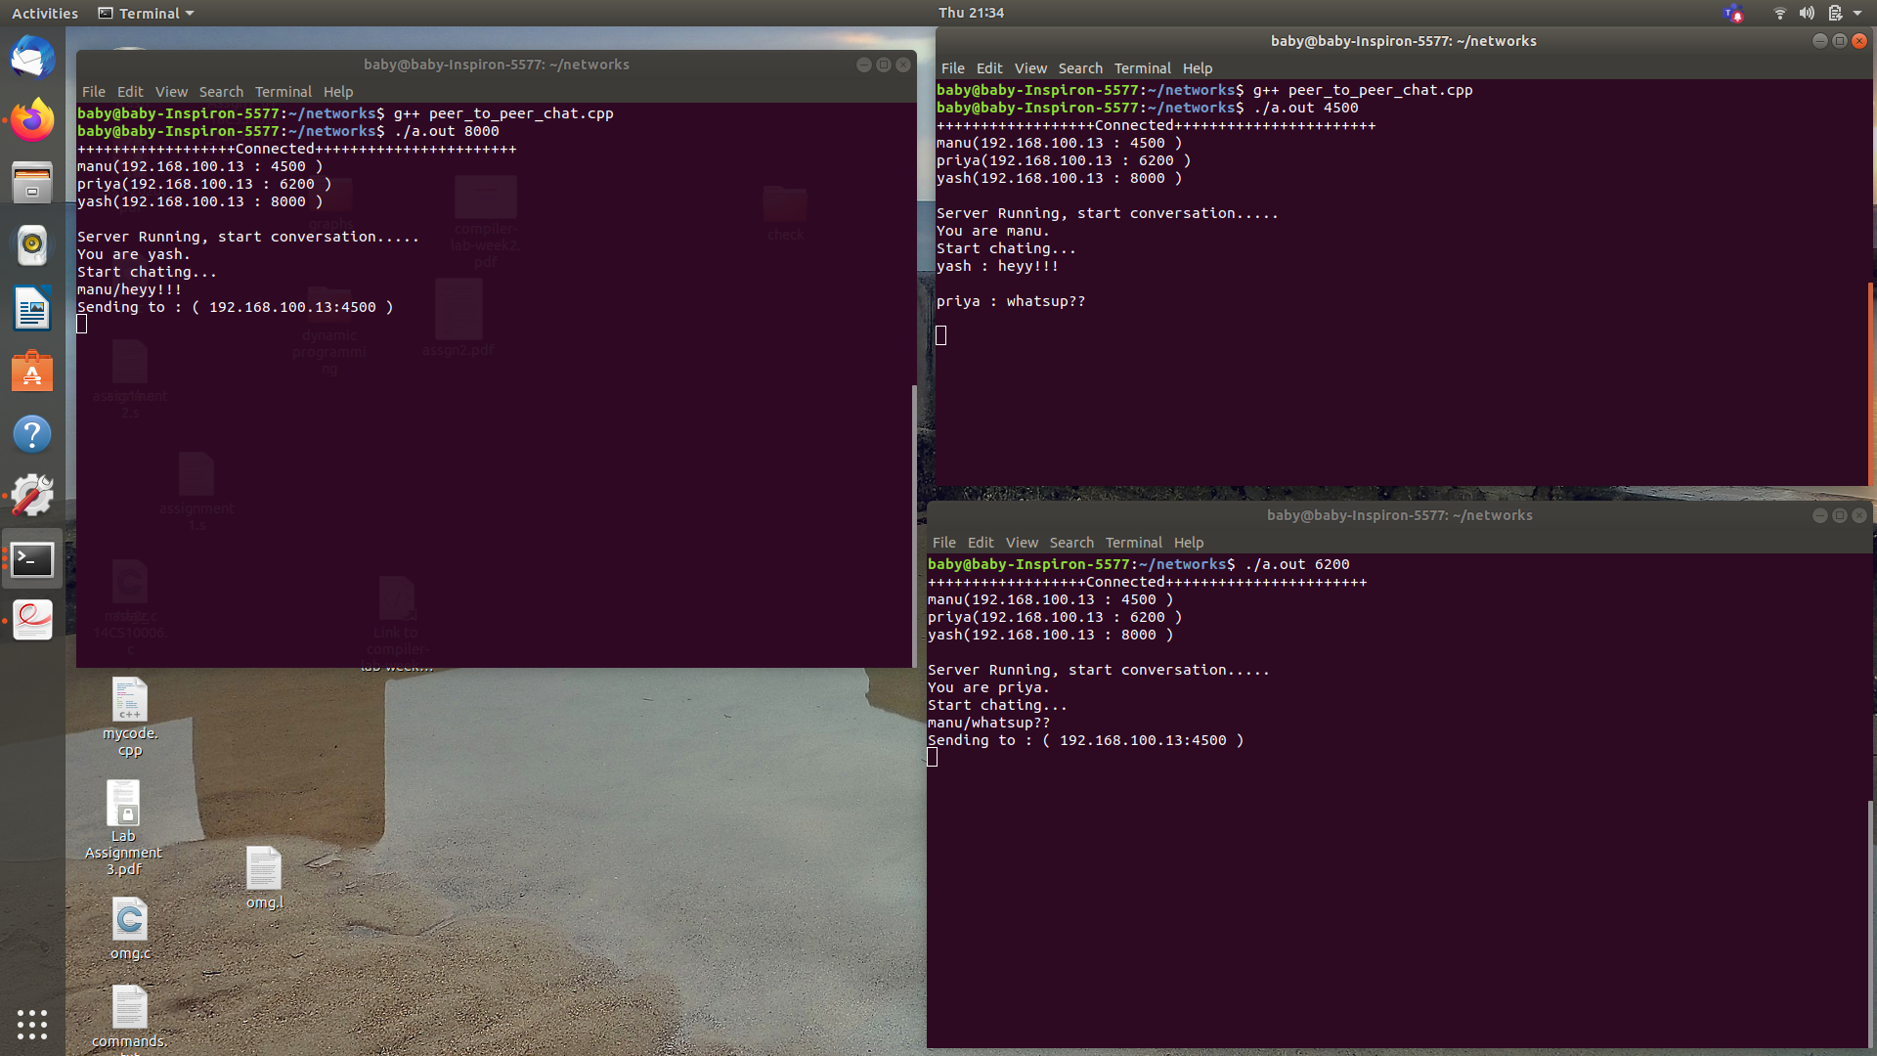

Priya sent a message to manu and manu received that message
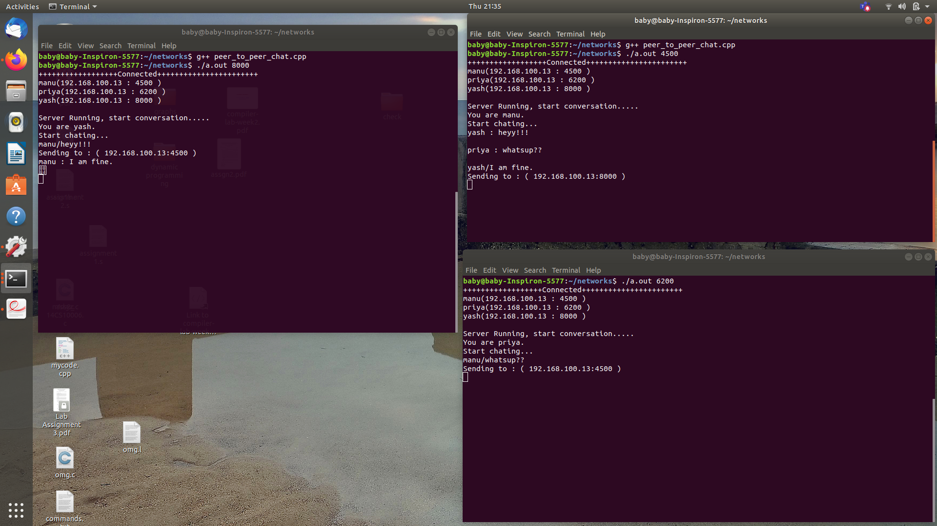

Manu sent reply to Yash and Yash received that message.
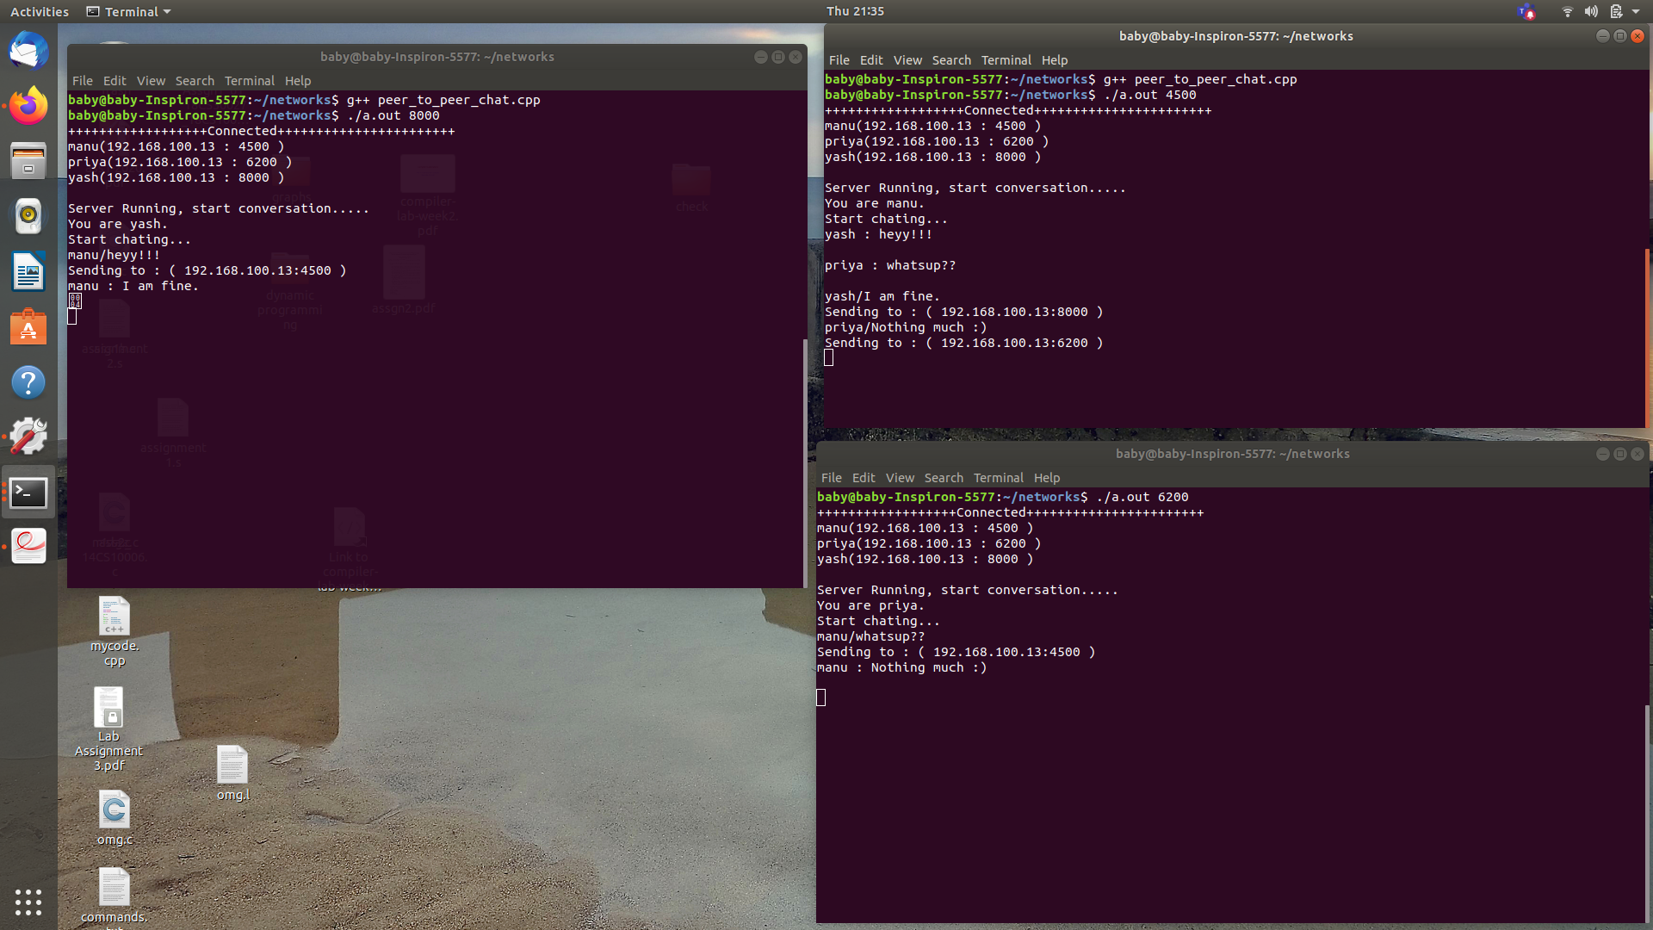
Manu replied to Priya’s message and priya received that message (This peer to peer chat application can be extended to 5 users also)
How to run?
-> g++ peer_to_peer_chat.cpp
->./a.out port_no
where port_no is the port number of the peer.

