Smart Control Arm: Arduino-Powered Robotic Precision with Smartphone Mastery
B.R.B.JASWANT ¹, Assistant professor, jaswanthiot@gmail.com
V. NEERAJA ², veerankineeraja5454@gmail.com, J. BABY SREYA ^{3,} jbabysreya@gmail.com ,
V. NAVYA SREE ⁴, navyasreevangalapati@gmail.com , P. AJITH KUMAR ⁵, puliajith3@gmail.com . Department of Internet of Things in Seshadri Rao Gudlavalleru Engineering College, Gudlavalleru.

Abstract—This study introduces an Arduino-based robotic arm designed and constructed to operate remotely through a mobile application. The robotic arm, featuring six degrees of freedom, was developed specifically for this research project. Utilizing the Arduino platform, the design is responsive to commands transmitted wirelessly from a user's mobile application via Bluetooth signals. Comprising five rotary joints and an end effector, the arm incorporates servomotors to facilitate rotary motion. The design process involved the use of SolidWorks for the initial design of each link, followed by 3D printing to create the physical components [2]. Assembly of the robot's parts, combined with the mechanical configurations of the motors, culminates in the completion of the arm's final prototype. The Arduino programming ensures that each corresponding servo motor receives rotation commands, facilitating remote control through the designed mobile application.
When discussing robots, there is a common misconception that they are exclusively designed for industrial use or for scientific experimentation with new technologies. Contrary to this perception, the primary purpose of robots is to assist humans in various tasks, be it within industrial settings or in performing everyday household chores. To challenge the prevailing notion that "robots are solely for industries," the internet serves as a crucial tool [4].
This study introduces the development of an internet-controlled robotic arm, enabling remote manipulation of the arm's movements through a computer connected to the internet [4]. The objective is to showcase that robots can be integrated into domestic environments to facilitate routine human activities. The robotic arm is operated by an Arduino Uno, interfaced with the internet using the Arduino Ethernet Shield. The project involves two types of analyses: servo motor analysis and accuracy testing [3].
The accuracy test reveals that the actual output of the servo motor, in comparison to the input sent to the Arduino Uno via the internet, falls within the range of 97% to 99%. This prototype demonstrates the successful operation of the robot. As a user-friendly innovation, this robot aims to bridge the existing gap between robots and household chores [2].
Keywords— Arduino, Servo Motors, Hc-05 Bluetooth Module, DC Motor Power Supply, Robotic Arm.

Introduction
In modern times, there is a growing trend of incorporating robots into various work tasks, particularly to handle repetitive functions that would traditionally be performed by humans. The realm of robotics is broadly categorized into industrial and service robotics. According to the International Federation of Robotics (IFR), a service robot is defined as a machine capable of operating semi- or fully autonomously, providing services beneficial to human well-being and equipment, excluding manufacturing operations[2].
These service robots, often mobile, find applications across diverse fields such as offices, military operations, hospitals, hazardous environments, and agriculture. They address challenges faced by workers, especially in scenarios where tasks involve picking and placing objects that may pose risks to human safety [1][2]. Instances include handling chemicals unsuitable for human touch and defusing bombs in military operations, where a robot becomes essential for picking up and relocating the explosive device[1].
The introduction of locomotion robots presents a viable alternative to human labour in various work scenarios. To ensure flexibility and extended reach, these robots are designed for wireless control, allowing them to operate at a distance from the user. A precedent for such wireless control is observed in previous projects, like the Autonomous Robot Navigation using radio frequency [2], where the robot was mechanically adapted to enable compatibility with radio frequency technology.
In addition to wireless control, Bluetooth serves as another platform for efficiently managing robot movements without the constraints of cables [3]. The robot's motion is remotely guided using Bluetooth connectivity, offering control in all directions, including forward, reverse, right, and left. The actuator, represented by the robot's arm, is manipulated through pulse width modulation (PWM) generated from the pin on the Arduino Mega board for precise control and versatility.

Methodology

For implementing a Smart Control Arm revolves around defining project objectives, conducting a literature review on Arduino-powered robotic arms and smartphone-controlled systems, and designing a detailed system architecture. The Arduino is programmed for precise movement control, while a dedicated smartphone application is developed for intuitive user interaction. Hardware components are integrated, and extensive testing is conducted to validate functionality and address any issues. The system undergoes optimization, with refinements made to algorithms and software. Comprehensive documentation is created, encompassing methodology, architecture, code, application, and testing procedures[3].

Components Required
S.no | Components | Specification
1.. | Required Software
1.. | - Arduino software
2. | Required Hardware
2. | - Arduino UNO | ATmega328P,  SRAM: 2 KB.  EEPROM: 1 KB
2. | - MG996 Servo Motor | Operating Voltage is +5V Current: 2.5A (6V)
2. | - SG90 Servo Motor | Operating voltage: 4.8-6.6v
2. | - HC - 05 Bluetooth Module | Operating Voltage: 3.3V  Bluetooth Version: 2.0 + EDR
2. | - Power Supply | Power supply: 5v  Operating current: 2mA
2. | - Jumper wires | -
2. | - Robotic Arm | -

Design Specifications

Arduino UNO
Arduino.cc The Arduino Uno is an open-source microcontroller board designed for ease of use and versatility in prototyping electronic projects. Developed by the Arduino project, it features the ATmega328P microcontroller at its core, providing a wide range of digital and analog input/output pins. The board comes with a USB interface for easy programming and communication with a computer [8].
One of the key features of the Arduino Uno is its simplicity, making it an excellent choice for beginners and professionals alike. It can be easily programmed using the Arduino Integrated Development Environment (IDE) [7], which supports a user-friendly programming language based on Wiring and C/C++. The board supports a variety of sensors, actuators, and other electronic components, enabling users to create interactive and responsive projects [8].

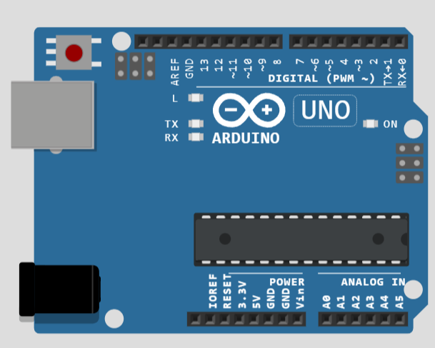
Fig 1: Arduino UNO
The Arduino Uno board incorporates a range of hardware features, including digital and analog pins, PWM (Pulse Width Modulation) outputs, UART (Universal Asynchronous Receiver-Transmitter) communication, and more. Its modular design allows for easy expansion using shields—additional boards that can be plugged into the Uno to add specific functionalities.

Servo Motor
A servo motor is a precise type of motor known for its accuracy in turning. Typically, it includes a control circuit that provides feedback on the motor shaft's present position, allowing it to rotate with great precision[5]. By utilizing this feedback, servo motors can turn an object to predetermined angles or lengths. A servo mechanism is powered by a basic motor, forming the foundation of a servo motor. A servo is made up of a motor (either DC or AC), a potentiometer, a gear assembly, and a control circuit. The below Fig 3 shows the Servo motor[6].
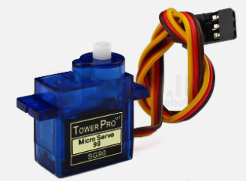
Fig 3: Servo motor
Initially, humans use a gear configuration to reduce the motor's RPM and increase its own torque. Consider setting this potentiometer knob to ensure no electrical signal is generated at the potentiometer's output port while the servo motor shaft is in its original position. Now an electrical signal is applied to the second network terminal of the error-detecting amplifier. The difference between these two signals—one from either the potentiometer or an outside source—will now be processed by a feedback loop, which will send the result as an error signal. The motor's input can be provided by this error function [6].

MG996 Servo Motor
The MG996 servo motor stands out as a highly reliable and versatile electromechanical device, widely embraced by hobbyists, engineers, and robotics enthusiasts. This digital servo motor is recognized for its precision and adaptability in diverse applications. Operating on a closed-loop control system, it ensures accurate positioning and movement and is compatible with both analog and digital control signals [2].

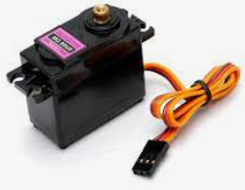
Fig 3: MG996 Servo Motor

The MG996 boasts impressive torque capabilities, making it well-suited for tasks demanding strength and stability. Encased in a durable plastic housing, the motor offers resilience against moderate mechanical stress and environmental factors. Operating within a voltage range of approximately 4.8 to 7.2 volts, it aligns with common power sources in electronic projects [8]. With a rotation angle of around 180 degrees, this servo motor is ideal for applications requiring precise angular movements, such as robotics, model airplanes, and camera stabilization systems. Controlled through PWM signals from a microcontroller or electronic circuit, the MG996 proves instrumental in achieving accurate and controlled motion [7].

HC - 05 Bluetooth Module
Bluetooth stands as a wireless protocol employing short-range communications technology to facilitate the transmission of data over limited distances between fixed and/or mobile devices, thereby establishing wireless personal area networks (PANs). The genesis of Bluetooth stems from the need for a unified digital wireless protocol capable of connecting multiple devices and overcoming synchronization challenges [6].

Operating on the robust radio technology of frequency hopping spread spectrum, Bluetooth efficiently divides the data into chunks and transmits them across up to 75 different frequencies. In its fundamental mode, Bluetooth utilizes Gaussian frequency shift keying (GFSK) for modulation [3], achieving a gross data rate of 1 Mb/s. This technology serves as a pivotal solution for connecting and exchanging information among a myriad of devices, including mobile phones, telephones, laptops, personal computers, printers, GPS receivers, digital cameras, and video game consoles [4].

CLASS | MAXIMUM PERMITTED POWER mW(dBm) | RANGE
CLASS 1 | 100mW (20 dBm) | 100 meter
CLASS 2 | 2.5 mW (4 dBm) | 10 meter
CLASS 3 | 1 mW (0 dBm) | 1 meter

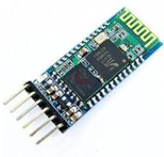

Fig 4: HC-05 Bluetooth Module

Block Diagram for Robotic Arm

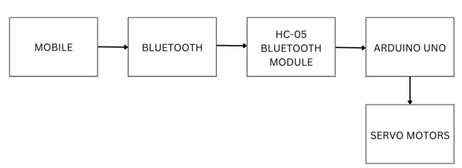

Fig 5: Block Diagram for Robotic Arm

The block diagram depicted in Figure 2 illustrates the fundamental structure of the robotic arm, comprising five distinct outputs: the robot base, robot shoulder, robot elbow, robot wrist, and robot gripper. For a more detailed representation of the robotic arm's components.
In terms of power supply, the robotic arm relies on a 12V/1.2Ah Lead Acid battery, chosen for its specific characteristics and advantages. To ensure a stable power output, the main source is regulated to 5 volts using voltage regulator. The utilization of servo motors is integral to the design, specifically DC-type motors with feedback. Servo motors, known for their applicability in systems requiring precise control in the up-down direction, play a crucial role in robotics [2]. Notably, servo motors provide low RPM (Rotations Per Minute) combined with high torque, making them particularly suitable for this project. Given the project's emphasis on high torque, the servo motor 180 is the preferred choice for implementation.

Flow Chart for Robotic Arm
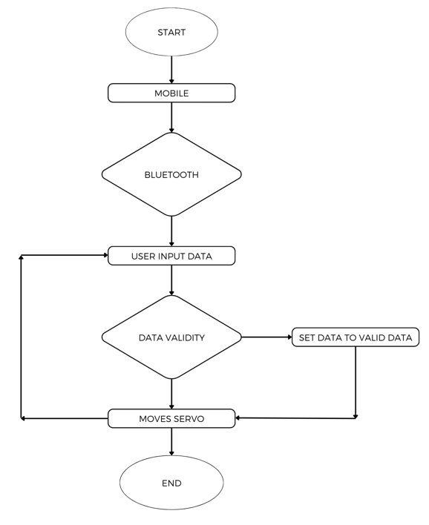
Fig 6: Flow Chart for Robotic Arm

Figure 6 outlines the procedural steps involved in programming the system. Initially, a server instance is initiated, which responds to Hypertext Transfer Protocol (HTTP) commands on port 80. Notably, port 80 is commonly designated as the default port for web servers. Within the Arduino platform, the signal is conveyed from the bluetooth and subsequently interpreted by the Arduino using a specific command (if a client is available). The Arduino controller monitors the receiver mobile command to identify each command directed to the controller. The subsequent task involves decoding the received instructions once the receiver mobile command is determined to be high [6].

Procedure for Robotic Arm

WIRING UP THE COMPONENTS:
The movement of the waist motor involves rotating the entire robotic arm on its base within the range of 0 to 180 degrees, corresponding to the rotation range of the servo motors. The shoulder motor, responsible for bearing the weight of the entire arm, moves up and down based on the angle θ2. The elbow motor is designed to facilitate comfortable maneuvering of the robotic arm. The waist roll motor enables the rotation of the arm around its axis between 0 and 180 degrees, denoted as angle θ4. The waist pitch motor controls the up and down movement of that joint [6]. The gripper motor serves as the end effector, interacting with the environment by performing opening and closing movements to grasp objects.
The control system of the robotic arm is implemented using the Arduino platform. A comprehensive understanding of Arduino micro-controller programming is crucial for effective control. The mechanical components comprise the assembled body parts of the robotic arm, while the electronic components involve configuring the motors, managing motor wire connections, integrating the Bluetooth module, and creating the mobile application [4].
The robotic arm incorporates six servo motors, consisting of three MG945 servo motors and three MG90S Micro servos. These motors are attached to different segments of the robotic arm, along with an Arduino Uno and an HC05 Bluetooth module [2].
Communication between the user and the robotic arm is established through a Bluetooth module, facilitating commands from a mobile application to the Arduino. The Arduino interprets these commands and generates corresponding movements in the robotic arm's motors. To enable this configuration [3], the Arduino must be programmed to activate the mobile device's Bluetooth. The application features sliders, with each slider associated with a specific motor movement. Adjusting the sliders in the application results in corresponding movements of the motors.
Arduino IDE is utilized for programming the Arduino, an open-source software developed by Arduino Company. The mobile application, created using the MIT App Inventor, enables Bluetooth connectivity with the robotic arm [2]. All servo motors are directly connected to a 5 V external power supply, requiring a minimum current of 1000 mA DC (2000 mA recommended). The Bluetooth module is powered through the Arduino board for safety reasons. The ground (GND) connections of all servo motors and the Arduino are interconnected [3].

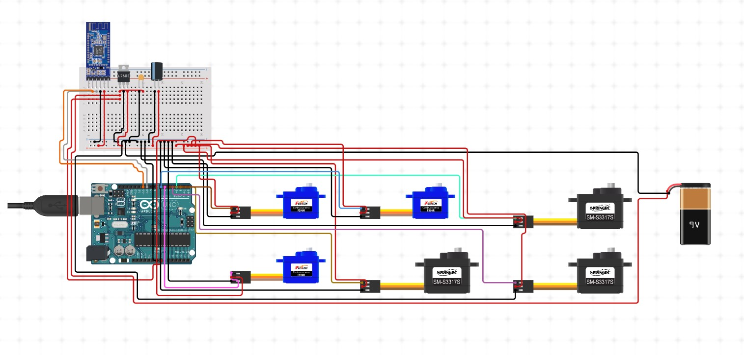
Fig 7: Circuit Diagram of Robotic Arm

In the mobile application, created using the MIT App Inventor, a button enables Bluetooth on the mobile device, and six sliders correspond to each servo motor for issuing commands and controlling their movements. The coding in the application's blocks section mirrors the Arduino code, with each slider sending a value via Bluetooth to the Arduino for precise control of the servo motors[8].

Working
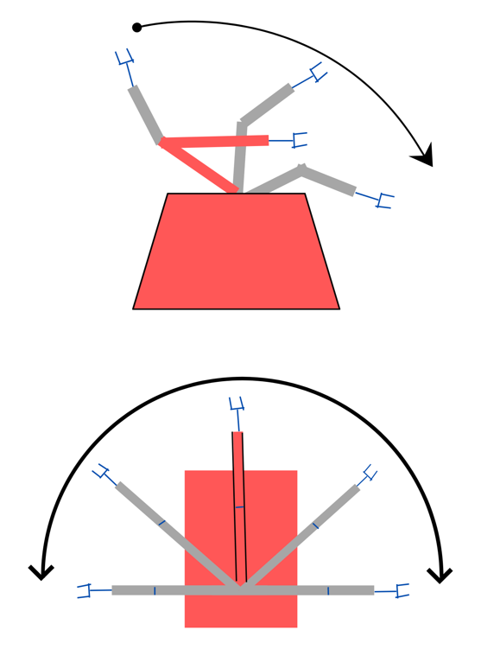
Fig 8: Working for Robotic Arm
Having connected, one should Verify that everything is connected properly and see if anything was overlooked after assembling the robotic arm and connecting all the devices. After establishing the connection [6], the Arduino must be programmed or uploaded with code before being powered. When the system is turned on, Arduino keeps an eye out for anything that approaches the servo motors from a specific command. In the mobile application, created using the MIT App Inventor, a button enables Bluetooth on the mobile device, and six sliders correspond to each servo motor for issuing commands and controlling their movements. The coding in the application's blocks section mirrors the Arduino code, with each slider sending a value via Bluetooth to the Arduino for precise control of the servo motors [1].
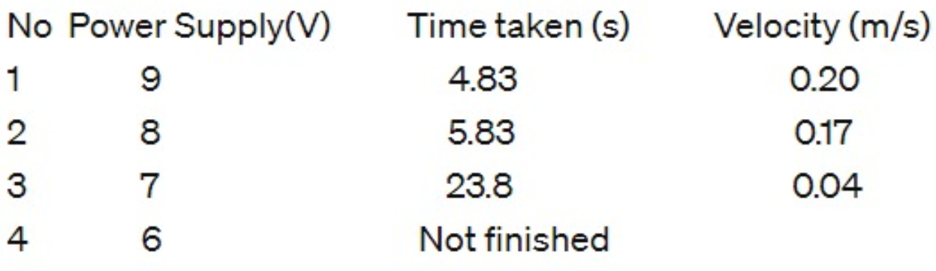
Fig 9 : Time taken for difference power supply.
The significance of the incoming power supply lies in its direct impact on the mobile robot, particularly in regulating the speed of the servo motor. This connection between power supply and servo motor speed is crucial for the robot's performance. Figure 9 provides an analysis of the robot's velocity over varying power supplies, specifically focusing on covering a distance of 1 meter. The findings indicate that a decrease in power supply leads to an increase in the time taken by the mobile robot to traverse the specified distance. Notably, when utilizing a 6V power supply, the mobile robot exhibits no movement.
Consequently, it can be inferred that the power supply for the mobile robot, particularly the 180 degree servo motor, maintains a proportional relationship with the robot's speed. The observed trend underscores the importance of an optimal power supply to ensure efficient and controlled mobility in the robot's operations.

Conclusion
This study aims to develop a robotic arm that is entirely managed by the Arduino platform, allowing remote control via a secure distance using a mobile application. The application of this robotic arm extends to diverse industries and environments deemed hazardous for human presence. The Arduino programming encompasses the provision of rotation to each servo motor, aligning with the sliders integrated into the mobile application, thereby facilitating remote operation. Rigorous testing of the final design validates its successful functionality, demonstrating that the implemented design effectively accomplishes its intended tasks.

Acknowledgment
We would like to thank everyone involved in this initiative for their helpful advice and assistance and prompt assistance that enabled us to finish the project on schedule. We would like to offer our sincere thanks to our department Assistant professor Dr. B. R. B. Jaswanth, for his crucial assistance, inspiration, and leadership. and constructive criticism throughout the project's work. Last but not least, we would like to express our gratitude to all of our group members as well as our family for their crucial support since we started our schooling.

References

- Hussein Mohammed Ali, Yasir Hashim, Ghadah Alaadden Al-Sakka, “Design and implementation of Arduino based robotic arm” , International Journal of Electrical and Computer Engineering (IJECE) Vol. 12, No. 2, April 2022, pp. 1411~1418 ISSN: 2088-8708, DOI: 10.11591/ijece.v12i2.pp1411-1418
- Wan Muhamad Hanif Wan Kadira , Reza Ezuan Saminb *, Babul Salam Kader Ibrahim c, “Internet Controlled Robotic Arm”, International Symposium on Robotics and Intelligent Sensors 2022 (IRIS 2022)
- C. S. Chen, S. K. Chen, C. C. Lai, and C. T. Lin, “Sequential motion primitives recognition of robotic arm task via human demonstration using hierarchical BiLSTM classifier,” IEEE Robotics and Automation Letters, vol. 6, no. 2, pp. 502–509, Apr. 2021, doi: 10.1109/LRA.2020.3047772
- A. Singh, P. Pandey, and G. C. Nandi, “Effectiveness of multi-gated sequence model for the learning of kinematics and dynamics of an industrial robot,” Industrial Robot, vol. 48, no. 1, pp. 62–70, Dec. 2021, doi: 10.1108/IR-01-2020-0010.
- T. T. Nguyen, “Fractional-order sliding mode controller for the two-link robot arm,” International Journal of Electrical and Computer Engineering, vol. 10, no. 6, pp. 5579–5585, Dec. 2020, doi: 10.11591/ijece.v10i6.pp5579-5585
- X. Chen, X. Huang, Y. Wang, and X. Gao, “Combination of augmented reality based brain- computer interface and computer vision for high-level control of a robotic arm,” IEEE Transactions on Neural Systems and Rehabilitation Engineering, vol. 28, no. 12, pp. 3140–3147, Dec. 2020, doi: 10.1109/TNSRE.2020.3038209
- M. A. Alblaihess, “Designing a robotic arm for moving and sorting scraps at Pacific Can, Beijing, China,” Beijing, 2015
[8] M. Arun, D. Jenson, V. J. Shree, V. M. Nandhini and B. Abinaya, "Smart Grid Robot Exclusively Designed for High Power Transmission Lines", 2019 5th International Conference on Advanced Computing & Communication Systems (ICACCS), pp. 652-654, 2019.

