Vulnerability Name- MySQL Root Account with Empty Password

Severity- critical

Vulnerability description-The MySQL root account is configured to allow authentication without a password (or with an empty password). This permits anyone with network access to the MySQL service to authenticate as the database administrator.

- Attack:
Unauthorized Database Access

Impacts-
- Full administrative access to the database.
- Read, modify, or delete all database contents.
- Create new database users.
- Execute administrative SQL operations.
Steps to reproduce-
- Configure the Kali Linux and Metasploitable 2 virtual machines on the same network.
- Verify that the MySQL service is accessible on TCP port 3306.
- Connect to the MySQL server using a MySQL client with the root account over the network.
- Observe whether the server allows authentication without a password (or using an empty password, if applicable).
- If authentication succeeds, verify that administrative access to the database has been obtained.
- Capture screenshots of the successful login and record the findings.
Proof of concept-
- Scan for target :
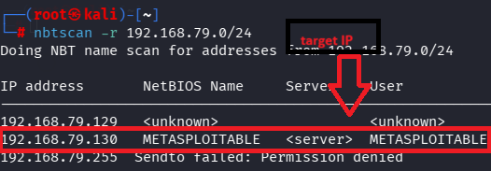
- Scan target:
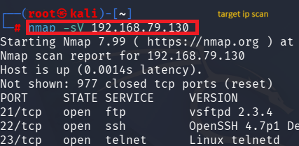
- Verify port:

- Command for exploit:
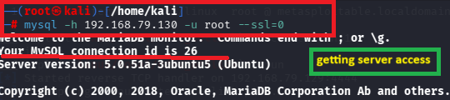
- Result:
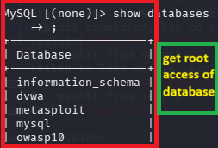
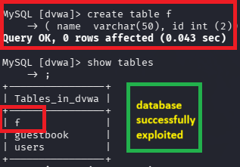

Remedy-
- Set a strong, unique password for all MySQL user accounts, especially the root account.
- Disable remote login for the root account unless it is absolutely required.
- Remove or disable default, anonymous, and unused MySQL accounts.
- Apply the principle of least privilege by granting users only the permissions necessary for their roles.
- Restrict access to TCP port 3306 using firewall rules or by allowing connections only from trusted hosts.
- Enable SSL/TLS encryption for remote MySQL connections to protect credentials and data in transit.

Reference-
https://cwe.mitre.org/data/definitions/1392.html
https://cwe.mitre.org/data/definitions/521.html

