Vulnerability Name- RPCBind / libtirpc – Denial of Service (DoS)

Severity- high

Vulnerability description- A denial-of-service vulnerability in RPCBind or libtirpc may allow an attacker to send specially crafted RPC requests that cause the RPC service to become unresponsive or crash. This affects the availability of RPC-dependent services until the service is restarted or the system recovers.

- Attack-
Denial of Service (DoS)

Impacts-
- RPC service becomes unavailable.
- Disruption of RPC-dependent services such as NFS.
- Temporary loss of availability for legitimate users.
- Potential interruption of network file sharing and related services.
Steps to reproduce-
- Configure the Kali Linux and Metasploitable 2 machines on the same network.
- Verify that the target system is reachable.
- Confirm that the RPC service (rpcbind) is running on the target (typically on port 111).
- Perform the DoS assessment in the authorized lab environment.
- Observe whether the RPC service becomes unavailable or stops responding.
- Record the findings and capture screenshots.
Proof of concept-
- Scan for target:
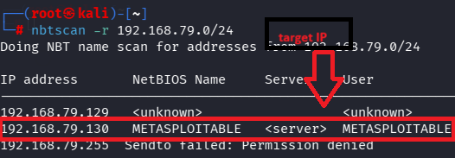
- Scan target:
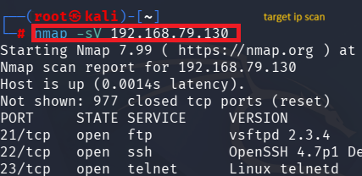
- Verify port:
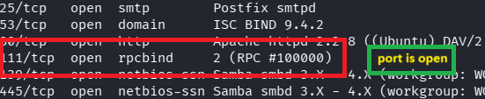
- Use of msfconsole:

- Target required details :
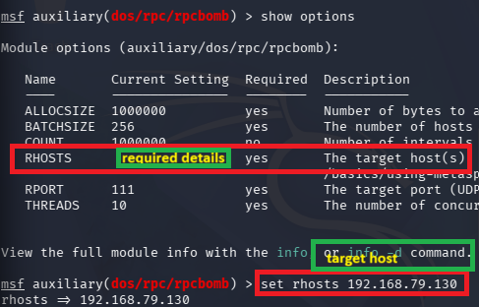
- Exploit:
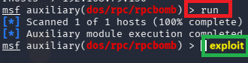


Remedy-
- Update rpcbind and libtirpc to the latest supported versions.
- Disable RPC services if they are not required.
- Restrict access to port 111 using firewall rules.
- Allow only trusted hosts to access RPC services.
- Monitor RPC logs and network traffic for abnormal activity.

References-
https://www.exploit-db.com/exploits/41974

