Vulnerability Name- Local Privilege Escalation

Severity- high

Vulnerability description- After obtaining initial access as a low-privileged user (for example, the tomcat service account), a local privilege escalation vulnerability or misconfiguration may allow an attacker to gain higher privileges, potentially obtaining root access.

- Attack
Privilege Escalation

Impacts-
- Gain root privileges.
- Full control of the target system.
- Access to sensitive files and system configurations.
- Ability to install persistent backdoors or modify security settings.

Steps to reproduce-
  - Obtain an initial low-privileged user session on the target system (for example, the tomcat service account).
  - Verify the current user privileges using standard system commands.
  - Assess the system for local privilege escalation vulnerabilities or misconfigurations.
  - Confirm that a privilege escalation weakness is present in the authorized test environment.
  - Validate whether elevated privileges (such as root) can be obtained.
  - Record the results and collect evidence (for example, the user identity before and after privilege escalation).
Proof of concept-
- Scan for target:
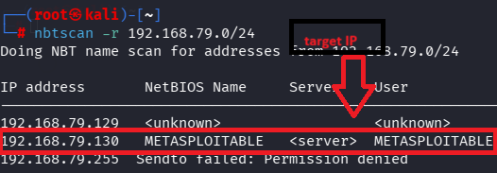
- Scan target:
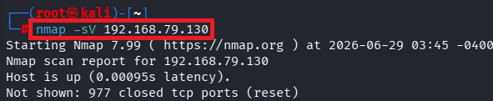
- Verify port:
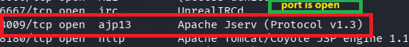
- Use of msfconsole:
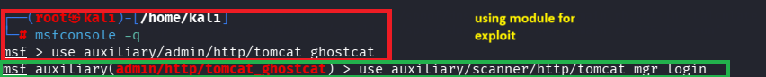
- Fill target details:
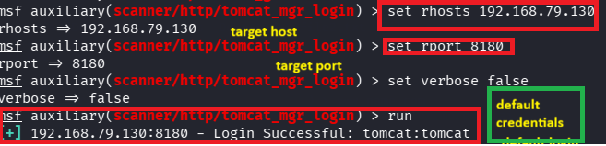
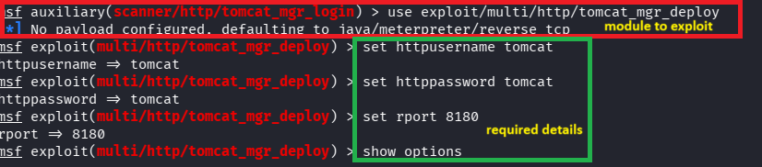
- Exploit:
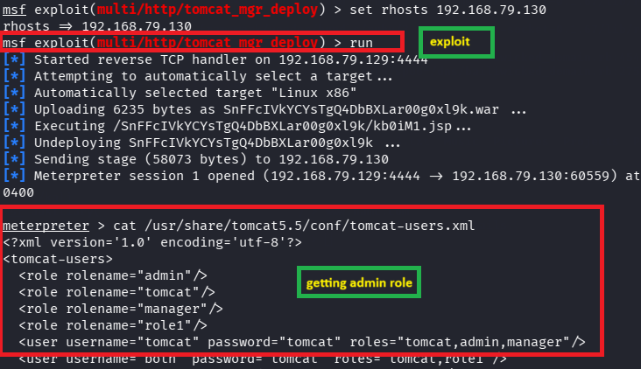

Remedy-
  - Keep the operating system and installed software fully patched.
  - Remove unnecessary SUID/SGID permissions.
  - Apply the principle of least privilege to service accounts.
  - Regularly audit local privilege escalation vulnerabilities and misconfigurations.
  - Monitor for suspicious privilege escalation attempts.

References:
https://attack.mitre.org/tactics/TA0004/
https://owasp.org/www-community/controls/Least_Privilege_Principle

