Vulnerability Name- Apache Tomcat Manager – Weak Credentials Allow WAR Deployment

Severity- critical

Vulnerability description- The Apache Tomcat Manager application was accessible with valid or weak credentials. An authenticated user with Manager privileges can deploy a WAR file, resulting in remote code execution with the privileges of the Tomcat service account.

Attack
Remote Code Execution (RCE)

Impacts-
- Remote code execution.
- Upload and execution of malicious web applications.
- Unauthorized access to the server.
- Potential privilege escalation.
Steps to reproduce-
- Scan the target and identify the Apache Tomcat service on port 8180.
- Access the Tomcat Manager web interface.
- Verify that Manager credentials are accepted.
- Confirm that a WAR application can be deployed.
- Verify successful code execution by obtaining a shell or executing a command in the authorized lab.
Proof of concept-
- Scan for target:
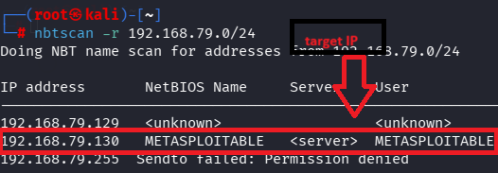
- Scan target:
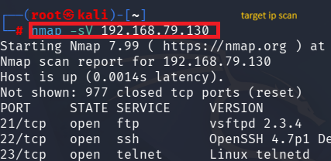
- Verify port:
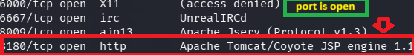
- Use of Msfconsole :
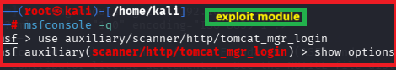
- Fill target details:
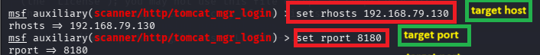
- Exploit:
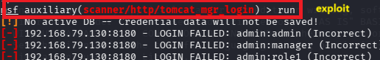
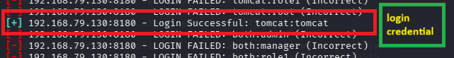
- Payload generation and execution:
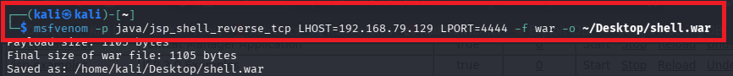
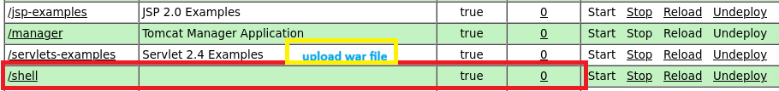
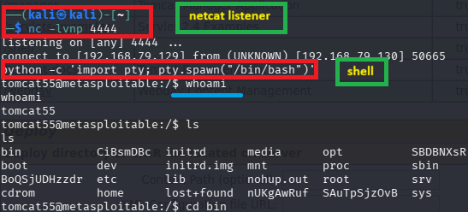

Remedy-
- Remove default or weak Tomcat Manager credentials.
- Restrict access to the Manager application using IP allowlists or VPNs.
- Grant the manager-gui and related roles only to trusted administrators.
- Disable the Manager application if it is not needed.
- Keep Apache Tomcat updated to a supported version.
References-
https://www.rapid7.com/db/modules/exploit/multi/http/tomcat_mgr_upload/?utm_source=chatgpt.com
https://tomcat.apache.org/tomcat-5.5-doc/manager-howto.html?utm_source=chatgpt.com

