Vulnerability Name- PHP CGI Argument Injection

Severity- critical

Vulnerability description- A vulnerability in PHP-CGI allows specially crafted HTTP requests to be interpreted as command-line arguments. An attacker can exploit this flaw to execute arbitrary PHP code on the server, potentially leading to remote code execution.

- Attack
Remote Code Execution (RCE)

Impacts-
- Remote code execution.
- Unauthorized access to the web server.
- Data theft or modification.
- Complete server compromise.

Steps to reproduce-
- Identify that the target is running a vulnerable PHP CGI service.
- Verify that the affected PHP CGI version is present.
- Perform the vulnerability assessment in the authorized lab environment.
- Confirm that remote code execution is possible.
- Verify successful access by establishing a Meterpreter session.
- Record the findings and capture screenshots.

Proof of concept-
- Scan for target:
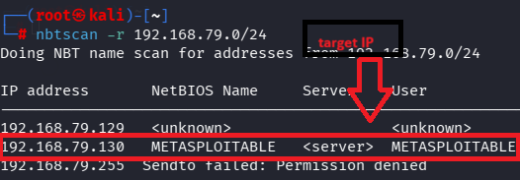

- Scan target:
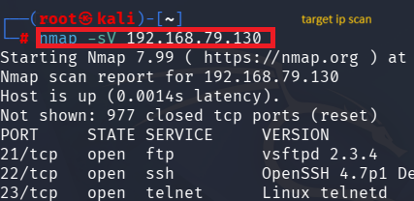

- Verify port:
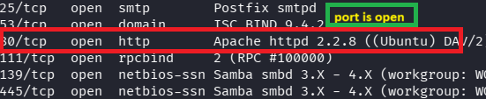

- Use of msfconsole:
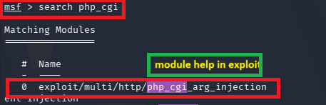

- Fill target details:

- Exploit:
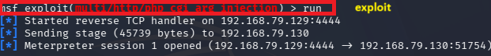
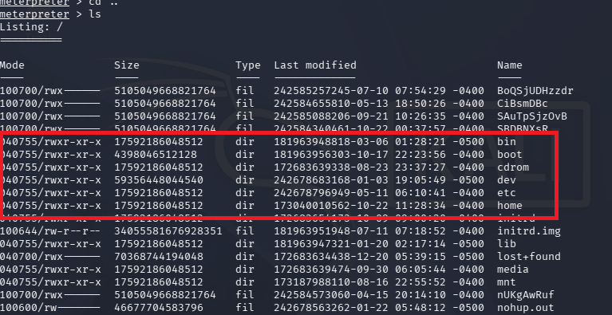

Remedy-
- Upgrade PHP to a patched version.
- Disable PHP-CGI if it is not required.
- Use PHP-FPM or another supported configuration.
- Apply the latest security patches.
- Restrict unnecessary web server access.
References-
https://www.rapid7.com/db/modules/exploit/multi/http/php_cgi_arg_injection/
https://nvd.nist.gov/vuln/detail/CVE-2012-1823

