Vulnerability Name- Java RMI Server Remote Code Execution

Severity- critical

Vulnerability description-An insecure Java RMI server allows an attacker to execute arbitrary code remotely by exploiting unsafe deserialization or insecure RMI object handling.

- Attack
Remote Code Execution (RCE) Attack.

Impacts-
- Remote code execution.
- Unauthorized remote access.
- Full system compromise.
- Execution of arbitrary commands with root privileges.
Steps to reproduce-
- Scan the target and identify the Java RMI service (port 1099).
- Verify that the Java RMI server is accessible.
- Use the authorized java_rmi_server exploit against the target in the lab.
- Obtain a Meterpreter session.
- Execute whoami to verify access.
- Confirm that the output is root.
Proof of concept-
- Scan for target:
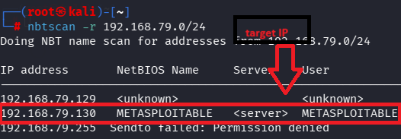

- Scan target ip:
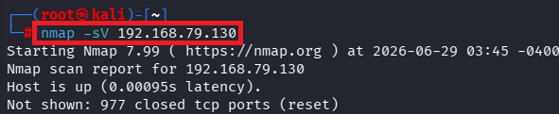

- Verify port:
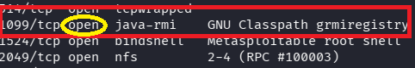

- Msfconsole:
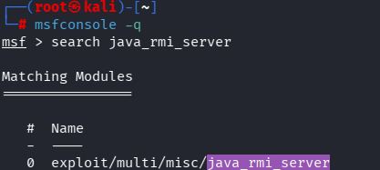

- Exploit:
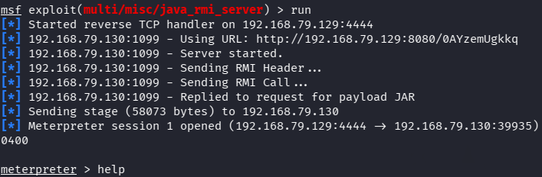

- Target required details:

- Shell access:
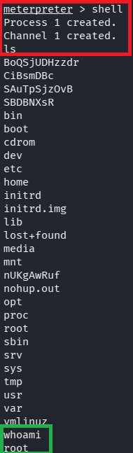

Remedy-

- Update Java and the RMI application to supported versions.
- Disable Java RMI if it is not required.
- Restrict access to the RMI service using a firewall.
- Enable authentication and secure RMI communication.
- Avoid exposing Java RMI services directly to untrusted networks.

References-

https://www.rapid7.com/db/modules/exploit/multi/misc/java_rmi_server/

