Vulnerability Name- Ingreslock Backdoor

Severity- critical

Vulnerability description- Port 1524 provides direct access to a root shell without proper authentication. In Metasploitable 2, this backdoor is intentionally included for security training.

Attack
Unauthorized Remote Root Shell Access

Impacts-
- Unauthorized root access.
- Complete system compromise.
- Ability to execute arbitrary commands.
Steps to reproduce-
- Scan the target and identify that port 1524/TCP is open.
- Connect to port 1524 using a terminal client (e.g., Telnet or Netcat).
- Verify that a root shell is obtained.
- Run commands such as whoami or ls to confirm access.
Proof of concept-
- Scan for target:
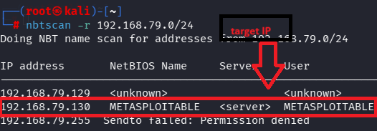

- Scan target ip:
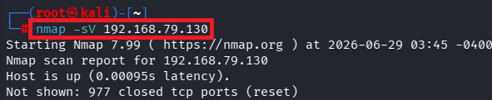

- Verify port :
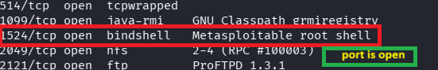

- Connect port(telnet):
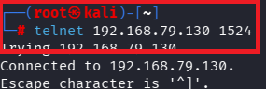
- Get shell access:
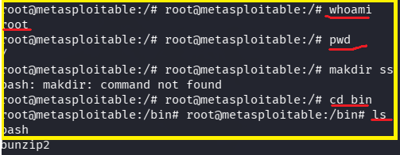

Remedy-
- Remove or disable the backdoor service.
- Close port 1524 if it is not required.
- Restrict access using a firewall.
- Use secure, authenticated remote administration methods (such as SSH).
- Regularly audit systems for unauthorized or unnecessary services.

References-

https://docs.rapid7.com/metasploit/metasploitable-2/?utm_source=chatgpt.com
https://nmap.org/book/nmap-services.html?utm_source=chatgpt.com

