Vulnerability Name- Insecure NFS Export Configuration

Severity- high

Vulnerability description- The NFS service exports directories with weak or no access restrictions, allowing unauthorized clients to mount shared directories and potentially access or modify sensitive files.

- Attack
Unauthorized NFS Share Access.

Impacts-
- Unauthorized access to sensitive files.
- Information disclosure.
- Unauthorized file modification.
- Potential privilege escalation if sensitive files are writable.
Steps to reproduce-
- Scan the target and identify that the NFS service is running.
- Enumerate the exported NFS shares.
- Mount an exported share from an authorized test machine.
- Verify access by listing or reading files in the mounted share.
Proof of concept-
- Scan for target :
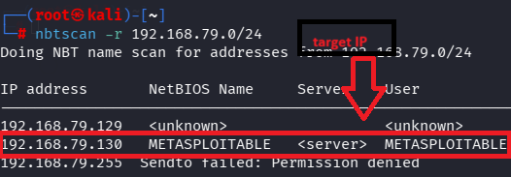

- Scan of target ip:
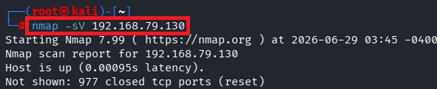

- Verify port:
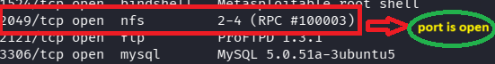
- Mounting the NFS Share:
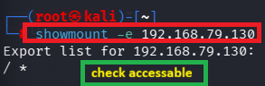

- Exploiting:

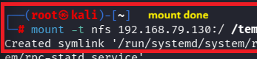
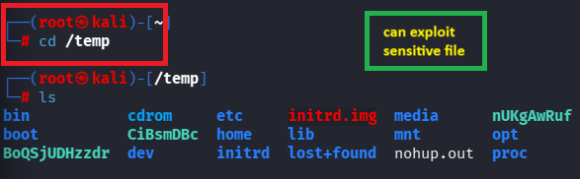

Remedy-
- Export only required directories.
- Restrict NFS access to trusted IP addresses.
- Use the root_squash option to prevent remote root users from acting as root on the server.
- Disable NFS versions that are not needed.
- Keep the NFS server updated with security patches.

References-

https://medium.com/@josegpach/identifying-and-exploiting-nfs-vulnerabilities-nessus-and-metasploitable-2-63f5446b0ecf

