Vulnerability Name- Insecure PostgreSQL Configuration

Severity- high

Vulnerability description- An insecure PostgreSQL configuration allows an authenticated user to upload a malicious shared library as a User Defined Function (UDF). When the UDF is loaded, arbitrary code can execute with the privileges of the PostgreSQL service account.

- Attack
Remote Code Execution (RCE).

Impacts-
- Remote Code Execution.
- Unauthorized access to the server.
- Potential compromise of the PostgreSQL host.
Steps to reproduce-
- Scan the target and identify the PostgreSQL service.
- Verify valid PostgreSQL credentials are available.
- Execute the authorized PostgreSQL payload module in the lab.
- Confirm that a Meterpreter or shell session is obtained.
- Verify access by listing files or checking the current user.
Proof of concept-
- Scan for target:
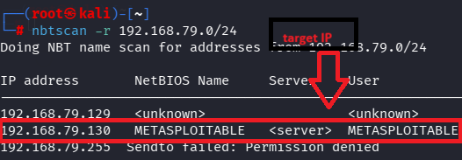
- Scan target:
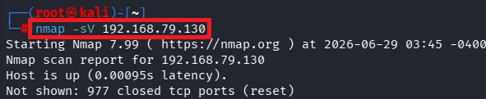
- Verify port:
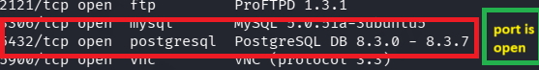
- Msfconsole for exploit:
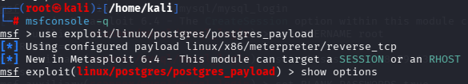
- Required target details:
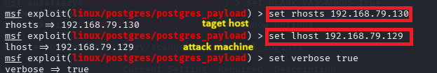
- Exploit:
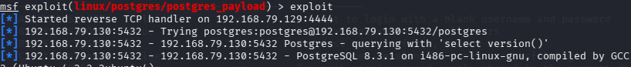
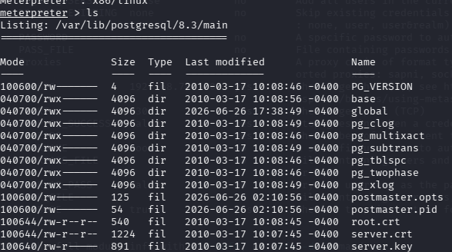

Remedy-
- Upgrade PostgreSQL to a supported version.
- Restrict write permissions to sensitive directories.
- Limit who can create or load User Defined Functions.
- Use strong authentication and restrict database access to trusted hosts.

References-

https://www.exploit-db.com/exploits/50847

