Vulnerability Name- Samba Username Map Script Remote Command Execution

Severity- critical

Vulnerability description- A vulnerability in Samba versions 3.0.20 through 3.0.25rc3 allows a remote, unauthenticated attacker to execute arbitrary commands by sending a specially crafted username during SMB authentication. Successful exploitation results in remote shell access.

- Vulnerability
A flaw in Samba's username map script feature allows an unauthenticated remote attacker to execute arbitrary commands on the target system, leading to remote shell access.
- Attack name – remote code execution.
- Attack vector-An attacker exploits the Samba Username Map Script vulnerability to execute arbitrary commands on the target system without authentication.

Impacts-
- Remote Code Execution (RCE)
- Unauthorized shell access
- Full system compromise
- Possible root access depending on the Samba configuration.
Steps to reproduce-
- Scan the target machine and identify the Samba (SMB) service.
- Verify that the Samba version is vulnerable (CVE-2007-2447).
- Use an authorized testing tool in the lab to exploit the vulnerability.
- A command shell is obtained on the target.
- Run the ls command to confirm remote command execution.
- Record the output as evidence.

Proof of concept-
- Verify target- (nbtscan -r 192.168.79.0/24)
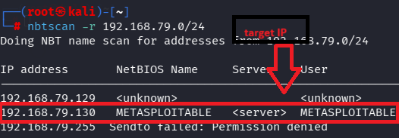
- Scan taget ip- 192.168.79.130
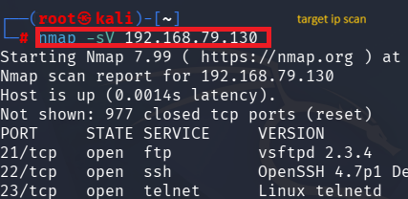

- Verify target port :
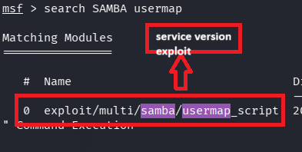

- Use metasploitable by msfconsole:
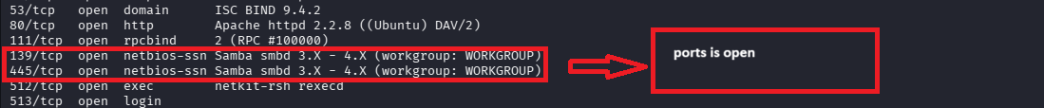

- Fill target details:
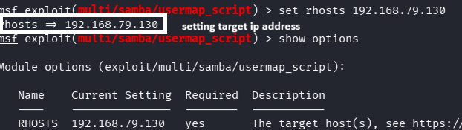

- Exploit:
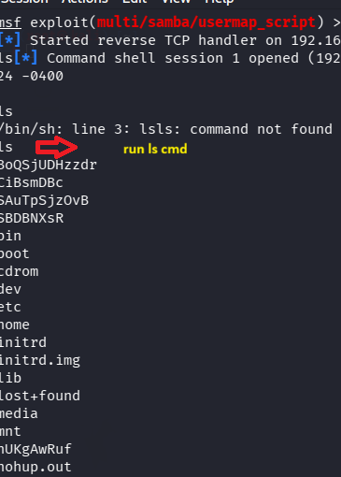

Remedy-

  - Upgrade Samba to a patched/latest version.
  - Apply all available security updates.
  - Disable the vulnerable username map script feature if it is not needed.
  - Restrict SMB access using a firewall and allow only trusted hosts.
  - Regularly monitor and audit SMB services for suspicious activity.
References-

https://medium.com/@mrjoemaina01/metaploitable-ii-exploiting-samba-smbd-3-x-4-x-2b567b767020

