Vulnerability Name- SMTP VRFY USER ENUMERATION.

Severity- low

method-

Vulnerability description- The SMTP server is configured to respond to the VRFY command, allowing remote users to determine whether specific usernames exist on the mail server.

- Vulnerability
The SMTP server allows remote users to verify whether specific usernames exist by responding differently to the VRFY command. This exposes valid usernames that attackers can use in further attacks.
- Attack
An attacker sends SMTP VRFY requests to the mail server to determine whether specific user accounts exist.
- Attack type - Information Disclosure

Impacts-
- Reveals valid usernames on the SMTP server.
- Assists attackers during the reconnaissance phase.
- Enables targeted brute-force and password spraying attacks.
- Increases the likelihood of successful credential stuffing attacks if usernames are paired with leaked passwords.
- Facilitates phishing and social engineering by identifying legitimate user accounts.
- Exposes internal user information, reducing the organization's privacy.
- Can be combined with other vulnerabilities to gain unauthorized access.
- Increases the overall attack surface of the mail server.
Steps to reproduce-
- Identify the SMTP service running on the target host (typically on TCP port 25).
- Connect to the SMTP service using an SMTP client or an authorized security assessment tool.
- Send user verification requests for selected usernames.
- Observe the SMTP server's responses.
- Compare the responses for existing and non-existing usernames.
- Confirm the vulnerability if the server returns different responses that disclose whether a username exists.
Proof of concept-
- Target scan (nbtscan - i.p.):
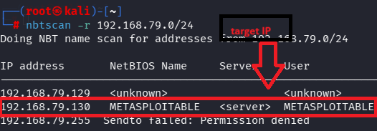

- Check the Service (nmap -sV 192.168.79.130):
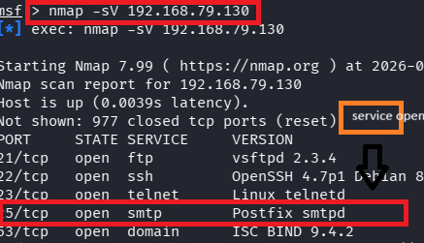
- Use of metasploitable via msf:

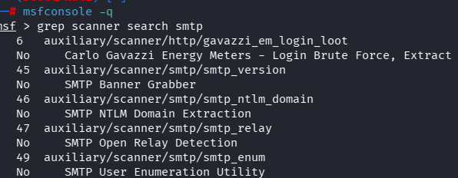
- Required tagert details:
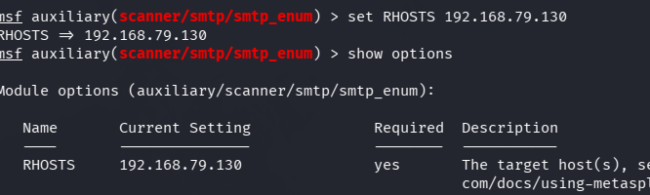

- Exploit: 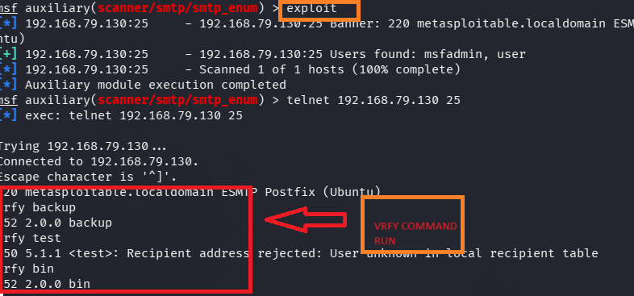

Remedy-

- Disable the SMTP VRFY and EXPN commands if they are not required.
- Configure the SMTP server to return generic responses that do not reveal whether a username exists.
- Restrict SMTP access to trusted networks or authorized hosts where possible.
- Keep the SMTP server (e.g., Postfix) updated with the latest security patches.
- Monitor SMTP server logs for unusual user enumeration or repeated verification requests and investigate suspicious activity.
References-
https://cve.mitre.org/cgi-bin/cvename.cgi?name=1999-0531&utm_source=chatgpt.com
https://nvd.nist.gov/

