Vulnerability Name- Default Credentials

Severity- high

Vulnerability description- The SSH service accepts default or known credentials, allowing an attacker to gain unauthorized remote access if the credentials have not been changed.

- Vulnerability
The OpenSSH service is configured with default or well-known credentials, allowing unauthorized users to authenticate successfully if the credentials have not been changed. This provides remote access to the system without requiring password guessing or exploitation of an OpenSSH software flaw.
- Attack
An attacker attempts to authenticate to the SSH service using known or default credentials.

Impacts-
- Unauthorized remote access to the system.
- Execution of commands as the authenticated user.
- Unauthorized access to sensitive files and directories.
- Potential privilege escalation through additional vulnerabilities.
- Increased risk of system compromise and lateral movement.
Steps to reproduce-
- Verify that the SSH service is running on the target host.
- Attempt authentication using the default credentials configured for the lab environment.
- Confirm that the SSH service accepts the credentials.
- Verify the authenticated session by checking the logged-in user.
Proof of concept-
- Target ip:
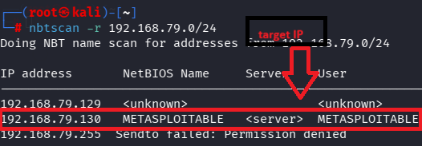
- Check for service status:
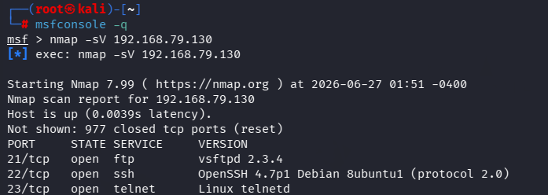
- Use of msf:
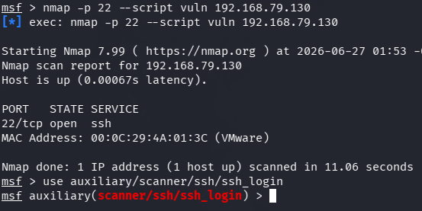
- Required target details:
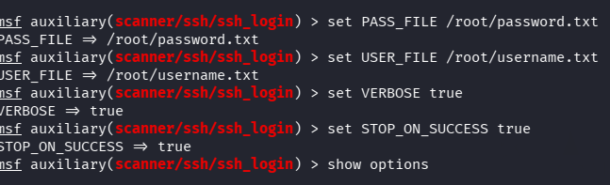
- Exploit:
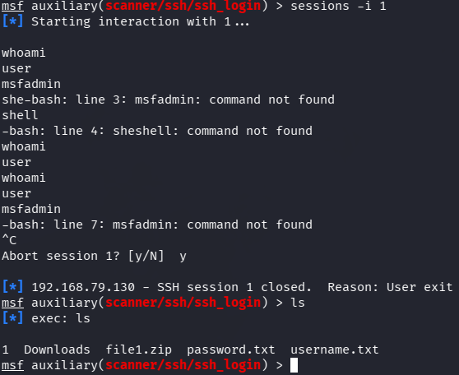

Remedy-

- Change all default usernames and passwords immediately.
- Enforce a strong password policy.
- Disable password-based SSH authentication where possible and use SSH public-key authentication instead.
- Restrict SSH access to trusted hosts or networks.
- Monitor SSH authentication logs for suspicious login attempts.
- Keep OpenSSH updated with the latest security patches
References-

https://www.youtube.com/watch?v=v8ARedkh6rw

