Vulnerability Name – Insecure Telnet Service (Cleartext Authentication)

Severity- high

Vulnerability description- The Linux system exposes the Telnet service, which transmits usernames, passwords, and all session data in plain text.

- Vulnerability
The protocol does not provide encryption, an attacker with the ability to observe network traffic may capture credentials or sensitive information. Modern best practice is to use SSH instead of Telnet for remote administration.
- Attack

Credential Guessing (Brute-Force Attack).

Impacts-
- Unauthorized access to the system using weak or default credentials.
- Exposure of sensitive information due to Telnet transmitting data in plain text.
- Potential compromise of user accounts.
- Increased risk of privilege escalation if an administrative account is compromised.
- Loss of confidentiality, integrity, and availability of the system.
- Attackers may use the compromised account as a foothold for further attacks within the network.
Steps to reproduce-
- Perform a network scan of the target host. (nmap 192.168.79.130)
- Verify that TCP port 23 (Telnet) is open.
- Confirm that the Telnet service is running.
- Perform an authentication assessment using authorized testing methods to evaluate whether weak or default credentials are accepted.
- Observe that the service accepts valid credentials, indicating weak/default authentication controls.
- Document the finding, including the affected host, service, and associated risk.

Proof of concept :
- Scan target ip: 192.168.79.130
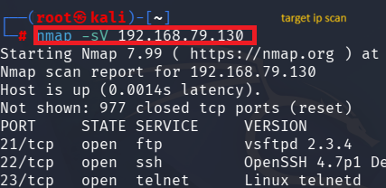

- Use of Metasploit by msfconsole:
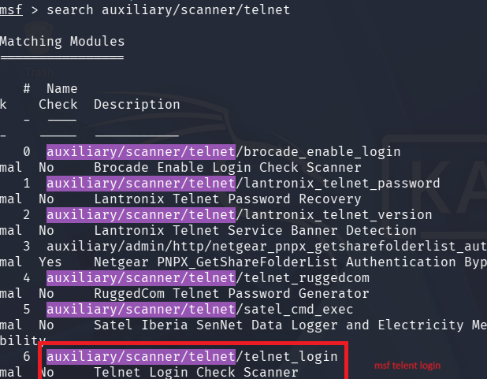

- Select path:

- Fill target host details:
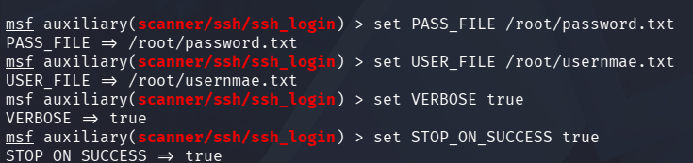

- Exploit:
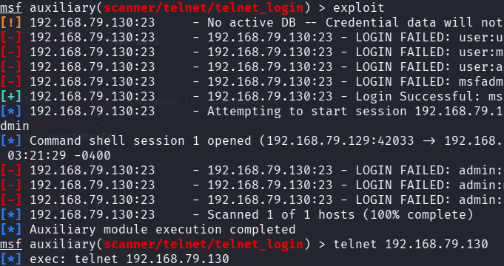

- result:

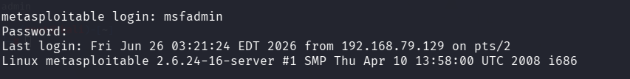

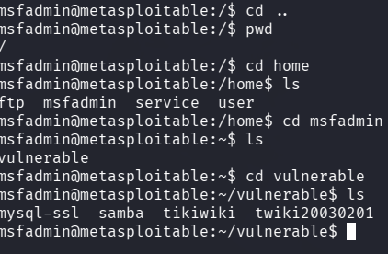

Remedy-

- Disable the Telnet service if it is not required.
- Replace Telnet with OpenSSH (SSH).
- Restrict remote administration to trusted networks.
- Use strong authentication and keep the system updated.
References-
https://www.google.com/search?q=linux+telnet+vulnerability&oq=linux
https://www.rapid7.com/db/modules/exploit/linux/telnet/telnet_encrypt_keyid/

