Vulnerability Name- UnrealIRCD 3.2.8.1 Backdoor Command Execution

Severity- critical

Vulnerability description- A malicious backdoor was inserted into the UnrealIRCD 3.2.8.1 source archive distributed between November 2009 and June 12, 2010. Systems built from the compromised archive allow an unauthenticated attacker to execute arbitrary commands remotely.

- Attack
Remote Code Execution (RCE).

Impacts-
- Remote command execution.
- Unauthorized remote access.
- Complete system compromise.
- Potential root-level access.
Steps to reproduce-
- Scan the target and identify the IRC service on port 6667.
- Verify that the server is running UnrealIRCD 3.2.8.1.
- Confirm that the installation matches the known backdoored release in an authorized lab.
- Validate the vulnerability using approved security testing tools.
- Record the findings as evidence.
Proof of concept-
- Scan for target:
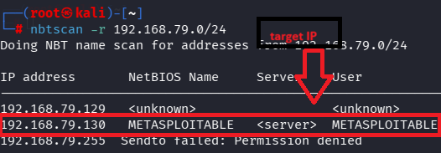
- Scan target:
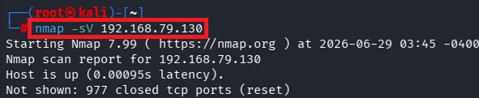
- Verify port:
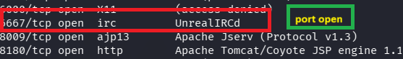
- Msfconsole:
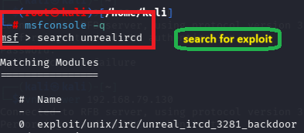
- Required target details:
- Exploit:
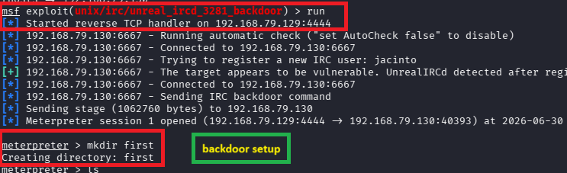

Remedy-
- Upgrade to a clean, supported version of UnrealIRCD.
- Replace any installation built from the compromised source archive.
- Restrict access to the IRC service with a firewall.
- Monitor for unauthorized activity.
- Apply the latest vendor security updates.

References-
https://www.rapid7.com/db/modules/exploit/unix/irc/unreal_ircd_3281_backdoor/

