Vulnerability Name- Legacy VNC Authentication Weakness

Severity- high

Vulnerability description- A legacy VNC service using the RFB 3.3 protocol was found on the target system. The assessment showed that the service relied on weak authentication controls, allowing unauthorized access under weak security conditions.

- Attack
Unauthorized Remote Desktop Access.

Impacts-
- Unauthorized remote desktop access.
- Exposure of sensitive applications and data.
- Potential privilege escalation.
- Complete system compromise if administrative access is obtained.
Steps to reproduce-
- Scan the target and identify the VNC service on port 5900.
- Verify that it is using RFB Protocol 3.3.
- Assess the authentication mechanism in an authorized lab.
- Confirm that authentication succeeds under weak security conditions.
- Verify access to the remote desktop.
Proof of concept-
- Scan for target:
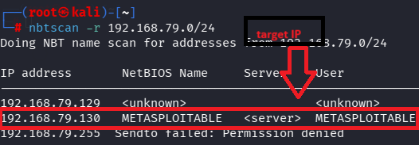
- Scan target:
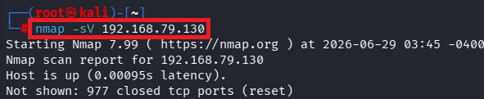
- Verify port:
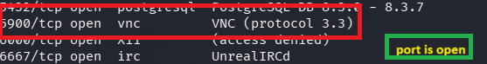
- Msfconsole:
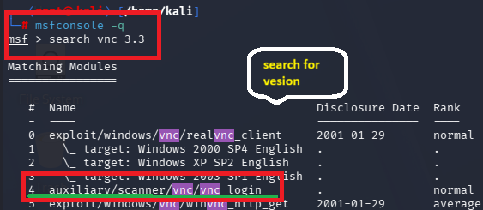
- Required details:
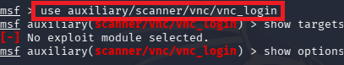
- Exploit:
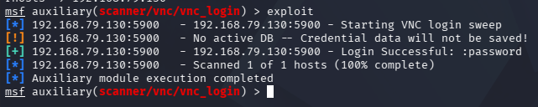
- Access to remote desktop:
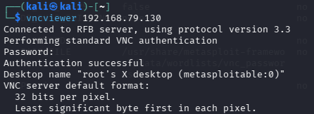
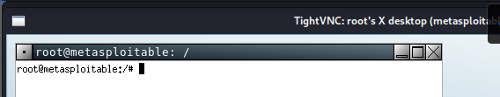

Remedy-
- Disable VNC if it is not required.
- Upgrade to a modern VNC implementation.
- Enforce strong, unique passwords.
- Restrict VNC access using firewalls or a VPN.
- Avoid exposing VNC directly to untrusted networks.

References-
https://medium.com/@getroutenet196/analyzing-a-legacy-vnc-authentication-weakness-in-a-controlled-lab-environment-c0b45fad41ab

