Vulnerability Name- vsftpd 2.3.4 vunlerability

Severity- critical

Method -

Vulnerability description - vsftpd 2.3.4 Backdoor is a vulnerability that can be exploited as an attack:

- Vulnerability
A compromised release of vsftpd 2.3.4 contains a backdoor that can allow unauthorized remote access to an affected system, potentially leading to complete system compromise.
- Attack
Remote Code Execution (RCE).
- Attack Vector
Network-based attack via the FTP service (TCP Port 21).

Impacts-
- Unauthorized access to the affected system
- Potential remote code execution
- Full system compromise
- Theft of sensitive data
- Modification or deletion of files
- Installation of malware or backdoors
- Service disruption or downtime
- Loss of confidentiality, integrity, and availability (CIA)
Steps to reproduce-
- Identify the target host running an FTP service.(nmap -sV target)
- Enumerate the FTP service version through banner information. (open, closed, filtered-may be open or closed)
- The service is running vsftpd version 2.3.4.
- Compare the identified version against known vulnerabilities.
- Record the affected host, service, port, and version information.
- Assess the risk and recommend remediation.

Proof of concept-

- Check ip of Metasploit machine : command -ifconfig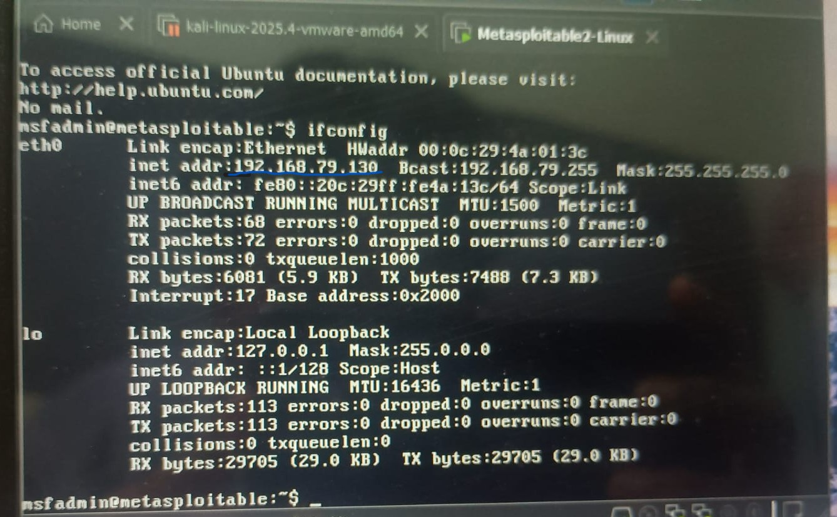
- Scan ip and service version: 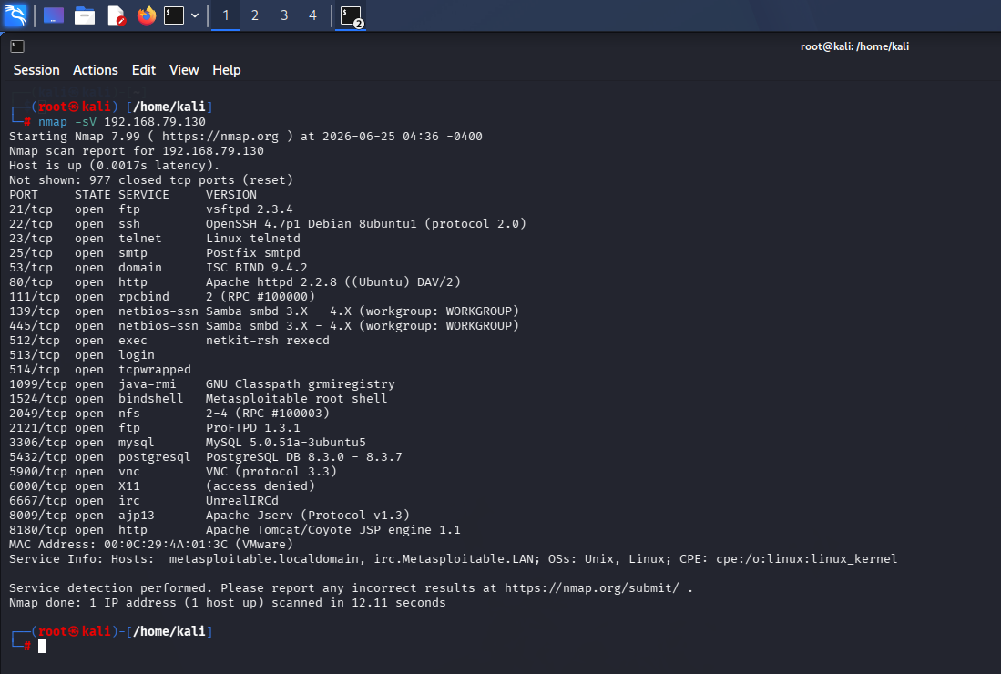
- Use of Metasploitable 2 by msfconsole: 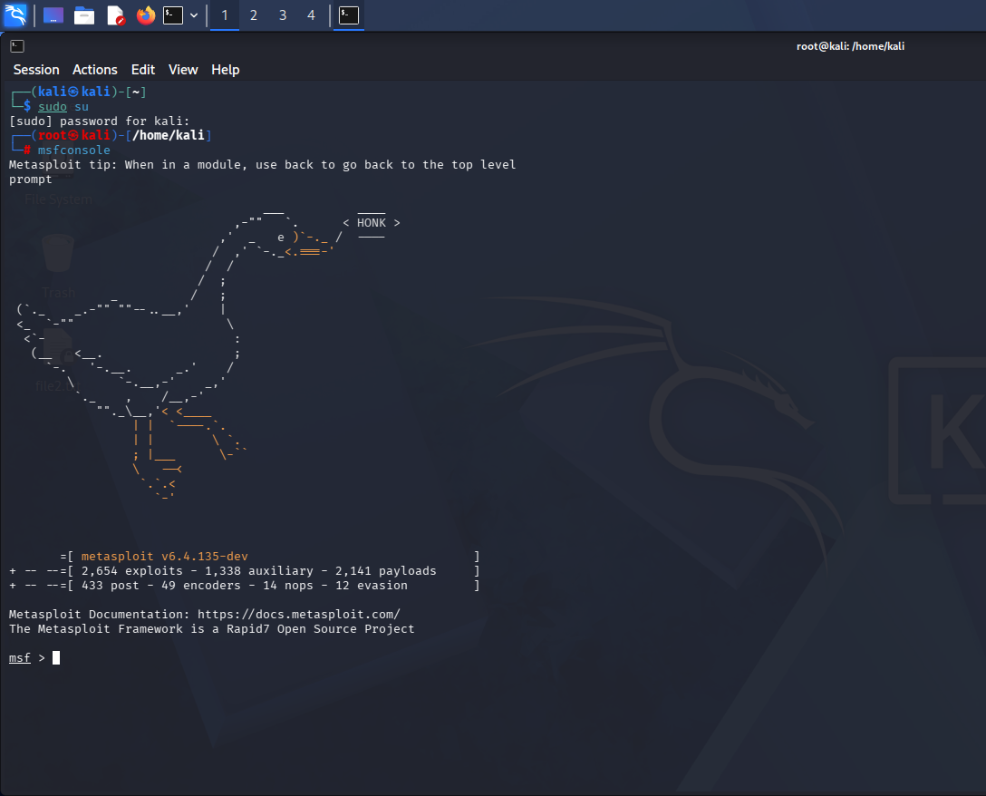
- Select path: 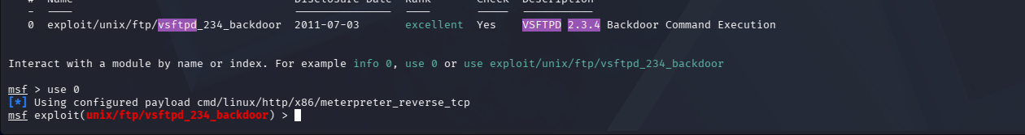
- Show options: 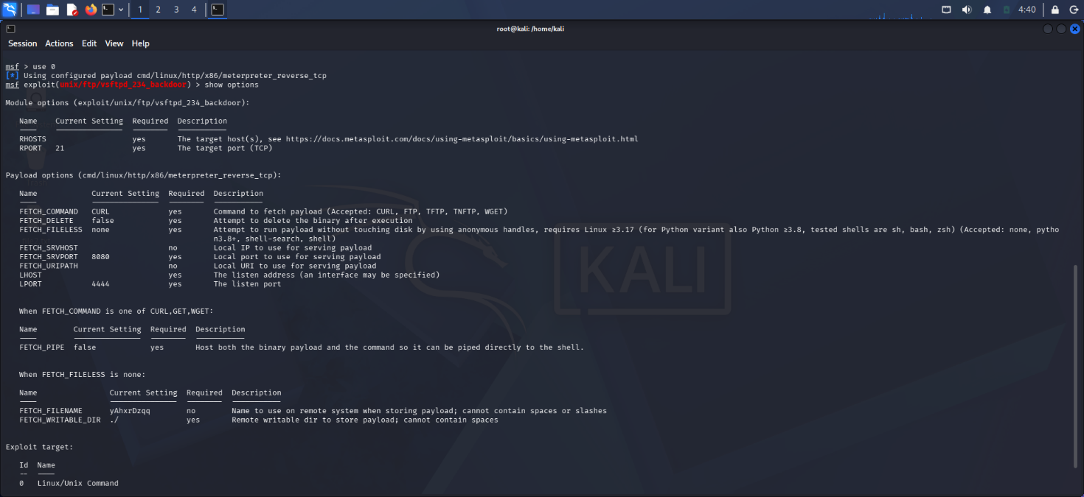
- Fill target host details:
- Exploit:
- For e.g. make directory and delete it :
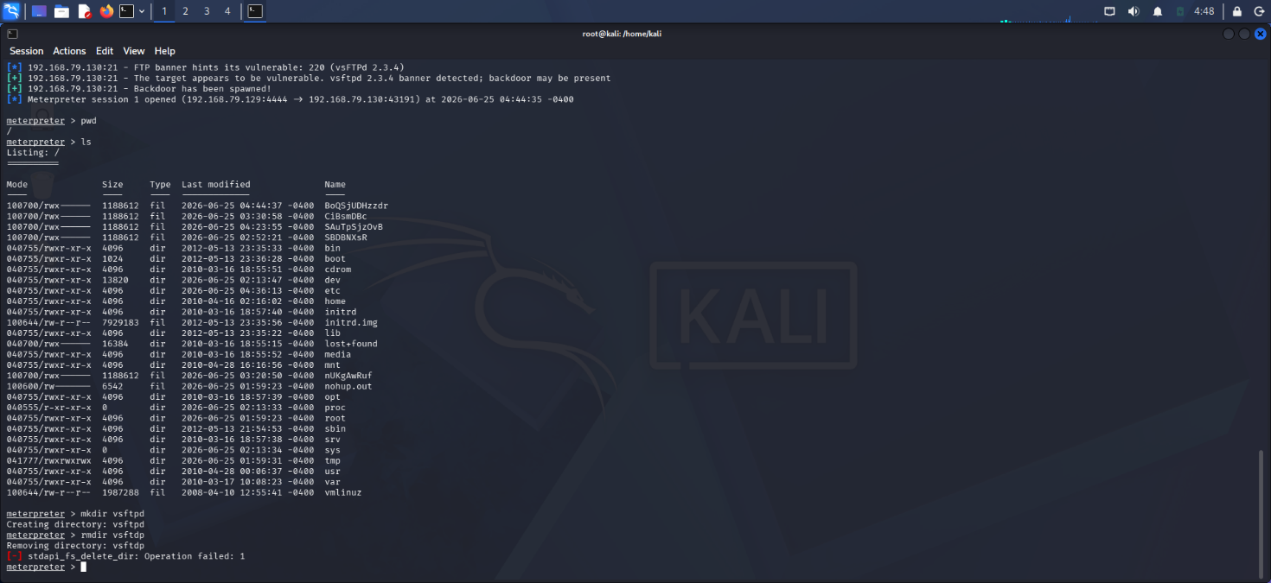

Remedy-

- Upgrade the vulnerable version of vsftpd.
- Install a clean, trusted version obtained from official repositories.
- Verify package integrity using vendor-provided checksums or signatures.
- Review system logs for indicators of compromise.
- Restrict FTP access to authorized users and networks only. (white listing)
- Apply security updates and maintain a regular patch-management process.
- Consider using secure alternatives such as OpenSSH SFTP instead of plain FTP where possible.
- Conduct a security review of any system that was running the affected version.

References-
https://www.rapid7.com/db/modules/exploit/unix/ftp/vsftpd_234_backdoor/
https://nvd.nist.gov/vuln/detail/CVE-2011-2523.

