Vulnerability Name- Xorg X11 Server SUID Logfile Privilege Escalation

Severity- critical

Vulnerability description- A flaw in the Xorg X11 Server allows a local authenticated user to overwrite arbitrary files through insecure handling of log file paths. If the Xorg binary has the SUID root bit set, an attacker can escalate privileges and obtain root access.

Attack-
Local Privilege Escalation.
Impacts-
- Local privilege escalation.
- Root access.
- Full system compromise.
- Unauthorized modification of system files.
Steps to reproduce-
- Identify a vulnerable Xorg X11 Server installation.
- Verify that the Xorg binary has the SUID permission enabled.
- Confirm that a local user session exists.
- Validate the privilege escalation in an authorized test environment.
- Verify that elevated privileges are obtained.
Proof of concept-
- Scan for target:
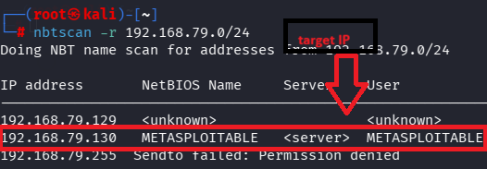
- Scan target:
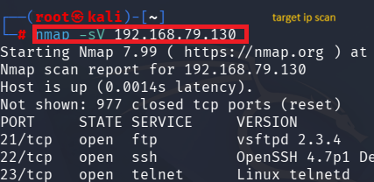
- Verify port:

- Use of msfconsole:
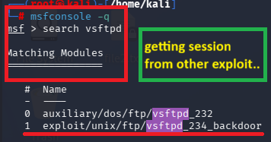
- Required target details:
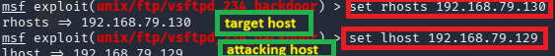
- Checking module for exploit:
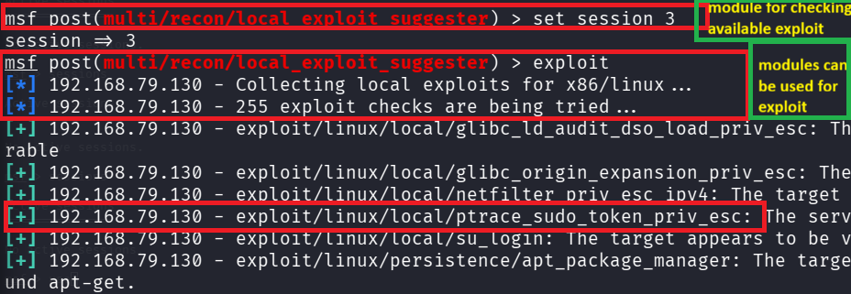
- Exploit:
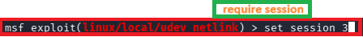
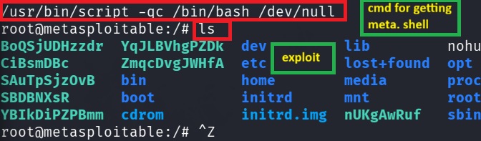

Remedy-
- Upgrade Xorg to a patched version.
- Remove unnecessary SUID permissions from the Xorg binary.
- Apply the latest operating system security updates.
- Restrict local user access.

References-
https://www.rapid7.com/db/modules/exploit/multi/local/xorg_x11_suid_server/?utm_source=chatgpt.com
https://cve.mitre.org/cgi-bin/cvename.cgi?name=CVE-2018-14665&utm_source=chatgpt.com

