

**College of Engineering**

**COMP 491 – Computer Engineering Design**

**Technology Document**

**KUPEP (Protecting Exam Platform)**

**Spring 2021**

**Participant Information:**

|  |  |  |  |
| --- | --- | --- | --- |
| **Name** | **ID** | **Email** | **Phone** |
| Umut Günçer | 60598 | uguncer16@ku.edu.tr | +90 530 944 84 94 |
| Yiğit Çırak | 49730 | ycirak14@ku.edu.tr | +90 543 879 99 93 |
| Batuhan Acar | 60186 | Bacar16@ku.edu.tr | +90 532 301 48 62 |
| Taluhan Öneş | 60035 | Tones16@ku.edu.tr | +90 537 717 74 12 |

**Project Advisor:**

Serkan Çil

**Table of contents**

Introduction 3

1. Architecture 3

Internet Connection (Before): 3

Step 1: Put a Proxy server in between the exam taker PCs and the Internet Provider. 4

Step 2: Develop and place the examiner application so that it can communicate with the Proxy Server 4

Step 3: Develop and configure the exam takers software. 5

References 6

**Table of FIGURES**

Figure 1: Internet connection from the Lab – The current situation 3

Figure 2: Internet connection architecture after placing the custom Proxy Server 4

Figure 3: Internet connection architecture after integrating the custom Proxy Server with the Examiner Program 4

Figure 4: Final Architecture 5

# Introduction

We will use Java and socket programming skills to develop our application. The main research area for our app was how to disable and enable internet connection. So, we did some research on how to achieve this goal. We have found some available solutions such as [1]:

1. Block Websites from Router's Web Interface : This option is to block the internet sites directly from our university router’s web interface but since there will be no integration with our application and the router, all the work should be done manually and more over by someone who knows how to configure the router so we passed on this option.

2. Block Websites by Editing Hosts File : Windows operating systems have a hosts file under the Systems directory that enables us to put fake local IP’s for corresponding names, thus disabling them but there is no option to disable the internet for all of the sites, so this option was not suitable for us also.

3. Block Websites using URL Blocker: There are some commercial programs that can block the outgoing traffic, but since this solution would not have any integration with our solution we also passed on this option as well.

After doing more research we decided to use a custom proxy server. A proxy server is a server application or appliance that acts as an intermediary for requests from clients seeking resources from servers that provide those resources.[2] But we need a proxy server that can communicate with our examiner program so we decided to customize a Java written proxy server so that the server would take commands from our examiner program by socket programming and will control the internet traffic accordingly.

# Architecture

## Internet Connection (Before):

Currently all the PCs (both the examiner and the exam taker PCs) are connected to internet via the universities’ Internet Provider as can be seen in Figure 1: Internet connection from the Lab – The current situation .

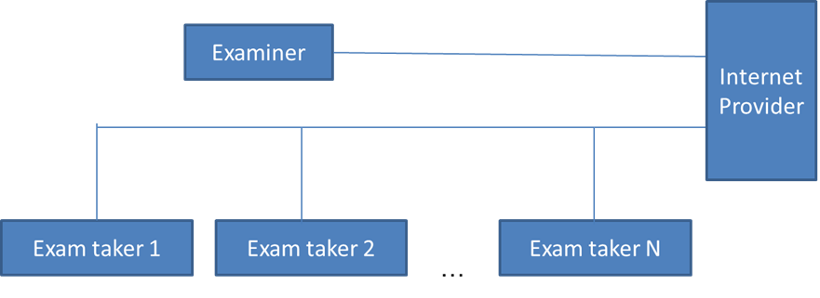

Figure 1: Internet connection from the Lab – The current situation

## Step 1: Put a Proxy server in between the exam taker PCs and the Internet Provider.

We will develop this Proxy server in Java, there are already some Java Proxy codes on the internet, we will enhance them with the functionality to communicate with the examiner program. Then we will configure all the exam taker computers to use this Proxy for their internet connection. The examiner will still reach the internet provider directly. The architecture after this step is shown in Figure 2: Internet connection architecture after placing the custom Proxy Server

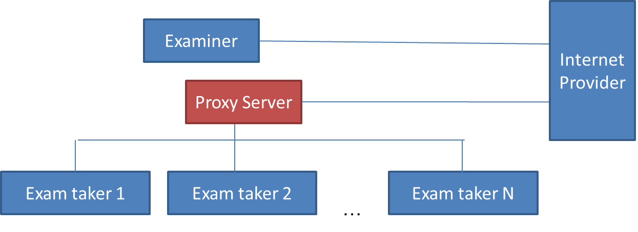

Figure 2: Internet connection architecture after placing the custom Proxy Server

## Step 2: Develop and place the examiner application so that it can communicate with the Proxy Server

This step will enable us to send commands for the purpose of enabling and disabling internet connections. The architecture after this step is shown in Figure 3: Internet connection architecture after integrating the custom Proxy Server with the Examiner Program.

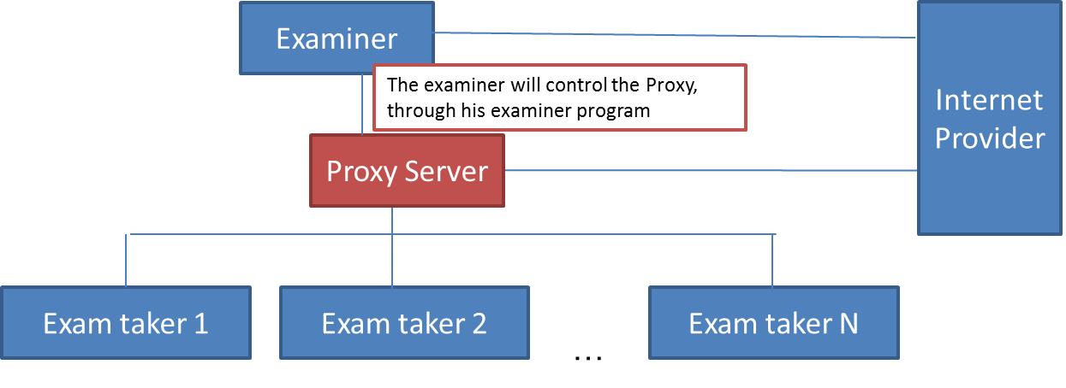

Figure 3: Internet connection architecture after integrating the custom Proxy Server with the Examiner Program

## Step 3: Develop and configure the exam takers software.

The exam takers application will communicate with the examiner software for all the exam operations except for the internet settings. The internet settings will be broadcasted to the Proxy Server by the examiner and the exam taker computer’s operating systems will be configured to use this proxy server. Thus, the internet settings will be in effect for the exam taker PCs. The final architecture after accomplishing this task can be seen in Figure 4: Final Architecture

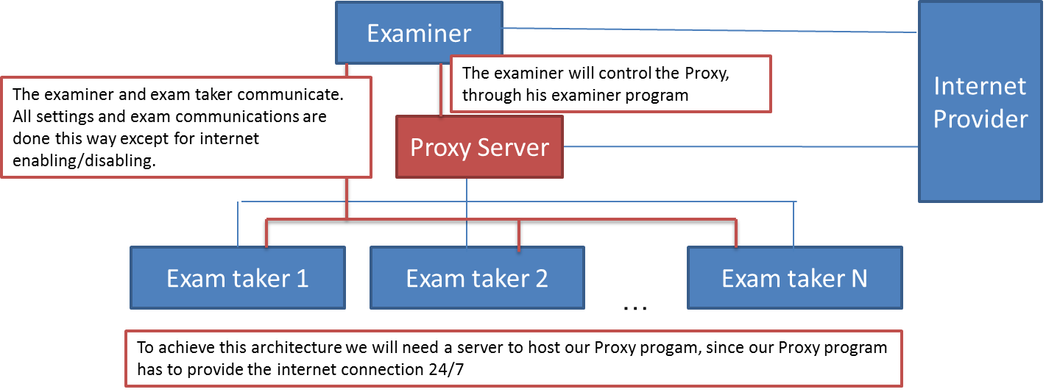

Figure 4: Final Architecture

References

**[1]** How to Block Websites on Computer Windows 10?, Retrieved March 10, 2021, from

<https://www.iseepassword.com/block-websites-on-windows-10-computer.html>

**[2]** World-Wide Web Proxies, Ari Luotonen, April 1994, Retrieved March 11, 2021, from

<https://courses.cs.vt.edu/~cs4244/spring.09/documents/Proxies.pdf>