

**College of Engineering**

**COMP 491 – Computer Engineering Design**

**User Interface**

**KUPEP (Protecting Exam Platform)**

**Spring 2021**

**Participant Information:**

|  |  |  |  |
| --- | --- | --- | --- |
| **Name** | **ID** | **Email** | **Phone** |
| Umut Günçer | 60598 | uguncer16@ku.edu.tr | +90 530 944 84 94 |
| Yiğit Çırak | 49730 | ycirak14@ku.edu.tr | +90 543 879 99 93 |
| Batuhan Acar | 60186 | Bacar16@ku.edu.tr | +90 532 301 48 62 |
| Taluhan Öneş | 60035 | Tones16@ku.edu.tr | +90 537 717 74 12 |

**Project Advisor:**

Serkan Çil

**Table of contents**

Examiner’s Panel 3

Exam Taker 8

Similar applications we have found 11

References 12

# Examiner’s Panel

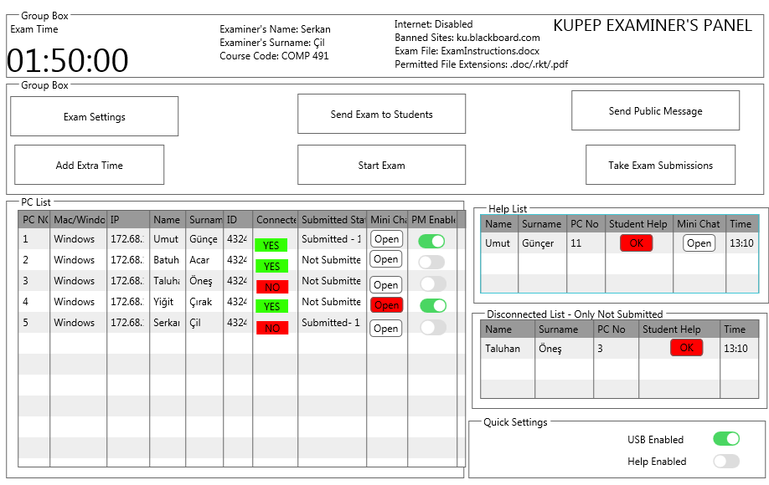



When examiner opens KUPEP, he will see this figure by default.

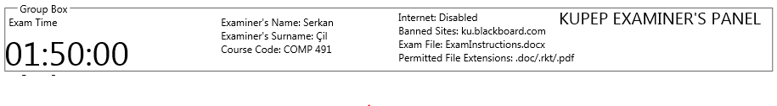

When examiner sets the “Exam settings”, all this information will be updated like this.

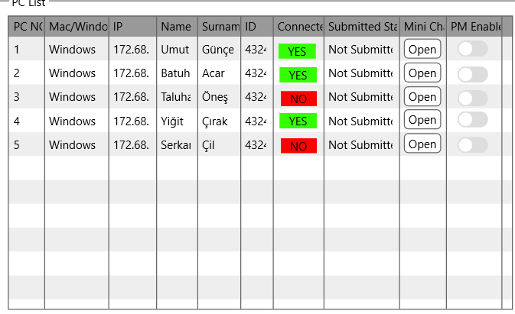 When students start to connect, examiner will see who has connected and not connected from here. “Submit Status” will look like “Not submitted” by default . Mini chat has an “Open” button and will look like this by default. “PM Enable” which is private message enabling button will be closed by default.

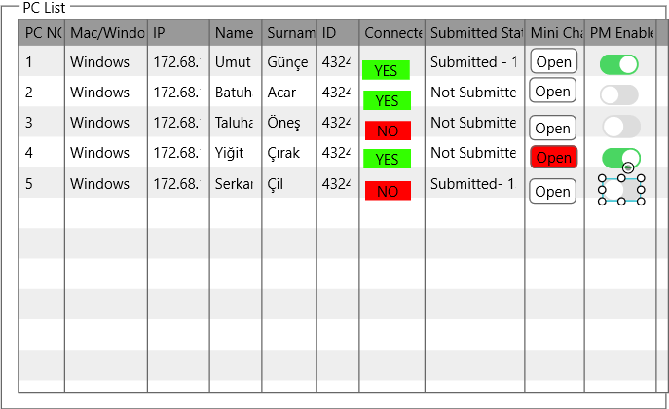During the exam, examiner will be able to see who is connected or not. Examiner can see the “Submit Status” in two ways. First, he can see “not submitted” and second he can see “submitted- (time submitted)”. For instance, Ahmet has submitted at 13:15, it will be seen as “submitted-13:15”. If examiner lets student use private message , students will be able to text to examiner. If a student texts to examiner, “open” button will be in red and it means examiner has a message from student. “pm enabled” will be green if examiner enables the private message for a specific student.

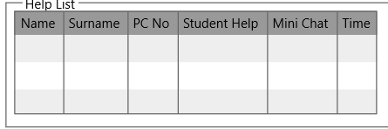**Help List**:

Examiner will be seeing the help list like this by default.

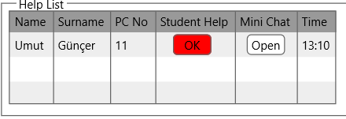

When a student presses “send help” button, it will appear in the help list. Examiner will be able to see his computer number, name and surname and the time he wanted help. Examiner can press “ok” in red to notify that the help message is received. He can open mini chat and write to student or by finding the computer number he can enable “pm enable” section. Another alternative, he can go next to the student and talk with student face to face. After examiner presses “ok” will disappear and student will still remain in the help list.

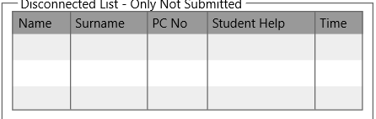After the exam starts, this part will be active. During the exam, if a student who has not submitted a thing lost his connection, examiner will be able to see it from here. This means student has a problem with his computer since this program can be closed by logging out your account or shutting down the computer. Admin will prevent the usage of task managers during the exam. So, examiner can go next to student.

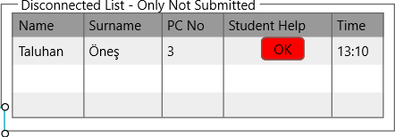

If a student has not submitted a work and appears to be disconnected during the exam, it will be seen like this. Again, a button “ok” in red will appear and examiner will press it. Because all the actions will be logged, and examiner must help student for changing the computer in the lab and it can be watched by the logs.

**Examiner panel**:

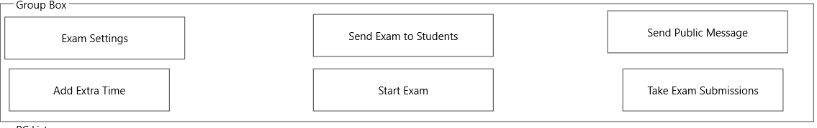

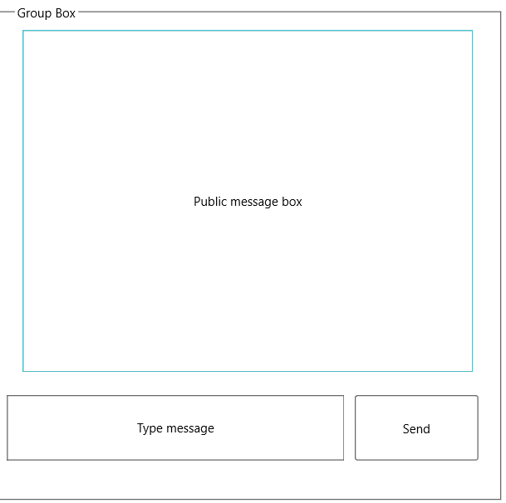Examiner can adjust the exam settings before the exam and during the exam. He can add extra time during the exam. After he adjust the exam settings, he will be able to use “send exam to students” and “start exam”. When examiner uses these two buttons, he will be asked for “are you sure you want to send exam to students” and “are you sure you want to start exam”. He can use “send public message” to make announcements during the exam. Examiner will be able to “take exam submissions” after the exam is finished.

**Send public message**:

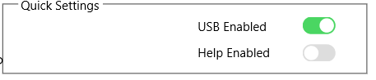Examiner will send all students any necessary announcements or changes during the exam

Examiner will be able to change some settings during the exam.

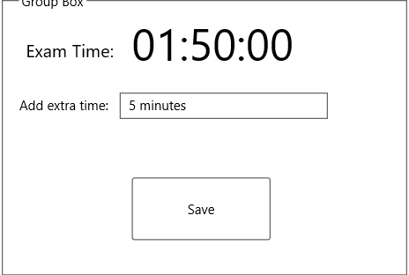**Add extra time**:

When examiner presses “add extra time”,

He can write the time; he wants to add more by writing it manually and then he will press “save” button. After pressing the “save” button, it will ask for “are you sure you want to save”

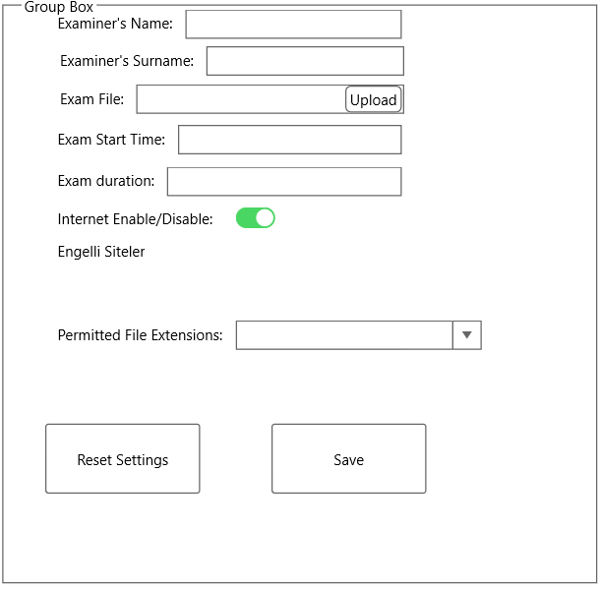**Exam settings**:

When examiner presses “Exam setting” button, this page will appear. Examiner will write his name, surname. This is because, in our university, generally professors do not come to exam lab and send his assistants. It is important to know who is starting and adjusting the exam. Examiner will be able to upload the exam file. He will also set the exam start time and exam duration. “Internet Enable/disable” will be open by default and examiner will close it or leave it open. Examiner will prevent students to enter the sites by writing the sites manually. He will choose the file extensions student will submit. He will be able to reset settings and save the exam settings. When he presses “save” button, it will ask “are you sure you want to save” to check whether examiner forgot something or not.

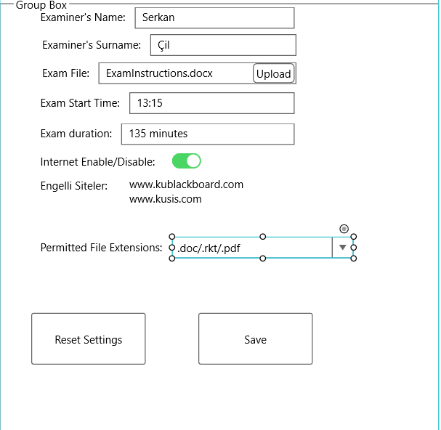After the examiner fills the exam settings, it will be seen like this. “Permitted File Extensions” will be seen .doc/.rkt/.pdf like this. Examiner will be able to choose more than one extension.

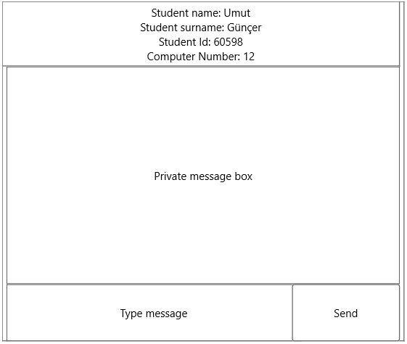

**Mini chat**:

Examiner will see this chat screen by pressing “open” in the “Mini Chat” section. He can text to any student whenever he wants. He can see the student name, surname, id and computer number. All the new and old messages will be seen in the “private message box”.

# Exam Taker

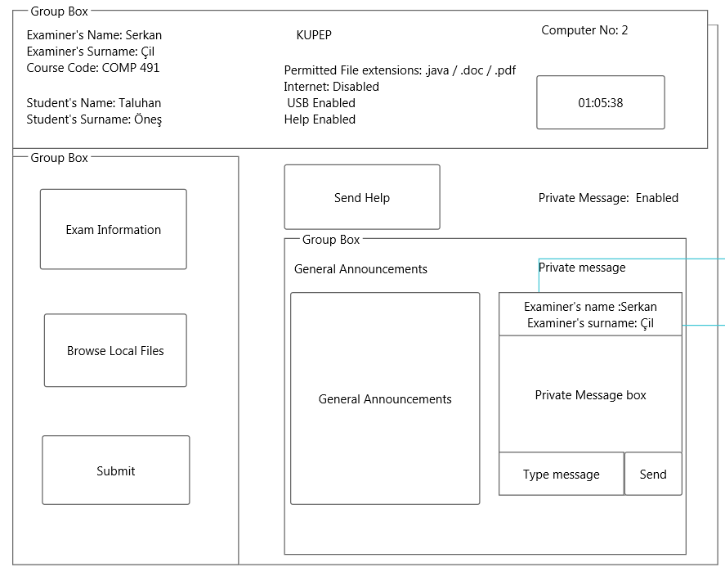

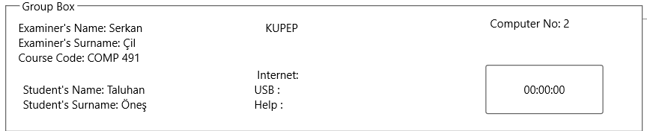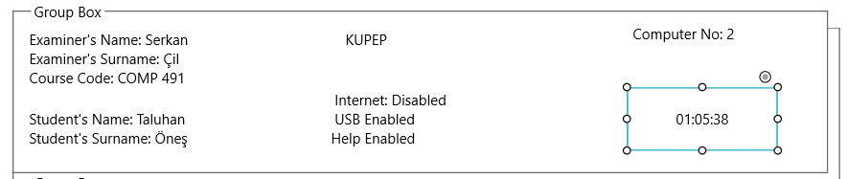Examiner’s name and surname will be seen, and student’s name , surname and computer number will be seen by default. Internet, usb, help and timer will be updated when examiner sets the exam settings and start the exam.

During the exam, internet, usb, help and timer will be seen like this.

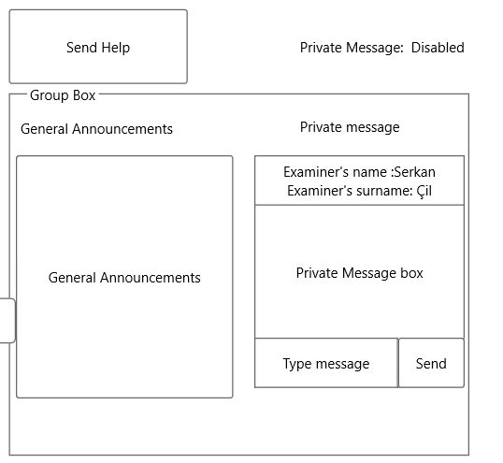

“General Announcements” which is public message will be seen like this. Examiner’s name and surname will be seen by default. Student will be able to see whether examiner let him use private message by looking “private message: disabled”. Student will be able to demand help by pressing “send help” button. Student can text to examiner by writing his message to type message box and then send it. All the new and old messages will be seen

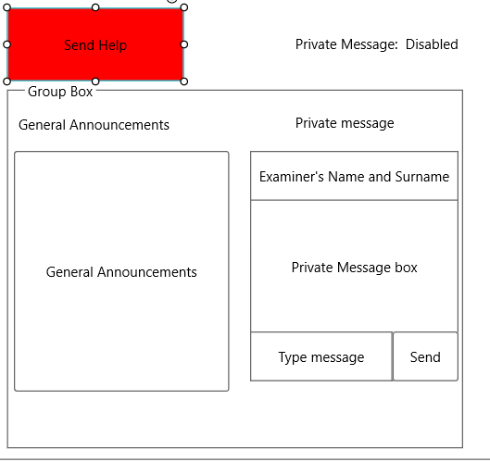

If a student presses “Send Help” button, the button will be red. Examiner will see who wants help in his panel.

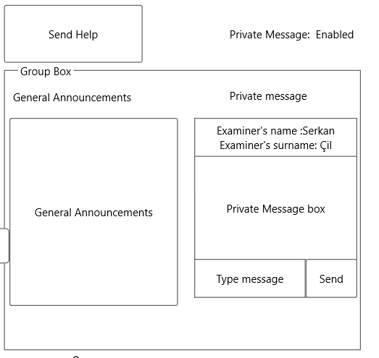

When the button will again turn to its default color from red, it means examiner saw the help message and by this way, student will understand whether his examiner saw his help message or not. As we can see in this figure, “private message: Enabled”, private message turned to enabled from disabled. Now, students will be able to send text. Another situation, “private message: disabled”, private message could be stayed like this and examiner might help student by going next to student.

**Student panel:**

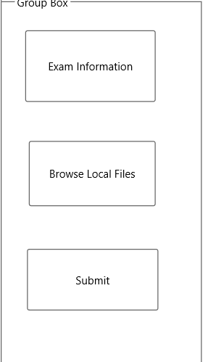Students will see the exam by pressing “Exam Information” and when they finish their work, they can choose the file by pressing “Browse Local Files”. After they choose the file, they can submit their work by pressing “Submit” button. “Submit” button will ask for “are you sure you want to submit” to check students whether they have chosen the right files.

# Similar applications we have found

Since most of the exam software’s are online based, which includes exam questions and answers to be loaded into the system, we were not able to find more than one freely available offline exam software to examine and compare the user interface.

The only one similar software we have found was the SimExams software. The Computer Based Test Software combines the CBT Author and CBT Exam Engine modules to create centralized question database which can be populated and edited by various Authors.

The Author Engine enables an author to perform several activities including Creating, editing, and/or deleting a test/Groups and Candidate profiles, Questions. [1]

**Examiner Side:**

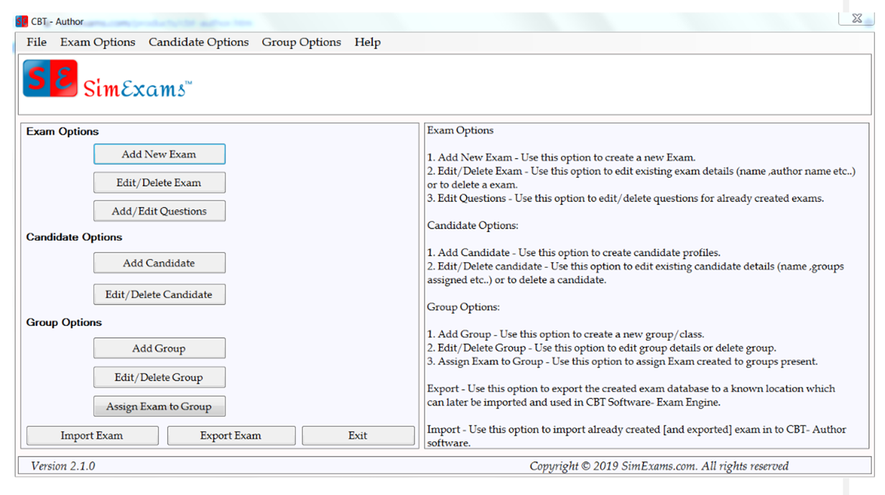

**Configurable exam options**

Number of questions in the exam (or quiz): The total number of questions that should be available in each Exam

Random or sequential : Instructor can select if questions present in the DB should be presented to candidate in sequential or random order. Feature for randomizing of answer options for each question is also available.

Exam Time : Instructor can set the Time allowed to the candidate for completing the exam

Pause Timer : Instructor can allow/deny pausing of the exam timer by the candidate while taking exam.

Question Bookmaking : Instructor can allow/deny bookmaking of the questions. Bookmarked questions can be viewed separately during the exam. Candidate can also view ONLY bookmarked questions after the exam.

**Ups:**

* Simple interface, not confusing
* Import and export features enable the examiner to re-use an exam setting
* Feature for randomizing of answer options for each question prevents cheating
* Add/Edit questions enables examiner to change or add new stuff easily.

**Downs:**

* Limited features,pausing can be problematic it is not definite on how much time the examiner will pause the exam
* Edit/Delete candidate is in the same section, accidentally during the exam or before the exam can delete one of the candidates.
* Examiner will make a group and wait for exam takers to join group. Then he will assign the exam. This is waste of time for examiner and hard to get used to the program for exam takers.
* Help button for Examiner is confusing and useless. If a problem occurs, examiner should ask for help of the IT department of university.

**Exam Taker side:**

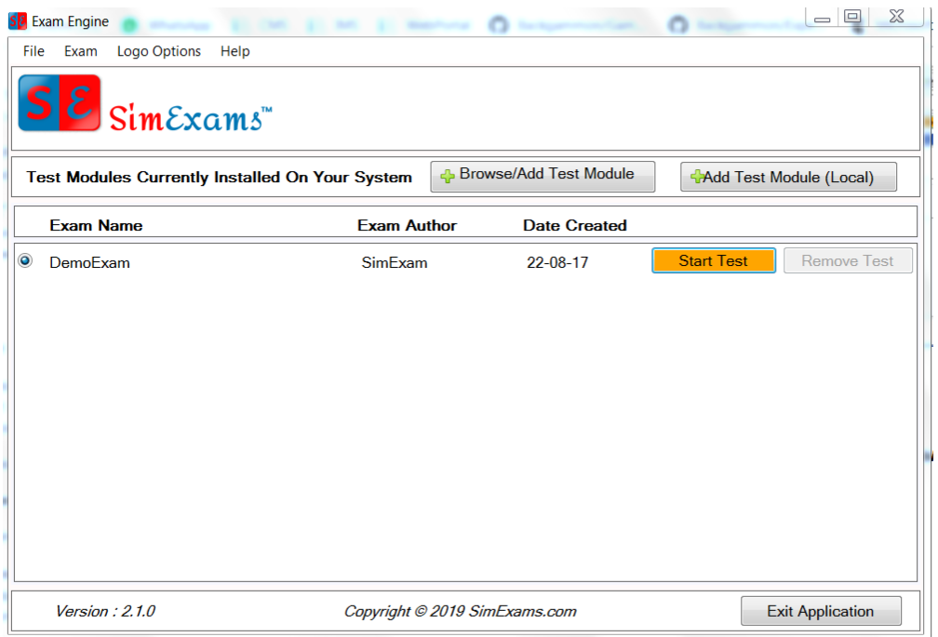

**Ups:**

* Simple Interface
* Exam taker can start the test by himself whenever he wants. No limited time to start the test.
* There is an exit application button

**Downs:**

* No timer for the exam taker
* No communicationfeature
* Help menu is confusing
* Exam taker will not be able to see new announcements
* Exam taker will not be sure what if the work is submitted correctly
* Exam taker first download the test from “brows/add test module”, then starts the test. He can choose the wrong one or will have problems to find the test.
* There is no student name or id, another person can enter the exam instead of the principal student.

References

**[1]** Offline Computer Based Exam Software - Offline Test Maker, Retrieved March 16, 2021, from

<https://www.simexams.com/products.htm>