1. Prototype screen

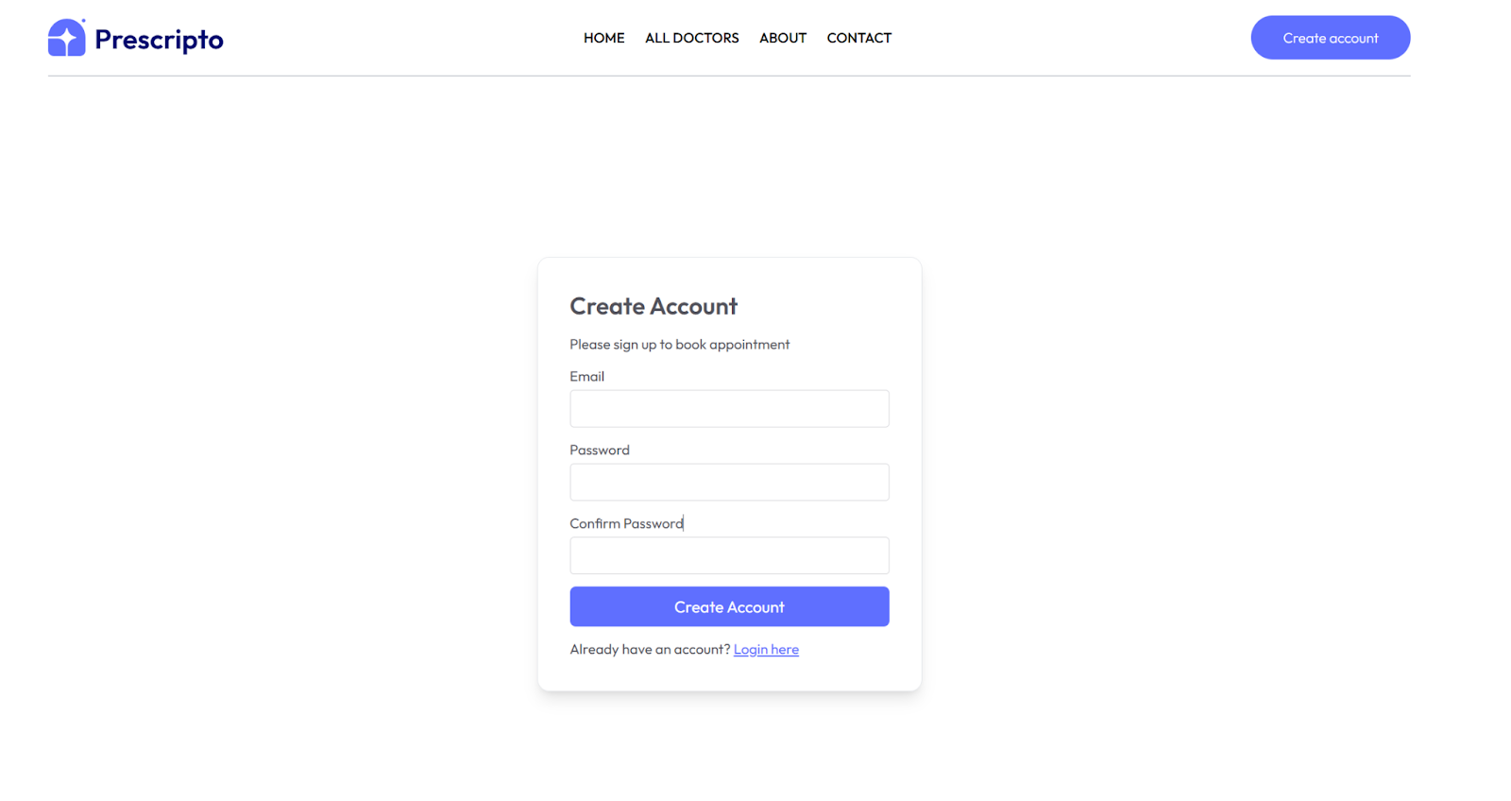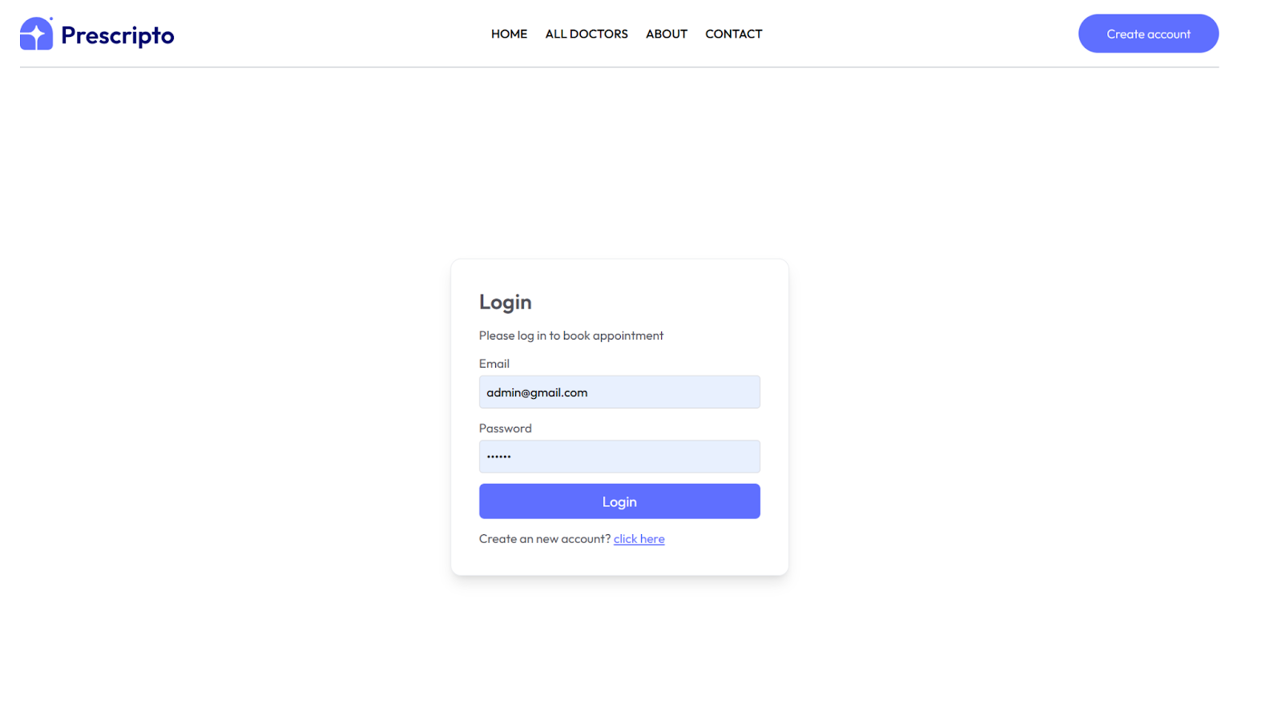

2.Test Design and test materials

**Test Objective**  
To evaluate how easy and clear the login and registration processes are for both new and returning users.

**Participants**  
3 university students and 2 older adults (ages 55–65).

**Test Tasks**

1. Sign up for a new account using your name, email, and password.
2. Log out and then log in using the account you just created.
3. Try logging in with an incorrect password and observe the system’s response.
4. Use the "show/hide password" button if available.
5. Click on "Forgot Password" and explain what you expect to happen.

**Test Script**  
"Thank you for participating. Today, you'll be testing the login and registration features of this app. Don't worry about doing anything wrong — we're testing the system, not you. Please speak your thoughts out loud as you go through the tasks."

**Post-Test Survey Questions**

1. Was the sign-up process easy to understand?
2. Did you have any trouble logging in?
3. Was anything confusing or unclear?
4. Did the login screen feel trustworthy and secure?
5. Do you have any suggestions to improve these features?