**Nguyễn Trọng Bách**

**20226014**

**ICT 01-K67**

**LAB 6: BUILDING A SMALL SIGNAL AMPLIFIER CIRCUIT**

**1. Objectives**

* Understand the operating principles of a bipolar junction transistor (BJT).
* Know how to build and analyze a common-emitter small signal amplifier circuit using a bipolar junction transistor.

**2. Theoretical basis - Small signal amplifier circuit**

The bipolar junction transistor has many practical applications depending on the polarization of the two p-n junctions (B-E and B-C). There are two basic applications of the bipolar junction transistor: switching circuit and small signal amplifier circuit. In this practical lesson, students will work with the small signal amplifier circuit.



*Figure 1 presents the circuit diagram of a common-emitter small signal amplifier using an npn bipolar junction transistor*

* The transistor must be polarized to operate in the forward-active mode to amplify the signal (voltage and current).
* The polarization for the transistor (to set the operating point Q) is performed using the resistor network R1, R2 (as on the diagram) and the DC source VCC.
* The resistor RE is used to keep the operating point Q stable, less dependent on the variation of the current gain factor β. However, RE reduces the voltage gain factor.
* The capacitors C1, C2 serve to filter unwanted DC components from the input signal (Vin) and the output signal (Vout); The capacitor CE will become a short circuit with a high-frequency signal (eliminating the impact of RE) so it has the effect of increasing the voltage gain factor.
* Feedback: leads the output signal back to the input
  + Negative feedback: the output voltage returns in phase opposition with the input
  + Positive feedback: the output voltage returns in phase with the input

The formula for calculating the voltage gain of a common-emitter amplifier is as follows:

* For low-frequency signals: , where rere​ is the internal resistance of the B-E junction (a few ohms).
* For high-frequency signals:
* **Example of designing a common-emitter small signal amplifier circuit**

When analyzing DC to find the operating point Q of the transistor, according to Thevenin’s theorem, the resistor network (R1, R2) in the circuit diagram in Figure 1 is equivalent to a circuit consisting of a resistor (RTH) and a voltage source (VTH) connected in series. Switching to analyzing the equivalent circuit simplifies the DC analysis problem.



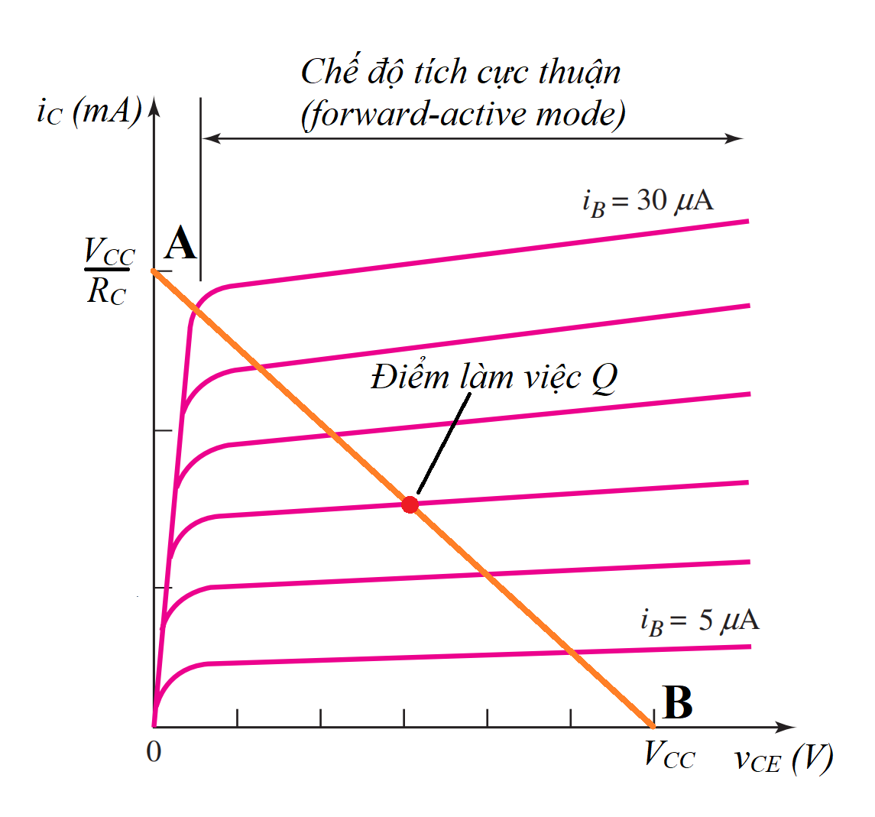

Suppose the circuit diagram in Figure 1 has the following parameters: VCC = 10 V; Vin = V0sin(2πft), where V0 = 1 V and f = 1 kHz; C1 = C2 = CE = 22 nF; β = 300; VBE (on) = 0.7 V.

* To ensure stable operation of the amplifier mode, the operating point Q should lie at the midpoint of the RC load line (the straight line connecting two points with coordinates A(Vcc/RC, 0) and B(Vcc, 0) on the V-A characteristic curve in Figure 2). Then, V_CE=1/2 V_CC=5V and according to Kirchhoff's law, I_CQ≈ (Vcc-V_CEQ)/(RC+RE)=(10V-5V)/(1000Ω+300Ω)=3.76mA.
* Typically, RC and RE are chosen to have small values (around a few hundred ohms), for example: RC= 1kΩ, RE= 330Ω.
* With β=300, I_C≈I_E. Therefore, we can calculate V_RE=3.76mA×330Ω=1.24V and I_BQ=I_CQ/β=3.76mA/300=12.5μA.
* Applying Kirchhoff's law, we have I_BQ= (V_TH-V_(BE(on)))/(R_TH+(1+β)RE), where V_TH= R_2/(R_1+R_2) Vcc and R_TH= (R_1 R_2)/(R_1+R_2) (according to Thevenin's theorem).
* Typically, R_TH is chosen to be approximately 0.1(1+β)RE=9.93kΩ. Therefore, we can calculate V_TH = 2.07V.
* Solving the system of equations for V_TH and R_TH, we get R_1=47.97kΩ and R_2=12.52kΩ. Note that in practice, approximate resistor values can be used, for example: R_1=47kΩ and R_2=12.5kΩ.

## ****3. Exercise****

Exercise 1. Construct and analyze a small signal Emitter-Common amplifier circuit according to the diagram in Figure 1.



*Hình 1. Mạch khuếch đại tín hiệu nhỏ E-chung.*

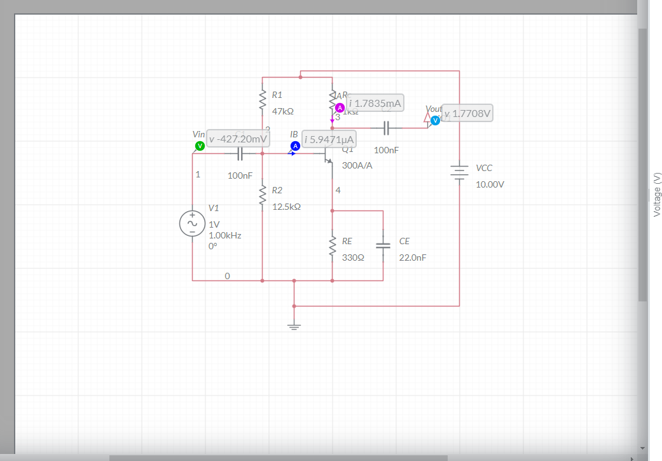

**1. Determine the current gain factor β of the transistor:**

Given: Icmax = 6.473mA, IBmax = 21.532µA

β = Icmax/IBmax = 6.473mA / 21.532µA ≈ 300.62

**2. Xác định hệ số khuếch đại điện áp của mạch và so sánh kết quả với lý thuyết.**

Voutmax = 2.8445V, Vinmax = 989.49mV => Av = Voutmax/Vinmax = 2.87

According to theory:

In DC analysis, we have IBQ = 11.565µA, VCEQ = 5.3817V, β = 300.62

Av=-(βRC)/((1+β)RE+re)≈-βRC/((1+β)RE) = -3.02

According to theory: Av = -3.02

The negative sign indicates that the input signal is out of phase with the output signal.

According to Multisim simulation: Av = 2.88

3. Set RC = 2 kΩ while keeping the other parameters of the circuit unchanged (Vin remains constant).

Observations and explanation regarding the output signal:

- The input and output voltages are out of phase with each other.

- When RC is increased beyond a certain level, the output signal will become distorted.

4. With RC = 2 kΩ, calculate the values of R1 and R2 so that the input and output signals are in-phase, and the measured amplification factor displayed on the oscilloscope matches the theoretical value.

