**TON DUC THANG UNIVERSITY**



**SOFTWARE ENGIRNEERING**

**Software Requirement Specifications**

**Project: Web Bookstore**

Prepare by :

Nguyễn Lê Thanh Bách – 51600007

Nguyễn Quốc Cường - 51600010

Nguyễn Thiện Chí - 51600009

Nguyễn Huỳnh Bảo Hân – 51600024

Phạm Anh Tuấn - 51600100Record of amendment

|  |  |  |  |  |  |
| --- | --- | --- | --- | --- | --- |
| Date | Index | Reason | Modify  (Add, edit, delete) | Describe | Version |
| 30/11 |  |  |  |  | Ver 1 |
| 11/12 |  |  |  |  | Ver 2 |
| 23/12 |  |  |  |  | Ver 3 |
|  |  |  |  |  |  |
|  |  |  |  |  |  |
|  |  |  |  |  |  |

# Sign

Project manager: Nguyen Le Thanh Bach Date:

<Administrator>

Tester: ………………………… Date:

<Quality manager>

INDEX

Introduce 5

1. Purpose 5

2. Scope 5

3. Acronym 5

Describe system 6

1. Target of system 6

2. Product Function 6

a) Account Registration 7

b) Account Login 7

c) Search 7

d) Read Demo 7

e) Add to Shopping Cart 8

f) Delete from Shopping Cart 8

g) Checkout 8

h) Contact Us 8

i) Update Account Information 8

j) View Shipping Status 9

k) View Account Purchase History 9

l) Account Logout 9

m) Help 9

3. User Characteristics 10

4. Assumptions and Dependencies 10

5. Non-functional requirements 10

6. Types of Information Used 10

7. Data Model 11

8. Design Constraints 11

9 Software System Attributes 11

9.1 Reliability 11

9.2 Availability 11

9.3 Security 11

9.4 Maintainability 11

9.5 Portability 11

Introduce

## Purpose

This document lays out the detailed requirement specification software for websites selling books, read books online.

## Scope

The objective of this project is to create and implement a website for the bookstore. The website will allow users to create and maintain individual secured accounts, search the Bookstore database. Users will also be able to contact site administrators. The website makes purchasing book quicker, easier, and more convenient.

## Acronym

ISBN: International Standard Book Number.

# Describe system

1. **Target of system**

* The bookstore shall accept orders over the Internet.
* The bookstore shall maintain a list of accounts for up to 1,000,000 customers.
* The bookstore shall provide password protection for all accounts.
* The bookstore shall provide the ability to search the master book catalog.
* The bookstore shall provide a number of search methods on that catalog, including search by author, search by title, search by ISBN number, and search by keyword.
* The bookstore shall provide a secure means of allowing customers to pay by credit card or payment in cash.
* The bookstore shall provide a secure means of allowing customers to pay via purchase order.
* The bookstore shall provide a special kind of account that is preauthorized to pay via purchase order.
* The bookstore shall provide electronic links between the Web and database and the shipping fulfillment system.
* The bookstore shall provide electronic links between the Web and database and the inventory management system.
* The bookstore shall maintain reviews of books, and allow anyone to upload review comments.
* The bookstore shall maintain ratings on books, based on customer inputs.
* The Bookstore have some books for free you can read online on website.

1. **Product Function**

The following list of function descriptions explains the major features of the website bookstore:

1. **Account Registration**

**The registration function shall allow users to create secure accounts.** The account will track the user’s name, address, credit card ( if you have ) information, username and password.

*Rationale:* This provides security to the account member by setting up anaccount that is password protected. This also offers convenience so the user only has to enter the information listed above once and then it is stored in the account.

1. **Account Login**

**The account login function shall allow account members to enter their username and password.** Once verified, users will be able toaccess account history, purchase books online, and update their account information.

*Rationale:* This provides a method by which the user can access therestricted operations.

1. **Search**

**The search function shall offer users the ability to search for books by title, author, subject, course number, professor, or ISBN number.**

*Rationale:* This offers a way to find a book if the user does not havecomplete information about it. It also provides price and availability information.

1. **Read Demo**

**Read Demo function shall allow users read a few page a book before buy this book with.**

*Rationale:* Know about the book content *,*considered for purchase the book you need to buy or not

1. **Add to Shopping Cart**

**The add to shopping cart function shall allow users to temporarily save books in a list that are being considered for purchase.**

*Rationale:* This offers convenience to the user by storing the books ofinterest online and allowing continuation of shopping.

1. **Delete from Shopping Cart**

**The delete from shopping cart function shall remove any unwanted books from the cart.**

*Rationale:* This allows users to change their orders easily and not beforced to purchase books that are no longer of interest.

1. **Checkout**

**The checkout function shall allow account members to purchase books online securely, or payment in cash**

*Rationale:* This offers easy purchasing and added assurance with aconfirmation number.

1. **Contact Us**

**The contact us function shall give users the store address, telephone number, email address, and its location on a map.**

*Rationale:* This helps the user gain trust in the bookstore by showing howeasy it is to have person-to-person contact with a bookstore employee.

1. **Update Account Information**

**The update account information function shall give account members access to edit their stored information.**

*Rationale:* This offers convenience to the account members by allowingthem to make changes to account information immediately.

1. **View Shipping Status**

**The view shipping status function shall allow account members to enter their confirmation number for a purchase and then view the status of shipment.**

*Rationale:* This offers convenience to account members so they can findout when they should expect shipment.

1. **View Account Purchase History**

**The view account purchase history function shall allow account members to see previous purchases made under their username.**

*Rationale:* This offers convenience to account members by allowing themto easily view purchase history.

1. **Account Logout**

**The account logout function shall allow account members to exit their account for security purposes.**

*Rationale:* This allows account members to exit their accounts, andprevent others from accessing it.

1. **Help**

**The help function shall give the user an overview of how to use the different functions listed above.**

*Rationale:* This allows the user to get answers to immediate questions onusing the website.

1. **User Characteristics**

The website is suitable for all users. Users of the website just know how to access.

1. **Assumptions and Dependencies**

Since the Bookstore is only accessible through the Internet, it is assumed that the end user has a connection to the Internet. It is also assumed that the user has a web browser able to display the website. (I.E. Microsoft Internet Explorer 4+ or some browser as google chrome,coccoc.....)

1. **Non-functional requirements**

* System login/logout shall take less than 5 seconds.
* Searches shall return results within 10 seconds.
* Orders shall be processed within 10 seconds.
* System shall support 10,000 simultaneous users

1. **Types of Information Used**

The types of information used by various functions of the website:

|  |  |  |
| --- | --- | --- |
|  | **Function** | **Types of Information Used** |
|  | Account Registration | User information (name, mailing address, credit |
|  |  | card type, number, expiration date, and user |
|  |  | name, and password) |
|  | Account login | User information (user name, and password) |
|  |  |  |
|  | Search | Book information (title, author, course number, |
|  |  | professor, ISBN, price, and quantity) |
|  | Checkout | Credit card information (credit card type, credit |
|  |  | card number), account purchase history (see |
|  |  | below, *View account purchase history*), book |
|  |  | information (number on hand) |
|  | Update Account info. | User information (name, mailing and billing |
|  |  | address, credit card type, number, and expiration |
|  |  | date, user name and password. |
|  | View account | Purchase history information (quantity, |
|  | purchase history | confirmation number, date of purchase, credit |
|  |  | card type, credit card expiration date, title of |
|  |  | book(s), price of book(s), total of purchases |

|  |  |  |
| --- | --- | --- |
| 1. **Data Model** |  |  |

The following diagram describes the attributes and the types of data that:

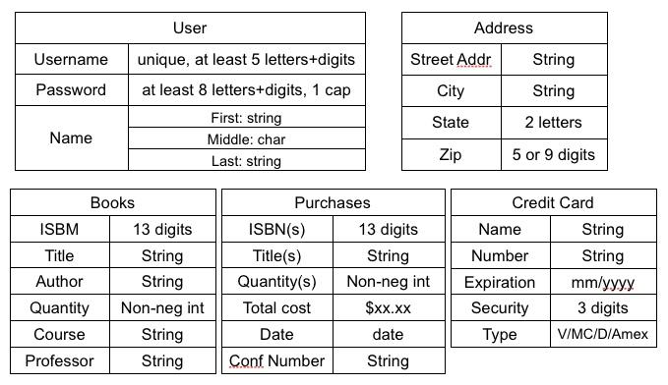

1. **Design Constraints**

• Able to support PC, Mac platforms.

• System logs out user after a ten minute inactivity period.

• System supports all web browsers (i.e. graphical, non-graphical).

1. **Software System Attributes**

**9.1 Reliability**

The average time to failure shall be 30 days. In the event that a server does crash, a backup server will be up and running within the hour.

**9.2 Availability**

The Bookstore shall be available to users 24 hours a day, 7 days a week, with the exception of being down for maintenance no more than one hour a week. If the system crashes, it should be back up within one hour.

**9.3 Security**

Users will be able to access only their own personal information and not that of other users. Purchases will be handled through a secure server to ensure the protection of user’s credit card and personal information.

**9.4 Maintainability**

Any updates or defect fixes shall be able to be made on server-side computers only without any patches required by the user.

**9.5 Portability**

Nothing required

1. Diagram

**10.1 Admin & User use case**

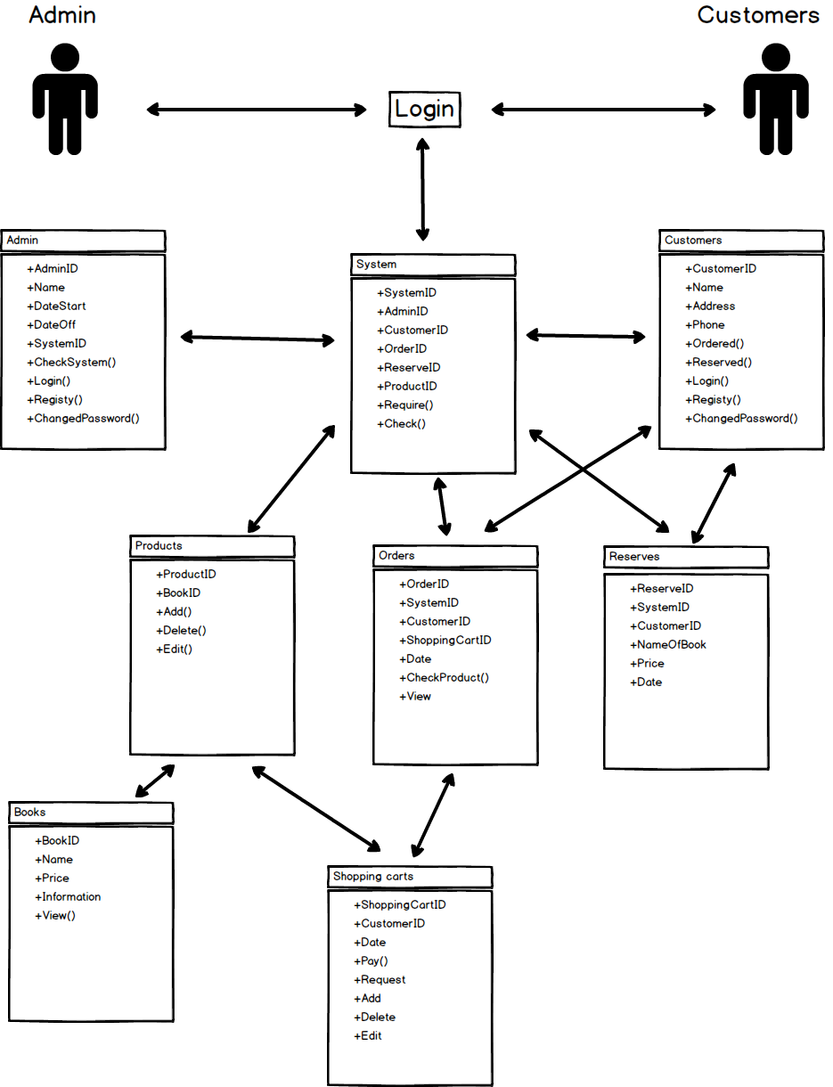

**10.2 Admin use case**

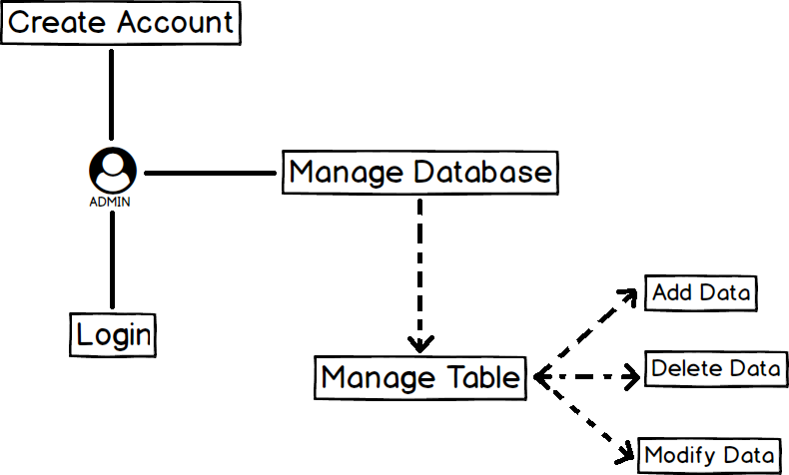

**10.3 User use case**

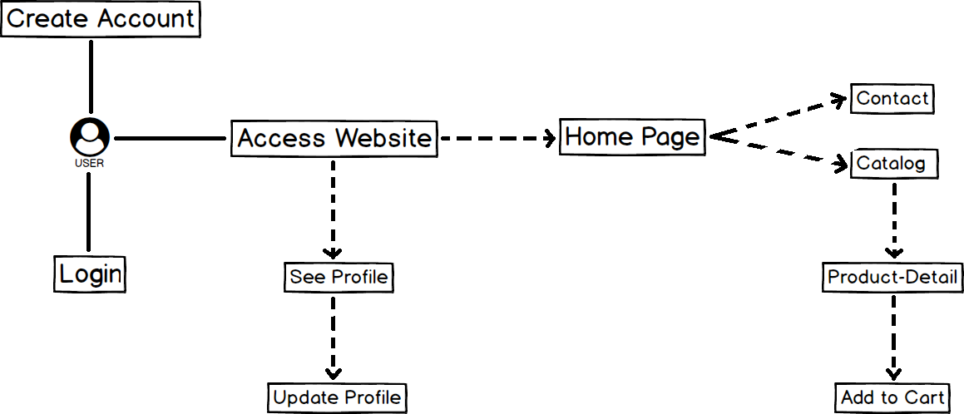

1. **Layout BookShop**
2. 