**Frequency**

A sound social theme and sound sharing theme for ionic app

Item number: th-0069

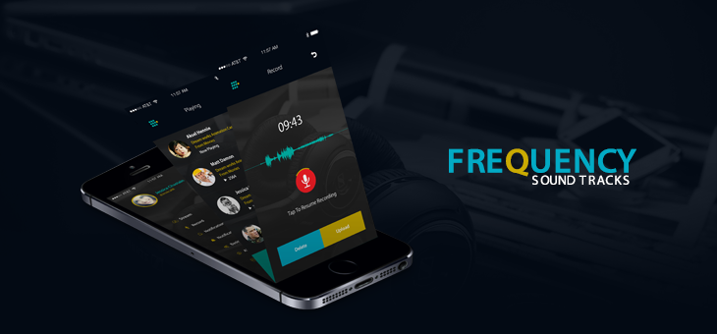

Description

Social media has a big size in our life and it is updated every day with new features so it is the time for "Frequency"theme. "Frequency" theme for ionic app is a social and the new in it is a sound social theme for ionic app.using this theme we can create an application allow us to record any sound track and let the world hear your voice and share it to the others in a social environment with all its action and listen to the other's records and show our feedback on it.record , upload and share your tracks

Screens

* Login
* Registration
* Home streams
* Playing page
* Record page
* Advanced record page
* Notification
* Notification setting
* Setting
* About us

Features

* Simple ,clear and attractive design.
* Easy ways to signup and login.
* Clear and strong side menu bar with important option.
* Strong record page.
* Strong streams page with audio player.
* Tested on Android and IOS platform.
* Can be used on Iphone and Android mobile phones.
* Built using IONIC platform.