**.Net Core/Vue Js**

Create an Instructor App with CRUD Functionalities with the following features

* Insert Instructor with basic information.
* Fetch Instructors.
* Update Instructor’s basic information.
* Delete Instructor from the database.
* Create a search functionality by instructor’s Last Name using JavaScript.
* Create filter feature by college using JavaScript.
* Add a dashboard widget, the sum of active instructors by college and its percentage with the total number of active instructors.
* Activate the loader component during fetching data.

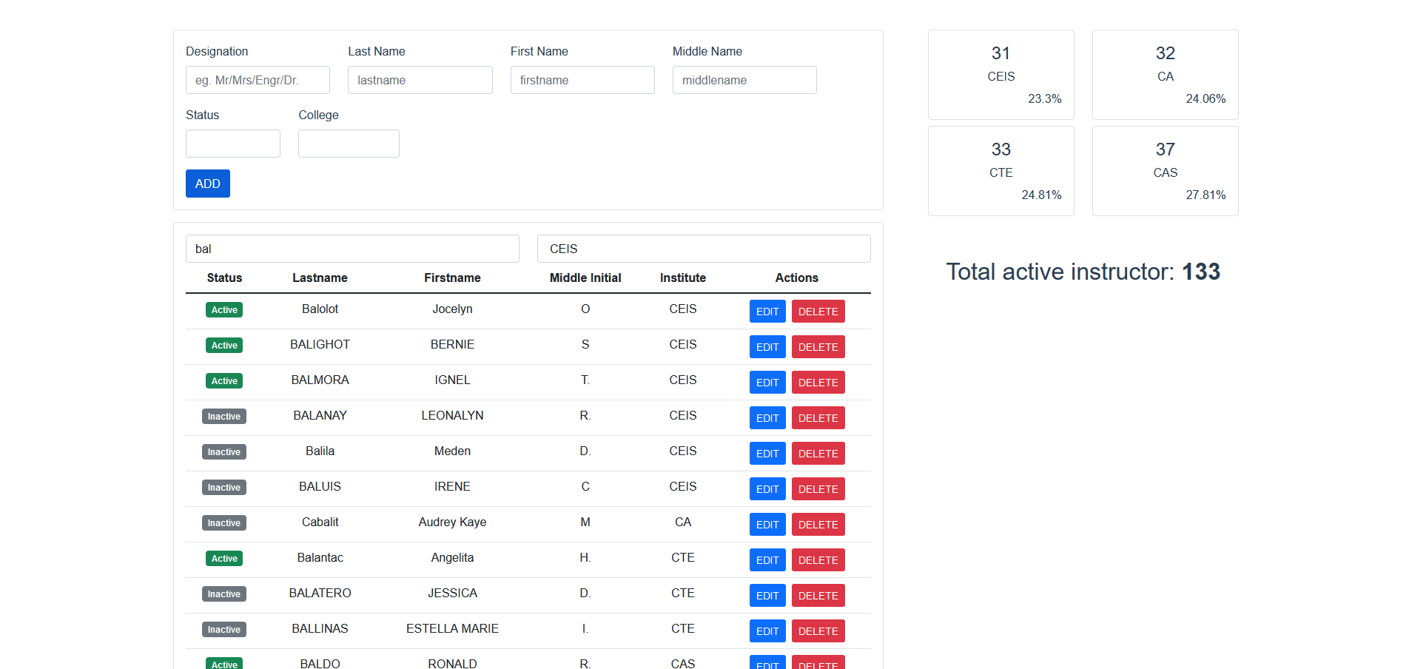Sample Screenshots:

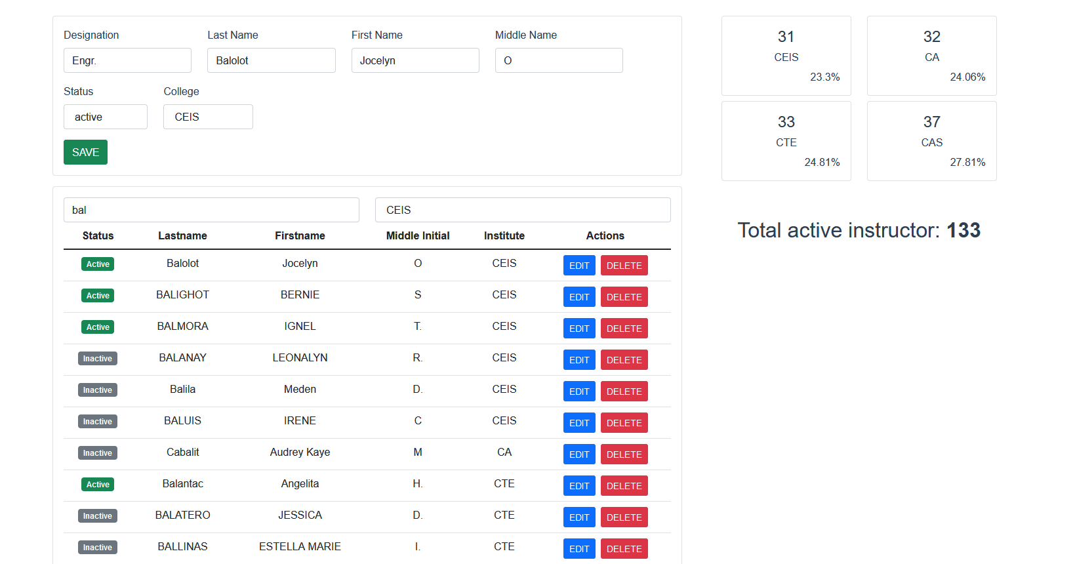

Dashboard widget

Instructor’s form

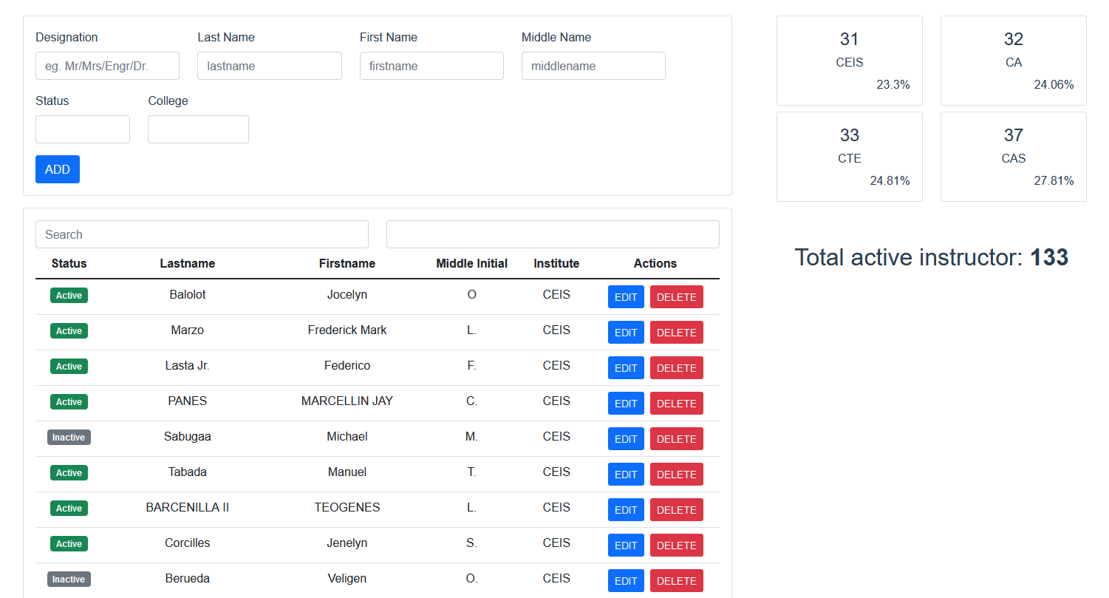

Filter box (filter by college)

Search box

List of Active and Inactive instructor