REAL-TIME POWER QUALITY MONITORING SYSTEM USING ESP32

Electronics and Telecommunication Engineering

Submitted by-
Yash Ganesh Bachhav

Department of Electronics and Telecommunication System
KCT’s Late G. N. Sapkal College of Engineering
Anjaneri, Nashik – 422 212
Academic Year: 2025–26

ABSTRACT
This project presents a real-time power quality monitoring system using ESP32 microcontroller and IoT technology. The system continuously measures AC voltage and AC current using voltage and current sensors. Based on the measured values, power and energy consumption (kWh) are calculated in real time.
The calculated parameters are displayed locally on a 16×2 LCD display and remotely on a mobile dashboard using the Blynk application through WiFi communication. The system enables users to monitor electrical parameters from anywhere using a smartphone.
The proposed system is low-cost, easy to implement, and suitable for residential, industrial, and smart grid applications. It provides an effective solution for monitoring electrical parameters and managing energy efficiently.

TABLE OF CONTENTS
Sr. No. | Title | Page No.
1 | Abstract | 2
2 | Table of Contents | 3
3 | CHAPTER 1 – Introduction | 4
4 | CHAPTER 2 – Literature Review | 6
5 | CHAPTER 3 – System Methodology | 8
6 | CHAPTER 4 – Hardware and Software Implementation | 10
7 | CHAPTER 5 – Results and Discussion | 12
8 | CHAPTER 6 – Conclusion and Future Scope | 13
9 | References | 14
10 | Appendix | 15

CHAPTER 1
INTRODUCTION
1.1 Background
In modern electrical systems, monitoring of voltage and current is very important. Variations in electrical parameters can lead to equipment damage, overheating, and increased power consumption. In industries and residential systems, real-time monitoring helps in maintaining system reliability and improving energy efficiency.
With the development of IoT technology and microcontrollers like ESP32, it is possible to monitor electrical parameters remotely using wireless communication.

1.2 Need for the Project
Traditional energy meters only show total energy consumption. They do not provide real-time monitoring of voltage, current, and power.
There is a need for a system that:
- Continuously measures electrical parameters
- Calculates power consumption
- Tracks energy usage
- Provides remote monitoring through mobile application
This project fulfills these requirements using ESP32 and Blynk IoT platform.

1.3 Scope of the Project
The system can be used for:
- Residential power monitoring
- Industrial load monitoring
- Commercial building energy management
- Smart grid applications
- Solar system monitoring
The system is designed to be low-cost and scalable for future upgrades.
1.4 Overview of the System
The project uses voltage and current sensors to measure AC supply parameters. These signals are processed by ESP32 microcontroller. The controller calculates RMS voltage, RMS current, power, and energy consumption.
The calculated data is displayed on a 16×2 LCD display and transmitted via WiFi to Blynk mobile dashboard for remote monitoring.

CHAPTER 2
LITERATURE REVIEW
2.1 Introduction
Power monitoring systems have been widely studied for improving energy efficiency and maintaining electrical system reliability. Many researchers have developed smart energy meters and IoT-based monitoring systems to track electrical parameters in real time.
2.2 Existing Systems
Traditional energy meters measure only total energy consumption in kWh. They do not provide real-time information about voltage, current, and instantaneous power.
Some advanced systems use microcontrollers like Arduino and Raspberry Pi for monitoring electrical parameters. These systems transmit data using IoT platforms for remote monitoring.
2.3 IoT-Based Monitoring Systems
With the advancement of Internet of Things (IoT), remote monitoring of electrical parameters has become easier. WiFi-enabled microcontrollers such as ESP8266 and ESP32 allow data transmission to cloud platforms and mobile applications.
IoT platforms like Blynk provide real-time dashboards for displaying voltage, current, and power values.
2.4 Research Gap
Many existing systems are either expensive or complex. Some systems lack real-time remote monitoring, while others do not provide complete electrical parameter analysis.
There is a need for a low-cost, real-time, and user-friendly power monitoring system that can:
- Measure voltage and current
- Calculate power and energy
- Provide mobile-based remote monitoring
- Be easy to install and operate

2.5 Summary
- Based on the literature study, it is observed that IoT-based monitoring systems improve accessibility and efficiency. However, a compact, cost-effective, and scalable solution is required. The proposed system using ESP32 and Blynk aims to fulfill these requirements.

CHAPTER 3
SYSTEM METHODOLOGY
3.1 System Overview
The proposed system is designed to monitor electrical parameters in real time. It measures AC voltage and AC current using sensors, processes the data using ESP32 microcontroller, and displays the results locally and remotely.
The system combines hardware sensing and IoT-based communication for efficient monitoring.
3.2 Block Diagram Description
The system consists of the following main blocks:
- AC Supply
- Voltage Sensor
- Current Sensor
- ESP32 Microcontroller
- LCD Display
- WiFi Communication
- Blynk Mobile Dashboard
The AC supply is connected to sensors. The sensors send analog signals to ESP32. The ESP32 processes the signals and calculates voltage, current, power, and energy. The results are displayed on LCD and transmitted via WiFi to Blynk app.
3.3 Working Methodology
Step 1: The voltage sensor measures AC voltage from the supply line.
Step 2: The current sensor measures load current.
Step 3: ESP32 reads analog signals using ADC pins.
Step 4: RMS voltage and RMS current are calculated.
Step 5: Power is calculated using:
Power = Voltage × Current
Step 6: Energy consumption is calculated using:
Energy = Power × Time
Step 7: The calculated values are displayed on LCD.
Step 8: Data is transmitted to Blynk mobile application through WiFi.
3.4 Data Processing
The analog sensor signals are sampled multiple times to obtain accurate readings. RMS values are calculated to determine effective AC voltage and current. Power and energy calculations are performed continuously to provide real-time monitoring.
3.5 System Flow
- Power ON
- Sensor Initialization
- Data Sampling
- RMS Calculation
- Power Calculation
- Energy Update
- LCD Display
- WiFi Data Transmission
- Repeat Process

CHAPTER 4
HARDWARE AND SOFTWARE IMPLEMENTATION
4.1 Hardware Implementation
The hardware section consists of sensors, microcontroller, display unit, power supply circuit, and load.
4.1.1 ESP32 Microcontroller
ESP32 is the main controller of the system. It reads sensor signals, performs calculations, and transmits data using built-in WiFi. It contains ADC pins to read analog signals from voltage and current sensors.
4.1.2 Voltage Sensor (ZMPT101B)
The voltage sensor is used to measure AC voltage. It provides isolation and converts high AC voltage into a low analog signal suitable for ESP32 input.
4.1.3 Current Sensor (ACS712)
The current sensor measures the load current flowing through the circuit. It provides an analog output proportional to the current value.
4.1.4 LCD Display (16×2)
The LCD display shows real-time voltage, current, power, and energy values locally.
4.1.5 Power Supply Circuit
The power supply section includes:
- Transformer
- Rectifier
- Electrolytic Capacitor (for ripple filtering)
- Ceramic Capacitor (for noise reduction)
- Voltage Regulator (for stable 5V output)
This circuit converts 230V AC into regulated DC suitable for ESP32 and other components.
4.1.6 Load (Bulb)
A bulb is used as a load for testing and demonstration. When switched ON, the system measures current and calculates power accordingly.
4.2 Software Implementation
Embedded C programming is used for system development.
The software performs the following tasks:
- Reading analog sensor values
- Calculating RMS voltage
- Calculating RMS current
- Computing power using formula:
Power = Voltage × Current
- Computing energy in kWh
- Updating LCD display
- Sending data to Blynk via WiFi
4.3 Communication Using Blynk
ESP32 connects to WiFi network and communicates with Blynk cloud server. The mobile application displays:
- AC Voltage
- AC Current
- AC Power
- Energy (kWh)
This enables real-time remote monitoring.

CHAPTER 5
RESULTS AND DISCUSSION
5.1 Experimental Setup
The system was tested using a 230V AC supply and a bulb as a load. The voltage sensor and current sensor were connected to ESP32. The LCD display and Blynk mobile dashboard were used to observe real-time values.
5.2 Observed Results
The system successfully measured and displayed:
- AC Voltage (around 230–240V)
- AC Current (based on load)
- AC Power (calculated using V × I)
- Energy consumption (kWh)
When the load was switched ON and OFF, corresponding changes in current and power were observed both on LCD and mobile dashboard.
5.3 Performance Analysis
- Real-time response observed
- Stable WiFi communication with Blynk
- Accurate measurement after calibration
- Smooth DC supply using capacitor filtering
The system demonstrated reliable monitoring capability for small-scale applications.
5.4 Discussion
The project successfully achieved real-time monitoring using ESP32 and IoT platform. Although power factor was not directly measured, the system provided satisfactory results for resistive loads.
The system can be improved by adding power factor calculation and data logging features.
CHAPTER 6
CONCLUSION AND FUTURE SCOPE
6.1 Conclusion
The Real-Time Power Quality Monitoring System using ESP32 was successfully designed and implemented. The system measures AC voltage and current, calculates power and energy consumption, and displays the data locally and remotely using Blynk application.
The system is low-cost, simple, and suitable for residential and small industrial applications. It provides an effective solution for real-time electrical parameter monitoring.
6.2 Future Scope
The system can be further enhanced by:
- Adding power factor measurement
- Implementing data logging
- Cloud-based storage and analytics
- Automatic fault detection
- Load control automation
- Industrial-grade sensor integration

REFERENCES
[1] IEEE Std 1159-2019, IEEE Recommended Practice for Monitoring Electric Power Quality, IEEE Standards Association, 2019.
Available: https://standards.ieee.org/standard/1159-2019.html
[2] K. Singh and P. Verma, “Detection and Classification of Power Quality Disturbances,” IEEE Transactions on Power Delivery, vol. 35, no. 4, pp. 1890–1898, 2020.
Available: https://ieeexplore.ieee.org/
[3] Espressif Systems, ESP32 Technical Reference Manual.
Available: https://www.espressif.com/en/support/documents/technical-documents
[4] Allegro Microsystems, ACS712 Current Sensor Datasheet.
Available: https://www.allegromicro.com/
[5] ZMPT101B AC Voltage Sensor Module Datasheet.
Available: https://components101.com/modules/zmpt101b-voltage-sensor-module

APPENDIX A
ESP32 PROGRAM CODE
Introduction
The following program is written in Embedded C for ESP32.
It reads voltage and current sensor data, calculates RMS voltage, RMS current, power, and energy consumption, and sends the data to the Blynk application using WiFi.
Example Code Structure
#define BLYNK_PRINT Serial
#include <WiFi.h>
#include <BlynkSimpleEsp32.h>
#include <LiquidCrystal.h>

char auth[] = "YourAuthToken";
char ssid[] = "YourWiFiName";
char pass[] = "YourWiFiPassword";

// LCD Pins (RS, E, D4, D5, D6, D7)
LiquidCrystal lcd(13, 12, 14, 27, 26, 25);

#define VOLTAGE_PIN 34
#define CURRENT_PIN 35

float voltage = 0.0;
float current = 0.0;
float power = 0.0;
float energy = 0.0;

float voltageOffset = 0;
float currentOffset = 0;

void setup()
{
Serial.begin(9600);
lcd.begin(16, 2);

WiFi.begin(ssid, pass);
Blynk.begin(auth, ssid, pass);

lcd.print("Power Monitor");
delay(2000);
lcd.clear();
}

void loop()
{
Blynk.run();

// Read analog values
int voltageRaw = analogRead(VOLTAGE_PIN);
int currentRaw = analogRead(CURRENT_PIN);

// Convert ADC to actual voltage
voltage = (voltageRaw - 2048) * (3.3 / 4095.0) * 100;
if (voltage < 0) voltage = -voltage;

// Convert ADC to actual current
current = (currentRaw - 2048) * (3.3 / 4095.0) * 30;
if (current < 0) current = -current;

// Calculate Power
power = voltage * current;

// Calculate Energy (kWh)
energy = energy + (power / 3600000.0);

// Display on LCD
lcd.setCursor(0, 0);
lcd.print("V:");
lcd.print(voltage);
lcd.print(" I:");
lcd.print(current);

lcd.setCursor(0, 1);
lcd.print("P:");
lcd.print(power);
lcd.print("W");

// Send to Blynk
Blynk.virtualWrite(V1, voltage);
Blynk.virtualWrite(V2, current);
Blynk.virtualWrite(V3, power);
Blynk.virtualWrite(V4, energy);

delay(1000);
}

APPENDIX B
CIRCUIT DIAGRAM AND CONNECTION DETAILS
B.1 Introduction
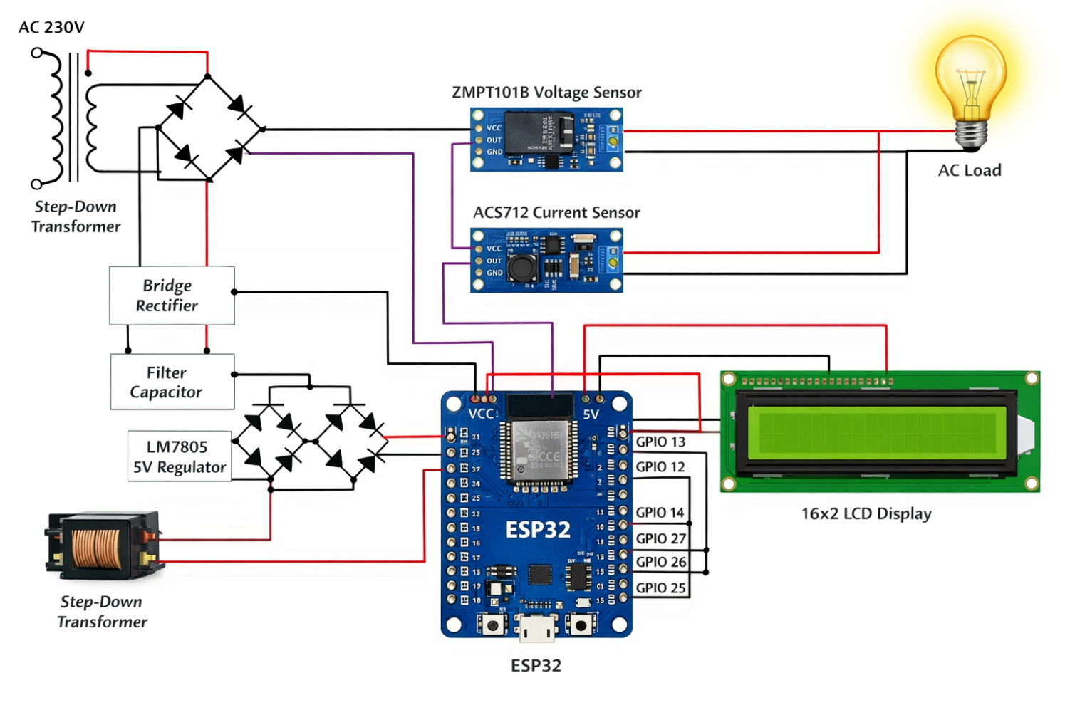
This appendix describes the hardware connections and circuit implementation of the Real-Time Power Monitoring System using ESP32.

B.2 Circuit Description
The system consists of:
- ESP32 microcontroller
- ZMPT101B voltage sensor
- ACS712 current sensor
- 16×2 LCD display
- Power supply circuit
The AC supply is connected to the voltage sensor and load. The current sensor is connected in series with the load. Both sensors provide analog output signals to ESP32 ADC pins.
B.3 ESP32 Pin Connection
Component | ESP32 Pin
Voltage Sensor Output | GPIO 34
Current Sensor Output | GPIO 35
LCD RS | GPIO 13
LCD E | GPIO 12
LCD D4 | GPIO 14
LCD D5 | GPIO 27
LCD D6 | GPIO 26
LCD D7 | GPIO 25
VCC | 5V
GND | GND
B.4 Power Supply Section
The power supply circuit includes:
- Step-down transformer
- Bridge rectifier
- Electrolytic capacitor (filtering)
- Ceramic capacitor (noise removal)
- Voltage regulator (5V output)
This circuit converts 230V AC to stable 5V DC required for ESP32 and LCD.
B.5 Working of Circuit
- AC supply is given to the system.
- Voltage sensor measures supply voltage.
- Current sensor measures load current.
- ESP32 processes sensor signals.
- RMS voltage and current are calculated.
- Power and energy are computed.
- Values are displayed on LCD.

