Contents

I. History 2

II. Introduction 3

III. High-Level Design 4

1. Component Model 4

2. Deployment Model 4

IV. Detailed Design 5

1. Search Servers 5

# History

|  |  |  |  |
| --- | --- | --- | --- |
| # | Date | Author | Description |
| 1 | 2024/08/18 | Bach Ha | Init document |

# Introduction

A backend system designed to support the frontend web and mobile applications. The application provides the main following functionality:

* Get reachable (online) URL(s).

The design needs to consider factors such as:

* Security
* High Availability
* Scalability
* Flexibility & Easy to use

We are not focusing on authentication and authorization as they are out of scope.

# High-Level Design

## Component Model

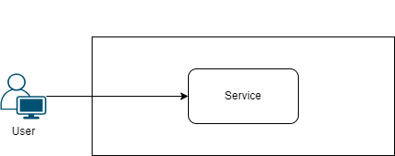

**Service**

This service is responsible for handling user requests.

## Deployment Model

We can chose between Container-based or Serverless

* 1. Container-based

**Service** is designed to be highly scalable and available to ensure it can handle a large number of concurrent users. To achieve this, we have chosen to deploy the service on Amazon Elastic Kubernetes Service (EKS)

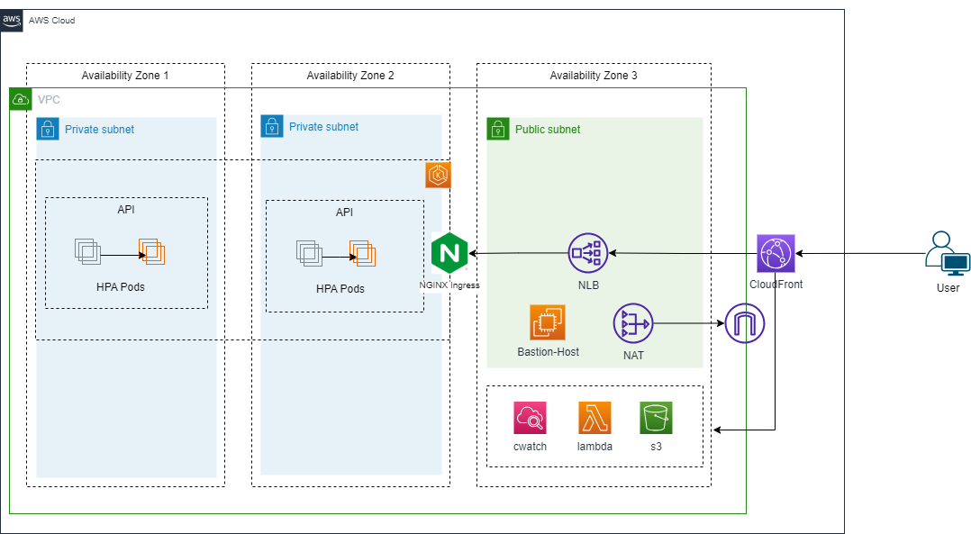

* 1. Serverless (AWS lambda)

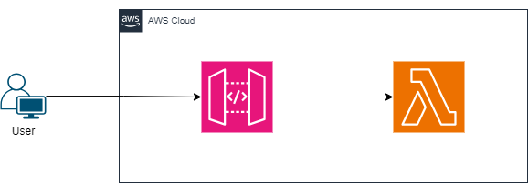

# Detailed Design

## Search Servers

This API allows users to retrieve online servers. Users can specify priority parameters to filter servers by their priority. The API returns a list of servers that match the search criteria, including details such as URL and priority.

***Out of scope: The API does not currently support pagination.***  
Sequence diagram  
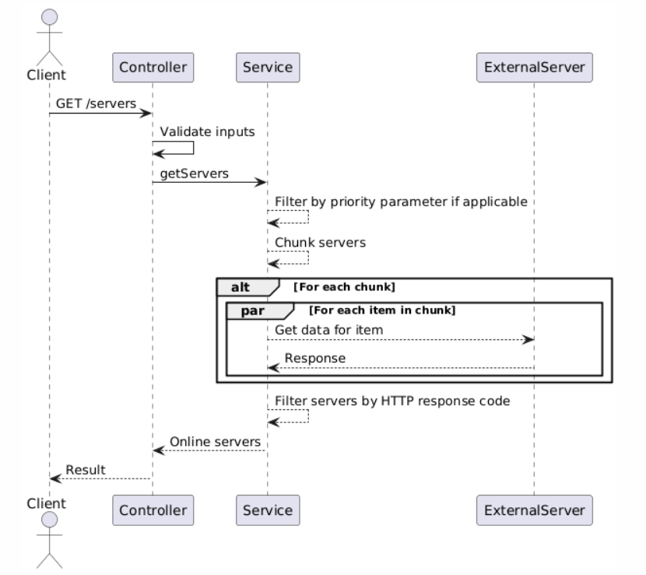  
  
API  
**Endpoints**: GET /servers

**Query-string**

|  |  |  |  |
| --- | --- | --- | --- |
| Name | Type | Required | Description |
| priority | string | Optional | The priority of the servers for search. |

**Response**

|  |  |  |  |
| --- | --- | --- | --- |
| Name | Type | Required | Description |
| url | string | Yes | The server’s url |
| priority | number | Yes | The priority of the server |