Create Maven Project in eclipse and add unit test cases to the project

1. Open Eclipse – Click on File->New->Other:

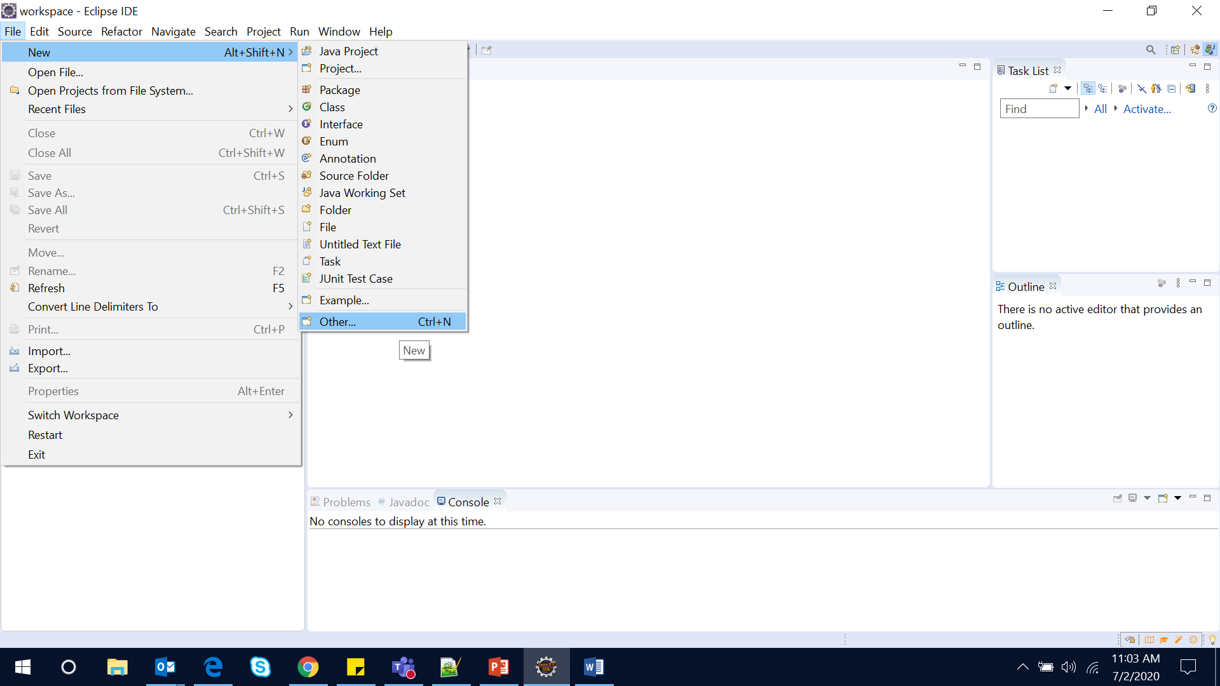

1. Search for maven and select Maven Project -> Next:

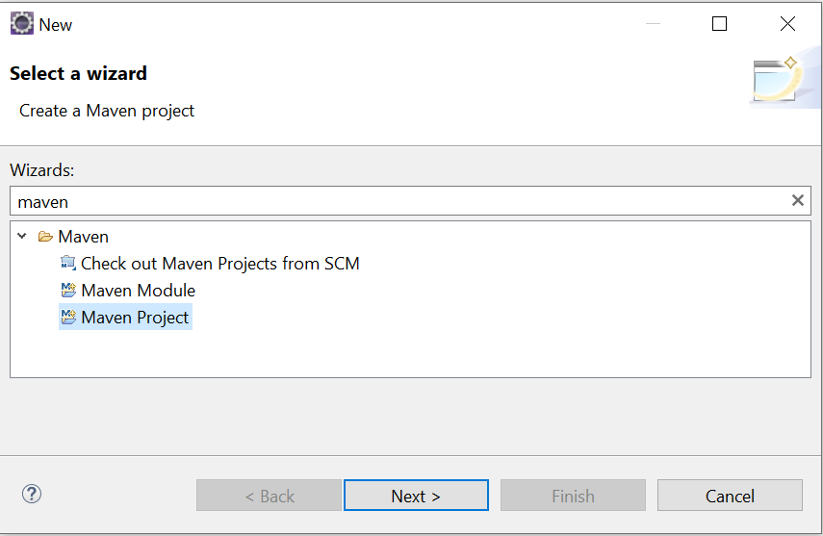 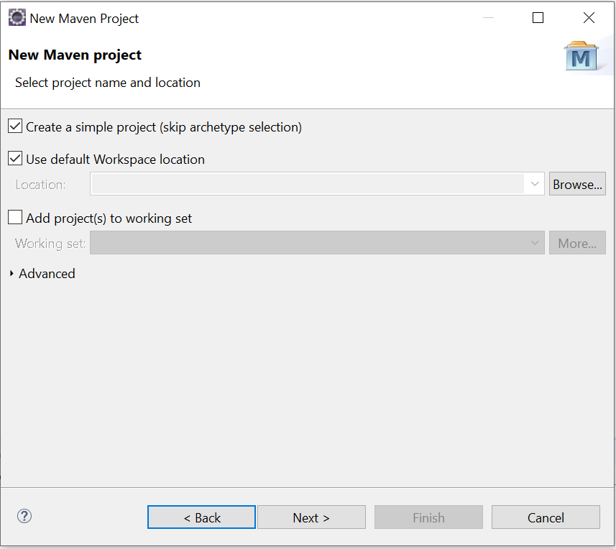

1. Provide the project details listed as below:

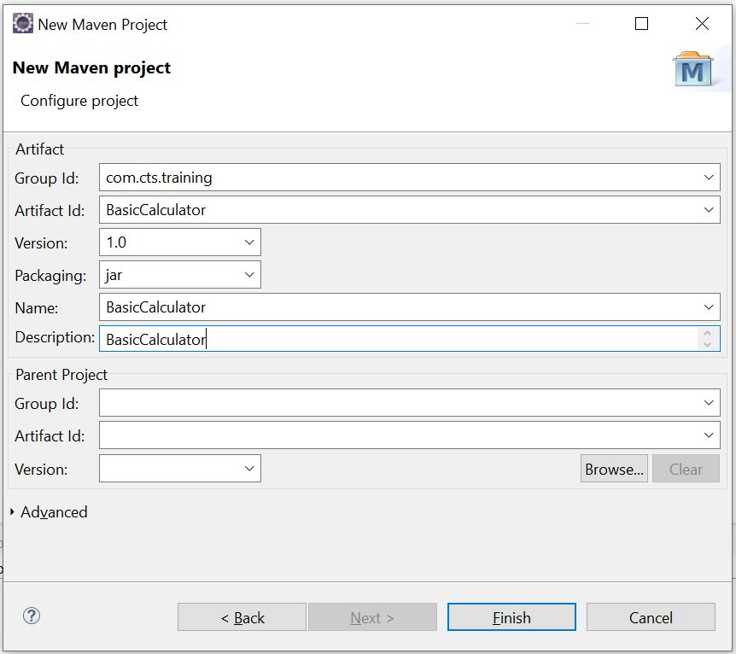**GroupId** will identify your project uniquely across all projects, so we need to enforce a naming schema. It has to follow the package name rules, what means that has to be at least as a domain name you control, and you can create as many subgroups as you want.

**ArtifactId** is the name of the jar without version. If you created it then you can choose whatever name you want with lowercase letters and no strange symbols. If it's a third party jar you have to take the name of the jar as it's distributed.

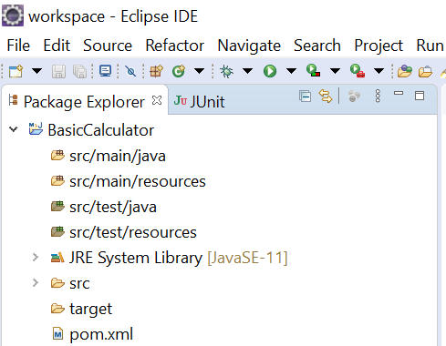

1. Create java class:

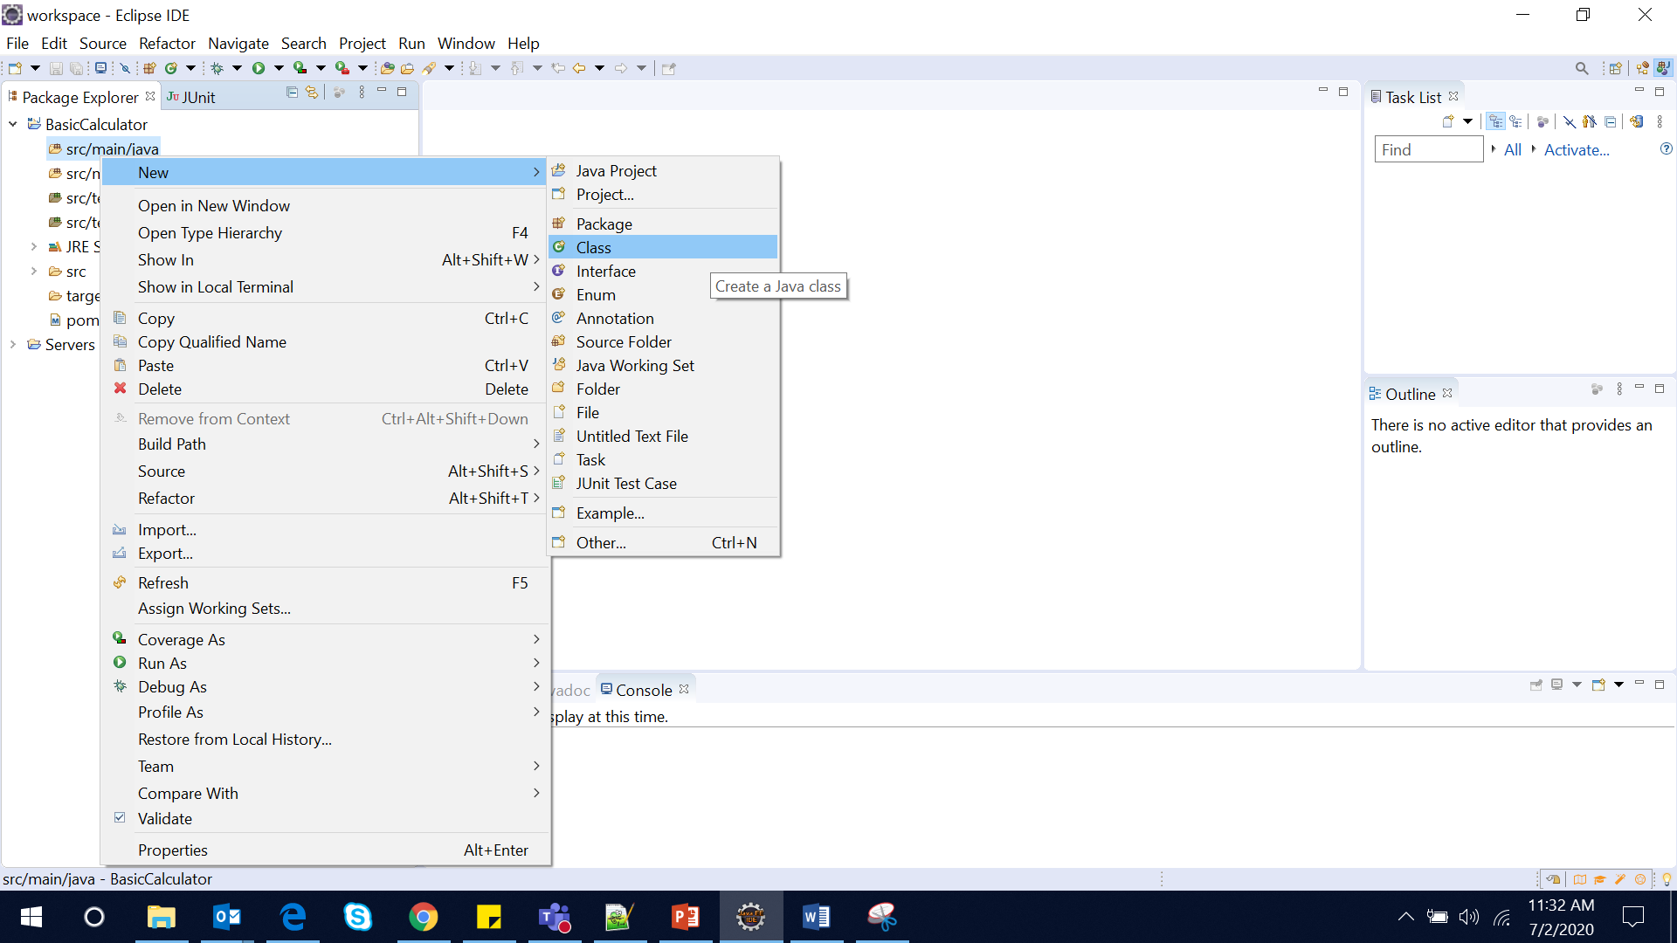

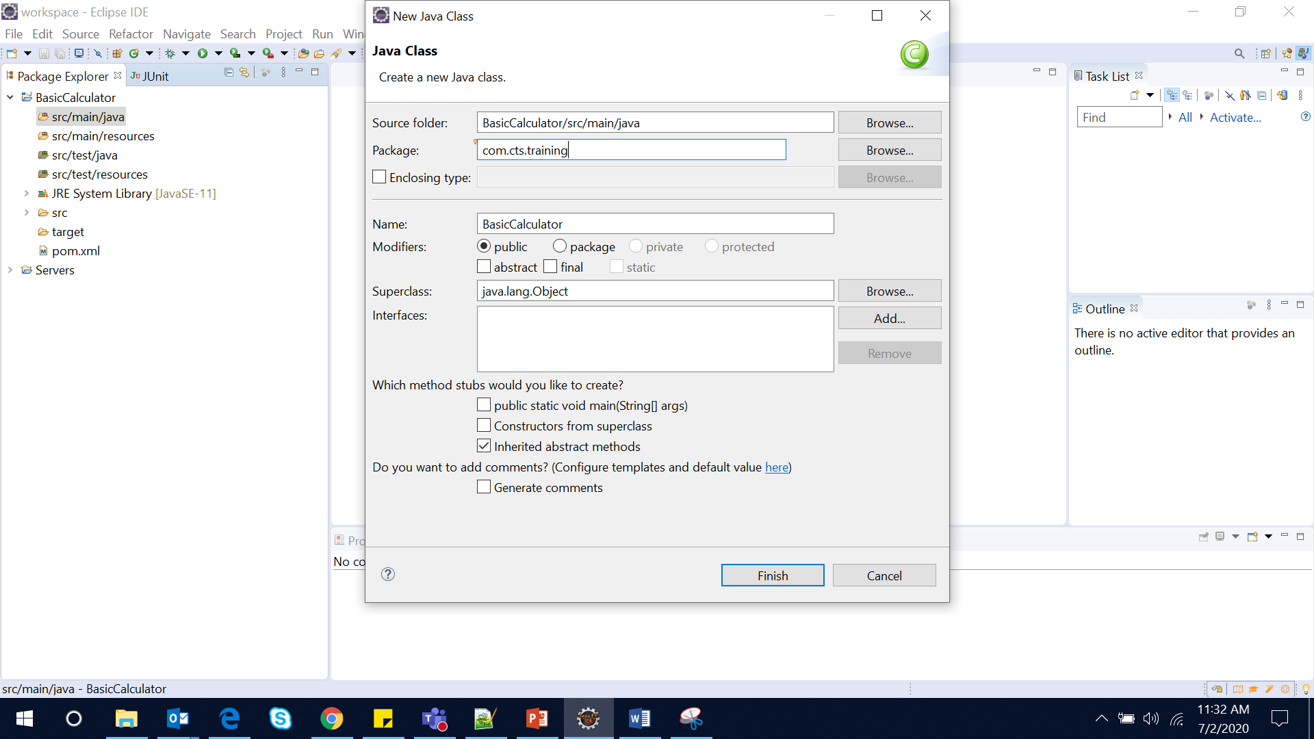

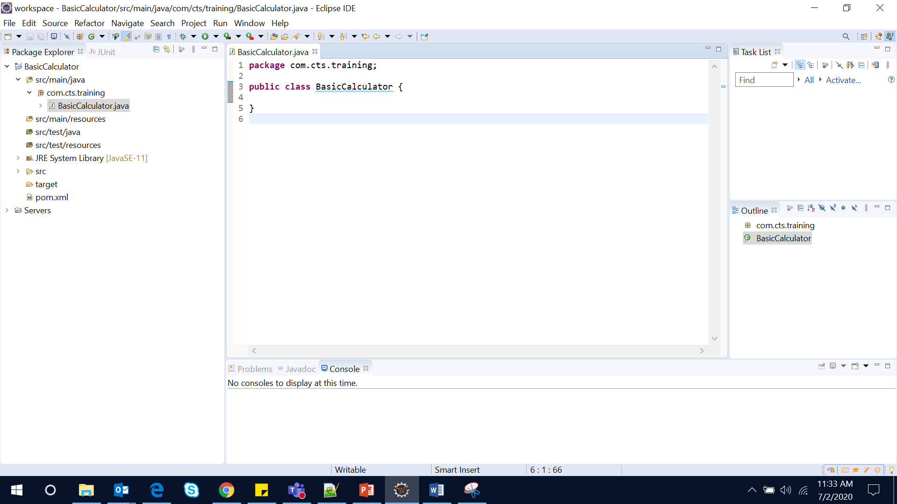

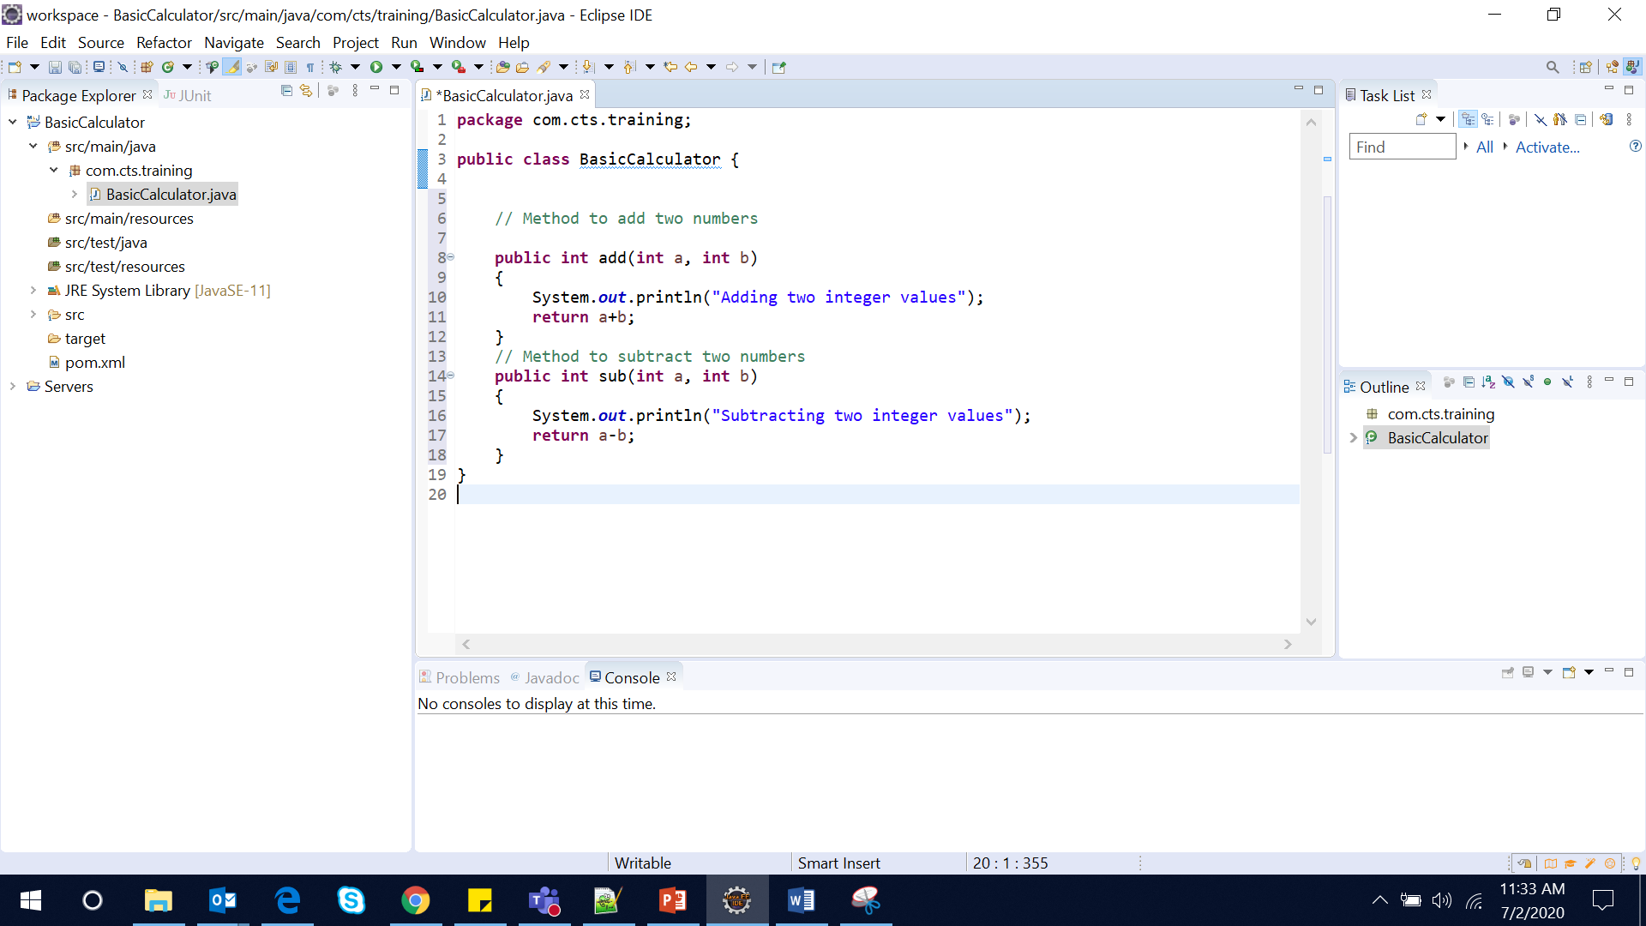

1. Update pom.xml with necessary dependencies:

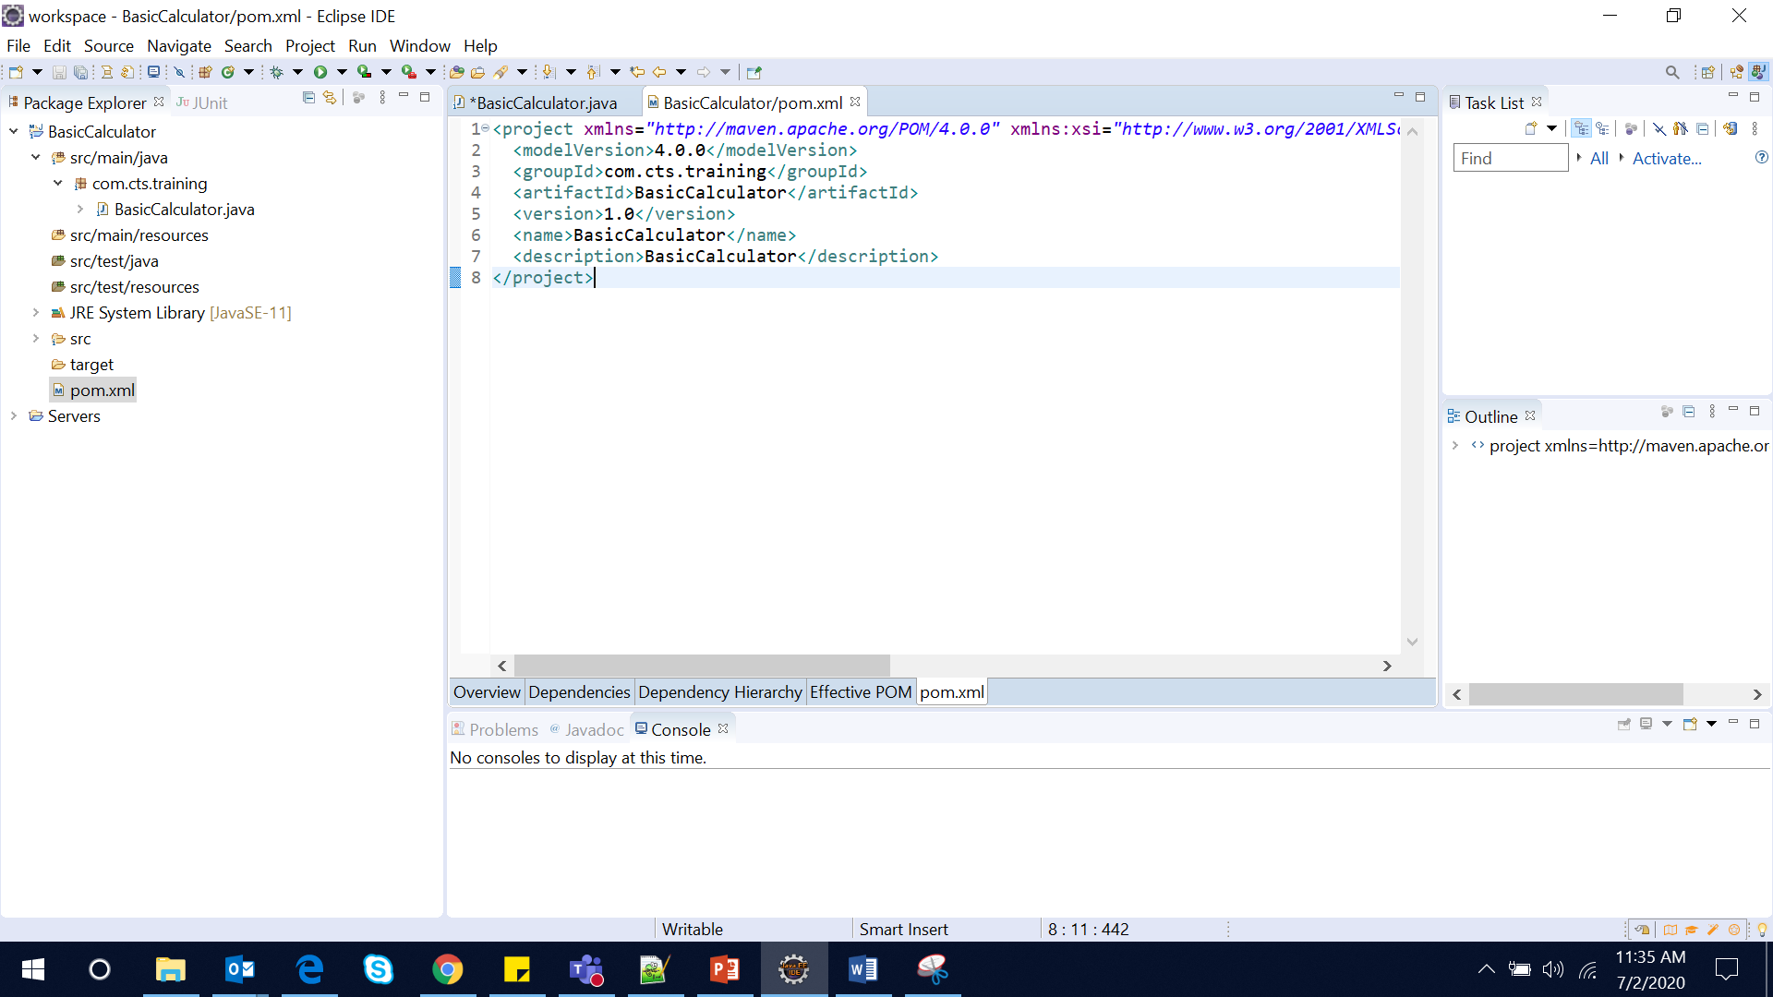

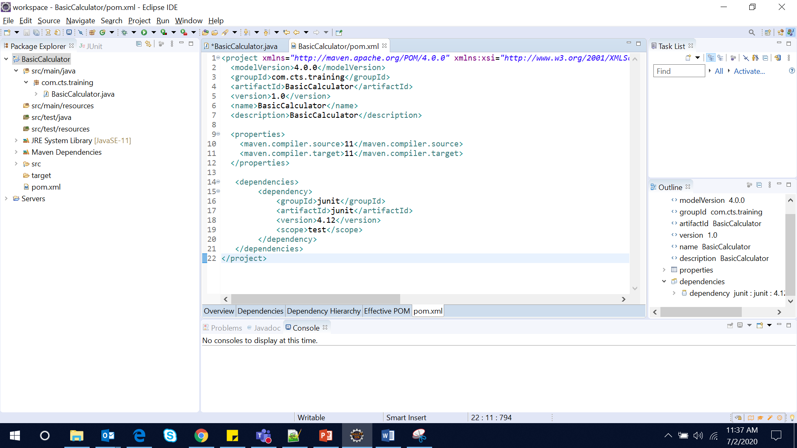

1. Create Run Configuration for Maven Build and click on Run:

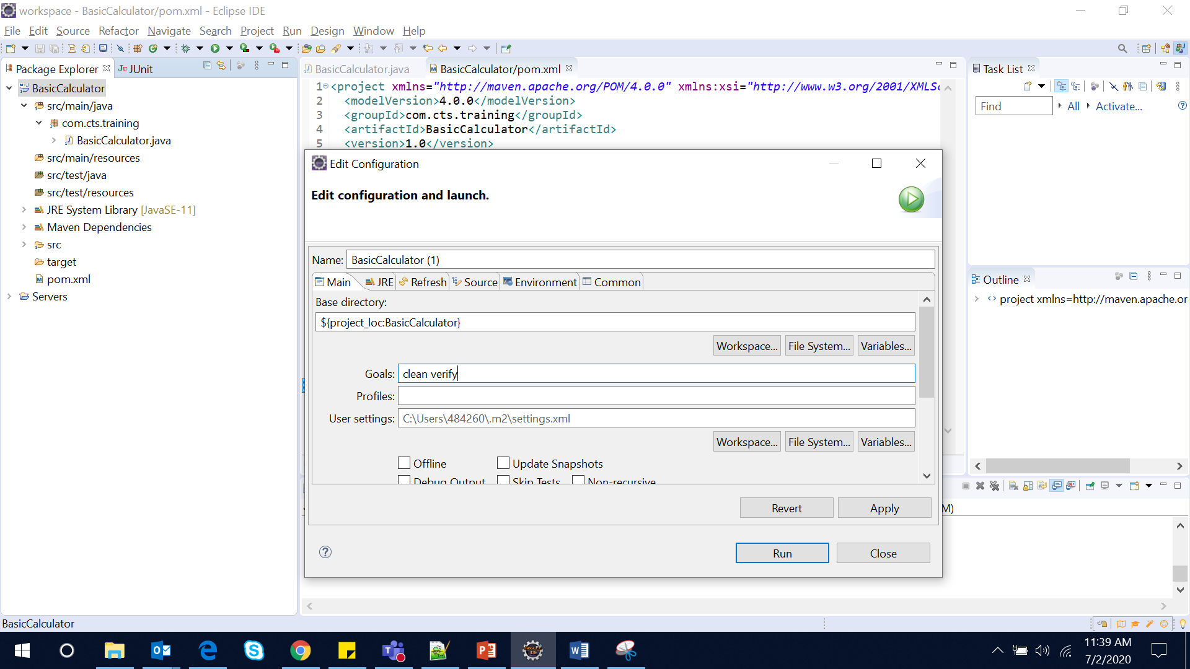

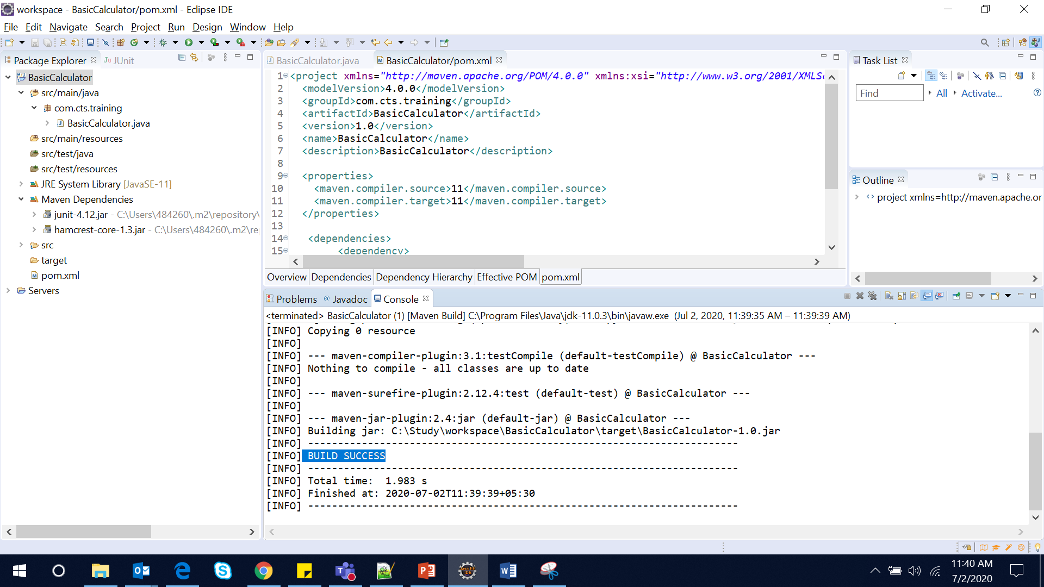

1. Create Junit Test Case:

