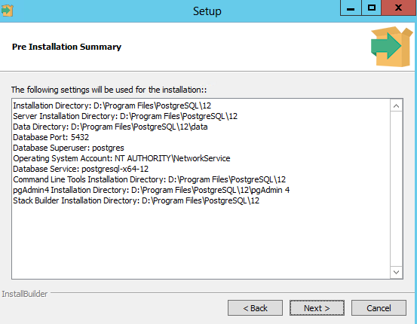

Postgres SQL Setup in M13

1) D Program Files

2) admin@999 password for superuser postgres

3) Server listen port 5432