**1311017-NguyenNgocBach-DIP-Lab06**

Case1: low pass filter => so noise

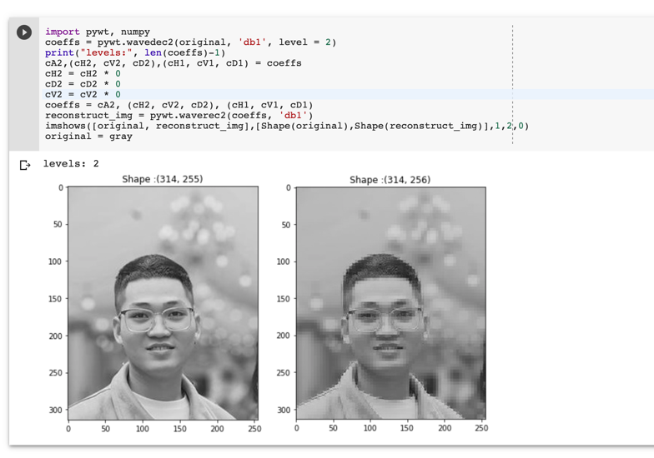

Case 2: high pass filter => low contrast

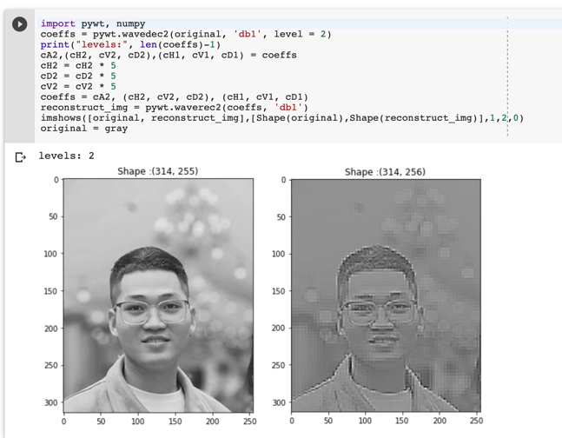

Case 3: original => perfect

