BÁO CÁO THỰC HÀNH LAB 4 – LAB 4 REPORT

LẬP TRÌNH HƯỚNG ĐỐI TƯỢNG – Object-oriented programming

GitHub repository: <https://github.com/bachthetrollface/OOPLab.git>

3. Create the Book class

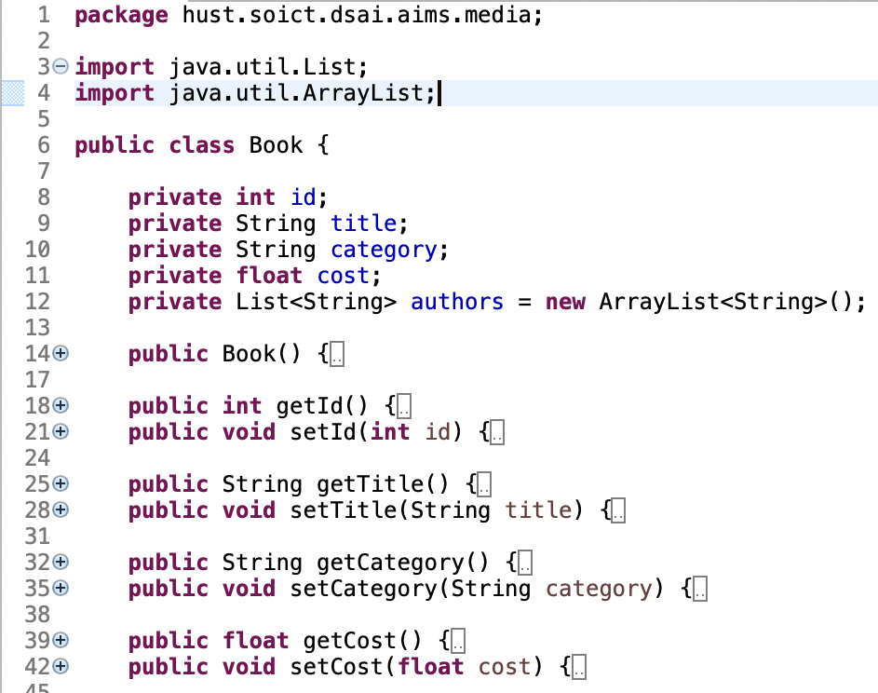

* addAuthor and removeAuthor methods:

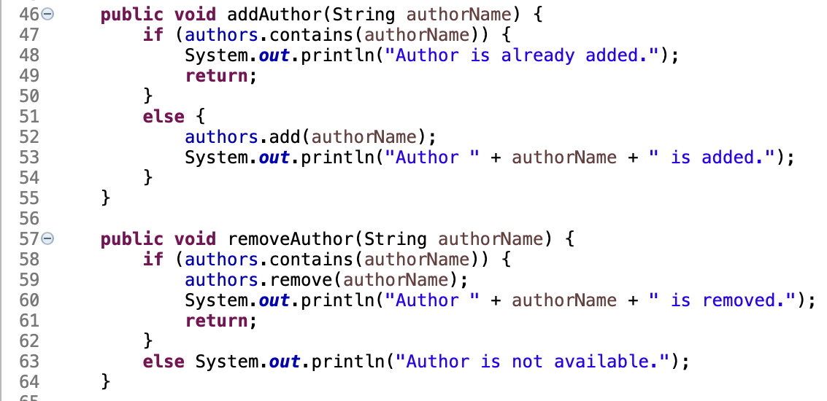

4. Create the abstract Media class

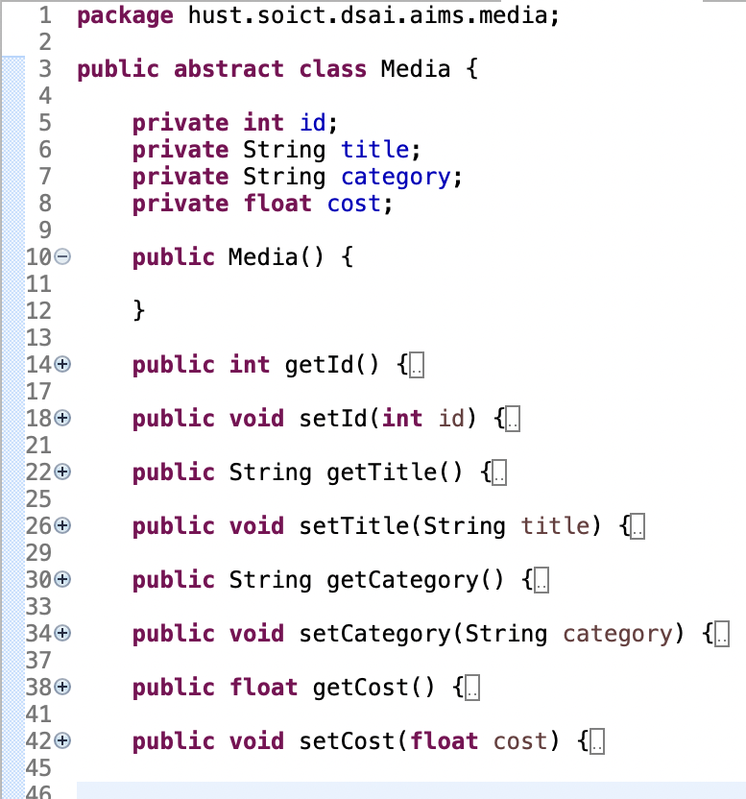

Update the Book and DigitalVideoDisc classes:

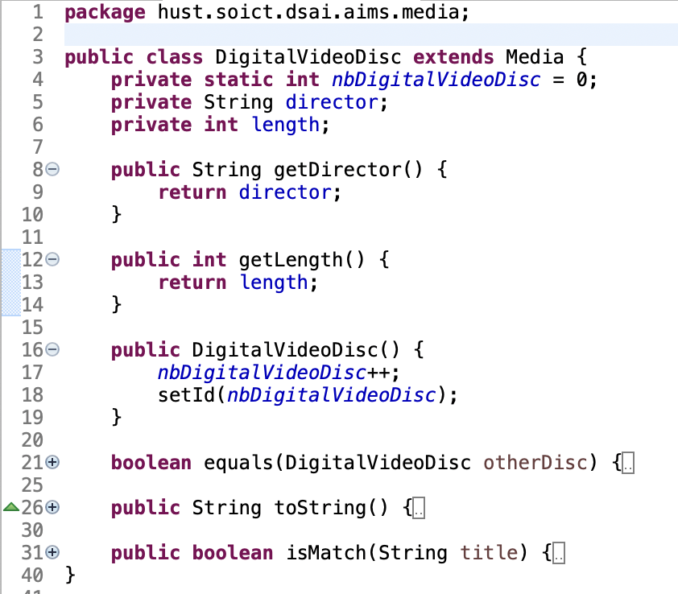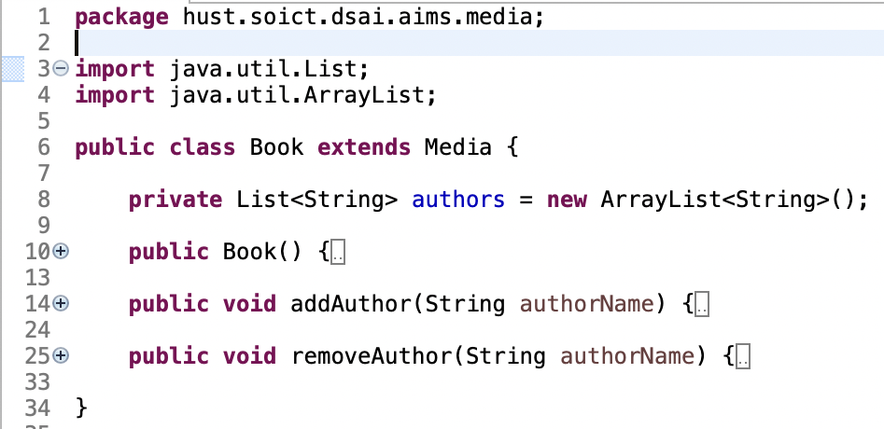

5. Create the CompactDisc class

* Create the Disc class:

Change to DigitalVideoDisc class:

* Create the Track class

