

**Thy Khuu**

**HOUSE AND HOMECARE MANAGEMENT SYSTEM**

**Research Report**

**CENTRIA UNIVERSITY OF APPLIED SCIENCES**

**Information Technology**

**May 20****22**

**ABSTRACT**

|  |  |  |
| --- | --- | --- |
| Centria University  of Applied Sciences | Date  29.05.2022 | Author  Thy Khuu |
| Degree programme  Information Technology | | |
| Name of research  House management and homecare system | | |
| Centria supervisor  Aliasghar Khavasi, Nina Hynynen, Hanna-Riina Aho | | Pages  4 + 11 |
| Instructor representing commissioning institution or company | | |
| Since the Covid epidemic becomes a global crisis and many countries in the world are facing with hard situation about moving away, work and study on campus. The domestic migration case has been detected that many regions become a red warning due to the critical spreading of disease. People tend to look for a peaceful province and area where the Covid situation has less become risk to protect themselves and their family. As the sequence of problem, the migration to safe region from risk region that makes a pressure under rental housing service at these green regions.  There are efforts from landlord in cities where a huge number of migrations is massively moving in, are trying to expand their rental housing service by upgrading building infrastructure and constructing new apartment to meet the significant increase of people looking for housing service temporarily. Dealing with the big statistics every day is truly challenged to the service while the need of renting house service is suddenly going on increased.  Effective solution for the demand of service management is important to meet the urgent needs. Therefore, the research is aims at exploring the design of application to manage the housing services based on the current situation and the wish of landlord about optimal ways for their service management. The research not only introduces about the necessary of efficient management system, but also involves the system design based on the techniques and subjects of software engineering. | | |
|  | | |
| Key words  House Management, Homecare, Software Architecture, System Design, Modelling, User Interface. | | |

**CONCEPT DEFINITIONS**

UML Unified Modelling Language

UI User Interface

UX User Experience

IOS Iphone Operating System

**ABSTRACT**

**CONCEPT DEFINITIONS**

**CONTENTS**

1 INTRODUCTION 1

2 SYSTEM DESCRIPTION 2

3 System design analysis 4

3.1 Software Architecture 4

3.2 System Requirements 4

3.3 Application and Networking Architecture 5

4 System design 6

5 USER INTERFACE DESIGN 7

6 DATABASE Design 8

7 CONCLUSION 9

**REFERENCES 10**

**FIGURES**

FIGURE 1. The page of checking room availability 1

FIGURE 2. The page of booking management 2

FIGURE 3. Application and Networking Architecture 3

FIGURE 4. Usecase Diagram by UML for the system 6

FIGURE 5. Homepage with functionalities for administrator 7

FIGURE 6. First, Second, and Third Normalization Form 8

# INTRODUCTION

Management system of a service become necessary towards business and organization because of the workflows and operation of data statistic to keep tracking activities. Nowadays, the field of Information Technology is being developed significantly. Thus, computer has been widely used in office, factory, school, etc... to solve mathematic problem and save human costs. The effectiveness of using computer is undeniable, helping to minimize the inefficient manual working stages. Thus, the access to management systems via a computer has become the top goal of organizations and businesses for their information management purposes. A housing service management system is one of information systems was built to address the needs of management in the house. The system will help businesses handle work accurately, quickly, save costs and human resources, on the other hand, also promote the image of the home to friends inside and outside the province, domestically and internationally.

House and homecare management system is one of business sectors that uses the progression of technologies. The progresses of system occur in sequences including computerized apartment reservation and house resource management. This research represents the advantages of effective system and the process of system design based on the knowledge of software engineering. The topic is one of the popular applies in the service management due to the increasing demand for the number of tourists, the number of services served, the commercial competition and the cost savings. Operating costs and more importantly, the correct and effective operation in management is the key to determining the success of the rental house service. The research is the most effective way to test the knowledge that student learned from school, the most effective approach to reality and more importantly the fundamentals for further research and development about information system in future.

# SYSTEM DESCRIPTION

Customers wishing a house for rent can visit to the official site to reserve a room in advance. The staff uses the program to record the booking information in the registration form: customer information, room number, room type, room type, arrival date, check-in date, etc. Customers can also book rooms at time to come. From the figure 1, after receiving the booking information, the system will check the availability of the rooms to make a notice for the customer's reservation.

FIGURE 1. The page of checking room availability

When the customer comes to check in, the staff will update other information on the registration form such as: arrival date, number of adults, payment method, prepaid amount, services service registration by customers. From the figure 2, the staff is adding a new customer in the database. Customers can view information about the room: room type, room type, room rate, room equipment and service information such as service name, service price for their data registration.

FIGURE 2. The page of booking management

# System design analysis

## Software Architecture

In software architecture, hardware and software are two most important components for designing a rental management system. Client computer, server and networks are sub-components of hardware part which connects to the computers. Clients play vital roles to display information and pass links as well as carrying system's input and output whereas the server is supporting and storing data. The interactive activities between clients and server in hardware design system called server-client architecture (Dennis, Wixom & Roth 2012). Moreover, in software architect, the abstraction of the software component in a system briefly represents the system behavior and the communication between elements in the system. This correlative structure provides an insight of different levels of system design for multiple purposes of uses and client's needs those who are programmers, software architects, contributors, managers, and customers.

## System Requirements

The system requirements take responsible to analysis, collect and details descriptions including the functionality of the system and user interface, non-visible and non-functional features of the system, development management and system deployment. The software architecture is constructive based on the most important requirements of the system. These requirements are mainly classified as requirements of functionality and non-functionality (Hanmer 2013, 11). System requirements describes a process of determining user expectations with an application that are being constructing and modifying during software cycle life. Requirements analysis involves all tasks performed to identify stakeholder needs. Therefore, requirements analysis is responsible for analyzing, documenting, defining, and managing requirements of the software or system. High-quality requirements are documented, measurable, testable, trackable to facilitate system design (Dennis, Wixom & Roth 2012).

## Application and Networking Architecture

The figure 3 describes the application and networking architecture which provides a communication between computers and data transmission. Computers act as clients does not provide resources to other computers, but they use resources given from the server. The server plays a supporting role in making client operations more efficient. The client server model is a computer network model in which the child computers act as a client, they are responsible for sending requests to the servers, ten return the result to the client.

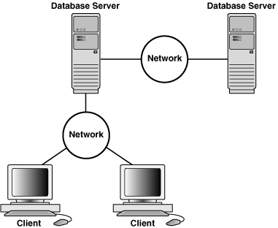

FIGURE 3. Application and Networking Architecture

In the client server model, the server accepts all valid requests from anywhere on the internet, and then returns the results to the computer that sent the request. Computers are considered as clients when they are responsible for sending requests to servers and waiting for a response to be sent. Protocol plays important role during the communication. If the request is accepted, the server collects the information and returns the result to the requesting client in the shortest time.

# System design

The architecture design is a phase of the system development process which determines the components, interface, and the data throughout the system. Subsystems of the architecture are also identified with the relevant dependencies. The modelling system are designed using UML, which is a standard system modelling language, specifying, documenting, and developing complex systems using set of diagrams (Lano 2005). From the figure 4, usecase diagram are drawn by UML describe the basic processes or activities correlating to the emphasis and aspects of the system to be developed. The behavioural diagrams visualize the dynamic behavioural aspects of components of the system.

FIGURE 4. Usecase Diagram by UML for the system

# USER INTERFACE DESIGN

User interface is the visual structure of a system that interacts with users and external systems. It mainly contains navigation fields, input mechanisms and output fields. Designing UI/UX should follow the concept of visuality design that are capable as attraction, simple, and information on how to use them. The management system has different user levels which they can interact to the system differently such as administrator as following the figure 5 and customer. Both have their own permission and privilege access to some certain functionalities on the system.

FIGURE 5. Homepage with functionalities for administrator

# DATABASE Design

A meaning and well structure database can resolve problems in managing data and storing data for daily task. This requires a logical and closed connection between database properties such as entity, domain, and type of attribute inside each entity. Before designing database, the collection of requirements based on practical data should be taken clearly. This helps to determine the entities, relations, domains, and type of attributes for database of management system which shows detailly information about the system. As from the figure 6, designing a database also follow the rules of modelling techniques such as normalization by the First Normal Form, Second Normal Form and Third Normal Form that efficiently performs storing information as well as reducing the redundant data during data processing.

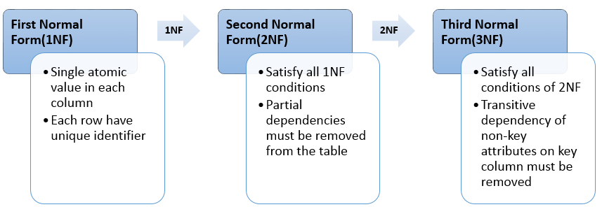

FIGURE 6. First, Second, and Third Normalization Form

# CONCLUSION

The currently version of house management offers only room renting services and the software ran on desktop and web environment. The research of this system can be further developed for the bigger purpose of usage such as homecare services and more specifically the software can be built on the Android or IOS environment in future. The future development should be successfully completed by studying all requirements and executed in logical ways to integrate with the existing ones. The system will be upgraded by incorporating better performing record management software, modern technologies in another programming language and open-source frameworks. Thus, designing a system in future will be significantly optimized in the consumption of time and work.

**REFERENCES**

Lano, K. 2005, Advanced Systems Design with Java, UML and MDA, Elsevier Science & Technology, Burlington.

Dennis A. Wixom B.H., Roth R.M 2012, System Analysis and Design, John Wiley & Sons. Available: [https://www.oreilly.com/library/view/system-analysis%20and/9781118057629/17_chap08.html. Accessed 18 April 2022](https://www.oreilly.com/library/view/system-analysis%20and/9781118057629/17_chap08.html.%20Accessed%2018%20April%202022).

Hanmer, RS. 2013, Pattern-Oriented Software Architecture for Dummies, John Wiley & Sons, Incorporated, Somerset.