Collections

List(ArrayList)

**2. Search an Element**

Write a program to:

* Create an ArrayList of integers.
* Ask the user to enter a number.
* Check if the number exists in the list.

import java.util.ArrayList;

import java.util.Scanner;

public class Ans2 {

public static void main(String[] args) {

ArrayList<Integer> numbers = new ArrayList<>();

numbers.add(10);

numbers.add(20);

numbers.add(30);

numbers.add(40);

numbers.add(50);

Scanner scanner = new Scanner(System.***in***);

System.***out***.print("enter number to search in the list: ");

int searchNumber = scanner.nextInt();

if (numbers.contains(searchNumber)) {

System.***out***.println(searchNumber + " is present in the list");

} else {

System.***out***.println(searchNumber + " is not present in the list");

}

}

}

**OUTPUT:**

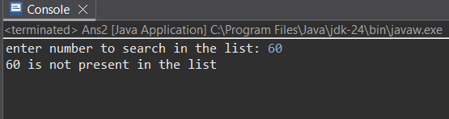

**3. Remove Specific Element**

Write a program to:

* Create an ArrayList of Strings.
* Add 5 fruits.
* Remove a specific fruit by name.
* Display the updated list.

import java.util.ArrayList;

import java.util.Scanner;

public class Ans3 {

public static void main(String[] args) {

ArrayList<String> fruits = new ArrayList<>();

fruits.add("Grapes");

fruits.add("Apple");

fruits.add("Orange");

fruits.add("Mango");

fruits.add("Banana");

System.out.println("Original Fruit List: " + fruits);

Scanner scanner = new Scanner(System.in);

System.out.print("Enter fruit name to remove: ");

String Removefruit = scanner.nextLine();

if (fruits.remove(Removefruit)) {

System.out.println(Removefruit + " removed successfully");

} else {

System.out.println(Removefruit + " not found in the list");

}

System.out.println("Updated Fruit List: " + fruits);

scanner.close();

}

}

**OUTPUT:**

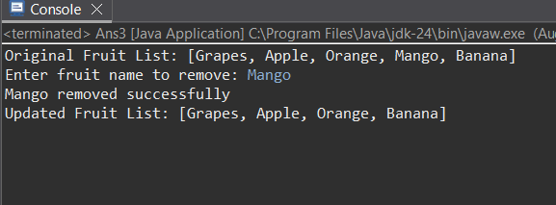

**4. Sort Elements**

Write a program to:

* Create an ArrayList of integers.
* Add at least 7 random numbers.
* Sort the list in ascending order.
* Display the sorted list.

import java.util.ArrayList;

import java.util.Collections;

public class Ans4 {

public static void main(String[] args) {

ArrayList<Integer> numbers = new ArrayList<>();

numbers.add(3);

numbers.add(22);

numbers.add(81);

numbers.add(6);

numbers.add(42);

numbers.add(19);

numbers.add(33);

System.out.println("Original List: " + numbers);

Collections.sort(numbers);

System.out.println("Sorted List" + numbers);

}

}

**OUTPUT:**

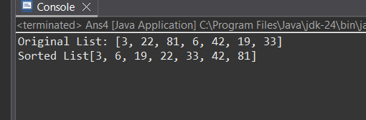

**5. Reverse the ArrayList**

Write a program to:

* Create an ArrayList of characters.
* Add 5 characters.
* Reverse the list using Collections.reverse() and display it.

import java.util.ArrayList;

import java.util.Collections;

public class Ans5 {

public static void main(String[] args) {

ArrayList<Character> charList = new ArrayList<>();

charList.add('A');

charList.add('B');

charList.add('C');

charList.add('D');

charList.add('E');

System.out.println("Original List: " + charList);

Collections.reverse(charList);

System.out.println("Reversed List: " + charList);

}

}

**OUTPUT:**

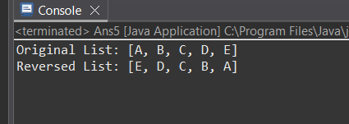

6. Update an Element

Write a program to:

• Create an ArrayList of subjects.

• Replace one of the subjects (e.g., “Math” to

“Statistics”).

• Print the list before and after the update.

import java.util.ArrayList;

public class Ans6 {

public static void main(String[] args) {

ArrayList<String> subjects = new ArrayList<>();

subjects.add("Math");

subjects.add("Physics");

subjects.add("Chemistry");

subjects.add("Biology");

subjects.add("English");

System.out.println("Before Update: " + subjects);

int index = subjects.indexOf("Math");

if (index != -1) {

subjects.set(index, "Statistics");

} else {

System.out.println("Subject not found");

}

System.out.println("After Update: " + subjects);

}

}

**OUTPUT:**

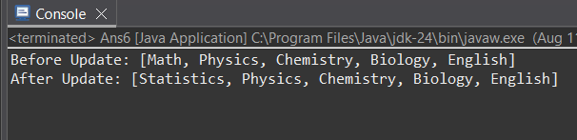

7. Remove All Elements

Write a program to:

• Create an ArrayList of integers.

• Add multiple elements.

• Remove all elements using clear() method.

• Display the size of the list.

import java.util.ArrayList;

public class Ans7 {

public static void main(String[] args) {

ArrayList<Integer> numbers = new ArrayList<>();

numbers.add(10);

numbers.add(20);

numbers.add(30);

numbers.add(40);

numbers.add(50);

System.***out***.println("Before clear(): " + numbers);

numbers.clear();

System.***out***.println("After clear(): " + numbers);

System.***out***.println("Size of list: " + numbers.size());

}

}

**OUTPUT:**

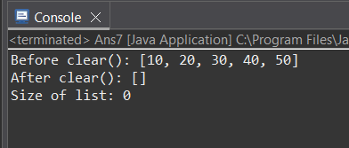

8. Iterate using Iterator

Write a program to:

• Create an ArrayList of cities.

• Use Iterator to display each city.

import java.util.ArrayList;

import java.util.Iterator;

public class Ans8 {

public static void main(String[] args) {

ArrayList<String> cities = new ArrayList<>();

cities.add("New York");

cities.add("London");

cities.add("Tokyo");

cities.add("Paris");

cities.add("Sydney");

Iterator<String> iterator = cities.iterator();

System.***out***.println("Cities in the list:");

while(iterator.hasNext()) {

String city = iterator.next();

System.***out***.println(city);

}

}

}

**OUTPUT:**

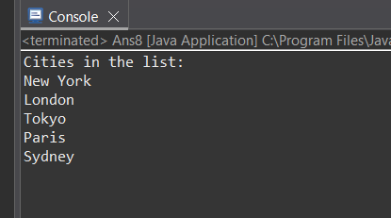

**9. Store Custom Objects**

Write a program to:

* Create a class Student with fields: id, name, and marks.
* Create an ArrayList of Student objects.
* Add at least 3 students.
* Display the details using a loop.

import java.util.ArrayList;

class Student {

private int id;

private String name;

private double marks;

public Student(int id, String name, double marks) {

this.id = id;

this.name = name;

this.marks = marks;

}

public int getId() { return id; }

public String getName() { return name; }

public double getMarks() { return marks; }

@Override

public String toString() {

return "Student [ID=" + id + ", Name=" + name + ", Marks=" + marks + "]";

}

}

public class Ans9 {

public static void main(String[] args) {

ArrayList<Student> students = new ArrayList<>();

students.add(new Student(101, "raj", 81.5));

students.add(new Student(102, "viajy", 72.0));

students.add(new Student(103, "rakesh", 78.3));

System.out.println("Student Details:");

for (Student student : students) {

System.out.println(student);

}

}

}

**OUTPUT:**

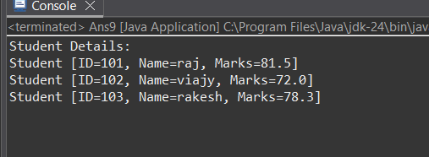

**10. Copy One ArrayList to Another**

Write a program to:

* Create an ArrayList with some elements.
* Create a second ArrayList.
* Copy all elements from the first to the second using addAll() method.

import java.util.ArrayList;

public class Ans10 {

public static void main(String[] args) {

ArrayList<String> list1 = new ArrayList<>();

list1.add("Apple");

list1.add("Banana");

list1.add("Cherry");

list1.add("Mango");

ArrayList<String> list2 = new ArrayList<>();

list2.addAll(list1);

System.out.println("First List: " + list1);

System.out.println("Second List (copied): " + list2);

}

}

**OUTPUT:**

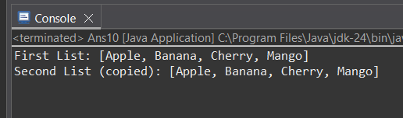

List(LinkedList)

**1. Create and Display a LinkedList**

Write a program to:

* Create a LinkedList of Strings.
* Add five colors to it.
* Display the list using a for-each loop.

**2. Add Elements at First and Last Position**

Write a program to:

* Create a LinkedList of integers.
* Add elements at the beginning and at the end.
* Display the updated list.

**3. Insert Element at Specific Position**

Write a program to:

* Create a LinkedList of names.
* Insert a name at index 2.
* Display the list before and after insertion.

**4. Remove Elements**

Write a program to:

* Create a LinkedList of animal names.
* Remove the first and last elements.
* Remove a specific element by value.
* Display the list after each removal.

**5. Search for an Element**

Write a program to:

* Create a LinkedList of Strings.
* Ask the user for a string to search.
* Display if the string is found or not.

**6. Iterate using ListIterator**

Write a program to:

* Create a LinkedList of cities.
* Use ListIterator to display the list in both forward and reverse directions.

**7. Sort a LinkedList**

Write a program to:

* Create a LinkedList of integers.
* Add unsorted numbers.
* Sort the list using Collections.sort().
* Display the sorted list.

import java.util.Collections;

import java.util.LinkedList;

import java.util.ListIterator;

import java.util.Scanner;

public class LL1{

public static void main(String[] args) {

Scanner scanner = new Scanner(System.in);

LinkedList<Integer> numbers = new LinkedList<>();

numbers.add(10);

numbers.add(20);

numbers.add(30);

numbers.add(40);

numbers.add(50);

System.out.println("1. Original LinkedList: " + numbers);

numbers.addFirst(5);

numbers.addLast(60);

System.out.println("\n2. After adding first and last elements: " + numbers);

numbers.add(3, 25);

System.out.println("\n3. After inserting 25 at position 3: " + numbers);

System.out.println("\n4. Removal Operations:");

System.out.println("Original list: " + numbers);

numbers.removeFirst();

System.out.println("After removing first element: " + numbers);

numbers.removeLast();

System.out.println("After removing last element: " + numbers);

numbers.remove(Integer.valueOf(25));

System.out.println("After removing value 25: " + numbers);

System.out.print("\n5. Enter a number to search: ");

int searchNum = scanner.nextInt();

if (numbers.contains(searchNum)) {

System.out.println(searchNum + " found in the list at position " +

numbers.indexOf(searchNum));

} else {

System.out.println(searchNum + " not found in the list");

}

System.out.println("\n6. ListIterator Demonstration:");

ListIterator<Integer> iterator = numbers.listIterator();

System.out.print("Forward iteration: ");

while (iterator.hasNext()) {

System.out.print(iterator.next() + " ");

}

System.out.print("\nBackward iteration: ");

while (iterator.hasPrevious()) {

System.out.print(iterator.previous() + " ");

}

Collections.sort(numbers);

System.out.println("\n\n7. Sorted LinkedList: " + numbers);

scanner.close();

}

}

**OUTPUT:**

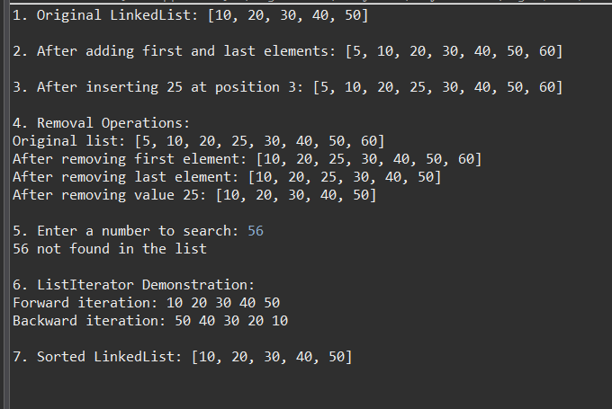

**8. Convert LinkedList to ArrayList**

Write a program to:

* Create a LinkedList of Strings.
* Convert it into an ArrayList.
* Display both the LinkedList and ArrayList.

import java.util.LinkedList;

import java.util.ArrayList;

public class LL8 {

public static void main(String[] args) {

LinkedList<String> linkedList = new LinkedList<>();

linkedList.add("Apple");

linkedList.add("Banana");

linkedList.add("Orange");

linkedList.add("Mango");

System.***out***.println("Original LinkedList:");

System.***out***.println(linkedList);

ArrayList<String> arrayList = new ArrayList<>(linkedList);

System.***out***.println("\nConverted ArrayList:");

System.***out***.println(arrayList);

System.***out***.println("LinkedList size: " + linkedList.size());

System.***out***.println("ArrayList size: " + arrayList.size());

}

}

**OUTPUT:**

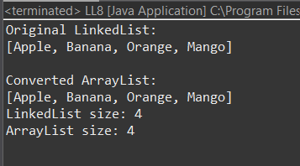

**9. Store Custom Objects in LinkedList**

Write a program to:

* Create a class Book with fields: id, title, and author.
* Create a LinkedList of Book objects.
* Add 3 books and display their details using a loop.

import java.util.LinkedList;

class Book {

private int id;

private String title;

private String author;

public Book(int id, String title, String author) {

this.id = id;

this.title = title;

this.author = author;

}

public int getId() {

return id;

}

public String getTitle() {

return title;

}

public String getAuthor() {

return author;

}

@Override

public String toString() {

return "Book [ID=" + id + ", Title=" + title + ", Author=" + author + "]";

}

}

public class LL9 {

public static void main(String[] args) {

LinkedList<Book> bookList = new LinkedList<>();

bookList.add(new Book(101, "The Great Gatsby", "F. Scott Fitzgerald"));

bookList.add(new Book(102, "To Kill a Mockingbird", "Harper Lee"));

bookList.add(new Book(103, "1984", "George Orwell"));

System.out.println("Books in the LinkedList:");

for (Book book : bookList) {

System.out.println(book);

}

}

}

**OUTPUT:**

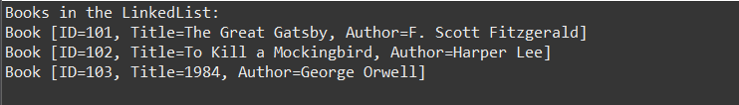

**10. Clone a LinkedList**

Write a program to:

* Create a LinkedList of numbers.
* Clone it using the clone() method.
* Display both original and cloned lists.

import java.util.LinkedList;

public class LL10{

public static void main(String[] args) {

LinkedList<Integer> originalList = new LinkedList<>();

originalList.add(10);

originalList.add(20);

originalList.add(30);

originalList.add(40);

System.out.println("Original LinkedList: " + originalList);

LinkedList<Integer> clonedList = (LinkedList<Integer>) originalList.clone();

System.out.println("Cloned LinkedList: " + clonedList);

originalList.add(50);

clonedList.removeLast();

System.out.println("\nAfter modifications:");

System.out.println("Original LinkedList: " + originalList);

System.out.println("Cloned LinkedList: " + clonedList);

}

}

**OUTPUT:**

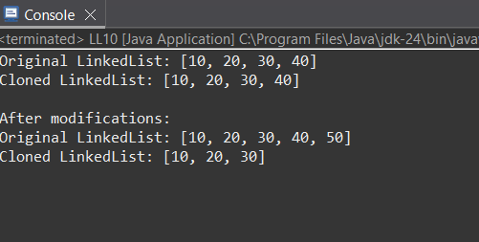

Vector

* **Create a Vector of integers** and perform the following operations:
* Add 5 integers to the Vector.
* Insert an element at the 3rd position.
* Remove the 2nd element.
* Display the elements using Enumeration.
* **Create a Vector of Strings** and:
* Add at least 4 names.
* Check if a specific name exists in the vector.
* Replace one name with another.
* Clear all elements from the vector.
* **Write a program** to:
* Copy all elements from one Vector to another Vector.
* Compare both vectors for equality.
* **Write a method** that takes a Vector<Integer> and returns the **sum of all elements**.

import java.util.Enumeration;

import java.util.Vector;

public class Vector1 {

public static void main(String[] args) {

Vector<Integer> intVector = new Vector<>();

intVector.add(10);

intVector.add(20);

intVector.add(30);

intVector.add(40);

intVector.add(50);

System.out.println("1. Original Integer Vector: " + intVector);

intVector.add(2, 25);

System.out.println(" After inserting 25 at position 3: " + intVector);

intVector.remove(1);

System.out.println(" After removing 2nd element: " + intVector);

System.out.println(" Elements using Enumeration:");

Enumeration<Integer> enumInt = intVector.elements();

while (enumInt.hasMoreElements()) {

System.out.println(" " + enumInt.nextElement());

}

Vector<String> strVector = new Vector<>();

strVector.add("Alice");

strVector.add("Bob");

strVector.add("Charlie");

strVector.add("David");

System.out.println("\n2. Original String Vector: " + strVector);

String searchName = "Bob";

System.out.println(" Does '" + searchName + "' exist? " +

strVector.contains(searchName));

strVector.set(2, "Eve");

System.out.println(" After replacing Charlie with Eve: " + strVector);

strVector.clear();

System.out.println(" After clearing: " + strVector);

Vector<Integer> copyVector = new Vector<>(intVector);

System.out.println("\n3. Copied Vector: " + copyVector);

System.out.println("4. Sum of elements: " + sumVector(intVector));

}

public static int sumVector(Vector<Integer> vec) {

int sum = 0;

for (int num : vec) {

sum += num;

}

return sum;

}

}

**OUTPUT:**

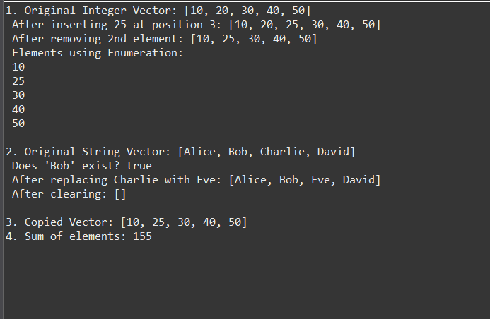

**Stack**

* Understand how to use the Stack class for LIFO (Last In, First Out) operations.
* **Create a Stack of integers** and:
* Push 5 elements.
* Pop the top element.
* Peek the current top.
* Check if the stack is empty.
* **Reverse a string using Stack**:
* Input a string from the user.
* Use a stack to reverse and print the string.
* **Use Stack to check for balanced parentheses** in an expression.
* Input: (a+b) * (c-d)
* Output: Valid or Invalid expression
* **Convert a decimal number to binary using Stack**.

import java.util.Stack;

import java.util.Scanner;

public class Stack1{

public static void main(String[] args) {

Scanner scanner = new Scanner(System.in);

Stack<Integer> numStack = new Stack<>();

numStack.push(10);

numStack.push(20);

numStack.push(30);

numStack.push(40);

numStack.push(50);

System.out.println("Stack after pushes: " + numStack);

System.out.println("Popped: " + numStack.pop());

System.out.println("Stack after pop: " + numStack);

System.out.println("Current top: " + numStack.peek());

System.out.println("Is stack empty " + numStack.empty());

System.out.print("\nEnter a string to reverse: ");

String input = scanner.nextLine();

Stack<Character> charStack = new Stack<>();

for (char c : input.toCharArray()) {

charStack.push(c);

}

StringBuilder reversed = new StringBuilder();

while (!charStack.empty()) {

reversed.append(charStack.pop());

}

System.out.println("Reversed string: " + reversed);

System.out.print("\nEnter an expression to check parentheses: ");

String expr = scanner.nextLine();

System.out.println("Parentheses balanced " + isBalanced(expr));

scanner.close();

}

private static boolean isBalanced(String expr) {

Stack<Character> stack = new Stack<>();

for (char c : expr.toCharArray()) {

if (c == '(') {

stack.push(c);

} else if (c == ')') {

if (stack.empty()) return false;

stack.pop();

}

}

return stack.empty();

}

}

**OUTPUT:**

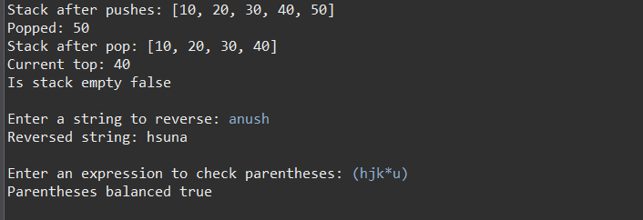

HashSet

1. **Create a HashSet of Strings**:
   * Add 5 different city names.
   * Try adding a duplicate city and observe the output.
   * Iterate using an Iterator and print each city.
2. **Perform operations**:
   * Remove an element.
   * Check if a city exists.
   * Clear the entire HashSet.
3. **Write a method** that takes a HashSet<Integer> and returns the maximum element.

import java.util.HashSet;

import java.util.Iterator;

import java.util.Scanner;

public class Hashset1{

public static void main(String[] args) {

Scanner scanner = new Scanner(System.in);

HashSet<String> cities = new HashSet<>();

cities.add("New York");

cities.add("London");

cities.add("Tokyo");

cities.add("Paris");

cities.add("Delhi");

System.out.println("Original HashSet: " + cities);

boolean added = cities.add("London");

System.out.println("'London' added " + added);

System.out.println("HashSet after adding: " + cities);

System.out.println("\nCities using Iterator:");

Iterator<String> iterator = cities.iterator();

while (iterator.hasNext()) {

System.out.println(iterator.next());

}

cities.remove("Delhi");

System.out.println("\nAfter removing 'Delhi': " + cities);

System.out.print("\nEnter city to check: ");

String city = scanner.nextLine();

System.out.println("Contains '" + city + "'? " + cities.contains(city));

cities.clear();

System.out.println("\nAfter clear(): " + cities);

System.out.println("Is empty " + cities.isEmpty());

HashSet<Integer> numbers = new HashSet<>();

numbers.add(10);

numbers.add(5);

numbers.add(20);

numbers.add(15);

System.out.println("\nInteger HashSet: " + numbers);

System.out.println("Max value: " + findMax(numbers));

scanner.close();

}

private static int findMax(HashSet<Integer> set) {

int max = Integer.MIN_VALUE;

for (int num : set) {

if (num > max) max = num;

}

return max;

}

}

**OUTPUT:**

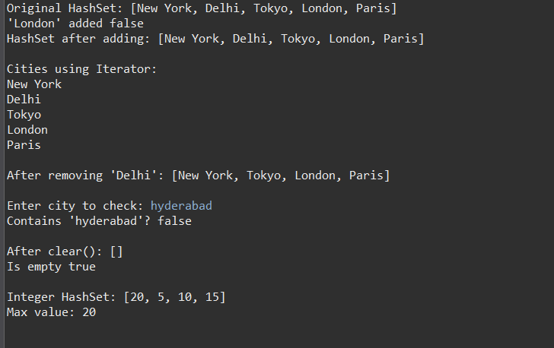

Queue

1. **Bank Queue Simulation**:
   * Create a queue of customer names using Queue<String>.
   * Add 5 customers to the queue.
   * Serve (remove) customers one by one and print the queue after each removal.
2. **Task Manager**:
   * Queue of tasks (String values).
   * Add tasks, peek at the next task, and poll completed tasks.
3. **Write a method**:
   * That takes a queue of integers and returns a list of even numbers.

import java.util.ArrayList;

import java.util.LinkedList;

import java.util.List;

import java.util.Queue;

public class Queue1{

public static void main(String[] args) {

Queue<String> customerQueue = new LinkedList<>();

customerQueue.add("Customer 1");

customerQueue.add("Customer 2");

customerQueue.add("Customer 3");

customerQueue.add("Customer 4");

customerQueue.add("Customer 5");

System.out.println("Bank Queue:");

while (!customerQueue.isEmpty()) {

String customer = customerQueue.poll();

System.out.println("Serving: " + customer);

System.out.println("Remaining queue: " + customerQueue);

}

Queue<String> tasks = new LinkedList<>();

tasks.add("Print reports");

tasks.add("Email clients");

tasks.add("Update database");

System.out.println("\nNext task: " + tasks.peek());

System.out.println("Completed: " + tasks.poll());

System.out.println("Remaining tasks: " + tasks);

Queue<Integer> numberQueue = new LinkedList<>();

numberQueue.add(1);

numberQueue.add(2);

numberQueue.add(3);

numberQueue.add(4);

numberQueue.add(5);

System.out.println("\nEven numbers: " + getEvens(numberQueue));

}

private static List<Integer> getEvens(Queue<Integer> queue) {

List<Integer> evens = new ArrayList<>();

for (Integer num : queue) {

if (num % 2 == 0) evens.add(num);

}

return evens;

}

}

**OUTPUT:**

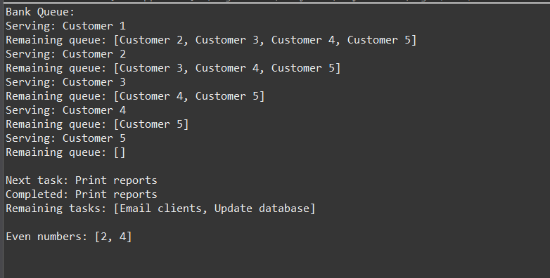

**PriorityQueue**

1. **Hospital Emergency Queue**:
   * Create a class Patient with fields: name and severityLevel (int).
   * Use PriorityQueue<Patient> with a comparator to serve the most critical patients first (highest severityLevel).
2. **Print Jobs Priority**:
   * Add different print jobs (String) with priority levels.
   * Use PriorityQueue to simulate serving high-priority jobs before others.
3. **Write a method**:
   * To merge two PriorityQueue<Integer> and return a sorted merged queue.

import java.util.PriorityQueue;

import java.util.Comparator;

public class PriorityQueue1 {

public static void main(String[] args) {

PriorityQueue<Patient> emergencyQueue = new PriorityQueue<>(

Comparator.comparingInt(Patient::getSeverity).reversed()

);

emergencyQueue.add(new Patient("Jay", 3));

emergencyQueue.add(new Patient("Sarath", 5));

emergencyQueue.add(new Patient("Mani", 1));

System.out.println("Hospital Queue (Most critical first):");

while (!emergencyQueue.isEmpty()) {

System.out.println("Treating: " + emergencyQueue.poll());

}

PriorityQueue<PrintJob> printQueue = new PriorityQueue<>(

Comparator.comparingInt(PrintJob::getPriority)

);

printQueue.add(new PrintJob("Document", 2));

printQueue.add(new PrintJob("Urgent Report", 1));

printQueue.add(new PrintJob("Presentation", 3));

System.out.println("\nPrint Jobs (Priority order):");

printQueue.forEach(System.out::println);

}

}

class Patient {

String name;

int severity;

public Patient(String name, int severity) {

this.name = name;

this.severity = severity;

}

public int getSeverity() { return severity; }

@Override

public String toString() {

return name + " (Severity: " + severity + ")";

}

}

class PrintJob {

String name;

int priority;

public PrintJob(String name, int priority) {

this.name = name;

this.priority = priority;

}

public int getPriority() { return priority; }

@Override

public String toString() {

return name + " (Priority: " + priority + ")";

}

}

**OUTPUT:**

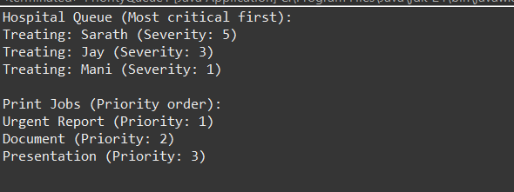

**Deque**

1. **Palindrome Checker**:
   * Input a string and check if it is a palindrome using a Deque<Character>.
2. **Double-ended Order System**:
   * Add items from front and rear.
   * Remove items from both ends.
   * Display contents of the deque after each operation.
3. **Browser History Simulation**:
   * Implement browser back and forward navigation using two deques.

import java.util.ArrayDeque;

import java.util.Deque;

import java.util.Scanner;

public class DeQueue1 {

public static void main(String[] args) {

Scanner scanner = new Scanner(System.***in***);

System.***out***.print("Enter a string to check for palindrome: ");

String input = scanner.nextLine();

System.***out***.println("Is palindrome? " + *isPalindrome*(input));

Deque<String> deque = new ArrayDeque<>();

deque.addFirst("Front 1");

deque.addLast("Rear 1");

deque.addFirst("Front 2");

deque.addLast("Rear 2");

System.***out***.println("\nDeque after additions: " + deque);

System.***out***.println("Removed from front: " + deque.removeFirst());

System.***out***.println("Removed from rear: " + deque.removeLast());

System.***out***.println("Deque after removals: " + deque);

}

private static boolean isPalindrome(String str) {

Deque<Character> deque = new ArrayDeque<>();

for (char c : str.toCharArray()) {

deque.addLast(c);

}

while (deque.size() > 1) {

if (!deque.removeFirst().equals(deque.removeLast())) {

return false;

}

}

return true;

}

}

**OUTPUT:**

