Neural Network and Deep Learning

ICP-2

Name – VIVEK BACHU

700 Number- 700756073

CRN- 30828

GitHub link - <https://github.com/bachuvivek/NNDL--2>

Drive Link - <https://drive.google.com/drive/u/1/folders/1KZQF5AYFQIeA2I1KqsOfOg12OS80UHdR>

1) Here I took two strings as input- first name, last name. Pass these variables as input and return the full name. A function named “string alternative” that returns every other char in the full name string.

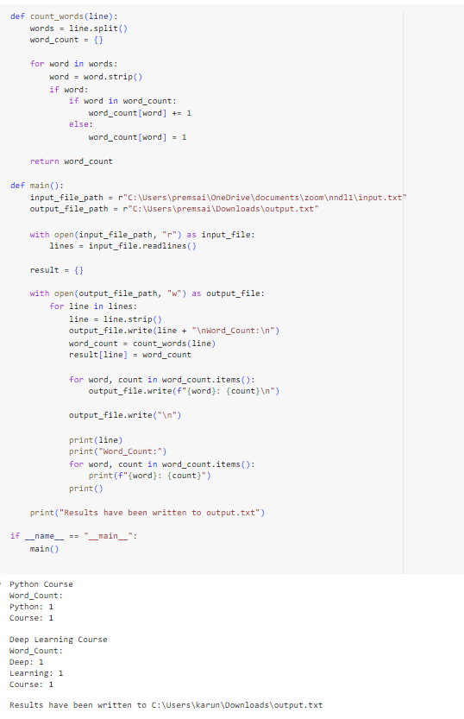

2) An input file includes two lines(input.txt). Function counts_words will take each line as input and give the word count. I stored the output in output.txt.

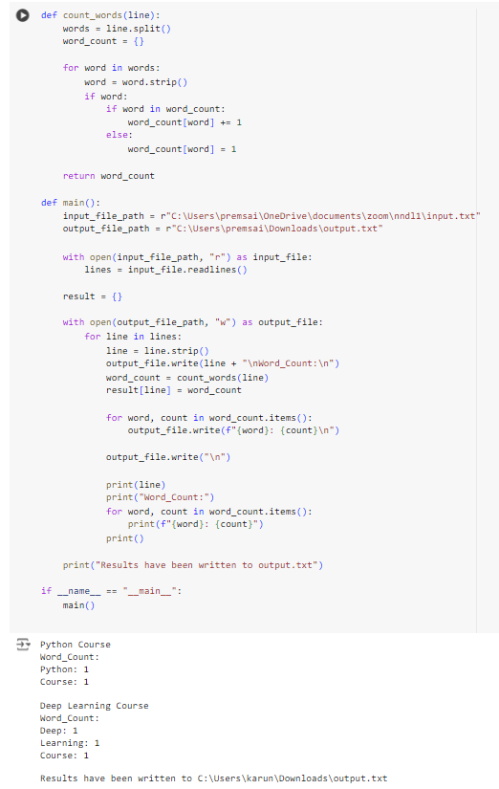

3) I took heights in inches of customers into a list as input. I wrote a function inches_to_centimeters) to convert the list into centimeters.

