The connotative meanings of sound symbolism in brand names: A conceptual framework

ABSTRACT
Phonetic elements of brand names can convey a range of specific meanings. However, an integrated understanding of the sound symbolism of brand names remains elusive. Here, we classify sound symbolism in brand names based on three key dimensions of the semantic differential (evaluation, potency, and activity). In particular, we demonstrated that the sound symbolism of brand names can be explained in terms of the two dimensions of evaluation and potency (but not activity). The presence of higher-frequency sounds (front vowels, fricative, and voiceless consonants) in brand names tends to be associated with concepts linked to higher evaluation and lower potency, whereas lower-frequency sounds (back vowels, stop, and voiced consonants) tend to be more strongly associated with concepts linked to lower evaluation and higher potency. This study provides an integrative understanding of sound symbolism in brand names in terms of semantic differential meanings.
Keywords: Phonetics; Brand names; Sound symbolism; Semantic meanings; Vowels; Consonants
1. Introduction
According to many commentators, brand name is one of the most important assets possessed by a brand (e.g., Keller et al., 1998; Klink & Wu, 2014). Brand names often represent the first point of contact between the consumer and a given brand, thereby helping to set consumers’ initial impressions and expectations concerning the latter (Keller et al., 1998). For this reason, companies have increasingly been investing their resources (both time and money) in trying to develop the most effective, and hopefully successful, new brand names. Although brand names are sometimes created on the basis of nothing more than the founders’ intuitions, a meaningful brand name is beneficial for most businesses, thereby highlighting the importance of this field of research.
Research has demonstrated that brand names provide a useful means of conveying relevant information about product features and/or benefits to consumers (Keller et al., 1998; Pavia & Costa, 1993). A number of major new product failures in the marketplace have been attributed to the choice of an inappropriate brand name (e.g., as in the case of the ill-fated Ford Edsel; Wallace, 1975; see also Klink, 2001).
One promising strategy is to create brand names using sound phonetics, specifically sound symbolism (Klink, 2001; Spence, 2012; Sprott & Liu, 2016). Sound symbolism can link phonetic sounds to certain meanings (e.g., soft sounds to pleasant product attributes; e.g., Klink, 2001). Over the past few decades, a number of consumer researchers have investigated the role of phonetics in brand naming (e.g., Klink, 2001; Lowrey & Shrum, 2007; Yorkston & Menon, 2004) and as a result, empirical research on the relevance of sound symbolism in brand naming has broadened rapidly (e.g., Roche, Shrum, & Lowrey, 2015; Spence, 2012, for reviews). By systematically manipulating the vowels and consonants in brand names, a growing body of evidence demonstrates that the specific sounds present in brand names (e.g., /i/ or /o/) help convey specific meanings or prime particular product attributes (e.g., smallness, sweetness; Klink, 2000; Motoki et al., 2020).
This study relies on the theory of the meaning of concepts originally proposed by Osgood et al. (1957) to provide an integrative framework for understanding the symbolic meanings that customers are likely to associate with specific brand names. Several studies have demonstrated that speech sounds embedded in (hypothetical) brand names can convey various meanings or attributes (e.g., small, sweet, heavy, friendly, soft, mild, strong, healthy, bitter; e.g., Klink, 2000; Motoki et al., 2020). However, the integrative and theoretical understanding of the role of sound symbolism in the creation of brand names remains a topic that is still comparatively unexplored. Why and how do the sounds that may be contained in brand names convey or prime various attributes? What psychological mechanisms can explain this phenomenon? One intriguing possibility relates to the connotative meaning of speech sounds (Sidhu & Pexman, 2018). Relying on the theoretical framework of the semantic differential meaning of concepts (Osgood et al., 1957), this research aims to provide an integrative and theoretical understanding of the role of sound symbolism in brand name development.
We begin by explaining sound symbolism in general and briefly explain phonetic terms (e.g., vowels and consonants). Next, we review previous findings in the field of sound symbolism concerning brand names and develop the theoretical framework behind the phenomenon. Finally, we identified several outstanding issues that can only be addressed by future research to further our mechanistic understanding in this area.
2. Sound symbolism
Sound symbolism refers to the claim that the mappings between the phonetic properties of speech sounds and their meanings are non-arbitrary (e.g., Knoeferle, Li, Maggioni, & Spence, 2017; Sidhu & Pexman, 2018). The debate on phonetic sounds and their meaning is by no means new, dating back to at least 400 BC (Plato, 1892). Almost a century ago, Köhler and Sapir both demonstrated empirical findings supporting the existence of sound symbolism (Köhler, 1929; Sapir, 1929). Köhler showed that when presented with a choice between a round and angular shape, people tend to associate the round shape with the name ‘baluma’, while associating the angular shape with the name (‘takete’) instead. Sapir, meanwhile, demonstrated that people tend to associate front vowels (e.g., /i/ in the word Mil) with a small object and back vowels (e.g., /a/ in the word Mal) with a large object. In recent years, a growing body of research has demonstrated the prevalence of sound symbolism in languages and its significant role in cognition, emotions, and human (and consumer) behavior (Blasi et al., 2016; Knoeferle et al., 2017; Sidhu & Pexman, 2018; see Figure 1). For example, the concepts of smallness and roundness tend to be associated with /i/ and /r/, respectively, in many languages (Blasi et al., 2016).
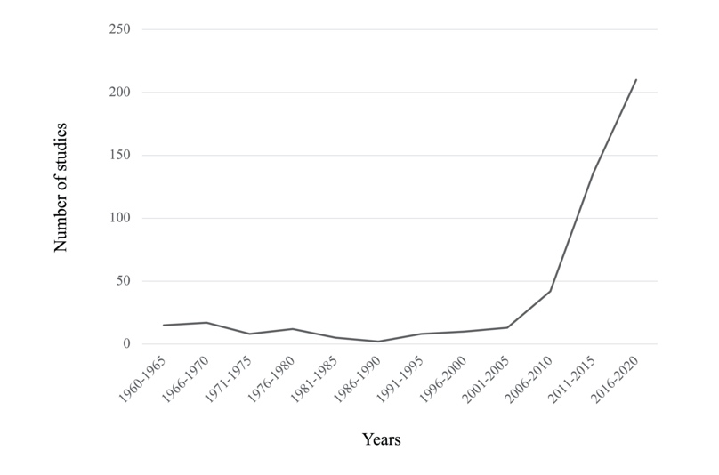
Fig. 1. Number of studies on sound symbolism published from 1960 to 2020. Search performed in December 2021, using the term “sound symbolism” or “phonetic symbolism” in the title, abstract, keywords.
2.1. The sound symbolic ‘meaning’ of vowels and consonants
It is important to explain the key phonetic features often discussed in the literature (see Table 1). Speech sounds can be segregated into vowels and consonants. Vowels are classified as either front (e.g., /i/, /e/) or back vowels (e.g., /o/, /u/), depending on the position of the tongue at the time of their utterance (i.e., front vs. back position of the tongue). Consonants can be categorized into fricatives and stops or voiceless and voiced in terms of their manner of articulation (i.e., the degree to which the oral tract of the mouth is closed off by the articulators--teeth, tongue, and lips--during their utterance) and the accompanying vibration of the vocal cords (Sidhu & Pexman, 2018; see Table 1 for a summary).
Table 1 Definitions of linguistic terms (vowels and consonants) used throughout the review
Sounds | Definitions | Examples
Front vowels | Articulated with the tongue relatively in front of the mouth. | /i/, /e/
Back vowels | Articulated with the tongue relatively back of the mouth. | /u/, /o/
Fricative consonants | Involving less closure of the articulators than a stop sound and produced by squeezing the air between a small gap as it leaves the mouth. | /f/, /s/, /v/, /z/
Stop consonants | Produced by complete closure of the articulators, such that all the airflow ceases in the mouth. | /p/, /t/, /b/, /d
Voiceless consonants | Produced without any vibration of the vocal cords. | /f/, /s/, /p/, /t/
Voiced consonants | Produced with the vibrations of the vocal cords. | /v/, /z/, /b/, /d/

2.2. Consumer evaluation of sound symbolism in brand names
A large body of research on sound symbolism has potential relevance to the development of more effective brand names. Those in charge of naming brands have used knowledge of sound symbolism to effectively communicate product attributes with consumers via the development of sound-symbolic brand names (e.g., see Abel & Glinert, 2008; Kumagai & Kawahara, 2020; Lowrey & Shrum, 2007). Over the years, several studies have demonstrated that consumers tend to associate vowels and consonants incorporated into brand names with different product attributes across a wide variety of product categories, from durable goods (e.g., cars, laptops, computers), daily goods (e.g., toilet paper, cleaner), fashion items (e.g., dresses, cologne) to foods and beverages (e.g., ice cream and beer), pharmaceutical drugs, and retail store evaluations (e.g., Abel & Glinert, 2008; Ketron & Spears, 2019, 2021; Klink 2000; Lowrey & Shrum 2007; Yorkston & Menon 2004; Park et al. 2020; Pathak et al. 2020). For example, according to Abel and Glinert (2008) and Klink (2000), brand names containing voiceless (versus voiced) consonants tend to be rated as smaller, sharper, more feminine, faster, and lighter (in terms of weight).
Notably, research in this area has often used crossmodal correspondences as the explanatory mechanism behind these linkages (Knöferle & Spence, 2012; Spence, 2011). Crossmodal correspondence refers to the tendency of people to map seemingly unrelated stimulus properties from different sensory modalities onto each other in a highly consistent/consensual manner (Knöferle & Spence, 2012; Koriat, 2008; Spence, 2011). For example, the majority of people would match high-pitched tones with small, elevated, fast, and light visual stimuli, whereas low-pitched tones would match with big, low, slow, heavy, and dark visual stimuli. Sound symbolism can thus be conceptualized as a subset of all crossmodal correspondences (namely those specifically involving speech sounds; see Spence, 2011, on this suggestion).
3. Conceptual framework of sound symbolism in brand names
Our aim is to use Osgood et al.’s (1957) theory of semantic differential (evaluation, potency, and activity) as the underlying theoretical foundation for building a conceptual framework that can explain the use of sound symbolism in brand name development. Although two decades of research in this area has generated a wide range of empirical findings (e.g., Spence, 2012 for a review), an underpinning theoretical framework and integrative understanding remain elusive. Moreover, to date, research on sound symbolism has not fully explored the connotative meanings of sounds embedded in names (Sidhu & Pexman, 2018). The framework outlined here provides insight into why certain sounds may be associated with particular attributes. Our framework also aims to provide the underlying psychological mechanisms that will help strengthen the theoretical underpinnings and enable researchers to better explain their findings in brand naming research.
3.1. The framework of meanings of concepts
A common semantic space may help explain sound symbolism’s involvement in the meanings primed/associated with brand names. Potentially relevant here, Osgood and his colleagues proposed a framework of concept meanings that is today known as the ‘semantic differential technique’ (Osgood et al., 1957; Snider & Osgood, 1969). These researchers measured the meanings of a wide array of concepts on a diverse array of bipolar adjective scales (e.g., good-bad, strong-weak; Osgood et al., 1957). Three dimensions (evaluation, potency, and activity) of the meanings of concepts were often identified using factor analyses (e.g., Osgood et al., 1957; Osgood & Suci, 1955; see Figure 2). Evaluation is measured by items such as positive–negative and good–bad. Potency is measured by items such as strong-weak and heavy-light, while activity is measured by items such as active-passive and fast-slow (Osgood et al., 1957). Note that evaluation and activity are considered to correspond to the two dimensions of core affect (valence and arousal; e.g., Cespedes-Guevara & Eerola, 2018). Moreover, evaluation, activity, and potency are often aligned with pleasure, arousal, and dominance, respectively, in the PAD emotion model (see Mehrabian, 1996).
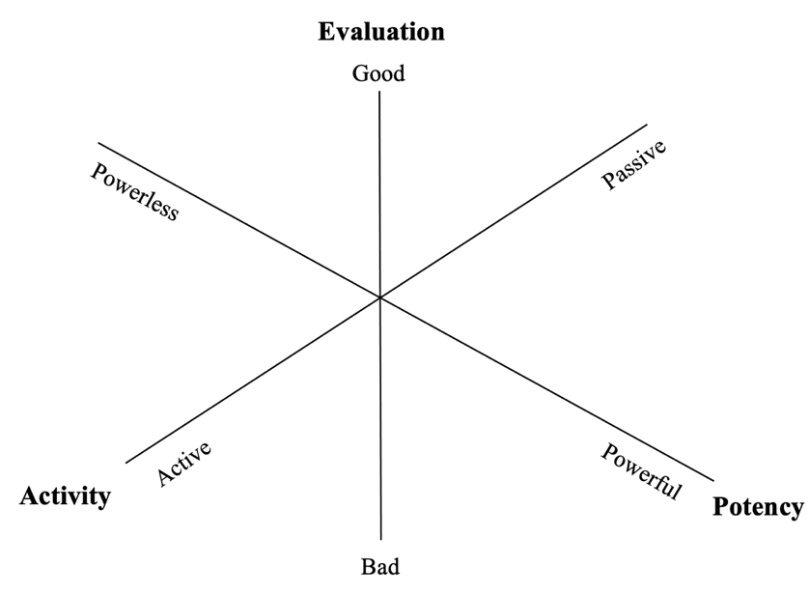
Fig. 2. Visual illustration of three dimensions of semantic space based on Osgood et al.’s (1957) EPA framework.
The semantic differential approach has been used for decades (Clevenger et al., 1965; Kelly & Stephenson, 1967; Park et al., 2020) in a diverse range of marketing and consumer research topics, such as retail patronage appeals (Kelly & Stephenson, 1967), corporate image (Clevenger et al., 1965), and assessing brand image, to name a few (Kelly & Stephenson, 1967; Park et al., 2020).
3.2. Connotative meanings as a potential mechanism underlying sound symbolism in brand names
Connotative meanings have been regarded as a potential mechanism underlying brand name sound symbolism (Sidhu & Pexman, 2018). Sound-symbolic associations might arise because of the shared connotative meanings between phonemes (e.g., front vowels) and attributes (e.g., smallness; Abel & Glinert, 2008; Gallace et al., 2011; Sidhu & Pexman, 2018). Phonetic features (e.g., vowels and consonants) are associated with a range of connotative meanings (e.g., Klink, 2001; Park et al., 2020), and these connotative meanings might prime the associated consumer behavior. Several studies empirically support the account of shared connotative meanings (e.g., Gallace et al., 2011; Park et al., 2020). Recently, Park et al. demonstrated that connotative meanings associated with phonetic features influence consumers’ evaluation of medicines. These researchers revealed that two of the connotative (or semantic differential) dimensions (potency and activity) associated with voiced consonants influence the effect of product-related expectancies in fictional pharmaceutical brand names. Specifically, names containing voiced (vs. voiceless) consonants induced higher ratings of potency and activity, which, in turn, led to various expectations concerning the attributes of the pharmaceutical product concerned (e.g., expected efficacy and potential side effects). These authors suggested that sound symbolism might convey similar connotative meanings (e.g., ‘if it is light, it might be fast’ association).
Although extensive research on sound symbolism has identified the relationship between speech sounds present in brand names and individual brand attributes (Table 1), an integrated understanding of the contribution of sound symbols to brand name development remains unexplored. Relying on the semantic differential framework of the meaning of concepts (Osgood et al., 1957), we explored how the three dimensions of connotative meanings can explain the effects of sound symbolism on brand names. First, we systematically identified published literature that investigated the effect of sound symbolism on brand names (Table 1). Next, we coded the attributes reported in these papers along the three key connotative differential dimensions (evaluation, potency, and activity) (see the section below for details on coding) and analyzed the data to explore the relationship between vowels/consonants and the three principal dimensions (i.e., evaluation, potency, and activity).
4. The connotative meanings of sound symbolism in brand names: A systematic review
4.1. Identifying relevant publications
We first identified relevant publications using a search term (see Appendix A for details). The studies identified using the search terms are listed in Appendix Table A2. A flowchart of the systematic review is shown in Figure 3.
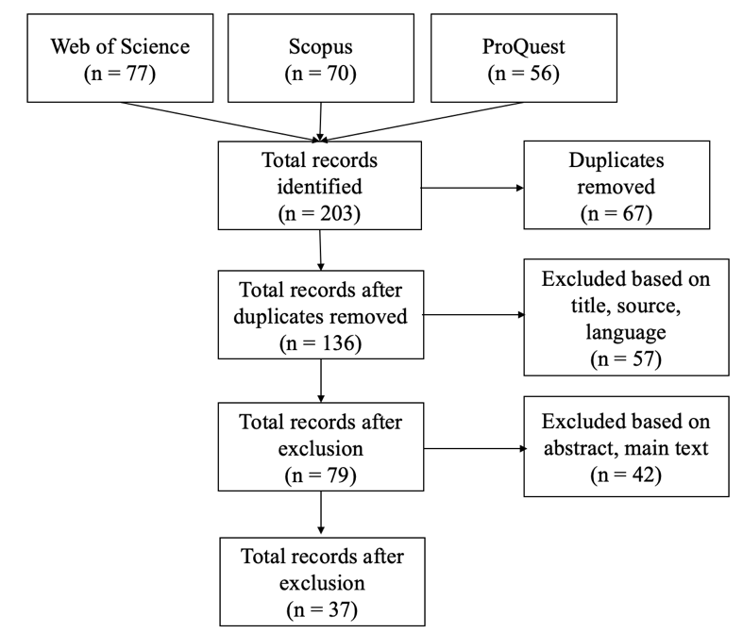
Fig. 3. Flow chart of the systematic review.
4.2. Data coding
We classified each of the attributes reported in previous research based on three principal semantic differential dimensions (i.e., Evaluation, Potency, Activity; Osgood et al., 1957). Attributes were selected from the main dependent variables of the identified studies (see Appendix Table 2A). Two raters independently rated the evaluation (higher evaluation, lower evaluation, not applicable), activity (more active, less active, not applicable), and potency (more potent, less potent, not applicable) for each of the 41 attributes (see Appendix B for details). When at least one of the raters rated the attributes as ‘not applicable, they were excluded from subsequent analyses. The detailed procedures are shown in Appendix B. Finally, 21 attributes were chosen for evaluation (15 attributes of higher evaluation, 6 attributes of lower evaluation), 19 attributes for potency (9 attributes of higher potency, 10 attributes of lower potency), and 17 attributes for activity (14 attributes of higher activity, 3 attributes of lower activity) (see Appendix C). Next, we discuss the results based on vowels and two types of consonants (fricative/stop, voiceless/voiced) because the majority of previous studies have used these sounds (see Appendix Table A). It should be noted that the attributes related to evaluation, potency, and activity are not mutually exclusive and can overlap. For example, an attribute (e.g., sweet) can be classified in two dimensions at the same time, that is, evaluation (higher evaluation) and potency (lower potency). Because of this overlap, the total number of attributes at the starting point (41 attributes) is not equal to the total number of attributes at the end (57 attributes).
4.3. Evaluation
We conducted a binomial test to investigate whether the frequency of the associations between higher (lower) evaluation and higher (lower) frequency sounds differed from that of their counterparts [i.e., lower (higher) evaluation and higher (lower) frequency of sounds)] (see Table 2). The results of the binomial test revealed that a higher (lower) evaluation was more associated with a higher (lower) frequency of sounds (39/51, 76.47%) than their counterparts (12/51, 23.53%) (p < .001). g = 0.265).
Table 2 The relations between semantic meanings and the frequency of the speech sounds
 | Evaluation
 | Higher (lower) evaluation | Lower (higher) evaluation
Higher (lower) frequency | 39 (76.47%) | 12 (23.53%)
 | Potency
 | More (less) potent | Less (more) potent
Higher (lower) frequency | 2 (2.56%) | 76 (97.44%)
 | Activity
 | More (less) active | Less (more) active
Higher (lower) frequency | 27 (62.79%) | 16 (37.21%)

4.4. Potency
A binomial test was conducted to investigate whether the frequency of the associations between more (less) potency and lower (higher) frequency of sounds differed from that of their counterparts [i.e., less (more) potency and higher (lower) frequency of sounds)] (Table 3). The results of the binomial test revealed that more (less) potency was associated with a lower (higher) frequency of sounds (76/78, 97.44%) than their counterparts (2/78, 2.56%) (p < .001, g = 0.474).
4.5. Activity
A binomial test was conducted to investigate whether the frequency of the associations between more (less) activity and higher (lower) frequency of sounds differed from that of their counterparts [i.e., less (more) activity and higher (lower) frequency of sounds)] (Table 3). Binomial test results did not reveal any significant differences. That is, the associations between more (less) activity and higher (lower) frequency of sounds (27/43, 62.79%) did not differ from those of their counterparts (16/43, 37.21%; p = .126, g = 0.128). It should also be noted that “non-significant differences” might reflect lower power (i.e., a small N).
However, it seems that there were no meaningful associations with the activity dimension for either vowels or consonants. Some attributes associated with more activity (e.g., faster, sharper, lighter color, lighter relative to heavier) are consistently linked to higher (vs. lower) frequency speech sounds, whereas others are associated with more activity (e.g., more rugged, arousing, strong) and are linked to lower (vs. higher) frequency speech sounds. Activity-related attributes might be explained by evaluation and potency dimensions rather than activity. For example, lighter colors are classified as more active and higher in terms of evaluation, according to our connotative categorizations. Although previous research shows that a ‘lighter color’ is associated with higher (vs. lower) frequency speech sounds, this association might be derived from higher evaluation and not necessarily from more activity. Similarly, ‘more rugged” was classified as more active, more potent, and lower in terms of evaluation in our connotative categorizations. The observed association between ‘ruggedness’ and lower frequency sounds might be explained by lower evaluation and more potency and not from more activity. This possibility has been tested in a follow-up study.
5. The connotative meanings of sound symbolism in brand names: an empirical follow-up test
A follow-up study was conducted to empirically test our theoretical framework based on semantic space. Our coding analyses of the semantic differential meanings of previous research revealed that evaluation and potency (but not activity) underlie the sound symbolic effects in brand names. Our follow-up study empirically tested for the semantic differential meanings underlying the sound symbolic effects of brand names by focusing on some attributes (e.g., sharpness, light weight, ruggedness) associated with the activity dimension. Even though some attributes (e.g., sharp, light in weight, ruggedness) are associated with the activity dimension (sharp, light in weight, ruggedness), it is likely that these sound symbolic associations might be explained by the other two connotative dimensions (namely evaluation and potency).
5.1. Participants and procedure
Data from 154 participants were obtained (mean age of participants was 42.28 years, SD of age 8.68, males 108, females 46). The sample size was determined using an a priori power analysis (Faul et al., 2007). We estimated that a sample size of 147 would be sufficient to detect dz = 0.30) with a 95% power at α = 0.05. Based on this calculation, we aimed to recruit N=150 and collect data from 154 participants. The participants were recruited from Lancers, and the experiment was conducted using the Qualtrics platform. Three pairs of fictitious brand names were created such that each pair contained higher- (f, s, i, e) or lower-frequency (b, d, g, o, u) vowels and consonants (Fise/Gubo, Fensen/Dongon, Selfam/Boldum) (see Klink & Wu 2014; Motoki et al. 2021). Three product categories and their attributes associated with the activity dimension were used (sharp sound of earphones, lightweight laptop, and rugged personality of a beer brand) to cover diverse products (i.e., hedonic and utilitarian products, food, and household products).
Participants were invited to rate the expected sharpness of the sound of earphones, the expected weight of a laptop, and the rugged personality of a beer brand with hypothetical brand names. For each of the product categories (earphones, laptop, beer), the participants saw two hypothetical brand names (e.g., “Selfam,” “Boldum”) and rated the expected attributes. Three pairs of hypothetical brand names with contrasting frequencies of sounds were used (Fise/Gubo, Fensen/Dongon, and Selfam/Boldum). The order of presentation of the brand name-product category pairing was counterbalanced between participants. The order of the two hypothetical brand names and the three product categories was randomized on a within-participant basis. The ratings were made on a 7-point Likert scale (1 = “not at all” to 7 = “very much”). The two expected attributes (i.e., the sharpness of the sound and the light weight of the laptop) were measured using a single item. Ruggedness was measured using the mean ratings of two items (toughness and masculinity; r = .843). Six trials were conducted in total. Next, the participants evaluated the three dimensions of the connotative meanings of six fictitious brand names (Fise/Gubo, Fensen/Dongon, Selfam/Boldum) on a seven-point bipolar semantic differential scale: evaluation (nice–awful, good-bad, mild–harsh, happy–sad; α = .852), potency (powerless–powerful, weak–strong, light–heavy, shallow–deep; α = .899), and activity (slow-fast, quiet/noisy, passive–active, dead–alive; α = .241) (Park et al., 2020; Velasco et al., 2016).
The alpha value of the activity dimension indicated a low level of reliability. To clarify this further, we conducted additional analyses (see Appendix D for further details). The results of the principal component analysis identified two components: one associated with potency (powerless–powerful, weak–strong, light–heavy, shallow–deep, quiet–noisy, passive–active) and the other with evaluation (awful–nice, bad-good, sad–happy, slow-fast, dead-alive). Notably, the two items of the activity dimension (quiet–noisy and passive–active) were loaded on the potency component. The other two items of the activity dimension (slow-fast and dead-alive) were loaded on the evaluation component. This supports our theoretical framework and suggests that even items of the activity dimension can be classified as evaluation and potency in the sound symbolism of hypothetical brand names. Although the alpha value of the activity dimension was lower in reliability, for completeness, we report all results here.
5.2. Statistical analyses
Paired t-tests were used to investigate the effect of the frequency of sounds present in brand names on expected product attributes, brand personality, and the three dimensions of connotative meanings. Given the low reliability of the activity dimension, we also report the results of the analyses investigating the effect of the frequency of sounds on each item of the activity dimension (see Appendices E-F for details).
Within-participant mediation analysis was also conducted for each product category and its associated attributes (i.e., the sharp sound of the earphones, the light weight of the laptop, and the rugged hunk personality’ of the beer). For mediation analyses, MEMORE (Montoya & Hayes, 2017) with 5,000 bootstrapped samples was used. The frequency of sounds (higher versus lower) was entered as the predictor variable, three dimensions of connotative meanings (evaluation, potency, and activity) as the mediator, and attribute expectation/brand personality rating as the dependent variable.
5.3. Results
5.3.1. Attributes expectation
The participants expected the hypothetical brand names containing higher (vs. lower) frequency sounds to have sharper sounds (M_{higher} = 4.89±1.14 vs. M_{lower} = 2.57±1.20; t₁₅₃ = 15.923, p < .001, dz = 1.283), lighter weight (M_{higher} = 5.38±1.00 vs. M_{lower} = 2.53±1.20;t₁₅₃ = 18.498, p < .001, dz = 1.491), and less ruggedness in ‘personality’ (M_{higher} = 3.06±1.18 vs. M_{lower} = 5.61±0.85; t₁₅₃ = -20.709, p < .001, dz = -1.669).
5.3.2. Evaluation, potency, and activity
The rating of evaluation was higher for those hypothetical brand names that contained higher (vs. lower) frequency sounds for the earphones (M_{higher} = 5.07±0.71 vs. M_{lower} = 3.64±0.77; t₁₅₃ = 15.908, p < .001, dz = 1.282), laptop (M_{higher} = 5.03±0.76 vs. M_{lower} = 3.69±0.80; t₁₅₃ = 14.593, p < .001, dz = 1.176), and beer (M_{higher} = 5.06±0.77 vs. M_{lower} = 3.76±071; t₁₅₃ = 14.703, p < .001, dz = 1.184). The rating of potency was lower for those hypothetical brand names that included higher (vs. lower) frequency sounds for the earphones (M_{higher} = 3.33±0.84 vs. M_{lower} = 5.41±0.89; t₁₅₃ = -18.436, p < .001, dz = -1.486), laptop (M_{higher} = 3.25±0.79 vs. M_{lower} = 5.49±0.88; t₁₅₃ = -20.614, p < .001, dz = -1.661), and beer (M_{higher} = 3.30±0.84 vs. M_{lower} = 5.52±080; t₁₅₃ = -20.482, p < .001, dz = -1.650). Importantly, the rating of activity did not differ in both set of names (i.e., those containing higher vs. lower frequency of sounds) for the earphones (M_{higher} = 4.22±0.68 vs. M_{lower} = 4.21±0.80; t₁₅₃ = 0.112, p = .911, dz = 0.009), laptop (M_{higher} = 4.17±0.71 vs. M_{lower} = 4.19±0.77; t₁₅₃ = -0.295, p = .769, dz = -0.023), or beer (M_{higher} = 4.18±0.72 vs. M_{lower} = 4.30±0.84; t₁₅₃ = -1.289, p = .199, dz = -0.104).
5.3.3. Mediating role of EPA dimensions on sound symbolic associations
The results of the analyses demonstrated significant indirect effects of evaluation and potency (but not activity) on the expected sharpness of sound. The results also revealed significant indirect effects of potency (but not evaluation or activity) on the weight expectations of a laptop. Such weight might be more related to potency than the evaluation dimension simply because the potency dimension happened to include an item (“light/heavy”), which is directly associated with “the weight of the laptop”. This may explain the nonsignificant effect of the evaluation dimension. Moreover, the results revealed significant indirect effects of evaluation and potency (but not activity) on ratings of the rugged personality of beer brands. The detailed results are presented in Appendix G.
6. Semantic space of sound symbolism in brand names
Our coding analyses of the semantic differential meanings of previous research and the results of our follow-up study revealed that the evaluation and potency (but not activity) dimensions underlie the sound symbolic effects in brand names. A visual illustration of the putative semantic space of sound symbolism in brand names is shown in Figure 4. Specifically, brand names with front vowels, fricative consonants, and voiceless consonants are likely to be regarded as having higher evaluation (e.g., good) and lower potency (e.g., weak) than those with back vowels, stop consonants, and voiced consonants. In other words, brand names with back vowels, stop consonants, and voiced consonants are likely to attract lower evaluation ratings (e.g., bad) and higher potency ratings (e.g., strong).
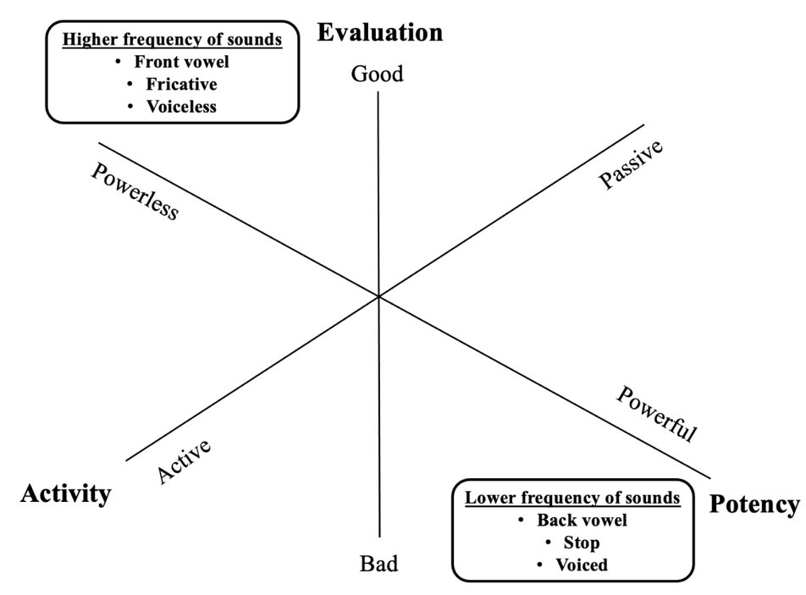
Fig. 4. Visual illustration of semantic space of sound symbolism in brand names based on Osgood et al.’s (1957) semantic differential dimensions. Higher frequency sounds (front vowel, fricative, voiceless) are located between higher evaluation and less potency. Lower frequency sounds (back vowel, stop, voiced) lie between lower evaluation and more potency.
7. Discussion
7.1. Summary of findings
The results of this study demonstrate how connotative meanings are associated with sounds present in fictitious brand names. Relying on the three core semantic differential dimensions of meanings (namely Evaluation, Potency, and Activity; Osgood et al., 1957), we demonstrate that vowels and consonants in (hypothetical) brand names are associated with attributes related to evaluation and potency, but not to activity. Specifically, our findings suggest that front (back) vowels, fricative (stop) consonants, and voiceless (voiced) consonants are associated with higher (lower) and lower (higher) potency. In other words, back (vs. front), stop (vs. fricative), and voiced (vs. voiceless) consonants were associated with lower evaluation and higher potency. Meanwhile, it appears that there are no consistent associations between vowels and consonants in the activity dimension. Taken together, this study’s results reveal Osgood et al. ’s semantic differential meanings as one of the potential psychological mechanisms underlying the sound symbolic meaning of brand names.
7.2. Theoretical contribution
A growing body of research has demonstrated that speech sounds present in brand names can influence consumers’ impressions of brands (Klink, 2000; Lowrey & Shrum, 2007; Pogacar et al., 2021; Spence, 2012). This stream of research has used brand name stimuli both visually (i.e., in the majority of the published research so far; e.g., Klink, 2000; Lowrey & Shrum, 2007) and sometimes aurally (e.g., Pathak et al., 2022) and it has been reported that the vowels present in brand names can influence the perception of product attributes (e.g. ,taste/flavor attributes and brand personality ;Klink, 2000; Motoki et al., 2020; Park et al., 2020; Pathak & Calvert, 2020). Despite the growing evidence reported thus far, the theoretical and integrative underpinnings of these associations remain unclear. Relying on the theory of sound symbolism (Sidhu & Pexman, 2018) and the semantic dimensions of meanings (Osgood et al., 1957), our findings demonstrate that connotative meanings can explain sound symbolism in brand names. Specifically, vowels (front/back) and two types of consonants (fricative/stop and voiceless/voiced) embedded in fictitious brand names are classified into evaluation and potency (but not activity) dimensions.
7.3. Suggested directions for future research
7.3.1. Are there other dimensions than those suggested by the EPA framework?
It is worth considering whether other semantic dimensions underlie the effect of sound symbolism on brand names. One possibility concerns the ‘shape-attribute’ association (e.g., round/spiky with sweet/bitter and higher-frequency/lower-frequency sounds). Our categorizations of EPA dimensions with attributes show certain tendencies [i.e., attributes categorized into higher (lower) evaluation and lower (higher) potency)]; however, there are some discrepancies. For example, ‘milder’ and “creamier/richer/smoother” are categorized into higher evaluation but are associated with back (vs. front) vowels, though most of the attributes categorized into high evaluation are associated with front (vs. back) vowels. Moreover, “cold” is categorized into lower activity and is associated with front (vs. back) vowels. Given that the activity dimension might well not explain the sound symbolic associations, other semantic meanings appear to explain the sound symbolic association with “cold”. The round/spiky dimension might provide a clue to resolving discrepancies, and a higher (lower) frequency of sounds (e.g., front vowel as higher-frequency, back vowel as lower-frequency) might be associated with spiky (round) meanings. Future research should test this possibility.
7.3.2. Do the spontaneous/automatic associations with sounds present in brand names reflect the EPA dimensions?
The spontaneous/automatic associations with speech sounds present in brand names also remain unknown. Typically, research on sound symbolism (including its applications to brand names) shows participants a few nonsense words/hypothetical brand names and asks them to rate the attributes on a restricted range/scale (e.g., taste, size; see Klink & Wu, 2012; Motoki et al., 2020; Yorkston & Menon, 2004). However, in a real-world setting, consumers see the brand names and spontaneously generate an impression about them (which can be wide-ranging and is obviously not restricted to a bipolar scale, as used in an experimental setting). In the case of shape-sound associations, it has been shown that when seeing round (vs. spiky) objects, participants tend to spontaneously generate round-sounding (vs. spiky-sounding) words (Vinson et al., 2021). To the best of our knowledge, no study has extended these findings to the context of sound symbolism in brand names. Given the theory of grounded cognition (see Barsalou, 2008), spontaneous associations of sounds in brand names appear to be different in different contexts (e.g., food, non-food, social situations, and locations). Future research can test how people spontaneously generate impressions of the sounds present in brand names and/or various contexts.
7.3.3. How, exactly, are the sounds present in brand names associated with emotions?
Affect (or emotional association) is a potential mechanism underlying sound symbolic associations with (hypothetical) brand names. The relationship between phonetic features and affect has been demonstrated (Rummer et al., 2014). For example, it has been reported that participants in a positive mood produce more words containing the front vowel /i/, while those in a negative mood produce more words containing the back vowel /o/ (Rummer et al., 2014), suggesting an association between certain phonetic features (i.e., front vs. back vowels) and affect. Affective dimensions (valence and arousal) would seem to be related to the theory of semantic differentials (evaluation, potency, activity; Osgood et al., 1957). The valence dimension (negative-positive) refers to evaluation (e.g., bad-good); the arousal dimension is closely related to the activity dimension (Moors et al., 2013), while the potency dimension appears to be related to the arousal dimension. Although previous research has shown that arousal links shape sounds (Aryani et al., 2020), our findings using Osgood's framework do not reveal a consistent role for activity (closely related to arousal) in brand name sound symbolism. Thus, it appears that arousal is insufficient to link sounds to meaning, whereas both the valence and dominance (potency) dimensions might be crucial when it comes to explaining brand names’ sound symbolism . Therefore, future research should aim to investigate how valence and arousal explain the symbolic effect of sound on brand names.
7.3.4. How does the interaction of vowels and consonants influence the connotative meanings of sound symbolism in brand names?
Another important issue concerns the interactive effect of vowels and consonants present in hypothetical brand names on their symbolic sound associations. Most previous studies have independently investigated the main effects of vowels (front vs. back), consonants [i.e., affricate (fricative vs. stop), and/or voicing (voiced vs. voiceless; e.g., Klink, 2000, 2003; Motoki et al., 2021; Pathak & Calvert, 2020)]. Few studies have investigated the interactive effects of vowels and consonants (see Motoki et al., 2020, for one recent exception). Our results suggest that the inconsistent findings of previous research concerning the sound symbolism of brand names in terms of the activity attribute of Osgood and colleagues’ semantic differential are potentially due to interactive effects. Studying the interactive effects of vowels and consonants might also potentially reveal the semantic dimension of activity. Further research is needed to investigate the interactive effects of vowels and consonants, especially concerning Osgood et al.’s (1957) semantic differentials.
7.3.5. How do the statistical regularities and structural correspondences explain the connotative meanings of sound symbolism in brand names?
Here, we tested the connotative meanings of sound symbolism in brand names. However, the literature on sound symbolism (Sidhu & Pexman, 2018) and crossmodal correspondences (e.g., Spence, 2011) also suggests the possibility of regularities and structural correspondences. Naturally occurring statistical regularities are considered one of the potential explanations for sound symbolism (and crossmodal correspondences; Sidhu & Pexman, 2018; Spence, 2011). In the biological world, larger animals (e.g., lions) tend to emit low-frequency sounds, whereas smaller animals (e.g., mice) emit higher-frequency sounds. Research on crossmodal correspondences has supported this account of naturally-occurring statistical regularities (see Korzeniowska, Root-Gutteridge, Simner, & Reby, 2019). Similarly, recent research has shown that phonemes related to roundedness (e.g., /m/, /u/) are more common in words referring to round objects, whereas phonemes related to angularity (e.g., /k/, /ɪ/) are overrepresented in words referring to spiky objects (Sidhu, Westbury, Hollis, & Pexman, 2021). Naturally occurring statistical regularities may partially explain the connotative meanings of sound symbolism in brand names. That is, there might be statistical regularities in pairs of sensory stimuli (e.g., lower frequency of sounds and heaviness) that are similar in connotative meaning (e.g., higher potency). Consumers likely internalize such naturally occurring statistical regularities (e.g., low-frequency sounds with large animals or large objects) with similar semantic meanings and assume an association of sounds present in brand attributes (e.g., names, jingles) with connotative meanings.
Structural correspondences are also considered a potential explanation for sound symbolism (and crossmodal correspondences; Sidhu & Pexman, 2018; Spence, 2011). Structural correspondences suggest that magnitude-related dimensions (e.g., stimulus intensity such as loudness, size; see Spence, 2011) might explain the underlying sound symbolism and crossmodal correspondences (Sidhu & Pexman, 2018; Spence, 2011; though note that Spence & di Stefano, 2022, have recently suggested that ‘physiological’ might be a better label for such correspondences, given the other uses of the term structural correspondence in the literature, e.g., see Sebba, 1991). The magnitude-related dimensions are also believed to be ingrained in the brain (see Walsh, 2003 for a detailed explanation of the theory of magnitude) and to be partially interpreted as activity (and possibly potency) dimensions in the EPA framework. Given that our findings did not reveal the involvement of the activity dimension in brand name sound symbolism, structural correspondences might not explain this association well. Hopefully, however, future research can clarify this issue.
7.4. Conclusion
In conclusion, the findings reported here summarize the existing findings on the sound symbolism of brand names and provide an integrative understanding based on the semantic space of meaning. Higher frequency sounds (front vowels, fricative, and voiceless consonants) present in brand names are associated with concepts linked to higher evaluation (e.g., good, nice, sweet) and lower potency (e.g., small, weak). Lower-frequency sounds (back vowels, stop, and voiced consonants) are related to concepts linked to lower evaluation (e.g., bad, awful, bitter) and higher potency (e.g., large, strong). This systematic review and empirical research study have also helped identify several important issues for future research.

Declaration of interest
The author(s) has/have declared that there are no competing interests.

References
Abel, G. A., & Glinert, L. H. (2008). Chemotherapy as language: Sound symbolism in cancer medication names. Social Science & Medicine, 66, 1863–1869.
Aryani, A., Isbilen, E. S., & Christiansen, M. H. (2020). Affective arousal links sound to meaning. Psychological Science, 31(8), 978–986.
Athaide, G. A., & Klink, R. R. (2012). Creating global brand names: The use of sound symbolism. Journal of Global Marketing, 25(4), 202–212.
Barsalou, L. W. (2008). Grounded cognition. Annual Review of Psychology, 59, 617–645.
Baxter, S. M., Ilicic, J., Kulczynski, A., & Lowrey, T. (2015). Communicating product size using sound and shape symbolism. Journal of Product & Brand Management, 24(5), 472–480.
Blasi, D. E., Wichmann, S., Hammarström, H., Stadler, P. F., & Christiansen, M. H. (2016). Sound–meaning association biases evidenced across thousands of languages. Proceedings of the National Academy of Sciences of the USA, 113(39), 10818–10823.
Clevenger, T., Lazier, G. A., & Clark, M. L. (1965). Measurement of corporate images by the semantic differential. Journal of Marketing Research, 2(1), 80–82.
Gallace, A., Boschin, E., & Spence, C. (2011). On the taste of “Bouba” and “Kiki”: An exploration of word–food associations in neurologically normal participants. Cognitive Neuroscience, 2(1), 34–46.
Guevremont, A., & Grohmann, B. (2015). Consonants in brand names influence brand gender perceptions. European Journal of Marketing, 49(1/2), 101–122.
Joshi, P., & Kronrod, A. (2020). Sounds of green: How brand name sounds metaphorically convey environmental friendliness. Journal of Advertising, 49(1), 61–77.
Keller, K. L., Heckler, S. E., & Houston, M. J. (1998). The effects of brand name suggestiveness on advertising recall. Journal of Marketing, 62(1), 48–57.
Kelly, R. F., & Stephenson, R. (1967). The semantic differential: An information source for designing retail patronage appeals. Journal of Marketing, 31(4), 43–47.
Ketron, S., & Spears, N. (2019). Sounds like a heuristic! Investigating the effect of sound-symbolic correspondences between store names and sizes on consumer willingness-to-pay. Journal of Retailing and Consumer Services, 51, 285–292.
Ketron, S., & Spears, N. (2021). Sound-symbolic signaling of online retailer sizes: The moderating effect of shopping goals. Journal of Retailing and Consumer Services, 58:102245.
Klink, R. R. (2000). Creating brand names with meaning: The use of sound symbolism. Marketing Letters, 11(1), 5–20.
Klink, R. R. (2001). Creating meaningful new brand names: A study of semantics and sound symbolism. Journal of Marketing Theory and Practice, 9(2), 27–34.
Klink, R. R. (2003). Creating meaningful brands: The relationship between brand name and brand mark. Marketing Letters, 14(3), 143–157.
Klink, R. R. (2009). Gender differences in new brand name response. Marketing Letters, 20(3), 313–326.
Klink, R. R., & Athaide, G. A. (2012). Creating brand personality with brand names. Marketing Letters, 23(1), 109–117.
Klink, R. R., & Athaide, G. A. (2014). Examining the brand name–mark relationship in emerging markets. Journal of Product & Brand Management, 23(4/5), 262–267.
Klink, R. R., & Wu, L. (2014). The role of position, type, and combination of sound symbolism imbeds in brand names. Marketing Letters, 25(1), 13–24.
Klink, R. R., & Wu, L. (2017). Creating ethical brands: The role of brand name on consumer perceived ethicality. Marketing Letters, 28(3), 411–422.
Knoeferle, K., Li, J., Maggioni, E., & Spence, C. (2017). What drives sound symbolism? Different acoustic cues underlie sound-size and sound-shape mappings. Scientific Reports, 7(1):5562.
Köhler, W. (1929). Gestalt psychology. New York, NY: Liveright.
Korzeniowska, A. T., Root-Gutteridge, H., Simner, J., & Reby, D. (2019). Audio–visual crossmodal correspondences in domestic dogs (Canis familiaris). Biology Letters, 15(11): 20190564.
Lowrey, T. M., & Shrum, L. J. (2007). Phonetic symbolism and brand name preference. Journal of Consumer Research, 34(3), 406–414.
Mehrabian, A. (1996). Pleasure-arousal-dominance: A general framework for describing and measuring individual differences in temperament. Current Psychology, 14(4), 261–292.
Montoya, A. K., & Hayes, A. F. (2017). Two-condition within-participant statistical mediation analysis: A path-analytic framework. Psychological Methods, 22(1), 6–27.
Moors, A., De Houwer, J., Hermans, D., Wanmaker, S., van Schie, K., Van Harmelen, A. L., et al. (2013). Norms of valence, arousal, dominance, and age of acquisition for 4,300 Dutch words. Behaviour Research Methods, 45(1), 169–177.
Motoki, K., Park, J., Pathak, A., & Spence, C. (2021). Constructing healthy food names: On the sound symbolism of healthy food. Food Quality and Preference, 90:104157.
Motoki, K., Saito, T., Park, J., Velasco, C., Spence, C., & Sugiura, M. (2020). Tasting names: Systematic investigations of taste-speech sounds associations. Food Quality and Preference, 80:103801.
Motoki, K., & Velasco, C. (2021). Taste-shape correspondences in context. Food Quality and Preference, 88:104082.
Osgood, C. E., & Suci, G. J. (1955). Factor analysis of meaning. Journal of Experimental Psychology, 50(5), 325–338.
Osgood, C. E., Suci, G. J., & Tannenbaum, P. H. (1957). The measurement of meaning. University of Illinois Press.
Park, J., Motoki, K., Pathak, A., & Spence, C. (2021). A sound brand name: The role of voiced consonants in pharmaceutical branding. Food Quality and Preference, 90:104104.
Pathak, A., & Calvert, G. A. (2020). Sounds sweet, sounds bitter: How the presence of certain sounds in a brand name can alter expectations about the product’s taste. Food Quality and Preference, 83:103918.
Pathak, A., Calvert, G. A., & Lim, L. K. S. (2020). Harsh voices, sound branding: How voiced consonants in a brand’s name can alter its perceived attributes. Psychology & Marketing, 37(6), 837–847.
Pathak, A., Calvert, G. A., & Motoki, K. (2021). Sound symbolism overrides articulation dynamics in the taste continuum. Food Quality and Preference, 91:104186.
Pathak, A., & Motoki, K. (2021). Evaluating brand names without vowels. Food Quality and Preference, 97:104450.
Pathak, A., Motoki, K., Techawachirakul, M., & Calvert, G. A. (2022). Spiky sounds sparkling: How voiceless consonants present in the brand name of a beverage are more appropriate in conveying its carbonation strength. Food Quality and Preference, 96:104404.
Pavia, T. M., & Costa, J. A. (1993). The winning number: Consumer perceptions of alpha-numeric brand names. Journal of Marketing, 57(3), 85–98.
Plato (1892). Cratylus in The Dialogues of Plato, Vol. 1, trans. Benjamin Jowett (pp. 253–289). Oxford, UK: Clarendon.
Pogacar, R., Angle, J., Lowrey, T. M., Shrum, L. J., & Kardes, F. R. (2021). Is Nestlé a lady? The feminine brand name advantage. Journal of Marketing, ahead of print, DOI: 002224292199306.
Roche, S., Shrum, L. J., & Lowrey, T. M. (2015). The aesthetics of brand name design: Form, fit, fluency, and phonetics. In R. Batra, C. Seifert, & D. Brei (Eds.), The psychology of design: Creating consumer appeal (pp. 202-218). London, UK: Routledge.
Rummer, R., Schweppe, J., Schlegelmilch, R., & Grice, M. (2014). Mood is linked to vowel type: The role of articulatory movements. Emotion, 14(2), 246–250.
Sebba, R. (1991). Structural correspondence between music and color. Color Research & Application, 16, 81–88. doi: 10.1002/col.5080160206
Shrum, L. J., Lowrey, T. M., Luna, D., Lerman, D. B., & Liu, M. (2012). Sound symbolism effects across languages: Implications for global brand names. International Journal of Research in Marketing, 29(3), 275–279.
Sidhu, D. M., & Pexman, P. M. (2018). Five mechanisms of sound symbolic association. Psychonomic Bulletin & Review, 25(5), 1619–1643.
Sidhu, D. M., Westbury, C., Hollis, G., & Pexman, P. M. (2021). Sound symbolism shapes the English language: The maluma/takete effect in English nouns. Psychonomic Bulletin & Review, 28, 1390–1398.
Sievers, B., Lee, C., Haslett, W., & Wheatley, T. (2019). A multi-sensory code for emotional arousal. Proceedings of the Royal Society B, 286:20190513.
Simner, J., Cuskley, C., & Kirby, S. (2010). What sound does that taste? Cross-modal mappings across gustation and audition. Perception, 39(4), 553–569.
Snider, J. G., & Osgood, C. E. (1969). Semantic differential technique: A sourcebook. Chicago, IL: Aldine Publishing.
Spence, C. (2011). Crossmodal correspondences: A tutorial review. Attention, Perception & Psychophysics, 73(4), 971–995.
Spence, C. (2012). Managing sensory expectations concerning products and brands: Capitalizing on the potential of sound and shape symbolism. Journal of Consumer Psychology, 22(1), 37–54.
Spence, C. (2014). Assessing the influence of shape and sound symbolism on the consumer’s response to chocolate. New Food, 17(2), 59–62.
Spence, C. (2021). The multisensory design of pharmaceuticals and their packaging. Food Quality and Preference, 91:104200.
Spence, C., & Di Stefano, N. (2022). Coloured hearing, colour music, colour organs, and the search for perceptually meaningful correspondences between colour and pitch. i-Perception, 13(3):1-42. DOI: 10.1177/20416695221092802.
Spence, C., & Gallace, A. (2011). Tasting shapes and words. Food Quality and Preference, 22(3), 290–295.
Sprott, D. E., & Liu, R. L. (2016). Research trends on branding in consumer psychology. Current Opinion in Psychology, 10, 124–128.
Velasco, C., Woods, A. T., Marks, L. E., Cheok, A. D., & Spence, C. (2016). The semantic basis of taste-shape associations. PeerJ, 4:e1644.
Vinson, D., Jones, M., Sidhu, D. M., Lau-Zhu, A., Santiago, J., & Vigliocco, G. (2021). Iconicity emerges and is maintained in spoken language. Journal of Experimental Psychology: General. Advance online publication. https://doi.org/10.1037/xge0001024
Wallace, D. (1975). Naming the Edsel. Automotive Quarterly Magazine, XIII (2; Second Quarter), 182–191.
Walsh, V. (2003). A theory of magnitude: Common cortical metrices of time, space and quality. Trends in Cognitive Sciences, 7, 483–488.
Wu, L., Klink, R. R., & Guo, J. (2013). Creating gender brand personality with brand names: The effects of phonetic symbolism. Journal of Marketing Theory and Practice, 21(3), 319–330.
Yorkston, E., & Menon, G. (2004). A sound idea: Phonetic effects of brand names on consumer judgments. Journal of Consumer Research, 31(1), 43–51.

