**The processing of the uva dataset is improved from the preprocessing method of the NTU RGB+D dataset in the CTR-GCN source code**

**UVA 3D Human Dataset address:https://github.com/SUTDCV/UAV-Human**

**CTR-GCN Source code address:https://github.com/Uason-Chen/CTR-GCN.**

**Changes to get_raw_skes_data.py**

**./data/ntu/get_raw_skes_data.py**

**1.** **Changing the file extension from '.skeleton' to '.txt' in 26 lines**



**2.** **Changing line 29 or comment it out**



**3.** **Deleting lines 43-45 from the original code**

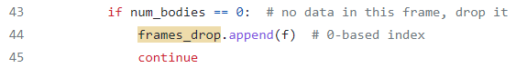

**4.** **In the following code, changing 25 to 17**

**5.** **Changing lines 51-55 to the following**

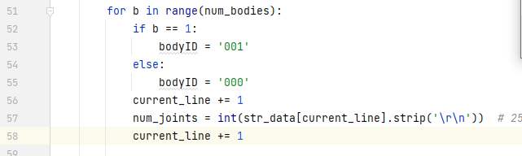

**6.** **Changing lines 57-61 to: (Here we store each node coordinate with a random value between 0 and 1e-6 to eliminate the effect of all-0 data frames)**

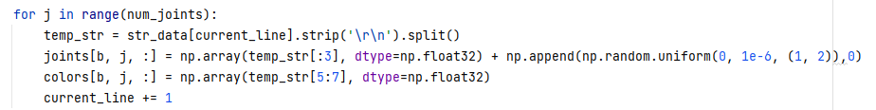

**7.** **The 137 lines uva data set storage path was modified**

**Changes to get_raw_denoisded_data.py**

**./data/ntu/get_raw_denoisded_data.py**

**1.** **The threshold value of 25 lines of noise frame length is set to zero**



**2.** **The filename has changed, so the following is where the label is captured**



1. **Changing all the numbers in the code from 25 to 17, 75 to 51, and 150 to 102**

**Changes to seq_transformation.py**

**./data/ntu/seq_transformation.py**

**1.** **Changing all the numbers in the code to 17 for 25, 51 for 75, 102 for 150, and 34 for 50**

**2.** **In line 132, 60 is changed to 155**



**3.** **Classify the training and testing according to the https://github.com/SUTDCV/UAV-Human amend the 197-205 lines of code is as follows (here is the reference he gave the second scheme).**

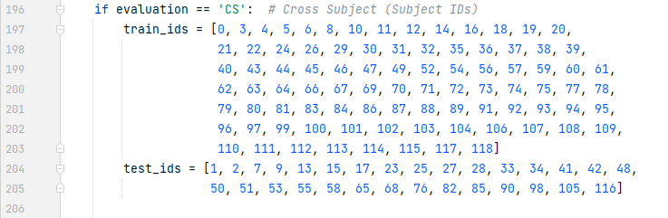

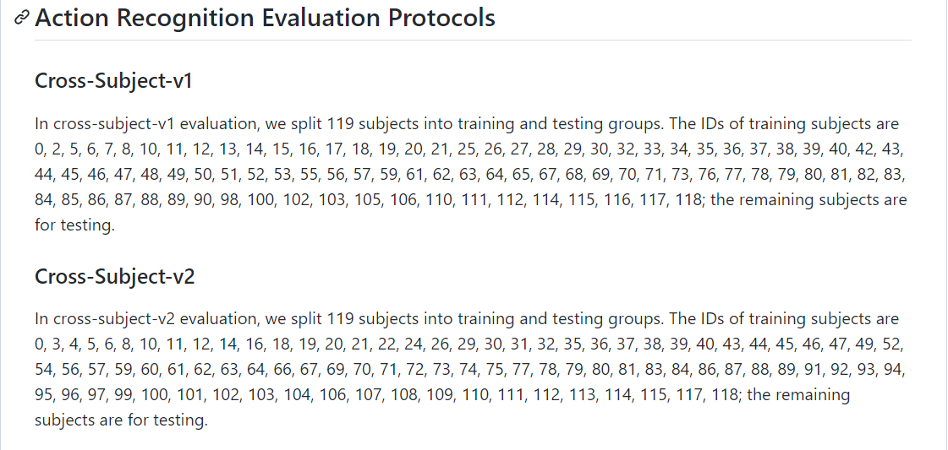

**Changes to statistics**

**./data/ntu/statistics**

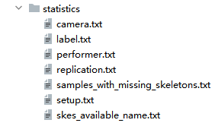

**The filename of all uva (A total of 23031 samples) is stored in skes_available_name.txt as shown below, and all sample action types are extracted (the number behind the blue box A in the following figure) and stored in the label.txt file as shown below**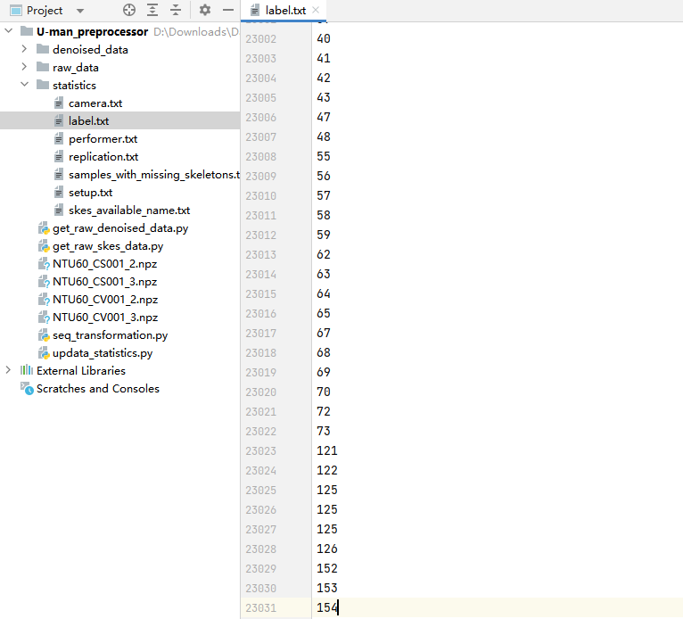

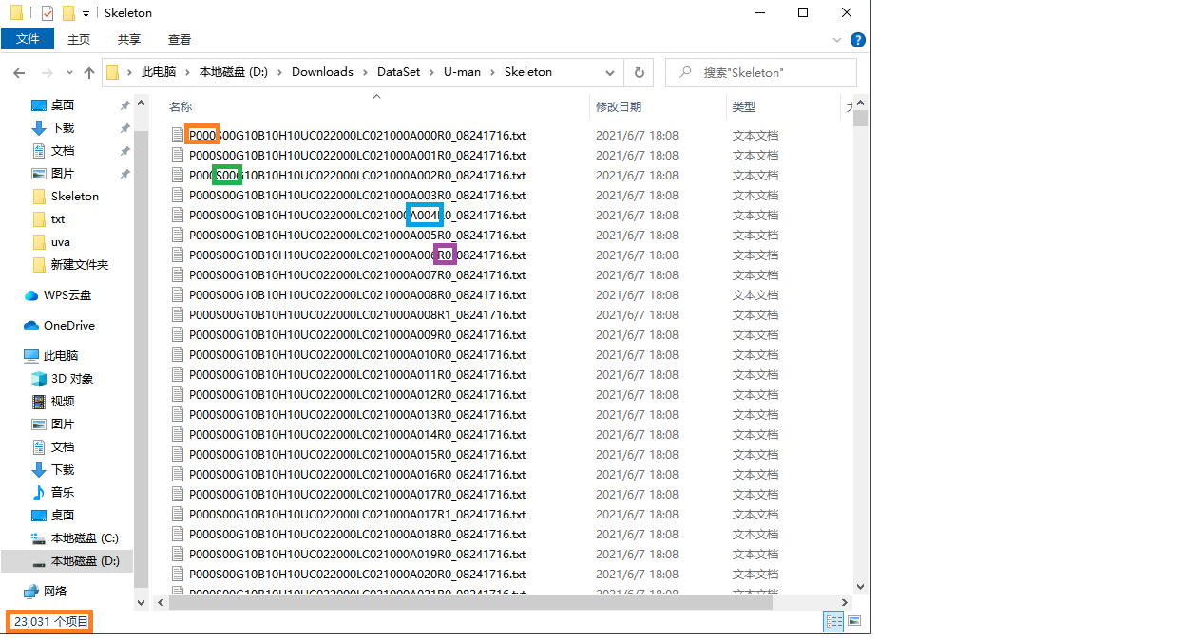

**Similarly, the numbers of the orange box, green box, and purple box in the above data are extracted and stored in performer.txt, setup.txt, and replication.txt files respectively, and 1 is stored in camera.txt**

**Write A PROGRAM TO READ ALL THE sample filenames AND extract the required data into the corresponding file. The file in statistics needs to be updated before get_raw_denoisded_data.py is executed)**

**Create a new updata_statistics.py with the following code:**

1. def updata_statistics():
2. *#updata label.txt*
3. f = open('./statistics/label.txt', "a")
4. f.truncate(0)
5. with open('./statistics/skes_available_name.txt', 'r') as fr:
6. str_data = fr.read()
7. str_data=str_data.split('\n')
8. for i in range(len(str_data)):
9. if i < len(str_data) - 1:
10. f.write(str(int(str_data[i][-14:-11]))+'\n')
11. else:
12. f.write(str(int(str_data[i][-14:-11])))
13. f.close()
14. *# updata performer.txt*
15. f = open('./statistics/performer.txt', "a")
16. f.truncate(0)
17. with open('./statistics/skes_available_name.txt', 'r') as fr:
18. str_data = fr.read()
19. str_data=str_data.split('\n')
20. for i in range(len(str_data)):
21. if i < len(str_data) - 1:
22. f.write(str(int(str_data[i][1:4]))+'\n')
23. else:
24. f.write(str(int(str_data[i][1:4])))
25. f.close()
26. *# updata replication.txt*
27. f = open('./statistics/replication.txt', "a")
28. f.truncate(0)
29. with open('./statistics/skes_available_name.txt', 'r') as fr:
30. str_data = fr.read()
31. str_data=str_data.split('\n')
32. for i in range(len(str_data)):
33. if i < len(str_data) - 1:
34. f.write(str(int(str_data[i][-10:-9]))+'\n')
35. else:
36. f.write(str(int(str_data[i][-10:-9])))
37. f.close()
38. *# updata setup.txt*
39. f = open('./statistics/setup.txt', "a")
40. f.truncate(0)
41. with open('./statistics/skes_available_name.txt', 'r') as fr:
42. str_data = fr.read()
43. str_data=str_data.split('\n')
44. for i in range(len(str_data)):
45. if i < len(str_data) - 1:
46. f.write(str(int(str_data[i][5:7]))+'\n')
47. else:
48. f.write(str(int(str_data[i][5:7])))
49. f.close()
50. *#updata camera.txt*
51. f = open('./statistics/camera.txt', "a")
52. f.truncate(0)
53. with open('./statistics/skes_available_name.txt', 'r') as fr:
54. str_data = fr.read()
55. str_data=str_data.split('\n')
56. for i in range(len(str_data)):
57. if i<len(str_data)-1:
58. f.write(str(1)+'\n')
59. else:
60. f.write(str(1))
61. f.close()
62. if __name__ == '__main__':
63. updata_statistics()

**After making these changes, running updata_statistics.py, get_raw_skes_data.py, get_raw_denoisded_data.py, and seq_transformation.py**