QUARTERLY ON-CHAIN HOLDER REPORT

How RBNT holders behaved in Q3 2026
1 July to 30 September 2026. Redbelly mainnet blocks 3,025,809 to 3,209,414. Data read 2026-10-25.


AT A GLANCE

The quarter in six points
01 Staking grew. The two Reddex pools held 754.8 million RBNT on 30 September, against 639.1 million on 30 June (+18.1%). Most of the change was in the no lock pool (+82.6 million). Addresses with an open stake went from 1,156 to 1,140 in the no lock pool and from 223 to 217 in the 365 day pool.
02 Reserved wallets mostly moved RBNT between themselves. Ecosystem (Locked) sent 500 million to Ecosystem 2 (Unlocked); Ecosystem 2 (Unlocked) sent 253.1 million to Investors; Governance (Locked) sent 33.3 million to Governance (Unlocked). Only Ecosystem (Unlocked) sent RBNT outside the reserved group: 43.8 million RBNT, mostly into WRBNT and the two staking pools.
03 Vesting contracts paid out. Contracts whose verified code is a vesting manager held 1.68 billion RBNT (as WRBNT) on 30 June and 1.58 billion on 30 September. They sent 127.8 million WRBNT to wallets in 1,885 transfers during the quarter.
04 The largest wallets added on balance. The 100 wallets that were largest on 30 June held 515 million RBNT then and 540.9 million on 30 September, counting wrapped and staked RBNT. 39 of them added more than 1%, 45 stayed within 1% and 6 reduced by more than 1%.
05 Holdings stayed concentrated. The largest 100 wallets held 76.7% of all wallet-held RBNT at the end, against 75.8% at the start. Half of it sits in just 12 wallets. The middle wallet holds 5.84 RBNT.
06 A few more wallets hold RBNT. 53,575 wallets held 1 RBNT or more on 30 September, 157 more than on 30 June. 243 wallets crossed 1 RBNT during the quarter and 86 dropped below it.
Read this first. This report describes what the public Redbelly chain shows. It is about trends, not people. It names only addresses that are already public: Redbelly's nine reserved wallets from the DAO treasury page, the Wrapped RBNT contract and the two Reddex staking pools. The explorer labels no exchange wallet on Redbelly, so none is named. Every other address appears only inside a group of at least five.
The chain records that coins moved. It does not record why, or who controls an address. When a group's holdings fall, the coins left those addresses: that may be a sale, a move to another address of the same owner, or a deposit into a contract. This report makes no price forecast and gives no advice.

NEW TO THIS? THREE IDEAS THE REPORT USES
Address. Every coin sits at an address, a public account number anyone can look up. Wallet or contract. A wallet address is controlled by a private key held by a person or organisation. A contract address is a program that holds coins under its own fixed rules. Counted once. Wrapped RBNT (WRBNT) and staked RBNT still belong to whoever wrapped or staked them, so this report counts them with that holder and never a second time at the contract.

SECTION 1

Who holds the RBNT
On 30 September 59.3% of all RBNT sat in Redbelly's reserved wallets, 19.6% with other wallets and 21.1% in contracts other than the named ones. The largest group of contracts is vesting contracts.
All 10 billion RBNT were created when the network started. Figure 1 adds up every holding on both dates and groups it by the kind of address that owns it. Wrapped and staked RBNT are counted with the address that wrapped or staked them.
FIGURE 1
Who holds the 10 billion RBNT
RBNT, WRBNT and staked RBNT counted with their owner. Labels show 30 September and the share of supply.
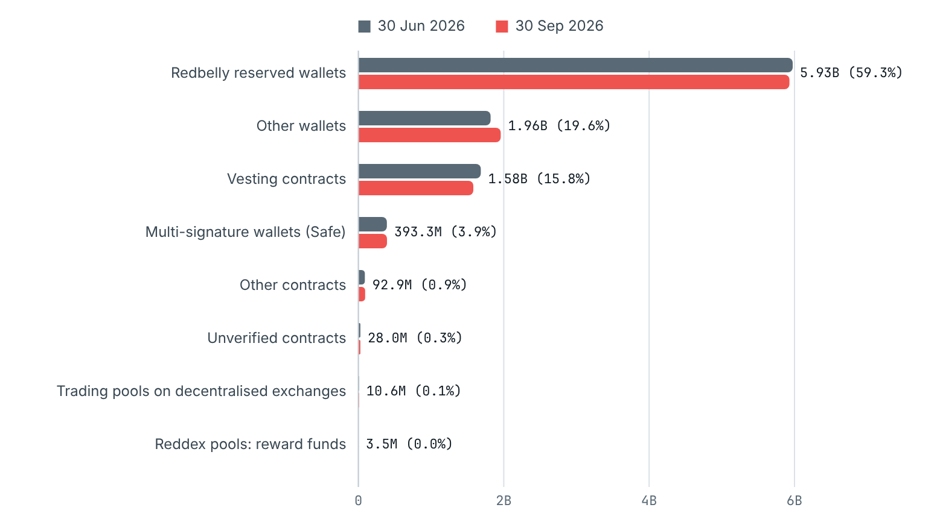
Source: Redbelly mainnet (chain ID 151), read with eth_getBalance and eth_call at blocks 3,025,809 and 3,209,414. Data read 2026-10-25. Data: 03_who_holds.csv.
Contracts publish their code on the explorer when their authors verify it. The name in that code says what kind of program a contract is, such as a vesting contract or a multi-signature wallet, though not who controls it. This report uses those names only to group contracts, and only for kinds with at least five contracts. Vesting contracts hold coins and release them to set addresses over time. Multi-signature wallets need more than one key to move coins. Bridge contracts hold RBNT moved to or from other blockchains. Trading pools hold the coins people trade against on decentralised exchanges.

Where the coins physically sit
The view above counts wrapped and staked RBNT with its owner. Figure 2 shows the same supply by the address that physically holds it, so the WRBNT contract and the two staking pools appear on their own.
FIGURE 2
Where the RBNT physically sits
Native RBNT balance of each place on both dates.
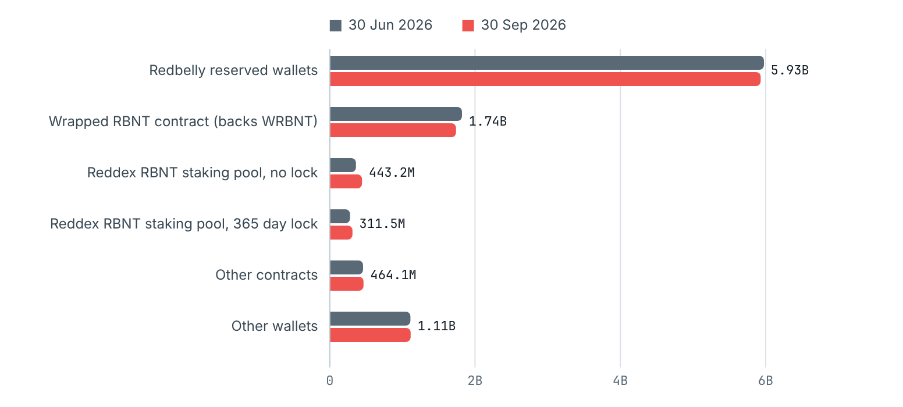
Source: Redbelly mainnet (chain ID 151), read with eth_getBalance and eth_call at blocks 3,025,809 and 3,209,414. Data read 2026-10-25. Data: 02_where_rbnt_sits.csv.
HOW COMPLETE IS THIS?
The balances read add up to 99.9996% of the 10 billion supply on 30 September. The remaining 36,485 RBNT sit at addresses that never sent or received a transaction this scan could see, such as addresses funded when the network started. That amount changed by 11 RBNT in the quarter, so it cannot change any trend here.

Where RBNT moved during the quarter
Figure 3 follows every transfer of RBNT and WRBNT between groups from 1 July to 30 September. The largest flows were stakes into the Reddex pools (196.4 million from wallets), WRBNT released by vesting contracts to wallets (127.8 million), RBNT unwrapped from the WRBNT contract (115.9 million to wallets) and withdrawals and rewards from the pools (95.7 million). Transfers inside the same group, such as from one reserved wallet to another, are left out of the diagram and shown in the table.
FIGURE 3
Where RBNT moved between groups, 1 July to 30 September
RBNT and WRBNT sent from one group (left) to another (right). Ribbons under 1 million RBNT are left out of the diagram but kept in the table.
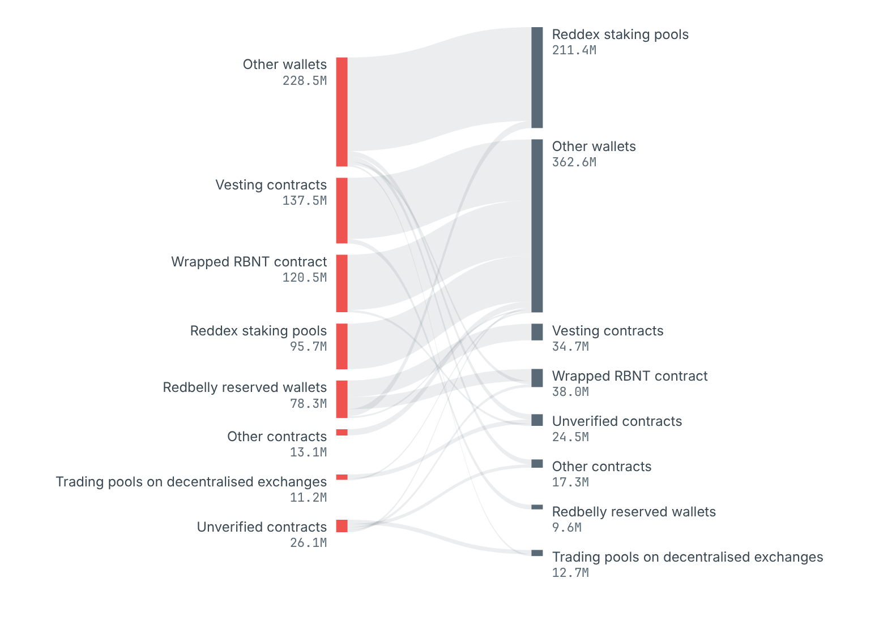
Source: every successful transaction and internal transfer with value, and every WRBNT Transfer record, between blocks 3,025,810 and 3,209,414. Data: 09_group_flows.csv.

SECTION 2

How many holders, and how big
53,575 wallets held 1 RBNT or more on 30 September, 157 more than on 30 June. Most hold a little: the most common size is 1 to 100 RBNT.
A holding here is everything a wallet owns: RBNT in the wallet, plus WRBNT, plus RBNT it has staked. Wallets with less than 1 RBNT are left out of the counts, because many addresses only keep a tiny amount left over from fees (111,509 such wallets on 30 September). Named wallets and contracts are not in these counts either; they are shown in section 1.
FIGURE 4
Share of wallets and share of RBNT by holding size
For each size band on 30 September: the share of all wallets in it (grey) and the share of all wallet RBNT it holds (red).
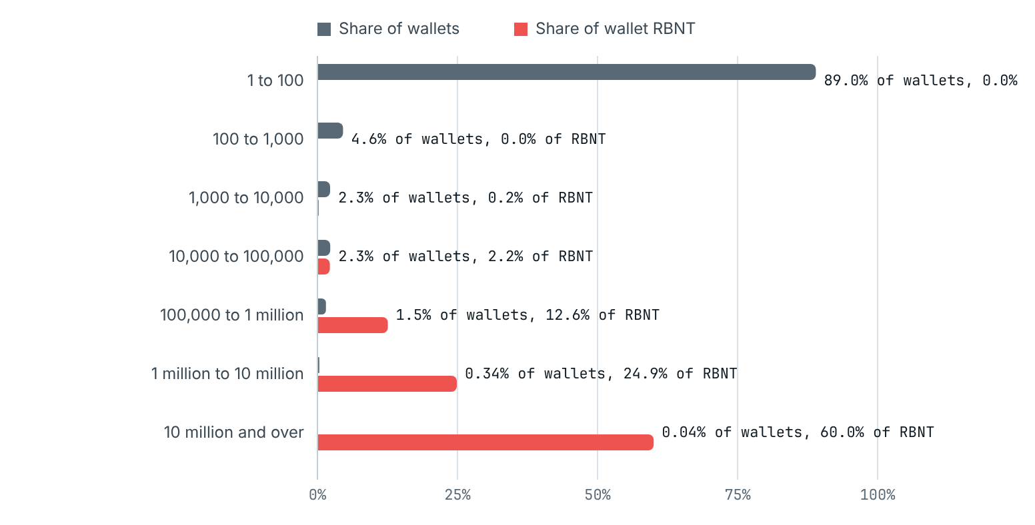
Source: Redbelly mainnet (chain ID 151), read with eth_getBalance and eth_call at blocks 3,025,809 and 3,209,414. Data read 2026-10-25. Data: 04_holders_by_size.csv.
FIGURE 5
Change in the number of wallets in each size
Wallets in each band on 30 September minus wallets in the same band on 30 June.
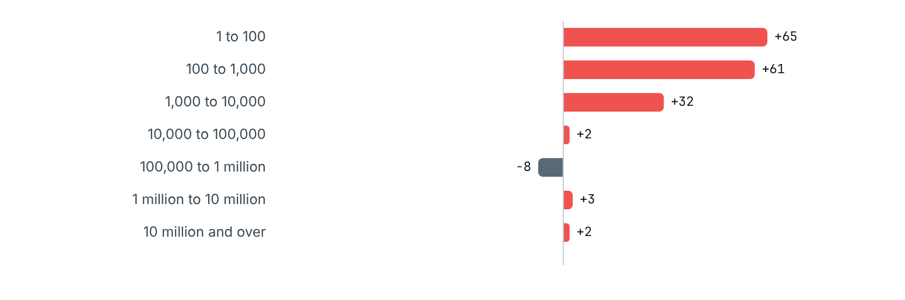
Source: Redbelly mainnet (chain ID 151), read with eth_getBalance and eth_call at blocks 3,025,809 and 3,209,414. Data read 2026-10-25. Data: 04_holders_by_size.csv.
Figure 4 shows the same pattern from both sides. 89% of wallets hold between 1 and 100 RBNT, yet together they hold 0.03% of wallet RBNT. The 23 wallets with 10 million and over RBNT hold 60%. The table under the figure also shows the two month ends inside the quarter.

SECTION 3

How concentrated holdings are
The largest 10 wallets held 48.4% of all wallet-held RBNT on 30 September and the largest 100 held 76.7%. Both shares rose slightly over the quarter.
Concentration asks how much of the RBNT sits with a few holders. It is measured here over wallets only, because Redbelly's reserved wallets and contracts are large by design and would hide what holders are doing. Three measures are used: the share held by the largest wallets, the number of wallets that together hold half, and the Gini score, which runs from 0 (every wallet holds the same) to 1 (one wallet holds everything).
Measure | 30 Jun 2026 | 31 Jul 2026 | 31 Aug 2026 | 30 Sep 2026
Wallets with 1 RBNT or more | 53,418 | 53,476 | 53,536 | 53,575
RBNT they hold | 1,819,550,653 | 1,841,192,760 | 1,942,733,447 | 1,958,624,111
Share held by the largest 10 | 47.5% | 47.4% | 48.5% | 48.4%
Share held by the largest 100 | 75.8% | 75.8% | 76.6% | 76.7%
Share held by the largest 1,000 | 97.2% | 97.2% | 97.4% | 97.4%
Wallets that together hold half | 12 | 12 | 11 | 12
Gini score (wallets) | 0.9951 | 0.9951 | 0.9953 | 0.9953
Middle (median) wallet, RBNT | 5.84 | 5.84 | 5.84 | 5.84

FIGURE 6
Share of wallet RBNT held by the largest wallets
All RBNT held by wallets with 1 RBNT or more, split by rank: the largest 10, the next 90, the next 900 and everyone else. A Lorenz curve of the same data is in 05b_lorenz_curve.csv.
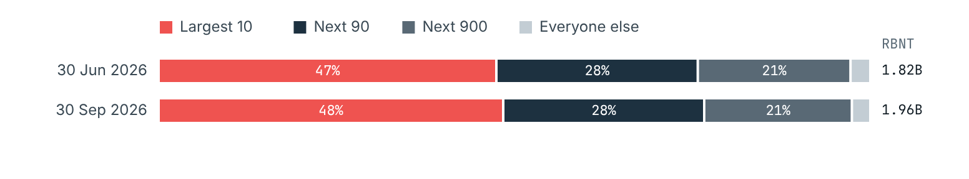
Source: Redbelly mainnet (chain ID 151), read with eth_getBalance and eth_call at blocks 3,025,809 and 3,209,414. Data read 2026-10-25. Data: 05_concentration.csv.
WHY THIS MATTERS, AND WHAT IT DOES NOT MEAN
A concentrated spread means a small number of wallets could move a large share of the supply. It does not say who those wallets belong to: one wallet can be shared by many people, such as an exchange, and one person can use many wallets.

SECTION 4

What the largest holders did
Wallets that started the quarter large mostly held steady or added. The 21 wallets that started with 10 million and over RBNT held 1.06 billion then and 1.09 billion at the end.
To see accumulation and selling without following any single wallet, wallets are put into groups by their holding on 30 June and the same wallets are followed to 30 September. A wallet added if its holding rose by more than 1%, reduced if it fell by more than 1%, and stayed within 1% otherwise. Staking or wrapping does not count as reducing, because the holding includes wrapped and staked RBNT.
FIGURE 7
What wallets did, grouped by their holding on 30 June
Share of wallets in each group that added, held steady, reduced or ended below 1 RBNT.
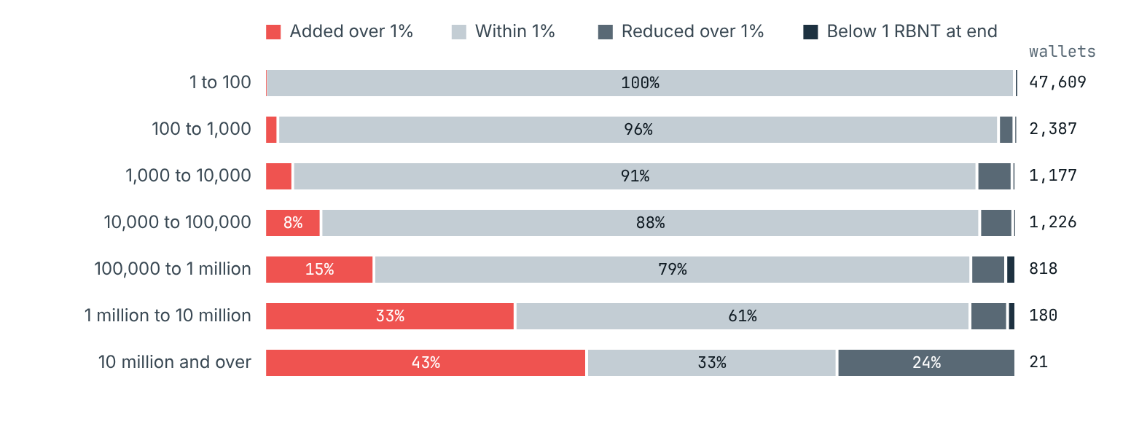
Source: Redbelly mainnet (chain ID 151), read with eth_getBalance and eth_call at blocks 3,025,809 and 3,209,414. Data read 2026-10-25. Data: 06_cohorts.csv.
FIGURE 8
Net change in RBNT by starting size
Total change in holdings of each group between 30 June and 30 September. The last row is wallets that held under 1 RBNT on 30 June.
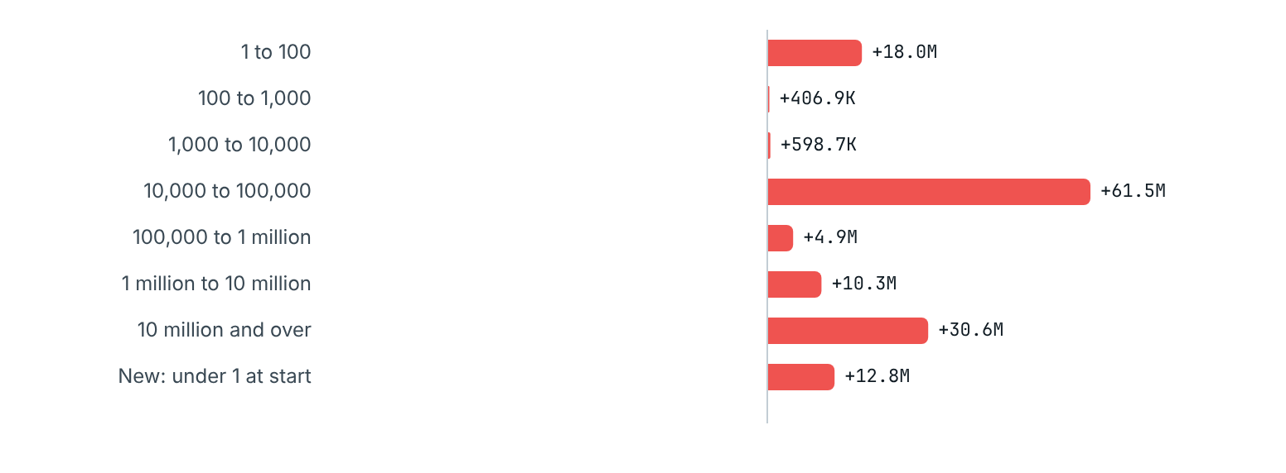
Source: Redbelly mainnet (chain ID 151), read with eth_getBalance and eth_call at blocks 3,025,809 and 3,209,414. Data read 2026-10-25. Data: 06_cohorts.csv.

The largest wallets, ranked on 30 June
Ranking wallets by their holding on 30 June and following the same wallets gives a second view. The largest 10 added on balance (+19.3 million RBNT), the next 90 added (+26 million). RBNT staked by the largest 100 wallets rose by 26.7 million.
Group (ranked on 30 June) | Wallets | RBNT 30 Jun | RBNT 30 Sep | Net change | Change | Added | Within 1% | Reduced | Below 1 at end
Largest 10 | 10 | 863,556,835 | 882,860,172 | +19,303,337 | +2.2% | 4 | 4 | 2 | 0
Ranks 11 to 100 | 90 | 514,959,338 | 540,931,017 | +25,971,678 | +5.0% | 39 | 45 | 5 | 1
Ranks 101 to 1,000 | 900 | 390,412,544 | 390,830,090 | +417,546 | +0.1% | 143 | 701 | 44 | 12
Ranks 1,001 and below | 52,418 | 50,621,935 | 131,192,086 | +80,570,151 | +159.2% | 251 | 51900 | 194 | 73

FIGURE 9
How the largest wallets hold their RBNT
Holdings of each rank group split into RBNT in the wallet, wrapped RBNT and RBNT staked in the Reddex pools.
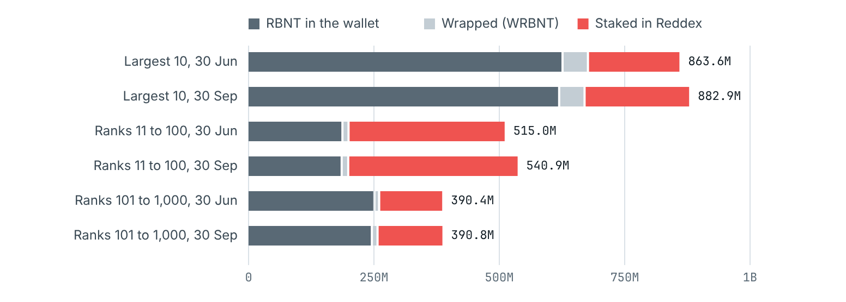
Source: Redbelly mainnet (chain ID 151), read with eth_getBalance and eth_call at blocks 3,025,809 and 3,209,414. Data read 2026-10-25. Data: 06c_largest_holders.csv.

Movement between size bands
The table below counts wallets by the band they started in (rows) and the band they ended in (columns). The shaded diagonal is wallets that stayed in the same band. Cells with fewer than five wallets show <5, so no cell can point to one wallet.
Start band \ end band | Under 1 | 1 to 100 | 100 to 1,000 | 1,000 to 10,000 | 10,000 to 100,000 | 100,000 to 1 million | 1 million to 10 million | 10 million and over
Under 1 | 0 | 79 | 73 | 37 | 34 | 17 | <5 | 0
1 to 100 | 56 | 47526 | 13 | 5 | 5 | <5 | <5 | <5
100 to 1,000 | 6 | 20 | 2335 | 17 | 9 | 0 | 0 | 0
1,000 to 10,000 | 6 | 12 | 12 | 1131 | 14 | <5 | 0 | 0
10,000 to 100,000 | 5 | 24 | 7 | 14 | 1156 | 18 | <5 | <5
100,000 to 1 million | 11 | 10 | 6 | 5 | 9 | 770 | 7 | 0
1 million to 10 million | <5 | <5 | <5 | 0 | <5 | <5 | 170 | <5
10 million and over | 0 | <5 | 0 | 0 | 0 | 0 | <5 | 19

SECTION 5

Staking in the Reddex pools
The two Reddex pools held 754.8 million RBNT on 30 September, up from 639.1 million on 30 June (+18.1%).
Staking means locking RBNT in a pool to earn rewards. Reddex runs two RBNT pools: one with no lock, where stakers can take their RBNT out at any time, and one with a 365 day lock, where each stake can only be taken out a year after it was made. As the brief asks, the headline figures are each pool's RBNT balance at the start and end of the quarter.
A pool's balance includes reward funds as well as stakes. Rewards are paid in RBNT out of the pool's own balance. So the balance is the stakers' RBNT plus RBNT set aside for rewards. The pool contract also records the total staked by its stakers (its totalStake), which lets this report split the two: staked RBNT, and reward funds = balance minus totalStake.

Pool | Balance 30 Jun | Balance 30 Sep | Change | Staked 30 Jun | Staked 30 Sep | Reward funds 30 Jun | Reward funds 30 Sep
No lock pool | 360,594,599 | 443,228,206 | +22.9% | 358,606,856 | 440,677,250 | 1,987,743 | 2,550,956
365 day pool | 278,467,724 | 311,548,346 | +11.9% | 277,156,292 | 310,573,758 | 1,311,432 | 974,589

FIGURE 10
RBNT in both Reddex pools, each day
Combined balance of the two pools at the end of each day.
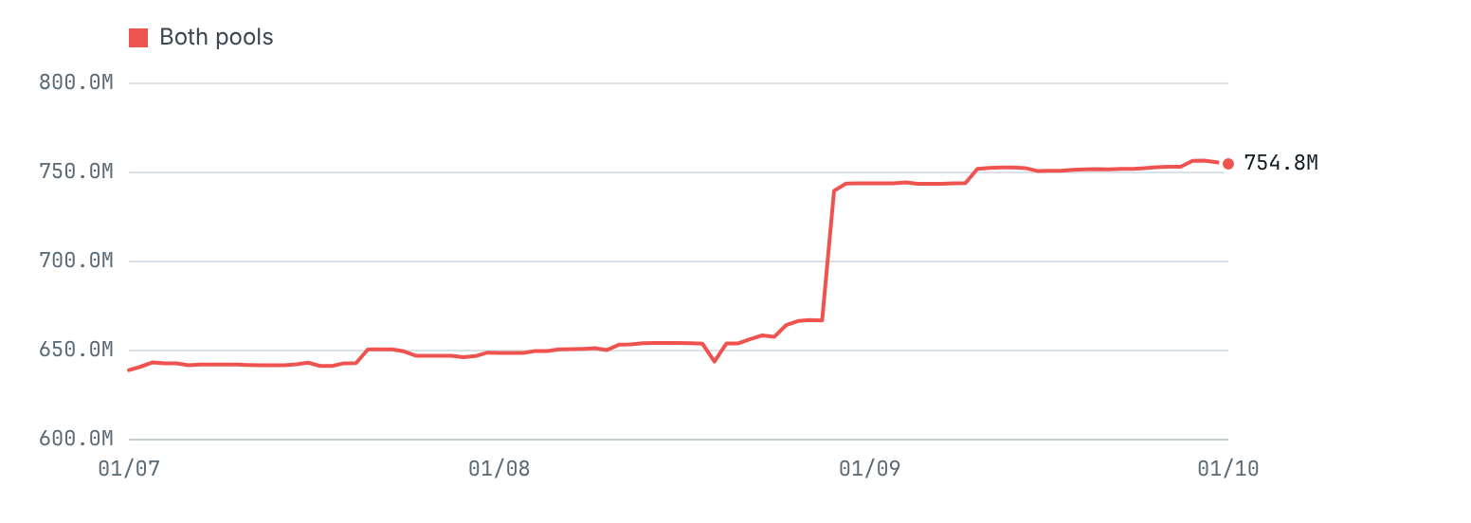
Source: Redbelly mainnet (chain ID 151), read with eth_getBalance and eth_call at blocks 3,025,809 and 3,209,414. Data read 2026-10-25. Daily snapshots, last block before 00:00 UTC. Data: 07b_daily_pools_and_wrbnt.csv.
FIGURE 11
No lock pool, each day
Pool balance (red) and staked RBNT (grey). The gap between the two lines is reward funds.
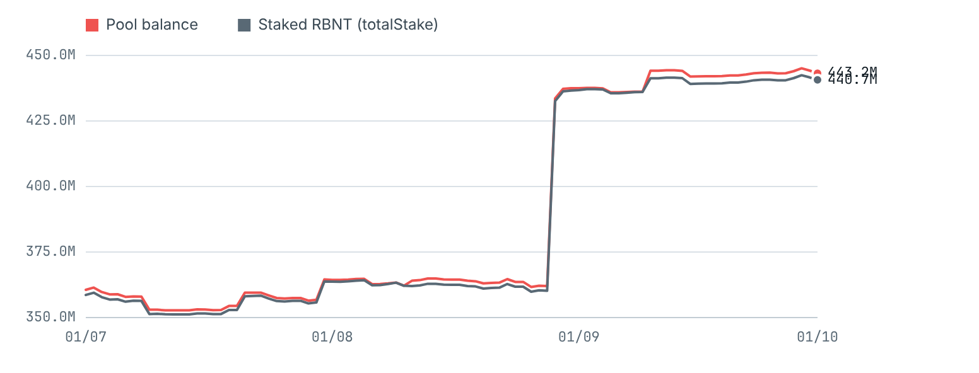
Data: 07b_daily_pools_and_wrbnt.csv.
FIGURE 12
365 day pool, each day
Pool balance (red) and staked RBNT (grey). The gap between the two lines is reward funds.
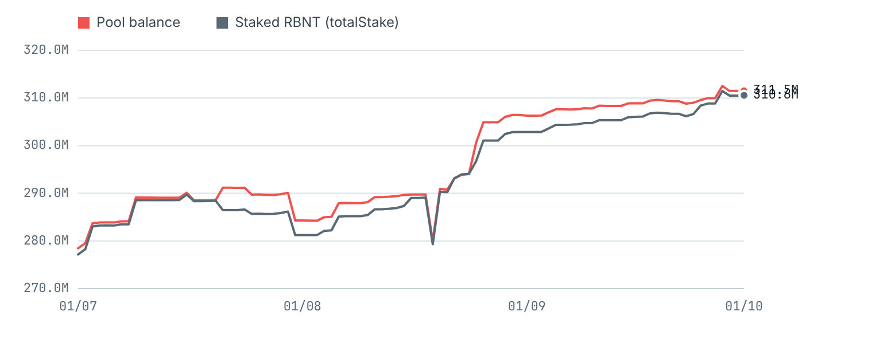
Data: 07b_daily_pools_and_wrbnt.csv.

Who is staking, in groups
Pool | Stakers 30 Jun | Stakers 30 Sep | New stakers | Stakers who left | Stakes made | RBNT staked | Withdrawals | RBNT withdrawn | Reward claims | Rewards paid
No lock pool | 1,156 | 1,140 | 13 | 29 | 262 | 132,965,677 | 102 | 50,895,283 | 512 | 4,436,787
365 day pool | 223 | 217 | 6 | 12 | 227 | 63,401,240 | 51 | 29,983,775 | 523 | 10,336,843

Measured as a share of everything wallets hold, staked RBNT went from 34.9% to 38.4% of wallet holdings over the quarter. Stakes and withdrawals come from the pools' own Stake and Unstake records; stakes made minus withdrawals equals the change in staked RBNT in each pool, to the last unit.
Pool | Stake size (RBNT) | Stakers | RBNT staked
No lock pool | Under 100 | 226 | 2,931
No lock pool | 100 to 1,000 | 227 | 71,742
No lock pool | 1,000 to 10,000 | 235 | 859,853
No lock pool | 10,000 to 100,000 | 238 | 7,669,064
No lock pool | 100,000 to 1 million | 151 | 49,183,438
No lock pool | 1 million to 10 million | 56 | 152,315,765
No lock pool | 10 million and over | 7 | 230,574,458
365 day pool | 1 to 100 | 10 | 204
365 day pool | 100 to 1,000 | 7 | 4,021
365 day pool | 1,000 to 10,000 | 29 | 142,372
365 day pool | 10,000 to 100,000 | 58 | 2,089,985
365 day pool | 100,000 to 1 million | 71 | 23,679,627
365 day pool | 1 million to 10 million | 36 | 110,530,334
365 day pool | 10 million and over | 6 | 174,127,214

When locked RBNT unlocks
Each stake in the 365 day pool unlocks one year after it was made. Figure 13 adds up, by month, the RBNT that was still staked on 30 September and when it becomes free to withdraw. Unlocking does not mean the RBNT will be withdrawn; stakers can leave it in the pool. 74.9 million RBNT unlocks in the next three months. Another 94.8 million RBNT was still staked on 30 September although its lock had already ended.
FIGURE 13
When RBNT staked in the 365 day pool unlocks
RBNT still staked on 30 September, by the month its lock ends (UTC).
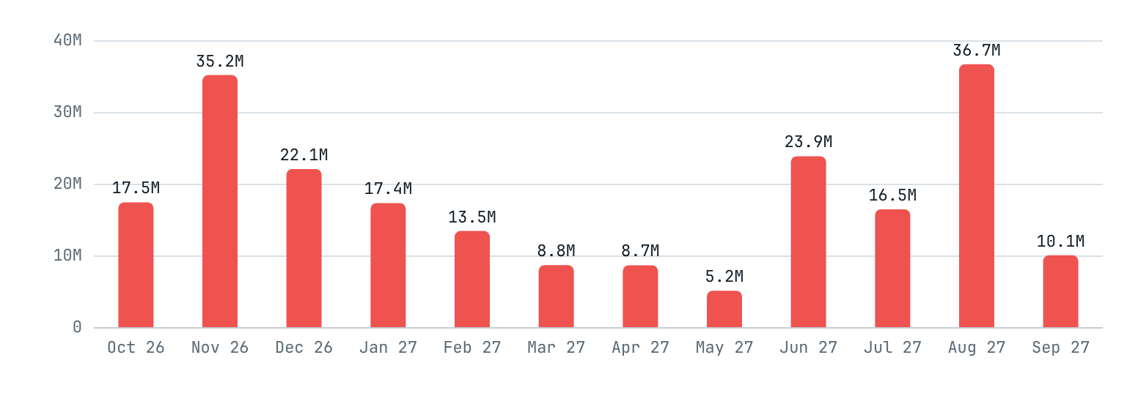
Source: getStakeUnlockTimes for every open stake, read at block 3,209,414. Data: 07d_lock_calendar_365_day.csv.

SECTION 6

The publicly named wallets
Redbelly's nine reserved wallets held 5.93 billion RBNT on 30 September, against 5.97 billion on 30 June. Most of the RBNT they moved went from one reserved wallet to another.
The DAO treasury page lists Redbelly's reserved wallets, their addresses and the amounts first allocated to them. Those amounts are the original allocations, not today's balances, so this report reads each balance from the chain. Every transfer in and out during the quarter is added up by counterparty, and each wallet reconciles exactly: start balance plus RBNT in, minus RBNT out, minus fees, equals the end balance.
FIGURE 14
Change in each reserved wallet
Balance on 30 September minus balance on 30 June.
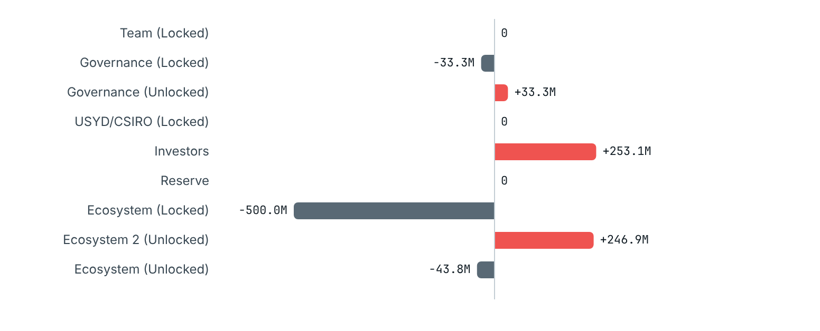
Source: Redbelly mainnet (chain ID 151), read with eth_getBalance and eth_call at blocks 3,025,809 and 3,209,414. Data read 2026-10-25. Data: 08_named_wallets.csv.
Named wallet | 30 Jun | 30 Sep | Change | RBNT in | RBNT out | Fees
Team (Locked)0xbcee2defb7cf136480e3619cf93e8129059977af | 333,909,314 | 333,909,314 | 0 | 0 | 0 | 0.00
Governance (Locked)0x9a83957d3399cbbcbef2112797b4a5b8e58c63d4 | 133,333,334 | 100,000,001 | -33,333,333 | 0 | 33,333,333 | 0.00
Governance (Unlocked)0x9e678318539d7c98057e9f89c58fb8f99752faea | 66,666,756 | 100,000,089 | +33,333,333 | 33,333,333 | 0 | 0.00
USYD/CSIRO (Locked)0xac27381ef74457c1258d54a808c2461eedc56270 | 200,000,000 | 200,000,000 | 0 | 0 | 0 | 0.00
Investors0xef816d556e01bc194ae302999930eacd6dc4e566 | 0 | 253,115,670 | +253,115,670 | 253,115,670 | 0 | 0.00
Reserve0x7473feaf836b5319d9190d8367991dc6ef33c16d | 2,000,000,000 | 2,000,000,000 | 0 | 0 | 0 | 0.00
Ecosystem (Locked)0xc5c131572d232512973e79204b93c2c1d57c879d | 2,794,132,788 | 2,294,132,788 | -500,000,000 | 0 | 500,000,000 | 0.00
Ecosystem 2 (Unlocked)0xe0c701c40166bbd8d5f5ec33c123f0a03e902df7 | 377,838,567 | 624,722,897 | +246,884,330 | 500,000,000 | 253,115,670 | 0.00
Ecosystem (Unlocked)0x415cad8fc89f75a63c5b830e06460eecde083c9f | 68,892,664 | 25,080,271 | -43,812,393 | 0 | 43,796,669 | 15,724.23
Wrapped RBNT (WRBNT)0x6ed1f491e2d31536d6561f6bdb2adc8f092a6076 | 1,819,066,451 | 1,736,902,022 | -82,164,428 | 38,674,776 | 120,839,204 | 0.00
Reddex RBNT staking pool, no lock0x43a1dc107bbb06df266278056055ae7fc5bd2817 | 360,594,599 | 443,228,206 | +82,633,607 | 137,965,677 | 55,332,070 | 0.00
Reddex RBNT staking pool, 365 day lock0x5e8040e85d0e6363d798a43bea939c026449946d | 278,467,724 | 311,548,346 | +33,080,622 | 73,401,240 | 40,320,618 | 0.00

FIGURE 15
Where RBNT sent by the reserved wallets went
Each ribbon is RBNT sent during the quarter, from a reserved wallet on the left to a counterparty on the right. Transfers under 100,000 RBNT are left out of the diagram but kept in the table.
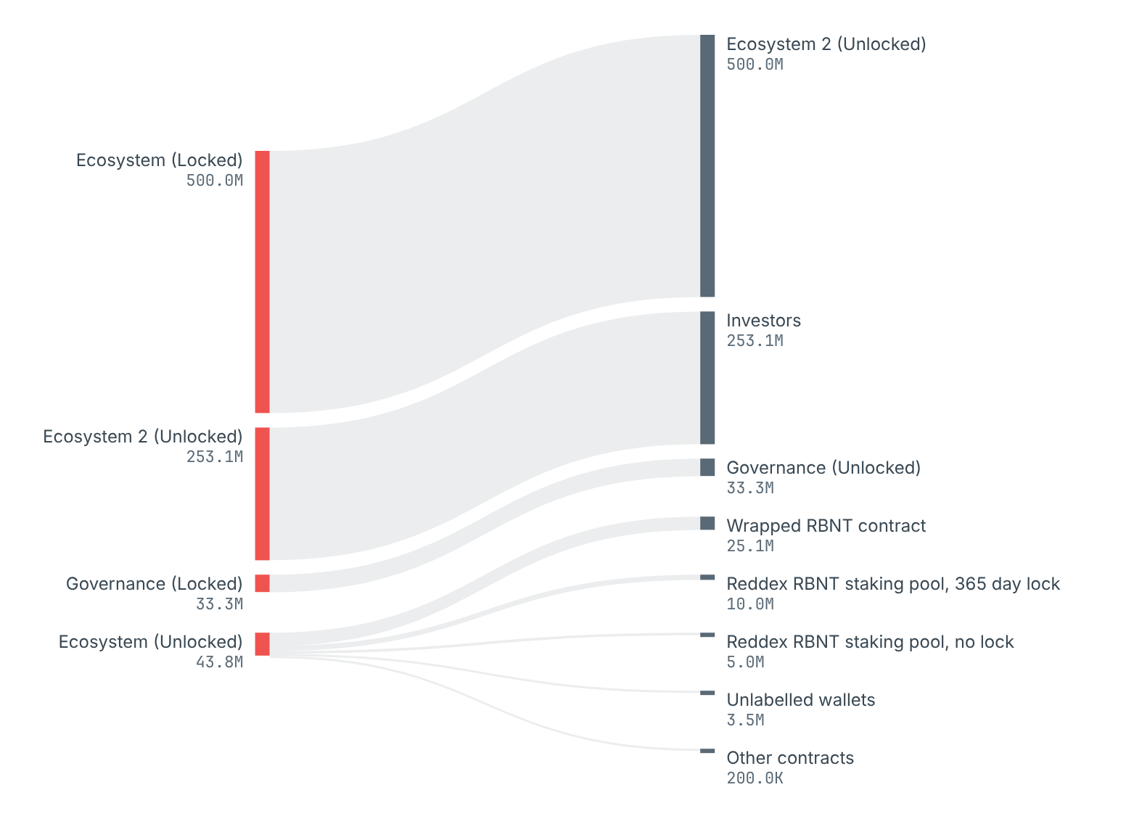
Source: every transaction and internal transfer of each reserved wallet between the two snapshot blocks. Data: 08b_named_wallet_flows.csv.

What the reserved wallets did, in order of size
- Ecosystem (Locked) sent 500 million RBNT to Ecosystem 2 (Unlocked).
- Ecosystem 2 (Unlocked) sent 253.1 million RBNT to Investors.
- Governance (Locked) sent 33.3 million RBNT to Governance (Unlocked).
- Ecosystem (Unlocked) was the only reserved wallet that sent RBNT outside the group: 25.1 million into the WRBNT contract (wrapping it), 15 million to the two Reddex pools as plain transfers rather than stakes, which adds to the pools' reward funds, 3.5 million to unlabelled wallets in 22 transfers, and 200,000 to other contracts.
- Ecosystem (Unlocked), in wrapped RBNT: received 9.6 million WRBNT from vesting contracts (1 transfer), sent 34.7 million WRBNT to vesting contracts (4 transfers) and wrapped 25.1 million RBNT into WRBNT (2 transfers).
- Team (Locked), USYD/CSIRO (Locked) and Reserve did not move during the quarter.
Wrapped RBNT is a token, so moving it does not change a wallet's RBNT balance in the table above. It is listed here so every movement of the reserved wallets is accounted for.

Exchanges and other labelled addresses
The explorer labels no exchange wallet on Redbelly mainnet, so the report names none. Of the 20,000 largest addresses in the explorer's list, the only one with a public name tag is Wrapped RBNT. Counterparties that are not named appear only as groups: unlabelled wallets, and contracts by the kind of program they are.

Wrapped RBNT
WRBNT is RBNT wrapped into a token so it can be used by apps that expect one. The WRBNT contract holds one RBNT for every WRBNT. The supply fell from 1.82 billion to 1.74 billion over the quarter.
FIGURE 16
Wrapped RBNT (WRBNT) supply, each day
WRBNT totalSupply at the end of each day.
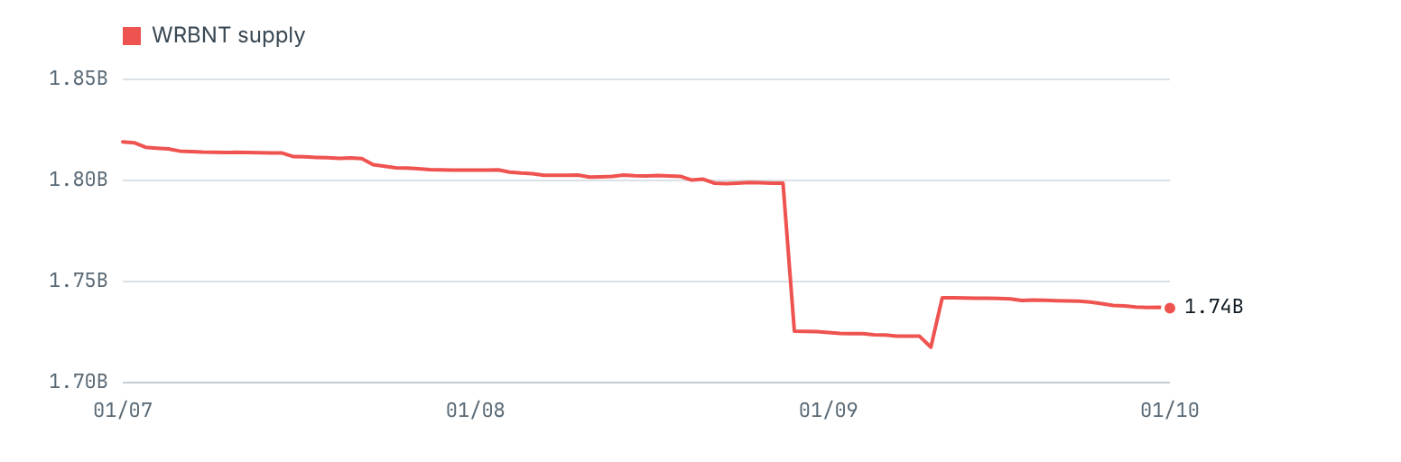
Source: WRBNT totalSupply() at daily snapshot blocks. Data: 07b_daily_pools_and_wrbnt.csv.

SECTION 7

How this report was made
Every balance was read directly from the Redbelly chain at two fixed blocks, and every published figure was read again from the node by a separate check before release.
- Two fixed moments. The start is block 3,025,809, the last block before midnight UTC at the end of 30 June 2026. The end is block 3,209,414, the last block before midnight UTC at the end of 30 September. Month ends and each day of the quarter use the same rule.
- Every address. All 3,209,415 blocks from the network's start to the end block were read, along with 1,753,030 internal transfers from the explorer, to find every address that could hold RBNT: 761,594 addresses in total.
- Balances from the chain. Each address's RBNT, WRBNT and staked RBNT were read at each snapshot block. Balances shown by the explorer's lists are never used, because they are today's figures and rounded.
- Counted once. RBNT inside the WRBNT contract and staked RBNT inside the pools are counted with their owners. The part of a pool's balance above its totalStake is reported as that pool's reward funds.
- Groups, never individuals. Only publicly named wallets are named. Every other address is counted only in a group of at least five, and a scan of every published file fails the build if any other address appears.
- Exact checks. 58 checks must pass in wei before anything is written: WRBNT supply equals the sum of all WRBNT balances, stakers add up to each pool's totalStake, stakes minus withdrawals equal the change in totalStake, every group adds up to the RBNT located, and every named wallet reconciles to the last unit.
# Balance of the Reserve wallet at the end of the quarter (result in wei; divide by 10^18)
curl -s https://governors.mainnet.redbelly.network -H 'content-type: application/json' \
-d '{"jsonrpc":"2.0","id":1,"method":"eth_getBalance","params":["0x7473fEAf836b5319D9190d8367991Dc6ef33C16d","0x30f8c6"]}'
# RBNT staked in the 365 day pool at the end of the quarter (totalStake)
curl -s https://governors.mainnet.redbelly.network -H 'content-type: application/json' \
-d '{"jsonrpc":"2.0","id":1,"method":"eth_call","params":[{"to":"0x5E8040e85D0E6363D798a43BEa939C026449946d","data":"0x8b0e9f3f"},"0x30f8c6"]}'
# The end snapshot block: last block before 1 October 2026 00:00 UTC
curl -s 'https://api.routescan.io/v2/network/mainnet/evm/151/etherscan/api?module=block&action=getblocknobytime&timestamp=1790812800&closest=before'
The full method, every endpoint and the steps to produce the next edition are in the method page, which is docs/METHOD.md in the repository that holds the code that produced every number.

Sources
Source | Used for
Redbelly mainnet RPC, chain ID 151https://governors.mainnet.redbelly.network | Every balance, WRBNT and pool figure, every block and receipt
Routescan API, Etherscan compatibleapi.routescan.io/v2/network/mainnet/evm/151/etherscan/api | Internal transfers, verified contract names, cross-check of snapshot blocks
Routescan address listapi.routescan.io/v2/network/mainnet/evm/151/addresses | Public name tags only, never balances
Redbelly DAO treasury pageredbellydao.network/treasury | Names and addresses of the reserved wallets
Reddex stakingreddex.io/stake and the pools' verified code | The two RBNT pools and how rewards are paid

Limits
- The chain shows that coins moved, not who controls an address or why. A fall in a group's holdings may be a sale, a move between a holder's own addresses or a deposit into a contract.
- One address is not one person. Counts of wallets show how widely RBNT is spread across addresses.
- Internal transfers come from the explorer, because the public node has no trace interface. They are checked indirectly: every named wallet, including the WRBNT contract and both pools, reconciles exactly.
- The explorer's address list was read for its 20,000 largest addresses. A public label on a smaller address would not be seen.

SECTION 8

The data
Every chart and table in this report is drawn from these files. Each holds groups or named wallets only. The numbers behind each figure are under "Show the numbers" on the web edition and in the Excel workbook.

WORDS USED

Words used in this report
RBNT. The coin of the Redbelly network. There are 10 billion in total, all created when the network started.
Address. A public account on the chain. Anyone can look up its balance.
Wallet. An address controlled by a private key, held by a person or an organisation.
Contract. An address that is a program. It holds and moves coins under its own fixed rules.
WRBNT. Wrapped RBNT. A token backed one to one by RBNT held in the WRBNT contract.
Staking. Locking RBNT in a pool to earn rewards, paid in RBNT.
totalStake. The pool contract's own record of how much RBNT its stakers have staked.
Reward funds. RBNT in a pool above its totalStake, used to pay rewards.
Reserved wallets. Redbelly's wallets listed on the DAO treasury page: team, investors, reserve, ecosystem, governance and USYD/CSIRO.
Snapshot block. The block whose balances stand for a moment in time: the last block before midnight UTC.
Gini score. A single number for concentration: 0 means every wallet holds the same, 1 means one wallet holds all.
Lorenz curve. A chart of how much the smallest holders hold together. A straight line would mean equal holdings.
Wei. The smallest unit of RBNT. 1 RBNT is 1018 wei. All checks in this report are exact to the wei.

