
REDBELLY DAO · ON-CHAIN HOLDER REPORT · EDITION 1

RBNT holders, July to September 2026
What the 10 billion RBNT did over one quarter: who holds them, how spread out they are, what the biggest wallets did, how much is staked with Reddex, and what moved in and out of the wallets with public names. Every figure comes from the Redbelly chain itself.
THE QUARTER IN NUMBERS
 | 30 Jun | 30 Sep | Change
RBNT in the Reddex pools | 639.1 million | 754.8 million | +18.1%
Wallets holding 1 RBNT or more | 53,418 | 53,575 | +157
Share held by the 100 largest wallets | 75.8% | 76.7% | +0.9 pts
RBNT in the 9 reserved wallets | 5.97 billion | 5.93 billion | -43.8 million
WRBNT in circulation | 1.82 billion | 1.74 billion | -82.2 million
Held by token vesting contracts | 1.68 billion | 1.58 billion | -102.7 million

CHAPTER 00

What the quarter looked like
+18.1% Staking grew. We counted 754.8 million RBNT in the two Reddex pools at the end of September, 115.7 million more than at the end of June. The no lock pool took 82.6 million of that change. Open stakers: 1,156 to 1,140 in the no lock pool, 223 to 217 in the 365 day pool.
127.8 million Vesting contracts paid out. The 18 contracts whose published code is a token vesting manager sent 127.8 million WRBNT to unnamed wallets in 1,885 transfers. Together they went from 1.68 billion to 1.58 billion.
786.4 million Reserved wallets reshuffled among themselves. Three moves inside the reserved group: Ecosystem (Locked) to Ecosystem 2 (Unlocked), 500 million; Ecosystem 2 (Unlocked) to Investors, 253.1 million; Governance (Locked) to Governance (Unlocked), 33.3 million. Ecosystem (Unlocked) was the only one to send RBNT outside the group (43.8 million), mostly into WRBNT and the pools' reward reserves.
+45.3 million The biggest wallets ended up with more. We ranked unnamed wallets on 30 June and followed the top 100. They held 1.38 billion RBNT then (wrapped and staked included) and 1.42 billion on 30 September. 43 grew by over 1%, 49 stayed within 1% and 8 shrank by over 1%.
48.4% Holdings stayed top-heavy. The ten largest wallets hold 48.4% of everything unnamed wallets hold, up from 47.5%. The largest 1% of wallets (535 of them) hold 93.5%. A typical wallet, the one in the middle, holds 5.84 RBNT.
+157 A few more holders. 53,575 wallets held at least 1 RBNT on 30 September against 53,418 on 30 June. Behind that net figure, 243 wallets rose past 1 RBNT and 86 dropped under it.
- Public names only. Twelve addresses are named: the nine reserved wallets published by the DAO, the WRBNT contract and Reddex's two RBNT pools. The explorer tags no exchange wallet, so we name none.
- Groups of five or more. Every other address is only ever part of a count or a total, in a group with at least four others. No address outside the named list appears anywhere.
- What, not why. The chain shows coins moving between addresses. It cannot show who is behind an address or the reason for a move. We forecast nothing and advise nothing.
THREE TERMS USED THROUGHOUT
Address. A public account on the chain. Anyone can look up what it holds.
Wallet or contract. A wallet is opened with a private key held by a person or an organisation. A contract is a program that holds and moves coins by fixed rules.
Holding. Everything an address owns: RBNT, plus WRBNT, plus RBNT it has staked. Wrapped and staked coins are counted once, with their owner, and never again at the contract.

CHAPTER 01

The 10 billion, group by group
At the end of September Redbelly's reserved wallets held 59.3% of all RBNT. Unnamed wallets held 19.6% and contracts outside the named list 21.1%, most of it in token vesting contracts.
Every RBNT that exists was minted when the network launched, so the total never changes. What changes is where the coins are. In chart 1 each holding is credited to its owner, so RBNT that a wallet has wrapped or staked still counts as that wallet's.
CHART 1
Who holds the 10 billion RBNT
Share of all RBNT by kind of owner, 30 June and 30 September.
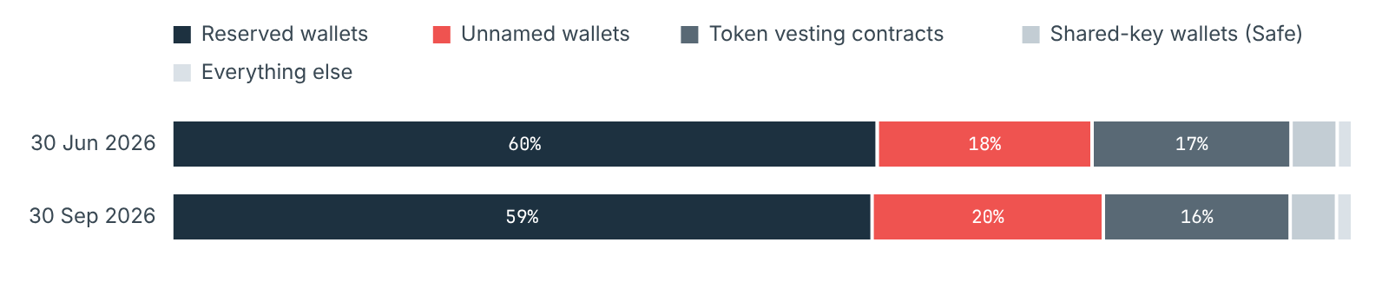
Read from Redbelly mainnet (chain ID 151), eth_getBalance and eth_call at block 3,025,809 (30 June, 23:57:19 UTC) and block 3,209,414 (30 September, 23:57:35 UTC). Read 2026-10-26.
HOW WE SORT CONTRACTS
When a contract's author publishes its source code on the explorer, the code carries a name such as TokenVestingManager or GnosisSafe. We use that name to put the contract in a broad kind, and we only show a kind when at least five contracts share it. A token vesting contract releases coins to fixed recipients on a timetable. A shared-key wallet (Safe) needs several keys to approve a payment. An exchange liquidity pool is the stock of coins people swap against on a decentralised exchange.

Counting by the address that holds the coins
Chart 2 adds up the same coins differently: by the address that physically holds them. Here the WRBNT contract and the two pools show up as places, because that is where wrapped and staked RBNT actually sit.
CHART 2
Where the coins sit, by the address that holds them
Share of all RBNT by holding address, 30 June and 30 September.
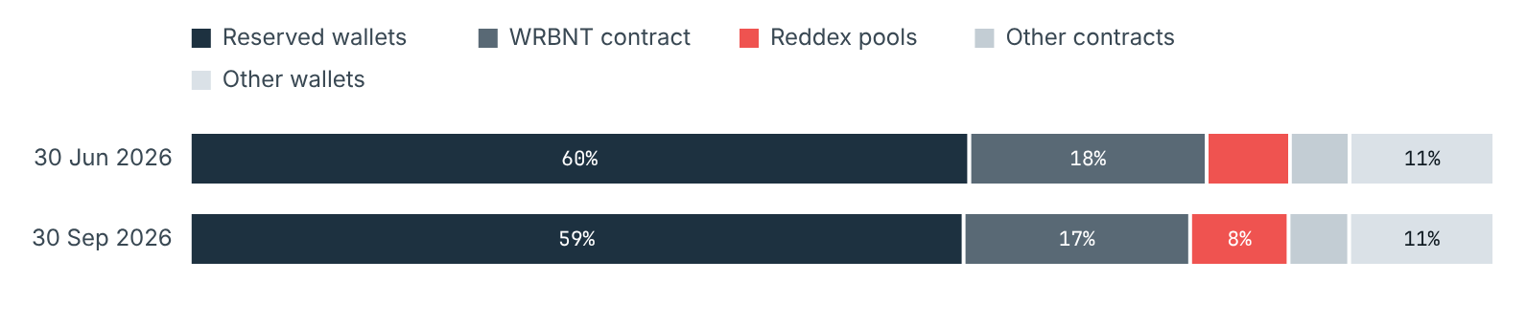
Read from Redbelly mainnet (chain ID 151), eth_getBalance and eth_call at block 3,025,809 (30 June, 23:57:19 UTC) and block 3,209,414 (30 September, 23:57:35 UTC). Read 2026-10-26.
DID WE FIND EVERY COIN?
Yes, to within 36,485 RBNT: the balances we read add up to 99.9996% of the supply on 30 September. The rest sits at addresses that never took part in any transaction, internal transfer or block header we read, most likely funded at launch and never touched. That amount moved by 11 RBNT over the quarter, far too little to affect any trend.

Where the coins went during the quarter
Chart 3 traces every transfer of RBNT and WRBNT between groups from 1 July to 30 September. The four biggest streams were stakes from wallets into the pools (196.4 million), WRBNT from vesting contracts to wallets (127.8 million), RBNT leaving the WRBNT contract as wallets unwrapped (115.9 million), and withdrawals plus rewards paid out of the pools (95.7 million). Moves inside one group are kept out of the picture and listed in the table.
CHART 3
RBNT and WRBNT moved between groups
Sending group on the left, receiving group on the right; ribbon width is the amount. Ribbons under 1 million are left out of the picture but kept in the table.
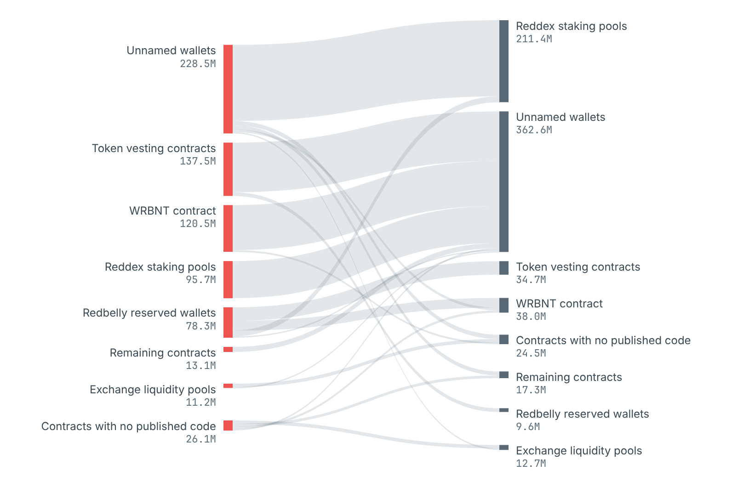
Read from every successful transaction and internal transfer with value, and every WRBNT Transfer event, from block 3,025,810 to 3,209,414.

CHAPTER 02

Big and small holders
53,575 wallets held 1 RBNT or more at the end of September. 89% of them hold under 100 RBNT, while 23 wallets with 10 million or more RBNT hold 60% of the total.
These counts cover unnamed wallets only. Reserved wallets and contracts are left out because they are large by design and would drown out everyone else. Wallets with less than 1 RBNT are left out too: there were 111,509 of them on 30 September, mostly holding fee change.
CHART 4
Share of wallets and share of wallet RBNT, by holding size
For each size on 30 September: the slate dot is the share of wallets, the red dot the share of RBNT.
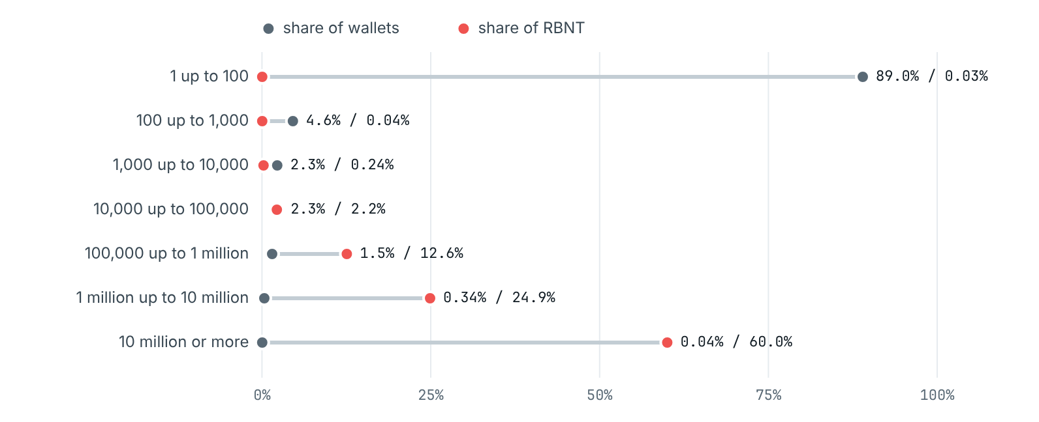
Read from Redbelly mainnet (chain ID 151), eth_getBalance and eth_call at block 3,025,809 (30 June, 23:57:19 UTC) and block 3,209,414 (30 September, 23:57:35 UTC). Read 2026-10-26.
CHART 5
Change in wallets per holding size
Wallets in each size on 30 September minus 30 June.
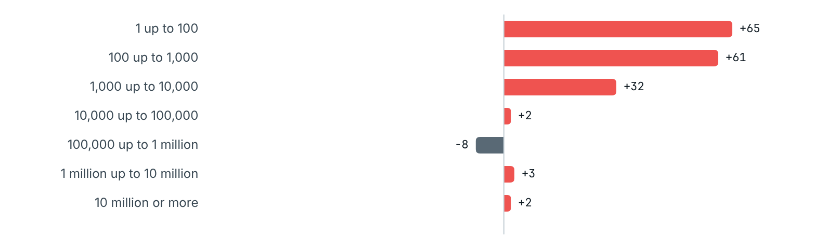
Read from Redbelly mainnet (chain ID 151), eth_getBalance and eth_call at block 3,025,809 (30 June, 23:57:19 UTC) and block 3,209,414 (30 September, 23:57:35 UTC). Read 2026-10-26.

CHAPTER 03

How top-heavy is it?
Very. The ten largest wallets hold 48.4% of all RBNT in unnamed wallets and the hundred largest 76.7%. Both shares edged up over the quarter.
We use four yardsticks, all over unnamed wallets with at least 1 RBNT: the share of the largest 10, 100 and 1,000 wallets; the share of the largest 1% of wallets; how few wallets it takes to hold more than half; and the Gini index, a single score where 0 would mean every wallet holds the same and 1 that one wallet holds it all.
Yardstick | 30 Jun 2026 | 31 Jul 2026 | 31 Aug 2026 | 30 Sep 2026
Wallets with 1 RBNT or more | 53,418 | 53,476 | 53,536 | 53,575
RBNT those wallets hold | 1,819,550,653 | 1,841,192,760 | 1,942,733,447 | 1,958,624,111
Largest 10 wallets | 47.5% | 47.4% | 48.5% | 48.4%
Largest 100 wallets | 75.8% | 75.8% | 76.6% | 76.7%
Largest 1,000 wallets | 97.2% | 97.2% | 97.4% | 97.4%
Largest 1% of wallets | 93.2% | 93.1% | 93.5% | 93.5%
Fewest wallets holding over half | 12 | 12 | 11 | 12
Gini index | 0.9951 | 0.9951 | 0.9953 | 0.9953
Middle wallet (median), RBNT | 5.84 | 5.84 | 5.84 | 5.84

CHART 6
How wallet RBNT splits by rank
All RBNT in unnamed wallets with 1 RBNT or more, split into the top 10, the next 90, the next 900 and the rest. The Lorenz curve points are in data/q3-2026/lorenz_points.csv.
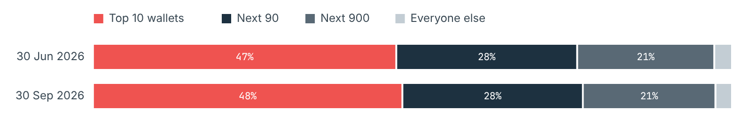
Read from Redbelly mainnet (chain ID 151), eth_getBalance and eth_call at block 3,025,809 (30 June, 23:57:19 UTC) and block 3,209,414 (30 September, 23:57:35 UTC). Read 2026-10-26.
READING THIS CAREFULLY
A top-heavy spread means a small set of addresses could move a large part of the supply. It says nothing about who those addresses belong to. An exchange can keep the coins of thousands of people in one wallet, and one person can spread coins over many wallets.

CHAPTER 04

Did the big wallets add or cut?
On balance they added. The 21 wallets that held 10 million or more RBNT on 30 June had 1.06 billion between them then and 1.09 billion three months later; 9 of them grew, 7 held flat and 5 shrank.
We never follow a single wallet. Instead we sort wallets into groups by what they held on 30 June, keep each group fixed, and count what its members held on 30 September. A wallet counts as up if its holding grew by more than 1%, down if it shrank by more than 1%, and flat in between. Staking or wrapping coins is not a fall, since the holding includes both.
CHART 7
Outcome for each wallet, grouped by its holding on 30 June
Share of each group that went up, stayed flat, went down or fell under 1 RBNT.
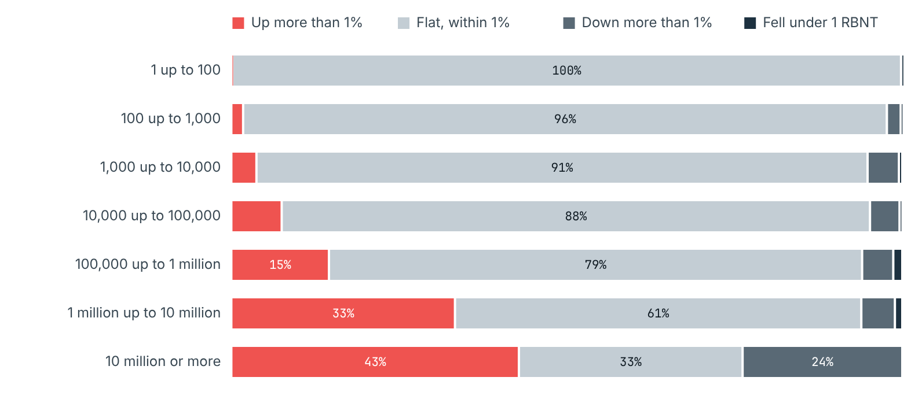
Read from Redbelly mainnet (chain ID 151), eth_getBalance and eth_call at block 3,025,809 (30 June, 23:57:19 UTC) and block 3,209,414 (30 September, 23:57:35 UTC). Read 2026-10-26.
CHART 8
Net change in RBNT for each group
Total held by each group on 30 September minus 30 June. The last row is wallets that started under 1 RBNT.
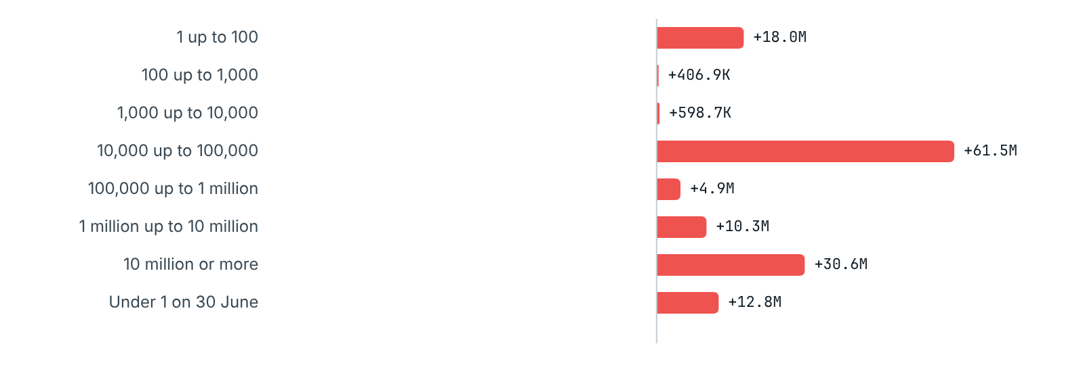
Read from Redbelly mainnet (chain ID 151), eth_getBalance and eth_call at block 3,025,809 (30 June, 23:57:19 UTC) and block 3,209,414 (30 September, 23:57:35 UTC). Read 2026-10-26.
A word of caution on the small groups: their net change can be driven by a handful of wallets that jumped several sizes in one quarter. The movement table further down shows how many wallets changed size, and in which direction.

The top 10, the next 90 and the next 900
Ranking unnamed wallets by holding on 30 June gives a second view. The top 10 grew by 19.3 million RBNT and the next 90 by 26 million. The RBNT the top 100 keep staked with Reddex rose by 52.8 million.
Ranked on 30 June | Wallets | RBNT 30 Jun 2026 | RBNT 30 Sep 2026 | Net | Change | Up | Flat | Down | Under 1 at end
Top 10 | 10 | 863,556,835 | 882,860,172 | +19,303,337 | +2.2% | 4 | 4 | 2 | 0
Next 90 | 90 | 514,959,338 | 540,931,017 | +25,971,678 | +5.0% | 39 | 45 | 5 | 1
Next 900 | 900 | 390,412,544 | 390,830,090 | +417,546 | +0.1% | 143 | 701 | 44 | 12
Everyone else | 52,418 | 50,621,935 | 131,192,086 | +80,570,151 | +159.2% | 251 | 51900 | 194 | 73

CHART 9
How the largest wallets hold their RBNT
Holdings of each rank group split into RBNT kept in the wallet, wrapped as WRBNT, and staked with Reddex.
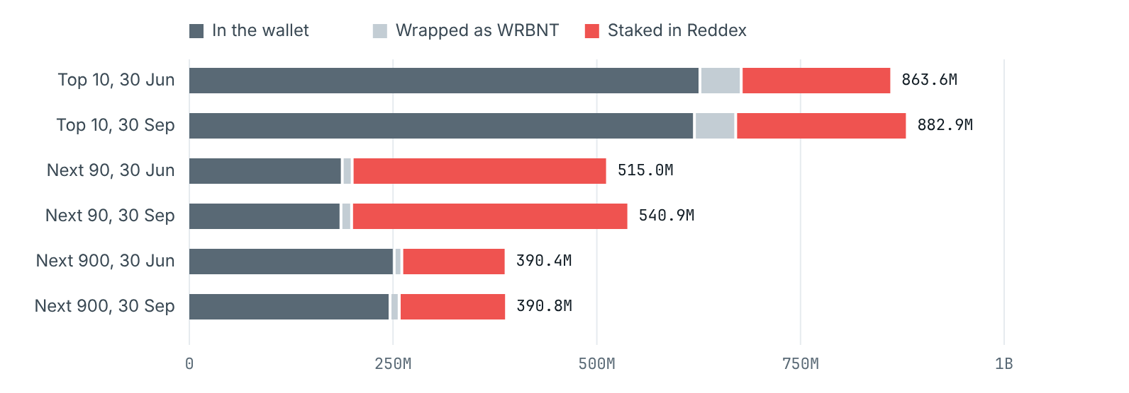
Read from Redbelly mainnet (chain ID 151), eth_getBalance and eth_call at block 3,025,809 (30 June, 23:57:19 UTC) and block 3,209,414 (30 September, 23:57:35 UTC). Read 2026-10-26.

Wallets that changed size
Rows are the size a wallet had on 30 June, columns the size on 30 September. The shaded diagonal is wallets that stayed in the same size. Any cell with fewer than five wallets shows <5.
On 30 June / on 30 September | Under 1 | 1 up to 100 | 100 up to 1,000 | 1,000 up to 10,000 | 10,000 up to 100,000 | 100,000 up to 1 million | 1 million up to 10 million | 10 million or more
Under 1 | 0 | 79 | 73 | 37 | 34 | 17 | <5 | 0
1 up to 100 | 56 | 47526 | 13 | 5 | 5 | <5 | <5 | <5
100 up to 1,000 | 6 | 20 | 2335 | 17 | 9 | 0 | 0 | 0
1,000 up to 10,000 | 6 | 12 | 12 | 1131 | 14 | <5 | 0 | 0
10,000 up to 100,000 | 5 | 24 | 7 | 14 | 1156 | 18 | <5 | <5
100,000 up to 1 million | 11 | 10 | 6 | 5 | 9 | 770 | 7 | 0
1 million up to 10 million | <5 | <5 | <5 | 0 | <5 | <5 | 170 | <5
10 million or more | 0 | <5 | 0 | 0 | 0 | 0 | <5 | 19

CHAPTER 05

Staking in Reddex
Up 18.1%: the two Reddex pools held 639.1 million RBNT on 30 June and 754.8 million on 30 September.
Reddex runs two pools for RBNT. In the no lock pool a staker can take coins back at any time. In the 365 day pool each deposit stays put for a year from the day it was made. Following the brief, our headline numbers are the RBNT each pool held at the two dates.
WHY A POOL'S BALANCE IS NOT ALL STAKES
Stakers are paid their rewards in RBNT straight out of the pool's own coins. So a pool's balance is two things mixed together: what stakers put in, and a reserve kept for paying rewards. The pool contract keeps its own running total of stakes, called totalStake. Subtracting it from the balance gives the reward reserve, and we show both.

Pool | RBNT 30 Jun 2026 | RBNT 30 Sep 2026 | Change | Staked 30 Jun 2026 | Staked 30 Sep 2026 | Reward reserve 30 Jun 2026 | Reward reserve 30 Sep 2026
Reddex no lock pool | 360,594,599 | 443,228,206 | +22.9% | 358,606,856 | 440,677,250 | 1,987,743 | 2,550,956
Reddex 365 day pool | 278,467,724 | 311,548,346 | +11.9% | 277,156,292 | 310,573,758 | 1,311,432 | 974,589

CHART 10
RBNT in the two Reddex pools, daily
Combined balance of both pools at the end of each day.
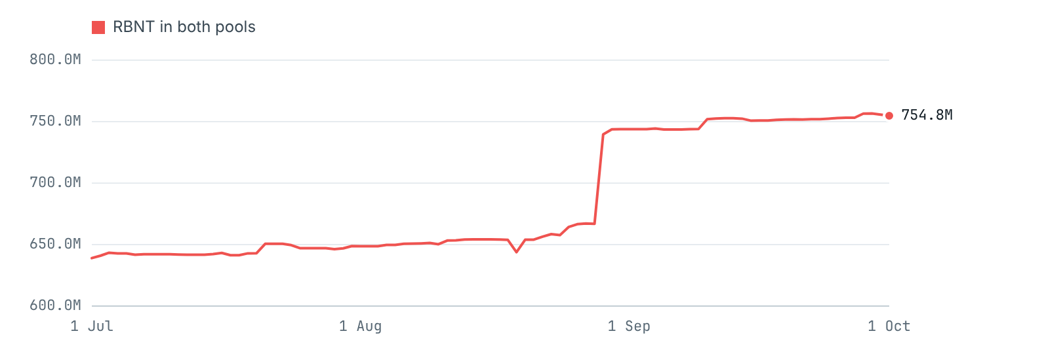
Read from daily snapshots, each the last block before 00:00 UTC. Redbelly mainnet (chain ID 151), eth_getBalance and eth_call at block 3,025,809 (30 June, 23:57:19 UTC) and block 3,209,414 (30 September, 23:57:35 UTC). Read 2026-10-26.
CHART 11
No lock pool, daily
Red: RBNT in the pool. Slate: staked RBNT (totalStake). The shaded gap between them is the reward reserve.
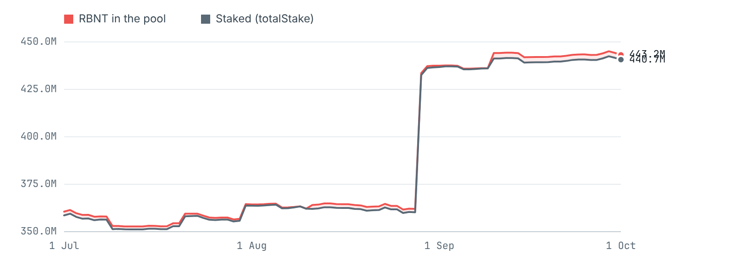
Read from daily snapshots, each the last block before 00:00 UTC.
CHART 12
365 day pool, daily
Red: RBNT in the pool. Slate: staked RBNT (totalStake). The shaded gap between them is the reward reserve.
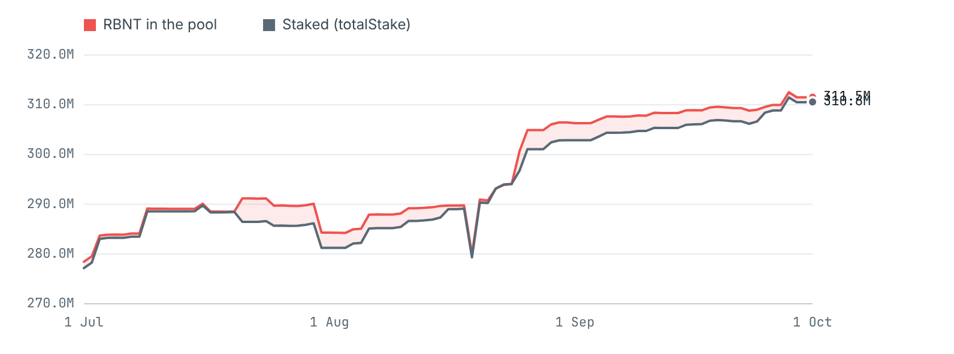
Read from daily snapshots, each the last block before 00:00 UTC.

Stakers, in groups
Pool | Stakers 30 Jun 2026 | Stakers 30 Sep 2026 | Joined | Left | Stakes | RBNT staked | Withdrawals | RBNT withdrawn | Reward claims | Rewards paid | Top-ups
Reddex no lock pool | 1,156 | 1,140 | 13 | 29 | 262 | 132,965,677 | 102 | 50,895,283 | 512 | 4,436,787 | 5,000,000
Reddex 365 day pool | 223 | 217 | 6 | 12 | 227 | 63,401,240 | 51 | 29,983,775 | 523 | 10,336,843 | 10,000,000

Stakes and withdrawals come from each pool's own Stake and Unstake events, and for both pools the stakes minus the withdrawals match the change in totalStake exactly. Top-ups are plain transfers into a pool that were not stakes; all 15 million RBNT of them came from a reserved wallet (see chapter 06). Measured against everything unnamed wallets hold, the staked share went from 34.9% to 38.4%.
Pool | Stake size (RBNT) | Stakers | RBNT staked
Reddex no lock pool | Under 100 | 226 | 2,931
Reddex no lock pool | 100 up to 1,000 | 227 | 71,742
Reddex no lock pool | 1,000 up to 10,000 | 235 | 859,853
Reddex no lock pool | 10,000 up to 100,000 | 238 | 7,669,064
Reddex no lock pool | 100,000 up to 1 million | 151 | 49,183,438
Reddex no lock pool | 1 million up to 10 million | 56 | 152,315,765
Reddex no lock pool | 10 million or more | 7 | 230,574,458
Reddex 365 day pool | Under 100 | 10 | 204
Reddex 365 day pool | 100 up to 1,000 | 7 | 4,021
Reddex 365 day pool | 1,000 up to 10,000 | 29 | 142,372
Reddex 365 day pool | 10,000 up to 100,000 | 58 | 2,089,985
Reddex 365 day pool | 100,000 up to 1 million | 71 | 23,679,627
Reddex 365 day pool | 1 million up to 10 million | 36 | 110,530,334
Reddex 365 day pool | 10 million or more | 6 | 174,127,214

When the locked coins come free
Chart 13 shows, month by month, when RBNT still locked in the 365 day pool on 30 September reaches the end of its year. Coming free is not the same as leaving: stakers may keep the coins in the pool. 74.9 million RBNT comes free in October, November and December, and another 94.8 million was already past its lock on 30 September but still staked.
CHART 13
Monthly unlocks in the 365 day pool
RBNT still staked on 30 September, by the month (UTC) its lock ends.
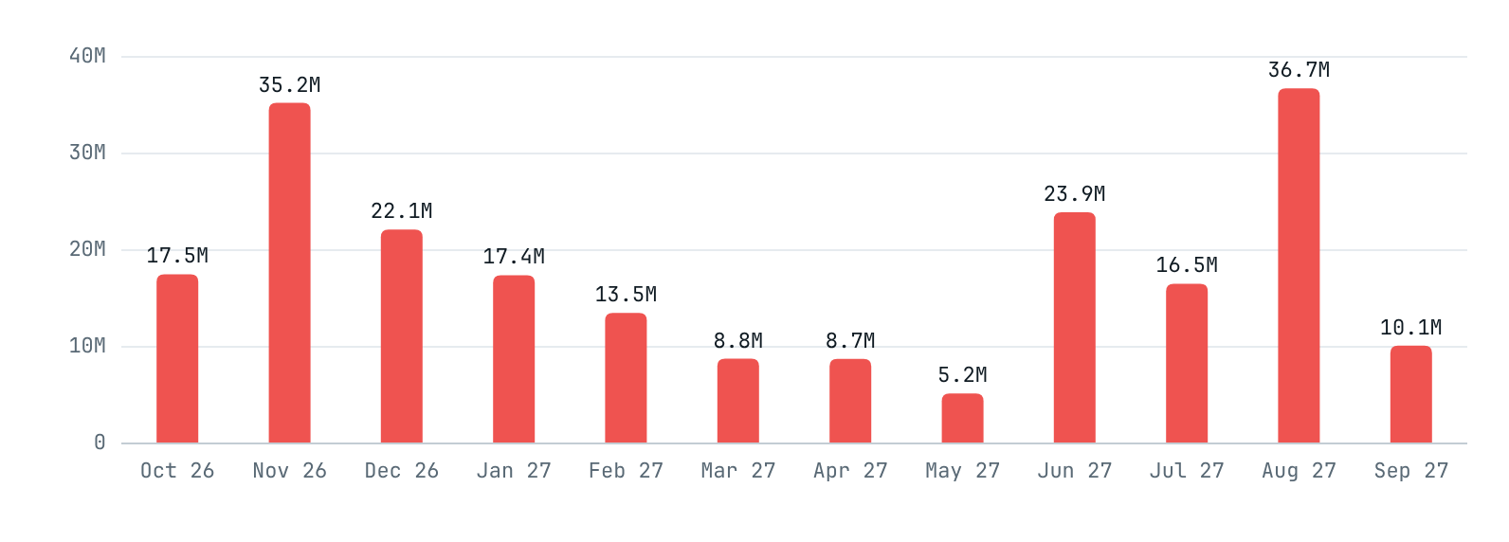
Read from getStakeUnlockTimes for every open stake, read at block 3,209,414.

CHAPTER 06

Wallets with public names
The nine reserved wallets held 5.93 billion RBNT at the end of September, against 5.97 billion at the end of June. 786.4 million of what they moved went from one reserved wallet to another.
The DAO treasury page lists each reserved wallet with its address and the amount it was first given. Those amounts are starting allocations, not today's holdings, so every balance here is read from the chain. For each wallet we add up every transfer in and out during the quarter and check the sum to the wei: opening balance, plus everything received, minus everything sent, minus fees, equals the closing balance.
CHART 14
Change in each reserved wallet over the quarter
Balance on 30 September minus 30 June.
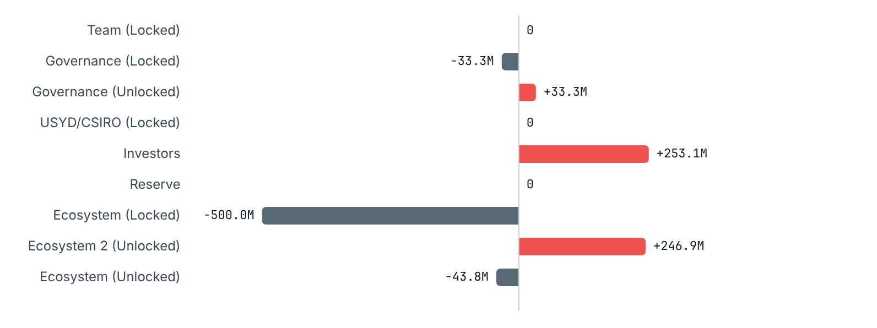
Read from Redbelly mainnet (chain ID 151), eth_getBalance and eth_call at block 3,025,809 (30 June, 23:57:19 UTC) and block 3,209,414 (30 September, 23:57:35 UTC). Read 2026-10-26.
Named wallet | 30 Jun 2026 | 30 Sep 2026 | Change | In | Out | Fees
Team (Locked) 0xbcee2defb7cf136480e3619cf93e8129059977af | 333,909,314 | 333,909,314 | 0 | 0 | 0 | 0.00
Governance (Locked) 0x9a83957d3399cbbcbef2112797b4a5b8e58c63d4 | 133,333,334 | 100,000,001 | -33,333,333 | 0 | 33,333,333 | 0.00
Governance (Unlocked) 0x9e678318539d7c98057e9f89c58fb8f99752faea | 66,666,756 | 100,000,089 | +33,333,333 | 33,333,333 | 0 | 0.00
USYD/CSIRO (Locked) 0xac27381ef74457c1258d54a808c2461eedc56270 | 200,000,000 | 200,000,000 | 0 | 0 | 0 | 0.00
Investors 0xef816d556e01bc194ae302999930eacd6dc4e566 | 0 | 253,115,670 | +253,115,670 | 253,115,670 | 0 | 0.00
Reserve 0x7473feaf836b5319d9190d8367991dc6ef33c16d | 2,000,000,000 | 2,000,000,000 | 0 | 0 | 0 | 0.00
Ecosystem (Locked) 0xc5c131572d232512973e79204b93c2c1d57c879d | 2,794,132,788 | 2,294,132,788 | -500,000,000 | 0 | 500,000,000 | 0.00
Ecosystem 2 (Unlocked) 0xe0c701c40166bbd8d5f5ec33c123f0a03e902df7 | 377,838,567 | 624,722,897 | +246,884,330 | 500,000,000 | 253,115,670 | 0.00
Ecosystem (Unlocked) 0x415cad8fc89f75a63c5b830e06460eecde083c9f | 68,892,664 | 25,080,271 | -43,812,393 | 0 | 43,796,669 | 15,724.23
Wrapped RBNT (WRBNT) 0x6ed1f491e2d31536d6561f6bdb2adc8f092a6076 | 1,819,066,451 | 1,736,902,022 | -82,164,428 | 38,674,776 | 120,839,204 | 0.00
Reddex RBNT staking pool, no lock 0x43a1dc107bbb06df266278056055ae7fc5bd2817 | 360,594,599 | 443,228,206 | +82,633,607 | 137,965,677 | 55,332,070 | 0.00
Reddex RBNT staking pool, 365 day lock 0x5e8040e85d0e6363d798a43bea939c026449946d | 278,467,724 | 311,548,346 | +33,080,622 | 73,401,240 | 40,320,618 | 0.00

CHART 15
RBNT sent by reserved wallets
Reserved wallet on the left, receiver on the right. Transfers under 100,000 RBNT are left out of the picture but kept in the table.
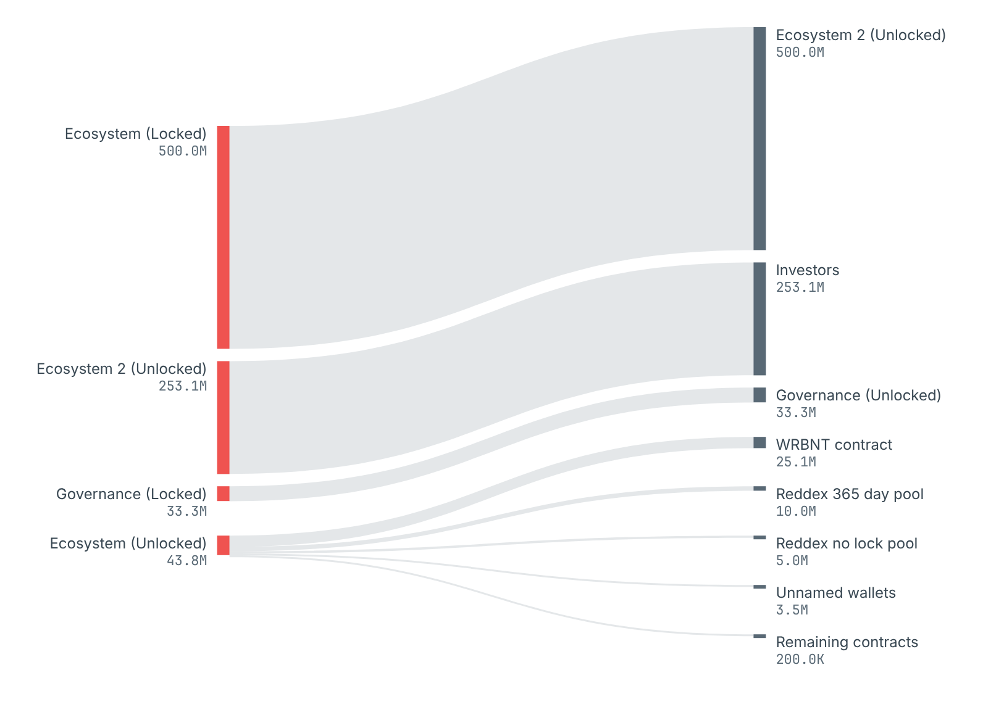
Read from every transaction and internal transfer of each reserved wallet between the two snapshot blocks.

Every move, largest first
- 500 million RBNT went from Ecosystem (Locked) to Ecosystem 2 (Unlocked).
- 253.1 million RBNT went from Ecosystem 2 (Unlocked) to Investors.
- 33.3 million RBNT went from Governance (Locked) to Governance (Unlocked).
- Ecosystem (Unlocked) sent 25.1 million into the WRBNT contract, which wraps it; 15 million to the two Reddex pools as plain transfers, which tops up their reward reserves; 3.5 million to unnamed wallets in 22 transfers; and 200,000 to other contracts.
- Ecosystem (Unlocked), in WRBNT: got 9.6 million WRBNT back from token vesting contracts (1 transfer), passed 34.7 million WRBNT to token vesting contracts (4 transfers) and wrapped 25.1 million RBNT (2 transfers).
- No transfer touched Team (Locked), USYD/CSIRO (Locked) or Reserve during the quarter; their balances are the same on both dates.
WRBNT is a token, so passing it on does not change a wallet's RBNT balance in the table above. We list it anyway so that every movement of the reserved wallets is on the page.

Exchanges and other tagged addresses
The explorer shows a public name on just one of the 20,000 largest addresses we read from its list: Wrapped RBNT. It tags no exchange wallet, so we name none. Any counterparty without a public name shows up only as a group: unnamed wallets, or contracts by kind.

Wrapped RBNT
WRBNT is RBNT packaged as a token so that apps built for tokens can use it. The WRBNT contract keeps one RBNT for each WRBNT in circulation; we checked this held at every snapshot. Over the quarter the amount of WRBNT outstanding went from 1.82 billion to 1.74 billion, a change of -82.2 million.
CHART 16
WRBNT supply, daily
totalSupply of the WRBNT contract at the end of each day.
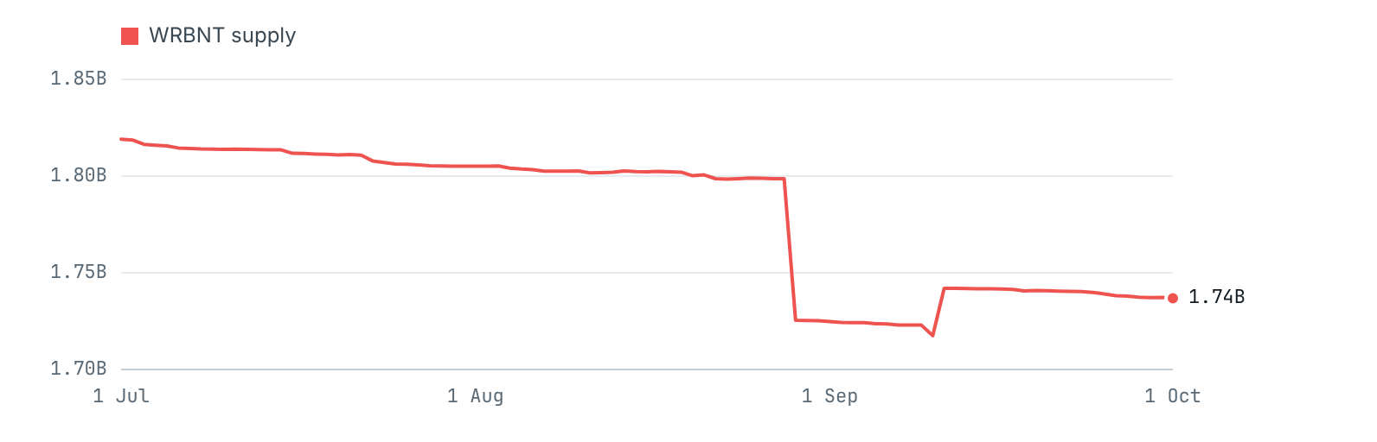
Read from WRBNT totalSupply() at the daily snapshot blocks.

CHAPTER 07

How we did it
We read the whole chain ourselves, took every balance at fixed blocks, and had a second program read the published numbers back from the node before release.
- Fixed blocks. Each date stands for the newest block stamped before midnight UTC: block 3,025,809 for the end of 30 June and block 3,209,414 for the end of 30 September. Month ends and every day of the quarter follow the same rule.
- The whole chain. We read all 3,209,415 blocks from launch to the end block and 1,753,030 internal transfers, which turned up 761,594 addresses that could hold RBNT.
- Balances from the node. For each address we read RBNT, WRBNT and staked RBNT at the snapshot blocks. We never use the balances shown in the explorer's lists, which are current and rounded.
- Exact checks. 58 checks must hold to the wei before any table is written, among them: the WRBNT supply equals the sum of all WRBNT balances; each pool's stakers add up to its totalStake; stakes minus withdrawals equal the change in totalStake; every group adds back to the coins found; every named wallet balances to the last wei.
- A second read. After the tables are built, a separate stage reads every named balance, both pools' totalStake and the WRBNT supply again straight from the node, plus 600 balances picked at random, and scans every published file for any address outside the named list.
Paste either command into a terminal to read a figure from this report directly from the chain.
# RBNT held by the Reserve wallet at the end of the quarter (answer in wei, divide by 10^18)
curl -s https://governors.mainnet.redbelly.network -H 'content-type: application/json' \
-d '{"jsonrpc":"2.0","id":1,"method":"eth_getBalance","params":["0x7473fEAf836b5319D9190d8367991Dc6ef33C16d","0x30f8c6"]}'
# Staked RBNT (totalStake) in the 365 day pool at the end of the quarter
curl -s https://governors.mainnet.redbelly.network -H 'content-type: application/json' \
-d '{"jsonrpc":"2.0","id":1,"method":"eth_call","params":[{"to":"0x5E8040e85D0E6363D798a43BEa939C026449946d","data":"0x8b0e9f3f"},"0x30f8c6"]}'
The full method, the list of sources and the steps for the next edition are on How we did it. The code that produced every number sits in the same repository as this page.

What the chain cannot tell us
- Who controls an address, or why coins moved. A group's holdings can fall because someone sold, moved coins to another address of their own, or put them into a contract.
- How many people there are. Counts here are counts of addresses: one person can run many, and one exchange address can hold coins for many people.
- The node we read cannot replay contract calls, so coins that contracts pass along inside a transaction were taken from the explorer's records. They hold up: the named wallets, the WRBNT contract and both pools pay out mostly that way, and every one of them balances to the wei.
- Public tags were read for the 20,000 largest addresses in the explorer's list. A tag on a smaller address would not be seen.

CHAPTER 08

Download the data
Every chart and table above is drawn from these files. They hold groups and named wallets only.
- Report as PDF: downloads/rbnt-holders-q3-2026.pdf
- Report as Word: downloads/rbnt-holders-q3-2026.docx
- Every table in one workbook: downloads/rbnt-holders-q3-2026-tables.xlsx
- Headline figures and checks: data/q3-2026/headline.json
- Second read from the node: data/q3-2026/audit.json
- Community summary: community/summary.md
- Supply and backing checks: data/q3-2026/supply_reconciliation.csv
- Coins by holding address: data/q3-2026/location_by_place.csv
- Holdings by group: data/q3-2026/holdings_by_group.csv
- Wallets by holding size: data/q3-2026/size_bands.csv
- Concentration yardsticks: data/q3-2026/concentration_measures.csv
- Lorenz curve points: data/q3-2026/lorenz_points.csv
- Outcomes by starting size: data/q3-2026/cohort_outcomes.csv
- Wallets that changed size: data/q3-2026/band_transitions.csv
- Top 10, next 90, next 900: data/q3-2026/rank_groups.csv
- Pools and WRBNT, daily: data/q3-2026/pools_daily.csv
- Reddex pools, start and end: data/q3-2026/pools_summary.csv
- Stakers by stake size: data/q3-2026/stake_size_bands.csv
- 365 day pool unlocks: data/q3-2026/unlock_schedule_365.csv
- Named wallet balances: data/q3-2026/named_balances.csv
- Named wallet counterparties: data/q3-2026/named_counterparties.csv
- Reserved wallets, WRBNT moves: data/q3-2026/reserved_wrbnt.csv
- Flows between groups: data/q3-2026/group_flows.csv
- Reserved wallets, daily: data/q3-2026/reserved_daily.csv

CHAPTER 09

Glossary
RBNT. The Redbelly network's own coin. 10 billion exist, all created at launch.
Address. An account number on the chain; what it holds is visible to everyone.
Wallet. An address whose owner signs with a private key; it may be a person or an organisation.
Contract. An address that is a program and handles coins by fixed rules.
Holding. RBNT plus WRBNT plus staked RBNT belonging to one address.
WRBNT. The token form of RBNT. Each one is matched by an RBNT locked in the WRBNT contract.
Staking. Depositing RBNT in a pool to earn rewards, which are paid in RBNT.
totalStake. A pool contract's own running total of the RBNT its stakers have deposited.
Reward reserve. RBNT in a pool beyond its totalStake, used to pay rewards.
Reserved wallets. The nine Redbelly addresses published on the DAO treasury page, covering the team, investors, the reserve, ecosystem funds, governance and USYD/CSIRO.
Snapshot block. The block that stands for a date: the newest one stamped before midnight UTC.
Gini index. One number for how uneven holdings are, from 0 (all equal) to 1 (one holder has all).
Wei. The smallest unit of RBNT; 1 RBNT is 1018 wei. Our checks are exact to the wei.

