Assignment-1.

● Create a class Student in Student.java then add member variables studentName, collegeName of type String ● Add a member variable studentID of type int. ● Make all the member variables as private. ● Add a main method. And print a message “Successful”. ● Compile the class ● Run the class (Follow Coding convention)

package lab_1;  
  
public class Student {  
 private String studentName;  
 private String collegeName;  
 private int studentId;  
  
 public static void main(String[] args) {  
 System.*out*.println("Successful");  
 }  
}

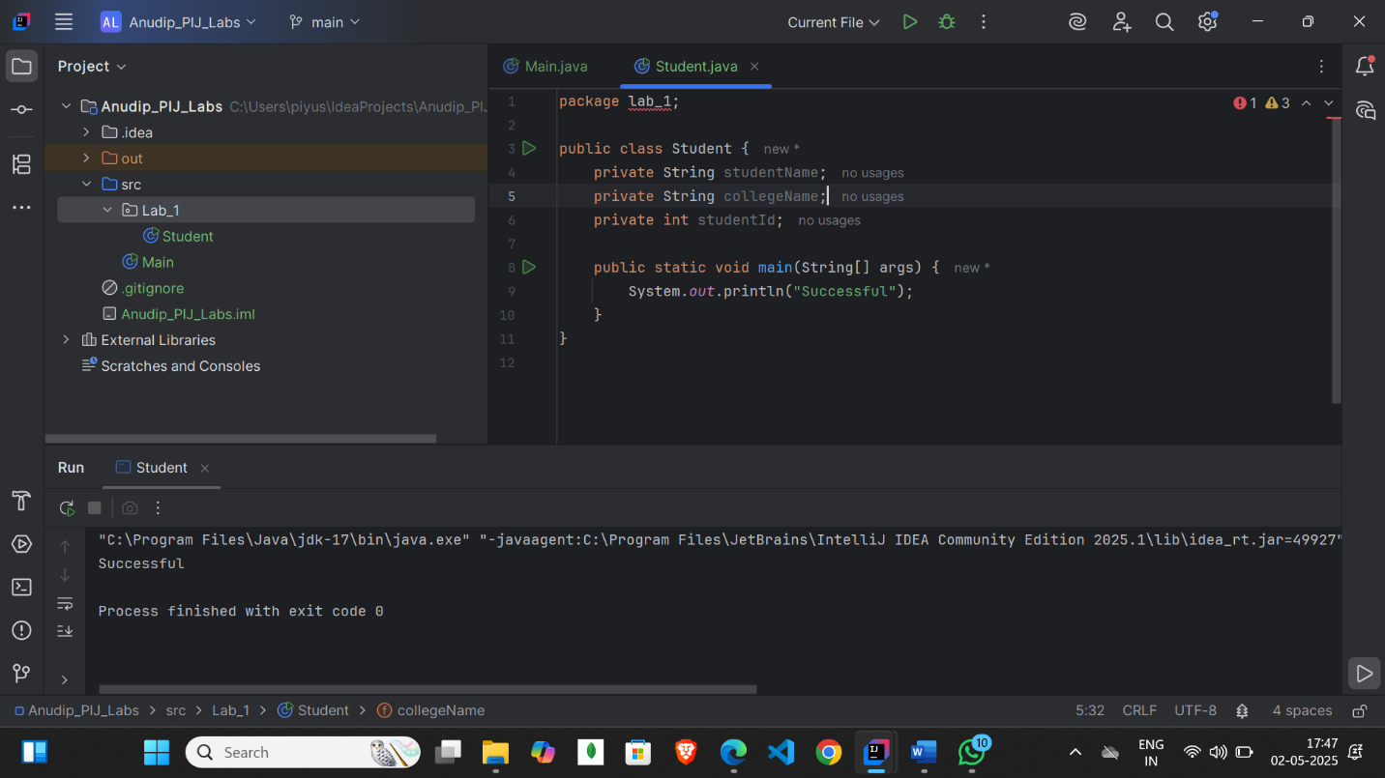

Assignment-2.

● Create a new class Employee ● Add member variables: id and age of type int, name of type String and is permanent of type boolean ● Now assign values 35.5 to age; See the error message. ● How can you avoid this error? Correct the error by casting. ● Make all the members protected ● Add a main method to it. Print message “Successfully started”. ● Compile the class.

package lab_1;  
  
public class Employee {  
 protected int id;  
 protected int age;  
 protected boolean isPermanent;   
  
 public static void main(String[] args) {  
 Employee employee = new Employee();  
 employee.age = (int)35.5;  
 System.*out*.println("Successfully started");  
 }  
}

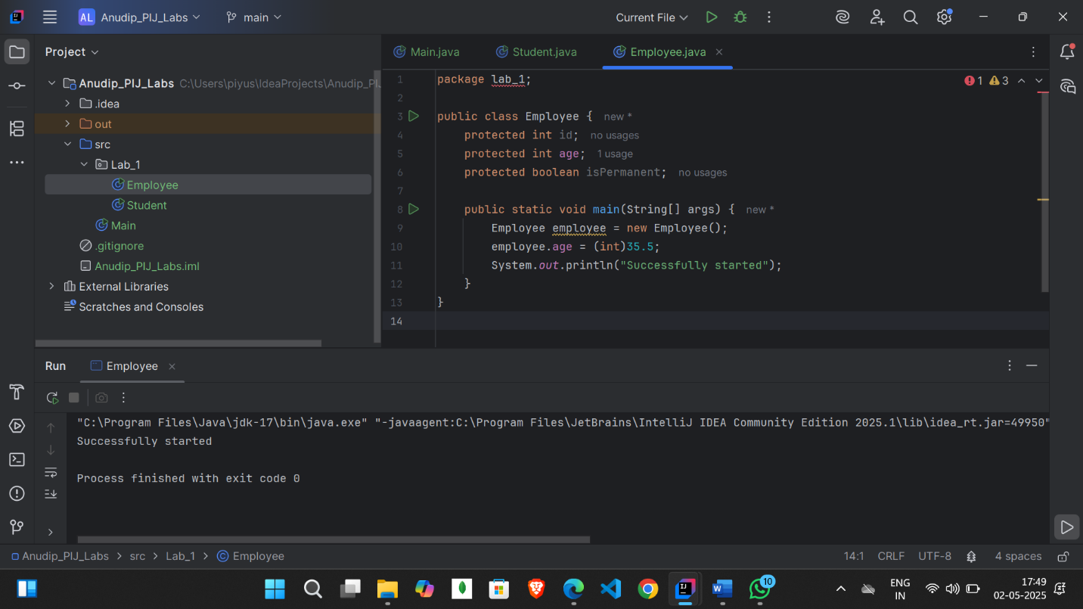

Assignment-3.

● Create a class Person ● Add member variables name as String, age and salary as int ● Initialize the member variable along with declaration. ● Now put the previous Person class in a package com.anudip.learning ● Add a main method. Add a print message “Test Successful”. ● Run the class after compilation. ● Modify the classpaths to see the error messages on the console.

package lab_1;  
  
public class Person {  
  
 private String name = "Piyush Dubey";  
 private int age = 24;  
 private int salary = 25000;  
  
 public static void main(String[] args) {  
 System.*out*.println("Test Successful");  
 }  
}

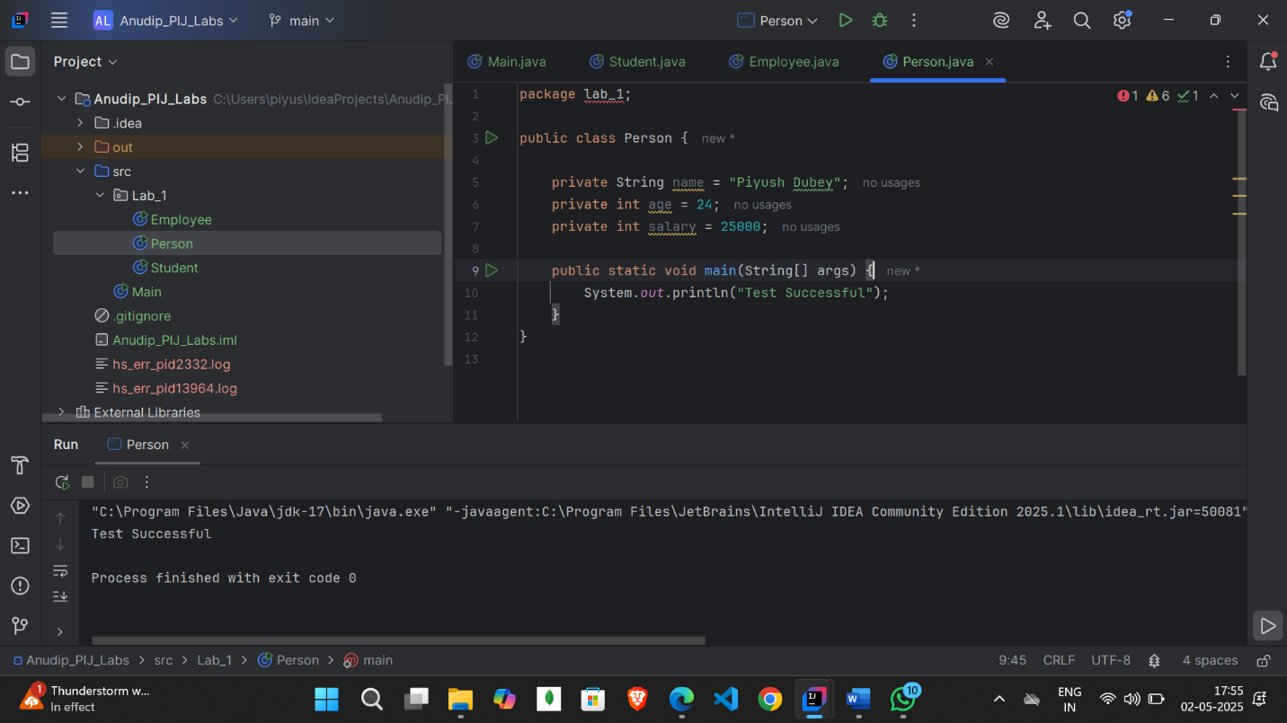

Assignment-4.

● Create a class Rectangle ● Add a member variable width and height of type double. ● Create an enum Color with values RED, GREEN, BLUE ● Create a member variable boxColor of type Color. ● Add a main method. ● In main method just print the enum Color.BLUE (You will notice that Java prints the enum name as it is.) ● Compile and run the class.

package lab_1;  
  
enum Color{  
 *RED*,*GREEN*,*BLUE*;  
}  
public class Rectangle {  
 private double width;  
 private double height;  
  
 Color boxColor;  
  
 public static void main(String[] args) {  
 System.*out*.println(Color.*BLUE*);  
 }  
}

